Table of Contents
What is Zoom? 3
Prerequisites 4
Joining a Zoom meeting 5
Step 1 of 3 5
Step 2 of 3 5
Step 3 of 3 5
Setting up your Computer audio and microphone for a Zoom meeting 6
Step 1 of 4 6
Optional step, if you don’t hear a ring tone through your speakers 6
Step 2 of 4 7
Optional step, if you don’t hear the playback of your voice recording 7
Step 3 of 4 8
Step 4 of 4 8
Zoom meetings functionality for attendees 9
Overview of bottom bar 9
Unmute button 9
Start Video Button 10
Participants button 10
Chat button and panel 11
Chat button and panel continued 12
Share Screen and Record buttons 12
Leave meeting button 12
Video Guides 13

The online SCURL Copyright conference on December 3rd, 2020, will be delivered using Zoom. Please note, this session will be recorded (this encompasses the audio video and chat box). The recording will be made available via the SCURL closed mailing list.

What is Zoom?
Zoom is a cloud-based video conferencing tool that can be used on desktop PCs and mobile devices, which allows users to meet online, with or without video. Zoom allows audio, video and wireless screen sharing across various platforms, i.e. computers and mobile phones.
People can converse through both audio and text via the ‘chat box’ in a ‘Zoom meeting’. Meetings can be scheduled to last for variables times and scheduled for a specific time/date.
Zoom can be viewed across the following devices/systems:
- Windows
- Mac
- Linux
- iOS
- Android
- Blackberry
- Zoom Rooms
- H.323/SIP room systems.

Prerequisites

Before you can join a Zoom meeting, please click on the link below to either download the free Zoom app for Windows or Mac (this will download automatically when clicked on).
You’ll also find links for both the Apple and Android apps for mobile devices, by clicking on the link below as well.
Click here to navigate to Zoom download page
When the Zoom app has downloaded, please make sure you go through the process of installing the app on your computer or device.

Joining a Zoom meeting

Step 1 of 3
Click on the link to the Zoom meeting (Copyright event), within the invitation.

Step 2 of 3
Once you’ve done this, your internet browser should open, and you’ll see the following pop up on screen. Click on the ‘Open Zoom Meetings’ button.
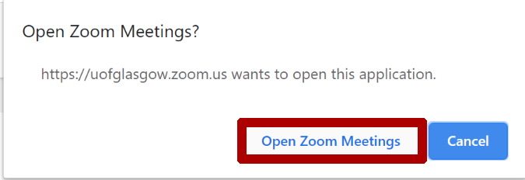

Step 3 of 3
A new pop up will appear on screen providing you with two options, before clicking on the ‘Join with Computer Audio, its’ advised to click on the ‘Test Speaker and Microphone’ button. As this will enable you to test your audio and microphone.
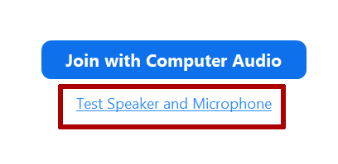

Setting up your Computer audio and microphone for a Zoom meeting

Step 1 of 4

The pop up shown below will appear on screen when your testing and configuring your audio for a Zoom meeting. A ring tone will play, which you should hear via the speakers from your computer, device or headset. Click on the applicable button to indicate if you hear the ring tone or not.

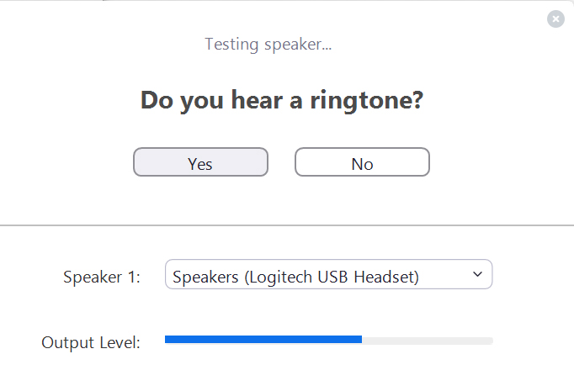

Optional step, if you don’t hear a ring tone through your speakers

If you didn’t hear the ring tone being played through your source, i.e. headset, computer speakers, click on the speaker source and make sure it’s’ selected in the drop-down menu (as shown in the image below).
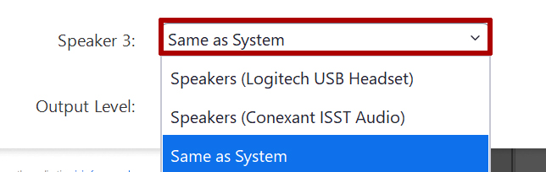
Once you can hear the ring tone, click on the ‘yes’ button (as shown in step one).

Step 2 of 4

Another pop up will appear screen, this time asking you to speak into the microphone you have available. This will be available through your computer, mobile device or in some cases headset. Speak into the microphone you have and when you have done this, you should hear a reply of what you’ve said via the speakers on your computer or device.
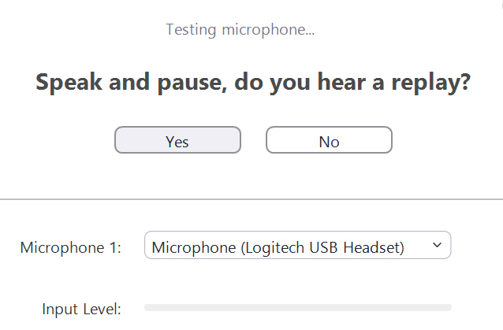

If you do hear the recording of what you said, click on the ‘yes’ button, if not proceed onto the optional step below.

Optional step, if you don’t hear the playback of your voice recording

If you didn’t hear a playback of what you said into your computer/devices microphone in the previous step, then click on the microphone button shown below and make sure your microphone the selected source in the drop-down list that appears.
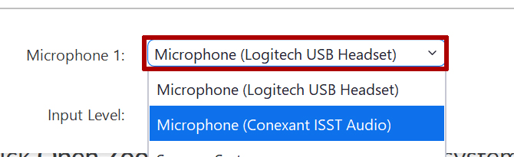
Once you have made sure your microphone is the source selected, repeat the process in step 1 (speak into your microphone), and you should hear a playback of your recording.

Step 3 of 4

Another pop up will appear on screen, with a message indicating that they’re being picked up ok by Zoom (note the sources are shown in this pop up). Click on the button called ‘Join with Computer Audio’.
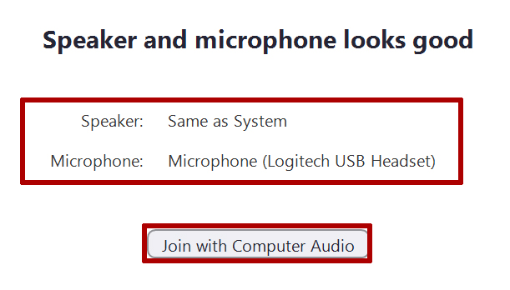

Step 4 of 4

The pop up that was initially on screen will appear on screen – click on the ‘Join with Computer Audio’ button.
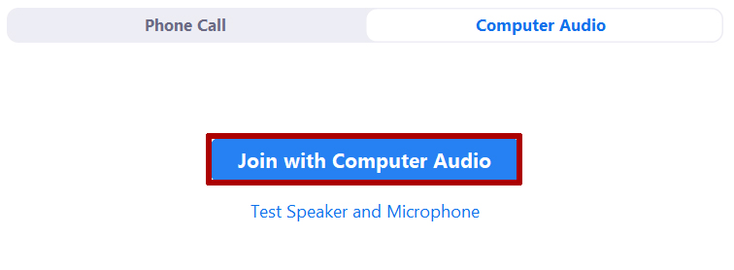
Note: you can log into a Zoom meeting using a traditional dial up phone. For further information on this, please click on the link below.
Link to guidance on using a phone to dial into a Zoom meeting

Zoom meetings functionality for attendees

Overview of bottom bar

When a Zoom meeting, located at the bottom of your screen, should be a toolbar with various buttons. We’ll now begin to go over what each of the buttons do.

Unmute button

When you’re logged into the Zoom meeting by default your microphone will be muted, this is to cut out any potential background noise.
You can unmute your microphone (when promoted by the host), by clicking on this button. This will enable you to speak.
By clicking on the arrow pointing up, you have access to audio settings, which you can adjust if required.
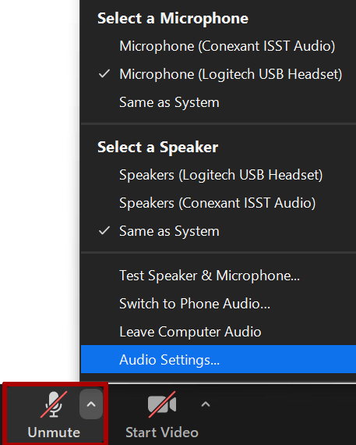

Start Video Button

When clicked on the start video, you can share your computer or devices camera. This is usually done to show the attendee, its very much your choice if you would like to share your devices video or not.
To access further settings for video, click on the arrow pointing up on the ‘start video’ button.
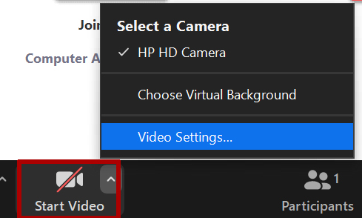

Participants button

The participants button allows attendees to give non-verbal feedback to the host, during a Zoom meeting. When this button is clicked on, a range of options are available to notify the host that something is; too fast or slow, thumbs up and down, a simple yes / no response. During the SCURL Copyright conference, if you have a question you would like to ask a speaker using your microphone during their Q and A section please click on the ‘raise hand’ button found in the participants menu or alternatively, type it in the chat box.

Chat button and panel

By clicking on the chat button, you can access a pop chat panel that allows you to use your keyboard to type text-based messages into it. The messages you type into this will be displayed here for everyone in attendance to see and engage with (including the speakers).
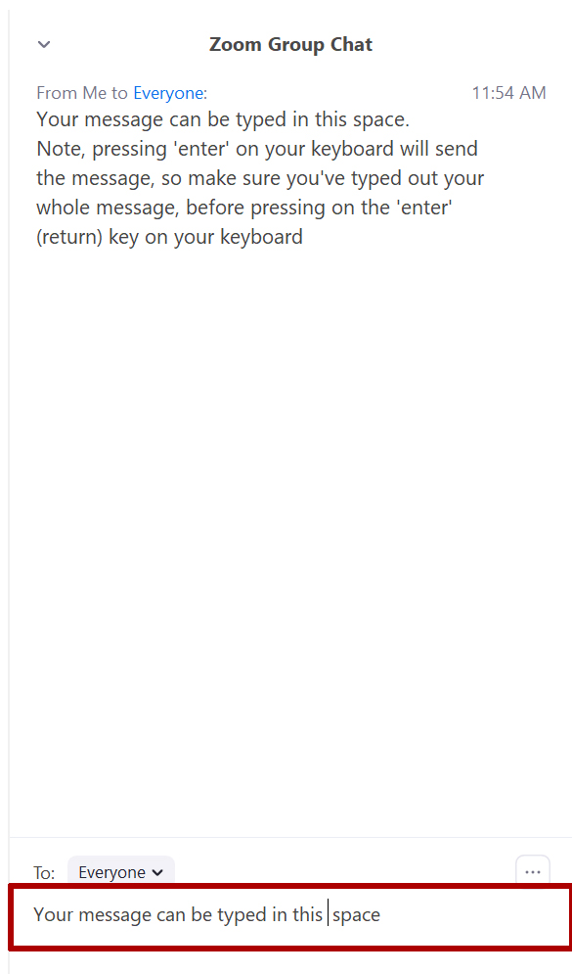
Note: when you click on the enter key (return) on your keyboard, this will send whatever you’ve typed in the chat window to everyone

Chat button and panel continued

You can close the chat window by clicking on the arrow pointing down, this will reveal a drop-down menu which contains the ‘close’ button and ‘pop out’ button.
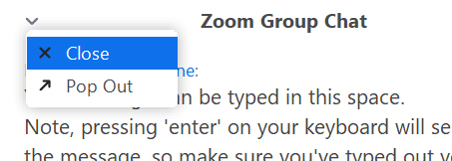

Share Screen and Record buttons

This session has been set up so anyone who is attending can share their screen. However, unless you are a speaker at the event, please do not click on the ‘Share screen’ button. The recording button has been disabled for everyone, aside from the host of the session.

Leave meeting button

When you are ready, click on this button to leave the Zoom meeting (Copyright conference).

Video Guides

You may prefer to see the process of using Zoom, the links below will take you to online video tutorials which go over certain aspects of logging into Zoom and how to use it.

- Link to: How to log into a Zoom meeting from an email invitation (watch between 0:00 – 0:43)
- Link to configuring audio and video when joining a Zoom meeting during a Zoom meeting

