Library
Knowledge Base

Library Search

Level: Type in level here

Contents

Library Search 3
Enter your search terms 4
Results List 4
Refining your search results 5
Advanced Search 6
Getting the best from your Search 6
Saving Results 7
Saving to EndNote Web 7
Saving to Desktop EndNote 7
Accessing Library Search from Off Campus 8

Library Search

Using Library Search allows you to find full-text articles and details of print books and book chapters across all subjects in the Library’s collections. Other materials covered include newspaper articles, trade publications and book reviews.

Coverage note: We have tried to ensure as much as possible of our online content is searchable in Library Search, but it is not comprehensive. This is due to a number of reasons including: restrictions imposed by publishers; and linking issues with some resources.
If you are looking for a specific type of publication, e.g. music scores, law reports etc. it may be easier to use the Specific Search options on the Library home page.

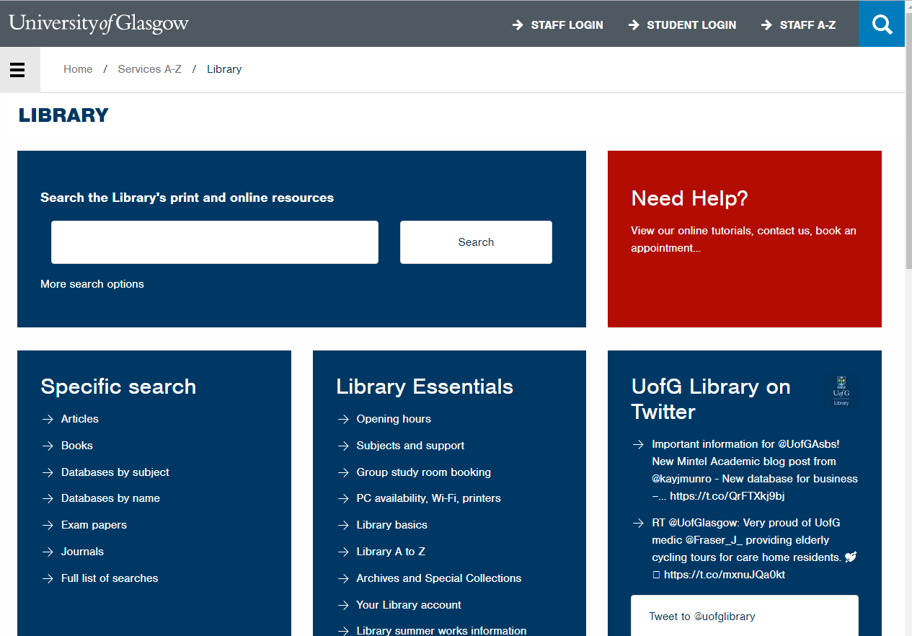

Library Search is quick and easy to use. It’s a bit like Google or Google Scholar but with direct access to many of subscribed resources. You only need to take three steps:
- Enter search terms or phrases into the single search box
- Refine results by date, subject, academic journals etc.
- View results, and link directly to full text or more information.

Enter your search terms

Start your search by entering key words or phrases into the Search Box, e.g. “corporate finance” AND gender. By placing the phrase inside quotes, this means that Library Search will search for all articles with the phrase “corporate finance” AND the word gender. When using Library Search all connecting words e.g. AND, OR, NOT must be entered in CAPITALS. If you don’t enter any connectors such as AND or OR the default search is for all keywords. Click on Search to run.

Results List

A list of results will be returned. Given the number and variety of resources being accessed by Library Search from across all subject areas, it is likely that a large number of results will be returned.
Each individual result will display the authors, title, source details, and part of a summary description. To see more information about an individual item, click on or hover over 'Preview'. To read the item, either click on the title, or click on 'Full-text online'.

Refining your search results

Once you have run your search you can use the 'Refine your search' options on the left of the screen to limit your results. You can include or exclude items in any of the following ways:
- Scholarly & peer review - limit results to the best quality sources by limiting by the first two options, and to freely available items using the Open Access option
- Full Text Online – limit results to material available in full-text online only. Please note that will exclude all print items from your results.
- Content type - restrict your results to just to journal articles, book chapters, and many other types of publication
- Publication date - limit to a specific date range using the slider, enter dates in the boxes, or select the latest 12 months, 3 years or 5 years
- Language - click on 'LANGUAGE' to select from the list of languages represented in your results
- Discipline - restrict results to items published in a specific discipline

Advanced Search
If you are finding too many results, try using the Advanced search to limit your search to specific fields e.g. author, title. You can also restrict results using date, content type, discipline, language, peer review and Open Access. It is also possible to remove certain content from your results: newspaper articles, book reviews and dissertations.
To access the Advanced Search click on the 'Advanced' link to the right of the search box.

Getting the best from your Search
Make your search as simple or as sophisticated as you wish. Just type in your search words or use the following techniques for a more controlled search.

Phrase searching
Use quotation marks to specify a phrase e.g. "corporate finance"

Search operators
Use operators 'AND', 'OR' and 'NOT' to narrow or widen your searches. The operators must be entered in CAPITALS. For example: “corporate finance” AND gender, film OR cinema, “youth crime” NOT drugs. If you want to combine AND with OR it’s probably best to use Advanced search.

Truncation and wildcards
- Use the asterisk on the stem of word to find different endings e.g. scot* to find scot, Scotland, Scottish
- Use the question mark within a word to replace a single letter e.g. organi?ation to find organisation or organization

Proximity
Use proximity search to find words appearing near one another in a document. It allows you to search more flexibly when a single phrase might be too restrictive. Use quotation marks round the words you are looking for and the tilde indicating how close the search terms need to be. For example:
“change management”~3 would find articles on ‘change management’ and the ‘management of change’.

Saving Results
You can save reference details of the items you find on Library Search into a temporary folder which you can then print, email or export to EndNote (referencing software).
- Click on the folder icon to the right of each result to add it to the Saved Items folder.
- When you have finished selecting items click on the folder icon next to the search box at the top of the screen.
- This will show your saved items.

Print/Email
- Select a citation format from the pick-list. Then click on Print or E-mail as appropriate to output your results in the selected style.

Saving to EndNote Web
- To save to EndNote Web click on the 'Export as' pick list and select EndNote.
- Save the file (by default it will be saved to your Downloads folder).
- In your EndNote Web account click on 'Collect' and then 'Import references'.
- Browse for your downloaded file of references (it will be a .ris file)
- From the Import option list select 'Citation’
- Lastly, select a group to put them in - if you don't have any groups just select [Unfiled]
- Click on 'Import'. The references will be added to your Library.
- Please note that this will save only the bibliographic details not the full-text. You will need to save the PDFs found via Library Search and attach them to your references manually.
- Alternatively, use the 'Find full-text' option from within EndNote to attach PDFs to references (although this might not find all of them, so you may need to attach some PDFs manually).

Saving to Desktop EndNote
- To save to EndNote click on the 'Export as' pick list and select EndNote. EndNote will open automatically and your references will be imported. Check that the information is complete before moving on to another search.
- Please note that this will save only the bibliographic details not the full-text. You will need to save the PDFs found via Library Search and attach them to your references manually.
- Alternatively, use the 'Find full-text' option from within EndNote to attach PDFs to references (although this might not find all of them, so you may need to attach some PDFs manually).

Accessing Library Search from Off Campus

Off Campus? Log in to access full text and more content.
When you are using Library Search from off campus you will see a prompt encouraging you to log in at the top of the screen. Logging in is not essential, but it will mean that you avoid having to log into individual ebooks and ejournals later.

August 2017

