How to use Gather Town

Gather Town simulates a real classroom. It lets you move around the room so that you can talk to people you are nearby rather than having everyone on screen at the same time. Some of your courses may use Gather Town for teaching and/or social events and conferences.

What you need:
- A desktop/laptop with a mic and camera.
- A web browser (Chrome or Firefox recommended, Edge does not work reliably).
- Headphones to help prevent microphone feedback – this is very important!

How it works:
- Gather is a video chat platform that has avatars move around a map. As you get close to other avatars, your video will pop up and you will be able to chat.
- Move around the space using the arrow keys on your keyboard.
- By moving your avatar around you can have spontaneous conversations with those around you. These can be either one-on-one or small groups depending on how many people are around you and what you set your interaction distance to be.
- When your avatar moves closer to an interactable object, there will be a notification that shows up saying ‘Press x to interact with -object-’. This can range from informational flyers, whiteboards, playable arcade games, integrated Zoom meetings, and more!

How to sign in
- Click on the link provided by your programme team. You will be asked for the password to the space. You will then be asked to provide a name for your avatar. You can use any name you wish. Please do not use your full name or student ID for data purposes. You do not need to create an account or give out your email address. Please allow the pop up to use microphone and video. You will then see a screen to test your audio and video options. You might be entered into a tutorial space, you can skip the tutorial (on left-hand side of the screen).

Icon explanation:

Screen sharing ability. This will let you share your screen with others who are close to you. You should only do this if instructed by your tutor.

Change your avatar character and clothing.

Change your interaction distance. This controls how close people must be to you for your camera to turn on.

Mini map to preview the space you’re in. If you’re in a large space, this can be helpful to navigate.

Raise hand feature: If you have a question for your tutor you can use the raise hand icon to get their attention. This is under the .

Opens the settings menu:
- Change Name - this is your choice
- Change Audio/Video Devices
- Respawn button to return to start – this may be helpful if you are in a large map with multiple rooms.
- Click for Mod Settings: Change room password, change mod message, toggle force mute whole space. This will only show if you have made your own map, it will not be there if you are in a UofG space for teaching as a student.

Chat
There is a messaging feature that allows you to message people in four ways:
- individually by clicking on their name in the participant panel,
- locally to the people you are video chatting with,
- globally to all the people in your map (this will include multiple rooms if they exist).

Spawn points
Spawn means where your avatar will appear in the room when you log in. The first time you enter a space you will spawn at a pre-determined point set by the person who made the space. However, Gather Town will remember where you were when you leave so the next time you log in you will appear in the same place you were when you left the space. This can be helpful if you’re in a classroom as you will spawn back into your seat! However, if you’re in a large space with multiple rooms, you may wish to hit the respawn button in the settings above before you leave so that you don’t appear in the wrong place.

Accessibility

The chat function in Gather Town is readable with a screen reader. If you have a visual impairment and would like a tour of the platform before your class, please contact your course lead who will be happy to do so. If you are deaf or hard-of-hearing, please ensure that you are registered with the disability service and your tutor will use the chat in addition to audio to communicate with the class.

Online etiquette

Gather Town may look like Pokémon but remember that it is a real classroom and that the same rules of etiquette apply! Be courteous and polite to all staff and students and follow any rules that the tutor has put in place. Use headphones to avoid any audio feedback and use the raise hand functions and the chat to aid communication. Remember that the same disciplinary rules will apply as if you were in a classroom on-campus and staff will have the ability to remove anyone from the room that is being disruptive.

Private spaces

Private spaces are where everyone in a certain range of tiles will be able to talk to each other. Sometimes private spaces will be marked by coloured circles, however, sometimes they will be invisible and instead you will get a notification at the bottom of the screen that says “You have entered a private space”. Typically, private spaces will be used so that everyone in a group round a table can talk to each other even if they move slightly outside of the interaction distance. In the virtual coffee these private spaces are marked out by the carpets. All spaces with carpet are private spaces.

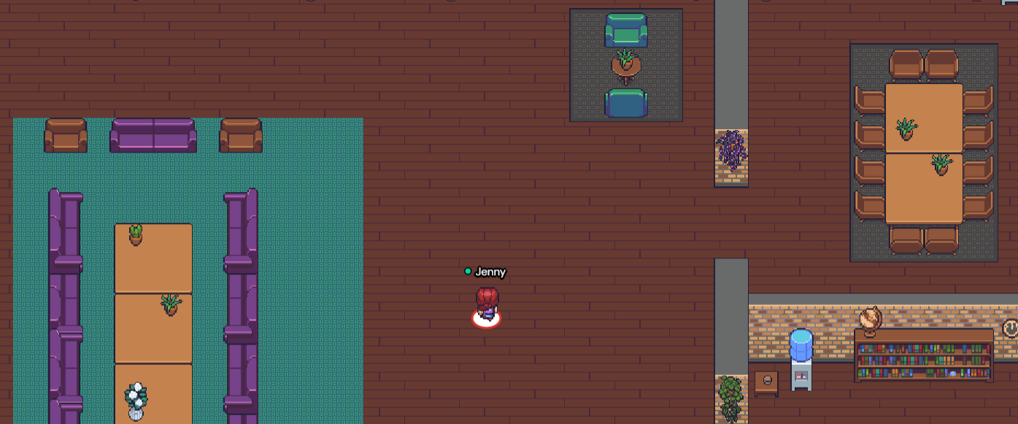

Technical difficulties
- Refreshing the page will fix most things!
- If that doesn’t work, try muting and unmuting your mic and camera in Gather Town.
- Check if your browser permitted camera and mic access
- Additional troubleshooting at https://gather.town/video-issues

Privacy Policies

The personal data collected by Gather Town is minimal, consisting of the nickname or affiliation that participants give their avatar and their email address. A user can request that their account and information is deleted.
Regarding usage data, Gather Town stores IP addresses and cookies for functionality. Full details are available in their privacy policy.

Gather Town’s servers are located in the United States and therefore are outside of the jurisdiction of GDPR. However, Gather Town’s privacy policy explicitly gives users the following GDPR rights:
- The right to access, delete, or update the information we have on you;
- The right to have your information rectified if that information is incomplete or incorrect;
- The right to object to our processing of your data;
- The right to request that we restrict the processing of your data;
- The right to request a copy of your personal data in machine-readable and commonly-used format;
- The right to withdraw your consent at any time where we rely on your consent to process your personal information.

Whilst no platform comes without risk, the risks posed to data protection by the use of Gather Town are minimal and proportionate.

