Copyright work report
Providing additional evidence and context for Greg Walters CMALT portfolio (2021)
Greg Walters
University of Glasgow greg.walters@glasgow.ac.uk
Contents
Executive Summary of UofG Copyright report 2
Scottish Confederation of University and Research Libraries (SCURL) background and activity 3
Background of Copyright and Legal Issues group 3
My role going forward in SCURL 3
Delivery and development of National Online event for SCURL Copyright Group – June 18th 2020, 10am – 12:30pm 4
Delivery and development of National Online event for SCURL Copyright Group – December 23rd, 2020, 10am – 12:30pm 5
Delivery and development of National Online event for SCURL Copyright Group – June 17th, 2021, 10am – 12:30pm 5
Association for Learning Technology Copyright and Online Special Interest Group (CoOLSOG) 6
Copyright Related Work 7
Copyright materials developed in response to sector wide shift to online and blended learning adopted by UofG (2020 analysis) 7
Copyright online workshops 10
Copyright queries via email (2020) 11
2021 update on copyright related work 12
Copyright webpage 12
Related long term objective for copyright web pages resources 12
Copyright Workshops 13
Copyright resources engagement during 2021 13
Further Evidence 15
YouTube video view analytics 15
Tineye video viewing figures 15
UK Fair Dealing video viewing figures 15
UK Copyright Exceptions video viewing figures 16
Searching for images effectively online video viewing figures 16
Licences video viewing figures 17

Executive Summary of UofG Copyright report
Based on the evidence within this report, I feel my output during the past several years (particularly 2020 – 2021), has greatly benefited both the UofG and national HE communities by providing well received online guidance, through the Copyright based workshops, events and resources I delivered. These endeavours follow on from previous years activities in my continued efforts to engage with staff and students by delivering eleven online Copyright workshops between March – Sept 2020 (attended by 167), to offer important guidance in this area. This is especially relevant given the sector wide shift to online/blended learning for teaching and learning in response to the global pandemic during 2020. In light of the changing circumstances, I actively promoted the Copyright service to academic, professional service staff and students via Social Media and email throughout the year. Which resulted in increased engagement with the online resources I developed, as the Sway page viewing figures went from 1009 (March 2020) – 2210 (November 2020). At the time of writing (January 2022), my video-based copyright based resources have been viewed thousands of times, with the combined versions of my Tineye video being viewed 3378 times, Fair Dealing video 903 times, and copyright exceptions video viewed 450 times. The other area of the Copyright service which saw a drastic increase over 2020/2021, was responding to the 83 individual queries from staff and students to my personal and queries-based inbox(s).
To build on the momentum experienced at UofG in terms of copyright support and guidance, I’ve been enriched in terms of knowledge and exposure to different copyright law and policies, by joining two external groups focusing on these areas. Both the SCURL Copyright and Legal Issues group along with ALT CoOLSIG, presented numerous opportunities. Some notable examples are; the 203 attendees across three of SCURL’s online copyright events I was involved in facilitating from 2020 – 2021, the speaking and writing opportunities presented by being an officer at ALT CoOLSIG.

The remainder of this report will provide background and more detailed information regarding several key copyright projects mentioned in Greg Walters’s CMALT reflection report (2021). It will also provide additional context and information regarding the SCURL, and ALT CoOLSIG groups Greg is involved in.

Scottish Confederation of University and Research Libraries (SCURL) background and activity

Background of Copyright and Legal Issues group
On November 12th, 2018, The Scottish Confederation of University and Research Libraries (SCURL) business committee approved the formation of a Copyright Group, after a recommendation paper had been submitted by a member of staff from Edinburgh University earlier in the year.
The groups remit includes effective advocacy and mutual support by providing a forum for discussion of copyright issues affecting SCURL member institutions. To facilitate a forum for discussion, the copyright and legal issues group decided to deliver an inaugural one-day Copyright event which took place on 11/03/2019. Since then, we delivered three more events during 2020 - 2021 in an online format, due to the pandemic and lockdown measures in place.
The group is small and is currently comprised of a member of staff (usually from Library and copyright background), from The University of Edinburgh, Strathclyde, and Caledonian. Our core members from 19 Scottish Universities & 6 Cultural Heritage institutions. However, due to the events going online, we expanded our audience to include members from the LIsCopyseek community (a Jisc private mailing list with 400 + subscribers comprising of UK and international copyright experts) and ALT CoOLSIG. This has been most welcome, as the range of attendees and expertise present, really add to the diversity of questions and comments during the online sessions. Our events comprise of industry expert speaking about a range of copyright and other issues ranging from exploring various licences, i.e., CLA, along with exploring areas such as Plan S and Creative Commons.
My role going forward in SCURL
Since November 2018 I’ve been a co-chair (I will be chair during 2022), and going forward, I’m intending to have one or two additional informal online events during the year, to focus on a singular issue or subject. An example of this, is the focused session I intend to facilitate around Fair Dealing, to coincide with the national UK event of the same name, which commences the last week in February. I think these focussed sessions will complement our regular online events which have multiple speakers and subjects, as they will give attendees the opportunity to have in depth discussions and knowledge exchange. I’m looking forward to being part of this group going forward, as I feel it provides a valuable forum of discussion for not just Scotland, but the UK as a whole.
N.B, the following pages in this section cover my contributions to the delivery of our previous online events in a descriptive fashion.

Delivery and development of National Online event for SCURL Copyright Group – June 18th 2020, 10am – 12:30pm
Normally the SCURL Copyright group would deliver two face-to-face events throughout the calendar year to attendees from the twenty-five institutions who are members. Due to this year’s (2020) circumstances, the planned face to face event due to be held in May, had to be cancelled. In response to this, on the 29th of April I suggested to the other Copyright group committee members (via email), we offer a ‘virtual conference’ as an alternative using the video conferencing platform Zoom.
I arranged a Zoom meeting with the other committee members (Gillian Daly (NLS), Deborah Ferns (Strathclyde) and Eugen Stoica (Edinburgh University), for the 6th of May to discuss the programme, potential theme, and speakers.
The outcome of the meeting was:
- We agreed the theme should focus on the application and best practice of Copyright Literacy and institutional licences in relation to the pandemic.
- The speakers would be Chris Morrison (Kent)/Jane Secker (University London), Thomas Margoni, Bartolomeo Meletti (both UofG) and James Bennett (CLA)
- I would arrange a follow up Zoom meeting with the Copyright group members, to test the functionality of screen sharing using Zoom (I delivered this on June 4th)
Based on the outcomes of the meeting, I contacted all of the speakers, to invite them to speak at our event and produced a Doodle poll for them to let us know what date(s) they were available on. The date that proved most popular amongst speakers was the 18th of June 2020.
Prior to the date of event, I did the following to help ensure it ran smoothly,
- I delivered one to one meeting’s (via Zoom), with speakers and chair (Jeanette Castle) to go over the functionality of using Zoom, their presentation(s) and the ‘flow’ of the online event.
- Worked with Gillian Daly, to produce text for use in both the web presence and Eventbrite booking page
- I developed users guides on how to use and log into Zoom for both participants and speakers
- I produced adverts for use on SCURLs Twitter account
On the day of the event (June 18th), I delivered the SCURL online Copyright event via Zoom, between 10am -12:30pm to an audience of 70 members and welcome external guests. I introduced the chair and speakers, along with facilitating the screen share so speakers could deliver their presentations and kept the flow of conversation going by delivering questions submitted via the chat box and my own comments as well.
Click here to view recording of session

Delivery and development of National Online event for SCURL Copyright Group – December 23rd, 2020, 10am – 12:30pm
To follow on from the success of the groups last virtual Copyright Conference, I suggested we deliver a session during the autumn of 2020 via email on 13/08/2020. I organised a Zoom meeting for 20/08/2020, so the Copyright group could discuss the programme and speakers. Our meeting determined which speakers we would approach and after an online poll was conducted between the group’s members, a date of 3rd of December was set.
I led on facilitating the online conference via Zoom, produced the user guides, presentation slides. My colleagues approached and liaised with our speakers and promoted the event via LisCopyseek and other relevant groups.

On the 3rd of December 2020, I delivered the Copyright groups second virtual conference to an audience of 95 SCURL members and welcome guests from other UK institutions and bodies using Zoom. I was also responsible for creating and editing the recording of the event, which was distributed online to attendees and the HE community via email.
Click here to view recording of session

Delivery and development of National Online event for SCURL Copyright Group – June 17th, 2021, 10am – 12:30pm
With format and platform (Zoom), established, this online event was simply a case of going through our previous processes of discussing our potential speakers and contacting them when we had identified possible relevant areas that could be discussed.
As with previous sessions, I facilitated the session using Zoom and promoted the event through our usual platforms of mailing lists and social media.
The third online SCURL copyright event, was delivered to an audience of 38 SCURL members and welcome guests from other UK institutions and bodies using Zoom. The immediate output of this session was different, as the Zoom recording and password weren’t emailed to attendees and HE community via email, instead it was directly uploaded to SCURL’s then newly created YouTube channel. Gillian and I discussed at the start of 2021 about creating a YouTube channel to create a permanent online archive of SCURL events recordings.
Click here to view recording of session

Association for Learning Technology Copyright and Online Special Interest Group (CoOLSOG)

CoOLSIG was created by Jane Secker and Chris Morrison, who envisaged the group during 2020 in response to the sector wide pivot to online learning and teaching due to the global pandemic. This shift, saw a heightened copyright risk, as more materials from lecturers, students, and researchers were being distributed online. Aside from these challenges, there was (and still is to an extent), a degree of uncertainty around how and if existing UK copyright exceptions and Fair Dealing framework would be adequate to enable online access to materials that would previously been suitable to show in their entirety in a classroom environment, i.e., a commercial DVD film. To provide support in this and other areas of copyright uncertainty, along with creating a community of practice, Chris, and Jane’s CoOLSIG group was launched during December 2020. The group is comprised of UK and international copyright practitioners from universities, who share the same ethos as Jane and Chris.
I have been the communications and marketing officer since the group was launched during December 2020, and have enjoyed the experience immensely, as it has provided me the opportunity to contribute to a very worthwhile group in the following ways:
- Speaking at OERx 21 discussing 4 key questions relating to exploring the relationship between open practices and copyright literacy. My reflective blog post, can be viewed here.
- Writing multiple blog entries around events and committee members
- Manage ALT’s social media presence
- Design logo for group, to be used in social media and merchandise

Whilst the above outputs may not initially seem to be relevant, I would argue that they are CPD related as by actively engaged in presenting or writing a reflective piece(s) around CoOLSIG, I am learning more about copyright or other related areas such as OER or controlled digital lending. This is knowledge that can be transferred to my professional practice and wider community, therefore benefitting others.
Similar to SCURL, I am enjoying being part of CoOLSIG, as I see opportunities to actively engage in events like the upcoming Fair Dealing week during February 2022, which will enable me to develop my knowledge around this legal framework, by allowing my peers and I to explore this area further. I’m anticipating this group will be greatly beneficial to the HE community in general to offer support for copyright in an online context, and I look forward to be part of it going forward.

Copyright Related Work

Copyright materials developed in response to sector wide shift to online and blended learning adopted by UofG (2020 analysis)
Below is an in-depth analysis of viewing figures and engagement with the online webpage (Sway) and resources I developed during 2020.

Based on data provided in the above graph, the following observations can be made:
- The largest increase in views came between March (1009 views) – June (1705 views). That is nearly an increase of 700 views over a three-month period. Was this due to a combination of academic staff preparing materials for the exam period and the next academic year or students gathering materials for use in their exams? At this point, I would speculate it was the former.
- The biggest increase in views came between March (1009 views) – April (1390). This would echo what is speculated in the previous point (academic staff preparing exam/teaching materials), and the sudden shift to online learning.
- There was steady but decreased engagement over the summer period (July 1769 views – August 1868 views). This reflects an average academic year (in terms of engagement with online resources), despite the unique circumstances surrounding this year
- Engagement from September (1981) – November (2210), has maintained at a steady pace, but not to the same level encountered earlier in the year
Based on the viewing figures of the resources I developed, the most popular and engaged with, were around the area of finding and searching for online media. Using Tineye (the reverse image search engine) YouTube video, and finding copyright free online sources for images, audio and video.
The graphs below show the data, to support the above statement.

Note: the original Tineye video that had 1275 views between March – October, was removed due to the interface shown in the video being out of date by October.

As the graph titled ‘EdShare document downloads between Match – Nov 2020’, demonstrates the most viewed resource with 346, was the list containing copyright free online sources for images, audio, and video. What will be interesting to view over the next academic year, is if this trend continues, or is repeated, or was a result of this year’s sudden shift to online learning in March?
What is illustrated is the positive response (in terms of views and engagement), in relation to quick, concise advice around searching for media and how to search for effectively. Given the relevance of online and blended learning, its possibly no surprise the resources that focused on this area would be popular. Another factor to take away from this exploration is, the types of resources that proved popular amongst users, documentation, and videos. This would indicate visual and ‘traditional’ styles of learners are engaging with the materials.
The in-depth learning objects I developed had downloads (views) ranging from 8 – 55 from March – November 2020. The most popular being the Learning object around Creative Commons Attribution. This level of engagement could be due to the subject area, but I would like to focus on their usage and development going forward. I very much see these types of resources being self-paced, reflective resources for learners who are looking to expand their knowledge in a specific area of Copyright. Creative Commons. These learning objects could be looked upon as supplemental and something that is viewed after either being to one of my Copyright workshops or after reading or viewing one of the more concise resources. The other use that I have always intended these be used for is either to be part of a larger copyright course that could be made available via a VLE like Moodle or as self-contained learning objects (as they already are). I can see potentially different outlets for these via the ALT group (as mentioned earlier in this report), and possibly through organisations like Creative Commons directly?

Going forward
- For UofG and wider educational community, continue to develop the Copyright based resources to support Copyright literacy, particularly for searching effectively/media using text and video-based learning
- Continue the development of the in-depth self-paced learning objects

Copyright online workshops
It was always my intention to continue delivering Copyright workshops to UofG staff and eventually students following on from the face-to-face workshops I delivered during 2018/19. Due to 2020’s unforeseen events, I delivered eleven online sessions to both UofG staff and students (all via Zoom). These copyright sessions offered support and guidance in response to the sudden shift to online and blended learning.
Two of the online sessions presented the opportunity to collaborate with different departments within the library and institution (Digital Education Unit & Learning Innovation Unit), to deliver copyright guidance to staff.
To follow on from the sessions I delivered in June, I thought it prudent to offer a range of sessions for staff and students during September in preparation for the online/blended learning format of the upcoming academic year. The eight sessions which ran over a two-week period covered four subject areas: Copyright basics for staff and students, Creative Commons and Box of Broadcasts.
Based on the overall attendance figures, and positive feedback from staff (received via email and Zoom sessions) I will continue to deliver the Copyright sessions next year in a similar format and via Zoom.
The attendance figures for each of the eleven sessions I delivered can be viewed below:

Attendance figures for online Copyright sessions 2020
Date of session | Subject delivered during session | Number of attendees
March 11th 2020 | Box of Broadcasts | 15
June 11th 2020 | Copyright basics for Staff | 33
June 19th 2020 | Copyright basics for Staff | 26
Sept 16th 2020 | Copyright basics for Students | 38
Sept 18th 2020 | Use of Video (BoB) in online teaching | 10
Sept 21st 2020 | Copyright basics for Students (2nd run) | 15
Sept 23rd 2020 | Creative Commons (both audiences) | 6
Sept 25th 2020 | Copyright basics for Staff | 10
Sept 28th 2020 | Creative Commons (2nd run) | 10
Sept 29th 2020 | Copyright basics for Students (3rd run) | 3
Sept 30th 2020 | Copyright basics for Staff (2nd run) | 1
Total |  | 167

Copyright queries via email (2020)
This year (2020) has seen a substantial increase in the number of Copyright queries from academic and professional services staff. A total of forty-eight individual queries were received between my personal email address and the Library Copyright inbox, between March – November 2020. Seventeen queries were received via the Library Copyright query inbox, whilst the remaining twenty-seven were sent to my personal (Greg Walters), email address. Nine of the queries originated from Lecturers who are part of the College of Arts, whilst seventeen were from the College of Medical, Veterinary and Life Sciences, the College of Social Sciences sent eleven queries, and the remaining eleven queries were from staff from various professional services.

The above figures demonstrate that both academic and professional services staff are aware of and engaging with Copyright in relation to their work for the UofG. The College of Science and Engineering (COSE) is the only subject area that did not send any copyright-based queries during 2020. This theme is reflected in previous years, where COSE did not send any copyright queries via email.

The increase in query figures, are due to following factors (in my opinion), the increase in promotion and awareness raising of copyright via email and Social Media, along with this year’s shift to online and blended learning in response to the global pandemic.

The types of query received were generally focused on the use of media (3rd party and Creative Commons), in lecture materials which were being uploaded to Moodle or via Zoom. Due to this year’s exceptional circumstances, queries around how 3rd party videos (DVDs) or content from BoB can be made available through Moodle and Zoom were sent. Several queries were around best practice around providing attribution for the use of 3rd party and Creative Commons materials. There were also several queries relating to the use of Creative Commons materials in Microcredentials, as these new types of courses were made available during July of this year.

As echoed throughout this section of the report, I am hopeful that 2021, can build upon the increase in engagement with Copyright. I have observed participants of either face – to face or online workshops, send queries after they have attended. This would indicate the workshops both raise awareness and engagement of Copyright, further justifying their continued, ongoing delivery (either face to face or online).

2021 update on copyright related work
Copyright webpage
The Sway page I developed during 2020 was replaced with a University of Glasgow webpage (aimed at staff/students), during January 2021, as the intention was/is to make it more discoverable online when using search engines. Changing the page’s format, provided the opportunity to revaluate how the copyright-based resources were presented to users. To ensure the page was accessible and easy to use, I sought advice from a member of our IT services, who has a background in UX design. The page layout of collapsible sections, text and tiles was chosen as this reduced the vertical scrolling required, “chunked up” the information into manageable sections and due to the T4 (Terminal Four) framework at UofG, is more accessible. These design and technical factors, equate to a more robust and future proof webpage, that will be more discoverable.
Going forward, I intend to expand on the initial copyright webpage by duplicating this and its resources (which will be edited/adapted), so these can be shared with the wider community. The resources on this page will all have a CC BY-NC licence associated with them, so they can be freely shared for non-commercial usage.
Both pages will be linked to through a centralised webpage (“portal”).
N.B., I’ve not been able to obtain viewing figures for webpage, I’ve asked an IT colleague to attach a HotJar Heatmap, to the webpage going forward so this data can be captured.

Related long term objective for copyright web pages resources
For a long-term objective, I intend to develop freely available interactive learning objects, which focus on various aspects of UK copyright law and Creative Commons. The objects will be in H5P format, as these can be integrated into VLE’s and edited with free downloadable software. I also intend to expand on freely available Articulate objects I’ve created, whilst these can be linked to, they cannot be edited as specialist software is required. To compliment the resources, and use them in a wider context, I intend to integrate them into Rise courses which I’ll develop.
These learning objects will also be made available via the web pages (UofG staff/students & external visitors).

Copyright Workshops
These continued through 2021, with more of a focus on delivering bespoke workshops to specific University audiences of academic staff, students, and professional services.
- Bespoke session around Box of Broadcast delivered on 24/11/2021 to staff from MVLS, 5 in attendance
- Bespoke online copyright session delivered on 12/05/2021 to Scottish Literature Staff, 11 in attendance
- Bespoke online copyright session delivered on 22/01/2021 to MSc Media, Comms & International Journalism students, 12 in attendance
During 2022, I intend to deliver more copyright-based workshops to the University of Glasgow audiences, through my own initiative and in collaboration with other departments/services.

Copyright resources engagement during 2021
The copyright-based videos I developed and made available via the webpage and YouTube channel continued to get engagement and views, which is demonstrated via the graph below.

N.B. both the ‘Using Tineye and ‘Searching for images effectively online, were uploaded on 04/03/2021

Based on the continued engagement with the video-based resources, I will continue to further develop and expand subject areas (i.e., critical thinking), as these are popular with learners.

Further Evidence

YouTube video view analytics
Tineye video viewing figures
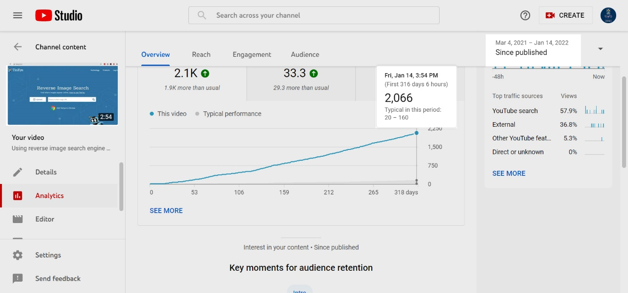
UK Fair Dealing video viewing figures
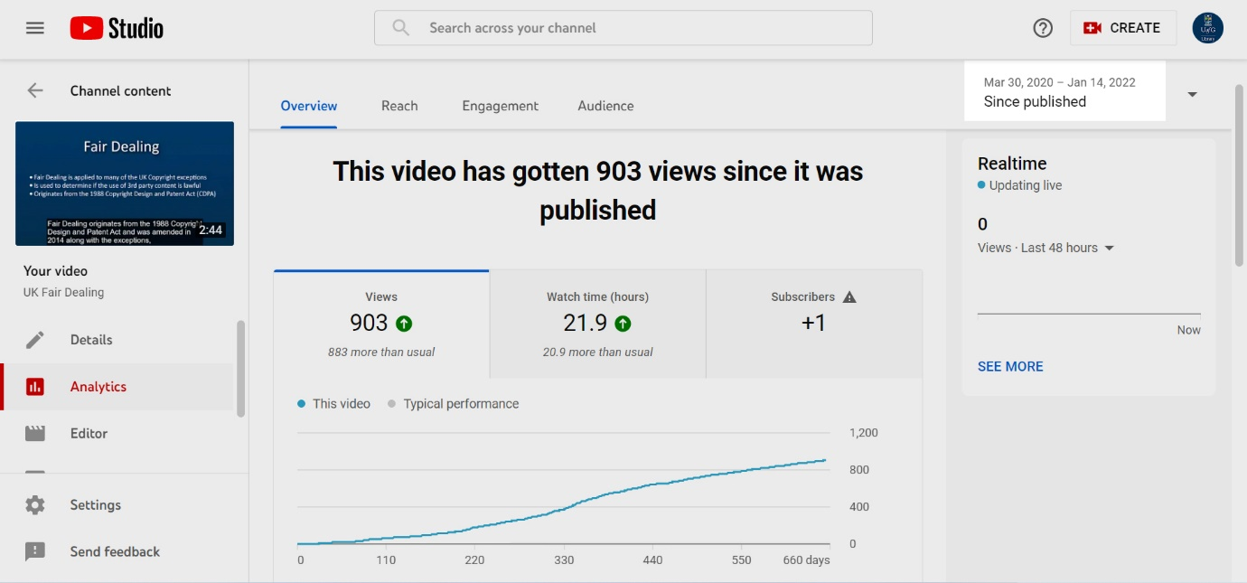

UK Copyright Exceptions video viewing figures
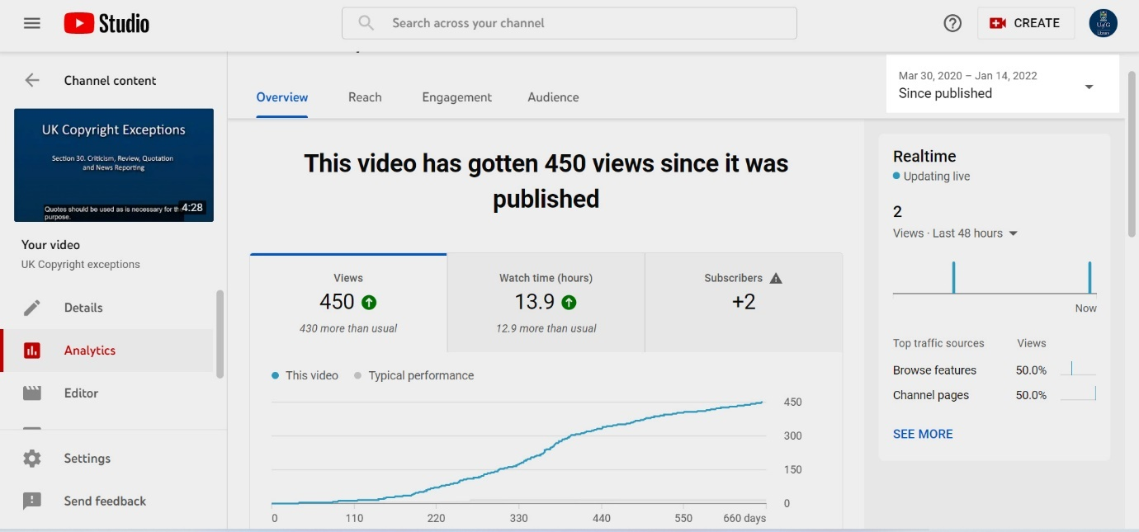

Searching for images effectively online video viewing figures
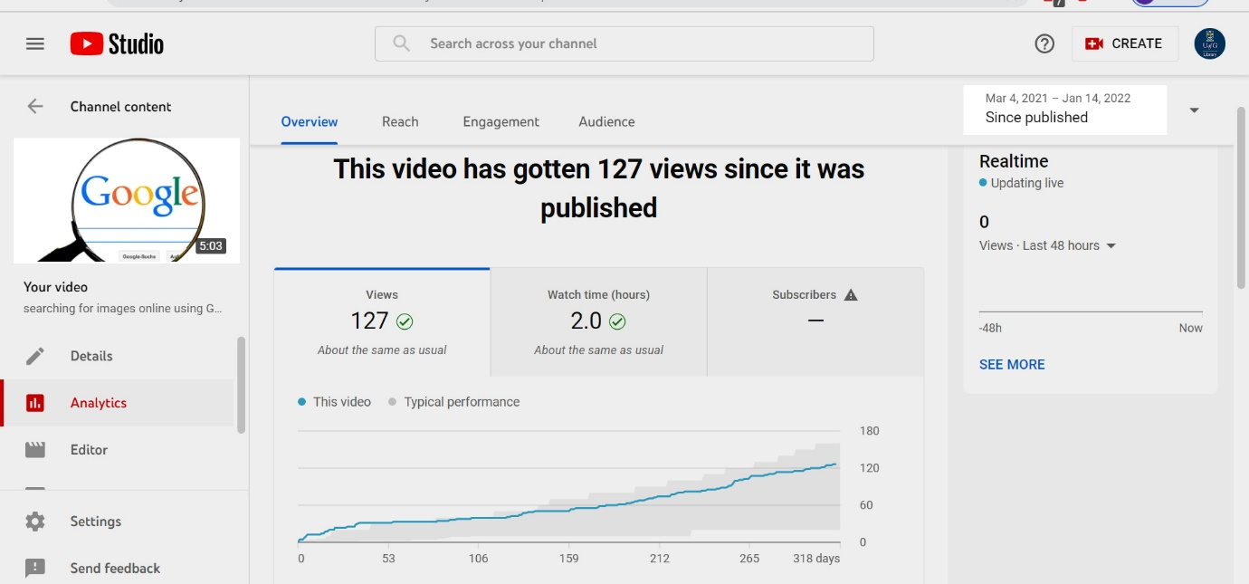

Licences video viewing figures
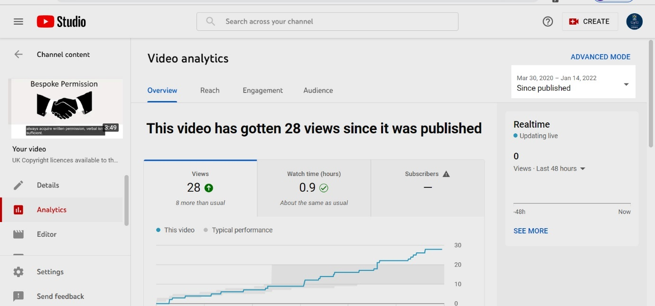

Copyright Sway page views (18th January 2021)
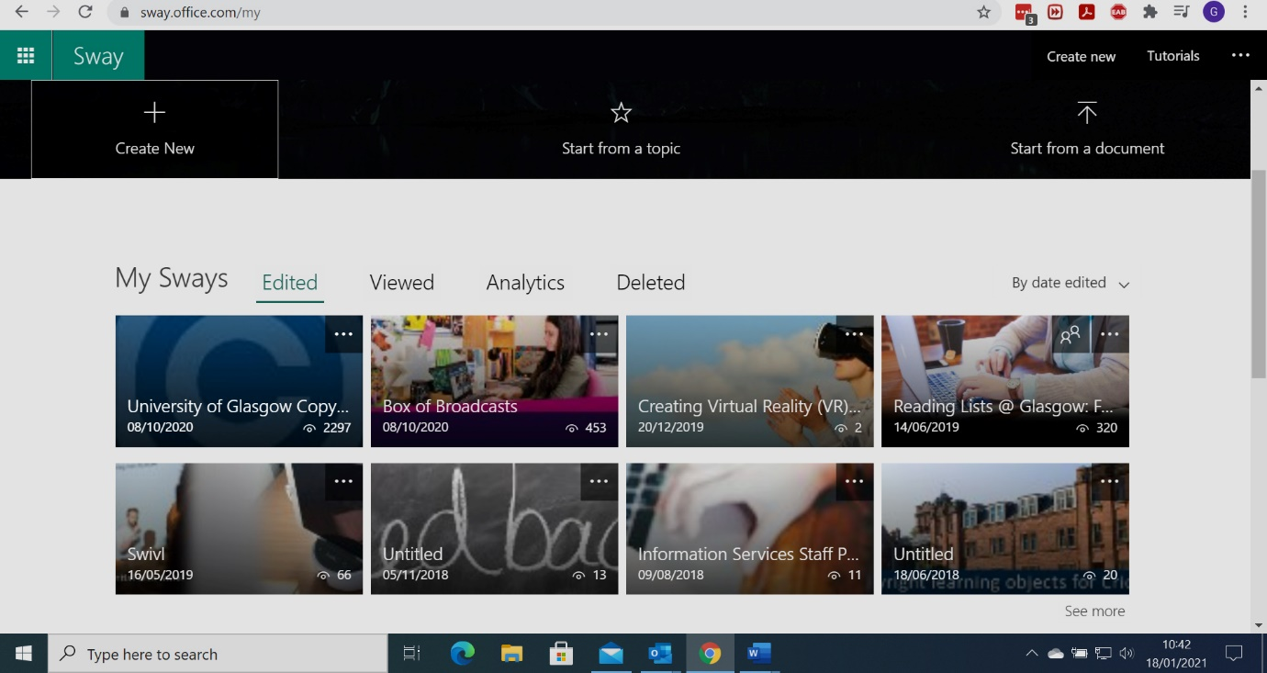
Total views of Copyright Sway page as of 18/01/2021: 2297

