Copyright work report
Providing additional evidence and context for Greg Walters CMALT portfolio (2021)
Greg Walters
University of Glasgow greg.walters@glasgow.ac.uk
Contents
Executive Summary of UofG Copyright report 2
Copyright Related Work 3
Copyright materials developed in response to sector wide shift to online and blended learning adopted by UofG (2020 analysis) 3
Copyright online workshops 6
Copyright queries via email (2020) 7
2021 update on copyright related work 8
Copyright webpage 8
Related long term objective for copyright web pages resources 8
Copyright Workshops 9
Copyright resources engagement during 2021 9
Further Evidence 11
YouTube video view analytics 11
Tineye video viewing figures 11
UK Fair Dealing video viewing figures 11
UK Copyright Exceptions video viewing figures 12
Searching for images effectively online video viewing figures 12
Licences video viewing figures 13
Copyright Sway page views (18th January 2021) 13

Executive Summary of UofG Copyright report
Based on the evidence within this report, I feel my output during the past several years (particularly 2020 – 2021), has greatly benefited both the UofG and national HE communities by providing well received online guidance, through the Copyright based workshops, events and resources I delivered. These endeavours follow on from previous years activities in my continued efforts to engage with staff and students by delivering eleven online Copyright workshops between March – Sept 2020 (attended by 167), to offer important guidance in this area. This is especially relevant given the sector wide shift to online/blended learning for teaching and learning in response to the global pandemic during 2020. In light of the changing circumstances, I actively promoted the Copyright service to academic, professional service staff and students via Social Media and email throughout the year. Which resulted in increased engagement with the online resources I developed, as the Sway page viewing figures went from 1009 (March 2020) – 2210 (November 2020). At the time of writing (January 2022), my video-based copyright based resources have been viewed thousands of times, with the combined versions of my Tineye video being viewed 3378 times, Fair Dealing video 903 times, and copyright exceptions video viewed 450 times. The other area of the Copyright service which saw a drastic increase over 2020/2021, was responding to the 83 individual queries from staff and students to my personal and queries-based inbox(s).
To build on the momentum experienced at UofG in terms of copyright support and guidance, I’ve been enriched in terms of knowledge and exposure to different copyright law and policies, by joining two external groups focusing on these areas. Both the SCURL Copyright and Legal Issues group along with ALT CoOLSIG, presented numerous opportunities. Some notable examples are; the 203 attendees across three of SCURL’s online copyright events I was involved in facilitating from 2020 – 2021, the speaking and writing opportunities presented by being an officer at ALT CoOLSIG.

The remainder of this report will provide background and more detailed information regarding several key copyright projects mentioned in Greg Walters’s CMALT reflection report (2021). It will also provide additional context and information regarding the SCURL, and ALT CoOLSIG groups Greg is involved in.

Copyright Related Work

Copyright materials developed in response to sector wide shift to online and blended learning adopted by UofG (2020 analysis)
Below is an in-depth analysis of viewing figures and engagement with the online webpage (Sway) and resources I developed during 2020.

Based on data provided in the above graph, the following observations can be made:
- The largest increase in views came between March (1009 views) – June (1705 views). That is nearly an increase of 700 views over a three-month period. Was this due to a combination of academic staff preparing materials for the exam period and the next academic year or students gathering materials for use in their exams? At this point, I would speculate it was the former.
- The biggest increase in views came between March (1009 views) – April (1390). This would echo what is speculated in the previous point (academic staff preparing exam/teaching materials), and the sudden shift to online learning.
- There was steady but decreased engagement over the summer period (July 1769 views – August 1868 views). This reflects an average academic year (in terms of engagement with online resources), despite the unique circumstances surrounding this year
- Engagement from September (1981) – November (2210), has maintained at a steady pace, but not to the same level encountered earlier in the year
Based on the viewing figures of the resources I developed, the most popular and engaged with, were around the area of finding and searching for online media. Using Tineye (the reverse image search engine) YouTube video, and finding copyright free online sources for images, audio and video.
The graphs below show the data, to support the above statement.

Note: the original Tineye video that had 1275 views between March – October, was removed due to the interface shown in the video being out of date by October.

As the graph titled ‘EdShare document downloads between Match – Nov 2020’, demonstrates the most viewed resource with 346, was the list containing copyright free online sources for images, audio, and video. What will be interesting to view over the next academic year, is if this trend continues, or is repeated, or was a result of this year’s sudden shift to online learning in March?
What is illustrated is the positive response (in terms of views and engagement), in relation to quick, concise advice around searching for media and how to search for effectively. Given the relevance of online and blended learning, its possibly no surprise the resources that focused on this area would be popular. Another factor to take away from this exploration is, the types of resources that proved popular amongst users, documentation, and videos. This would indicate visual and ‘traditional’ styles of learners are engaging with the materials.
The in-depth learning objects I developed had downloads (views) ranging from 8 – 55 from March – November 2020. The most popular being the Learning object around Creative Commons Attribution. This level of engagement could be due to the subject area, but I would like to focus on their usage and development going forward. I very much see these types of resources being self-paced, reflective resources for learners who are looking to expand their knowledge in a specific area of Copyright. Creative Commons. These learning objects could be looked upon as supplemental and something that is viewed after either being to one of my Copyright workshops or after reading or viewing one of the more concise resources. The other use that I have always intended these be used for is either to be part of a larger copyright course that could be made available via a VLE like Moodle or as self-contained learning objects (as they already are). I can see potentially different outlets for these via the ALT group (as mentioned earlier in this report), and possibly through organisations like Creative Commons directly?

Going forward
- For UofG and wider educational community, continue to develop the Copyright based resources to support Copyright literacy, particularly for searching effectively/media using text and video-based learning
- Continue the development of the in-depth self-paced learning objects

Copyright online workshops
It was always my intention to continue delivering Copyright workshops to UofG staff and eventually students following on from the face-to-face workshops I delivered during 2018/19. Due to 2020’s unforeseen events, I delivered eleven online sessions to both UofG staff and students (all via Zoom). These copyright sessions offered support and guidance in response to the sudden shift to online and blended learning.
Two of the online sessions presented the opportunity to collaborate with different departments within the library and institution (Digital Education Unit & Learning Innovation Unit), to deliver copyright guidance to staff.
To follow on from the sessions I delivered in June, I thought it prudent to offer a range of sessions for staff and students during September in preparation for the online/blended learning format of the upcoming academic year. The eight sessions which ran over a two-week period covered four subject areas: Copyright basics for staff and students, Creative Commons and Box of Broadcasts.
Based on the overall attendance figures, and positive feedback from staff (received via email and Zoom sessions) I will continue to deliver the Copyright sessions next year in a similar format and via Zoom.
The attendance figures for each of the eleven sessions I delivered can be viewed below:

Attendance figures for online Copyright sessions 2020
Date of session | Subject delivered during session | Number of attendees
March 11th 2020 | Box of Broadcasts | 15
June 11th 2020 | Copyright basics for Staff | 33
June 19th 2020 | Copyright basics for Staff | 26
Sept 16th 2020 | Copyright basics for Students | 38
Sept 18th 2020 | Use of Video (BoB) in online teaching | 10
Sept 21st 2020 | Copyright basics for Students (2nd run) | 15
Sept 23rd 2020 | Creative Commons (both audiences) | 6
Sept 25th 2020 | Copyright basics for Staff | 10
Sept 28th 2020 | Creative Commons (2nd run) | 10
Sept 29th 2020 | Copyright basics for Students (3rd run) | 3
Sept 30th 2020 | Copyright basics for Staff (2nd run) | 1
Total |  | 167

Copyright queries via email (2020)
This year (2020) has seen a substantial increase in the number of Copyright queries from academic and professional services staff. A total of forty-eight individual queries were received between my personal email address and the Library Copyright inbox, between March – November 2020. Seventeen queries were received via the Library Copyright query inbox, whilst the remaining twenty-seven were sent to my personal (Greg Walters), email address. Nine of the queries originated from Lecturers who are part of the College of Arts, whilst seventeen were from the College of Medical, Veterinary and Life Sciences, the College of Social Sciences sent eleven queries, and the remaining eleven queries were from staff from various professional services.

The above figures demonstrate that both academic and professional services staff are aware of and engaging with Copyright in relation to their work for the UofG. The College of Science and Engineering (COSE) is the only subject area that did not send any copyright-based queries during 2020. This theme is reflected in previous years, where COSE did not send any copyright queries via email.

The increase in query figures, are due to following factors (in my opinion), the increase in promotion and awareness raising of copyright via email and Social Media, along with this year’s shift to online and blended learning in response to the global pandemic.

The types of query received were generally focused on the use of media (3rd party and Creative Commons), in lecture materials which were being uploaded to Moodle or via Zoom. Due to this year’s exceptional circumstances, queries around how 3rd party videos (DVDs) or content from BoB can be made available through Moodle and Zoom were sent. Several queries were around best practice around providing attribution for the use of 3rd party and Creative Commons materials. There were also several queries relating to the use of Creative Commons materials in Microcredentials, as these new types of courses were made available during July of this year.

As echoed throughout this section of the report, I am hopeful that 2021, can build upon the increase in engagement with Copyright. I have observed participants of either face – to face or online workshops, send queries after they have attended. This would indicate the workshops both raise awareness and engagement of Copyright, further justifying their continued, ongoing delivery (either face to face or online).

2021 update on copyright related work
Copyright webpage
The Sway page I developed during 2020 was replaced with a University of Glasgow webpage (aimed at staff/students), during January 2021, as the intention was/is to make it more discoverable online when using search engines. Changing the page’s format, provided the opportunity to revaluate how the copyright-based resources were presented to users. To ensure the page was accessible and easy to use, I sought advice from a member of our IT services, who has a background in UX design. The page layout of collapsible sections, text and tiles was chosen as this reduced the vertical scrolling required, “chunked up” the information into manageable sections and due to the T4 (Terminal Four) framework at UofG, is more accessible. These design and technical factors, equate to a more robust and future proof webpage, that will be more discoverable.
Going forward, I intend to expand on the initial copyright webpage by duplicating this and its resources (which will be edited/adapted), so these can be shared with the wider community. The resources on this page will all have a CC BY-NC licence associated with them, so they can be freely shared for non-commercial usage.
Both pages will be linked to through a centralised webpage (“portal”).
N.B., I’ve not been able to obtain viewing figures for webpage, I’ve asked an IT colleague to attach a HotJar Heatmap, to the webpage going forward so this data can be captured.

Related long term objective for copyright web pages resources
For a long-term objective, I intend to develop freely available interactive learning objects, which focus on various aspects of UK copyright law and Creative Commons. The objects will be in H5P format, as these can be integrated into VLE’s and edited with free downloadable software. I also intend to expand on freely available Articulate objects I’ve created, whilst these can be linked to, they cannot be edited as specialist software is required. To compliment the resources, and use them in a wider context, I intend to integrate them into Rise courses which I’ll develop.
These learning objects will also be made available via the web pages (UofG staff/students & external visitors).

Copyright Workshops
These continued through 2021, with more of a focus on delivering bespoke workshops to specific University audiences of academic staff, students, and professional services.
- Bespoke session around Box of Broadcast delivered on 24/11/2021 to staff from MVLS, 5 in attendance
- Bespoke online copyright session delivered on 12/05/2021 to Scottish Literature Staff, 11 in attendance
- Bespoke online copyright session delivered on 22/01/2021 to MSc Media, Comms & International Journalism students, 12 in attendance
During 2022, I intend to deliver more copyright-based workshops to the University of Glasgow audiences, through my own initiative and in collaboration with other departments/services.

Copyright resources engagement during 2021
The copyright-based videos I developed and made available via the webpage and YouTube channel continued to get engagement and views, which is demonstrated via the graph below.

N.B. both the ‘Using Tineye and ‘Searching for images effectively online, were uploaded on 04/03/2021

Based on the continued engagement with the video-based resources, I will continue to further develop and expand subject areas (i.e., critical thinking), as these are popular with learners.

Further Evidence

YouTube video view analytics
Tineye video viewing figures
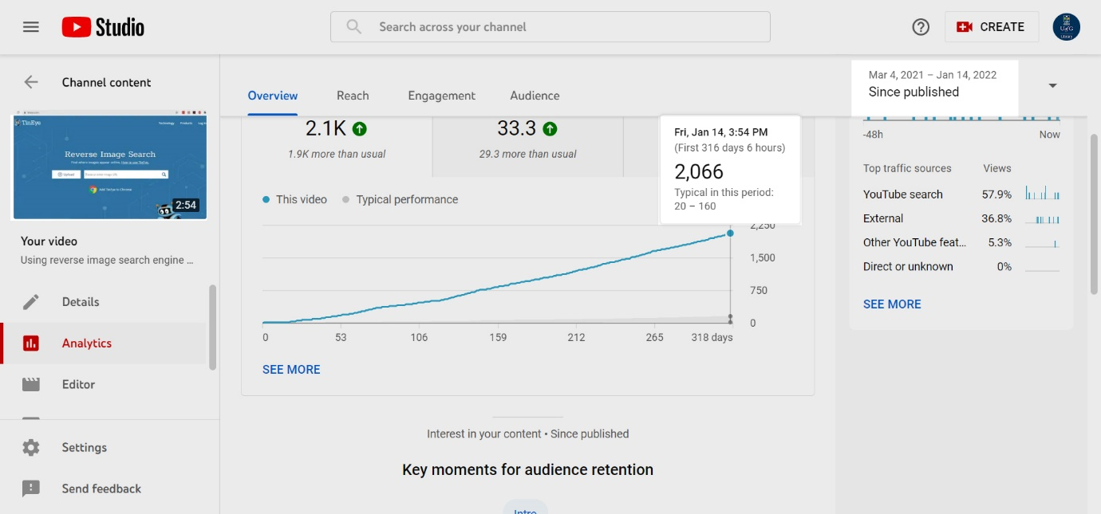
UK Fair Dealing video viewing figures
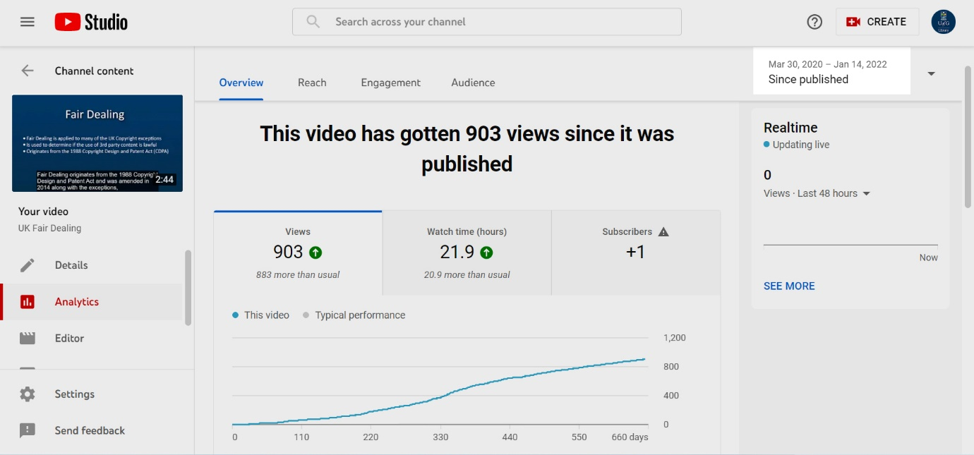

UK Copyright Exceptions video viewing figures
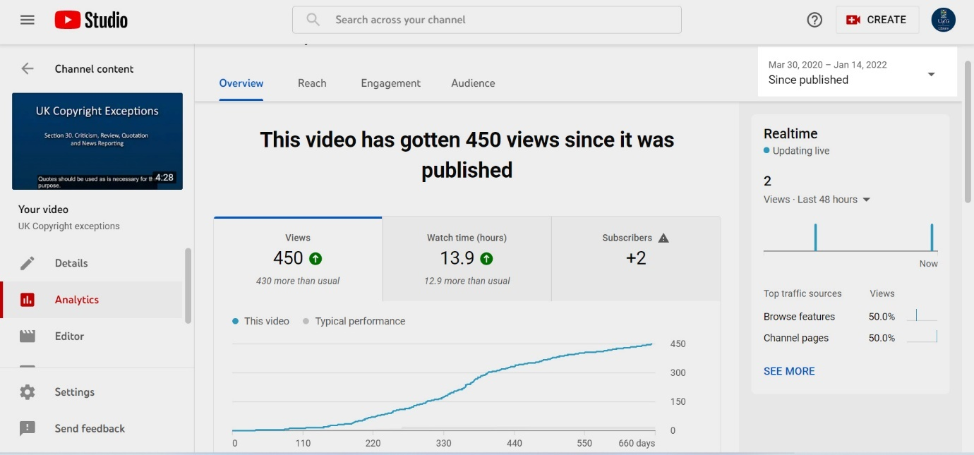

Searching for images effectively online video viewing figures
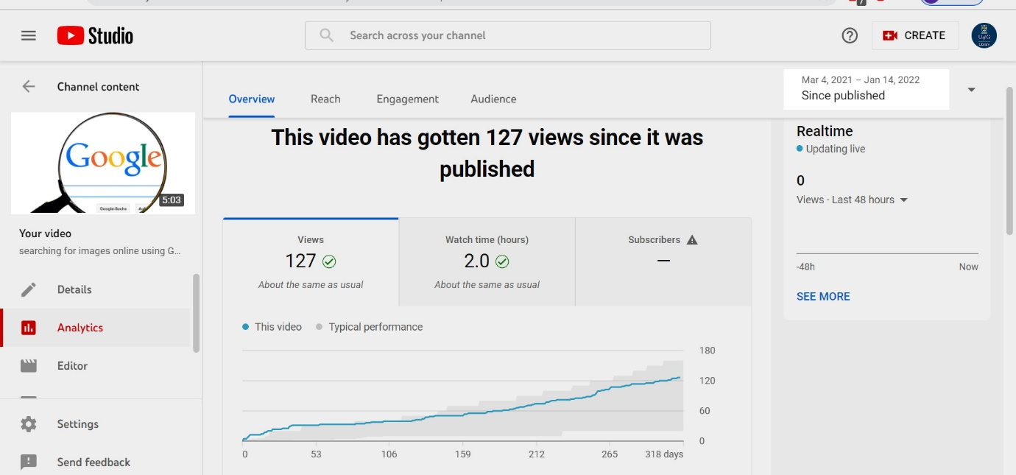

Licences video viewing figures
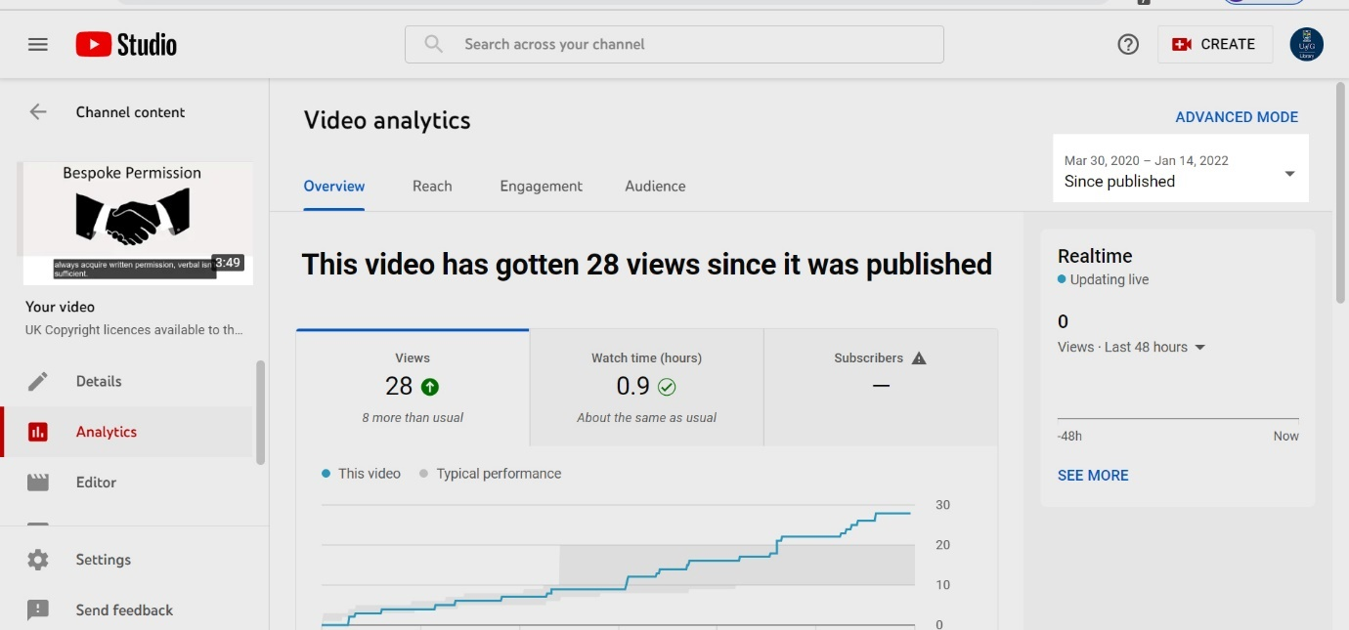

Copyright Sway page views (18th January 2021)
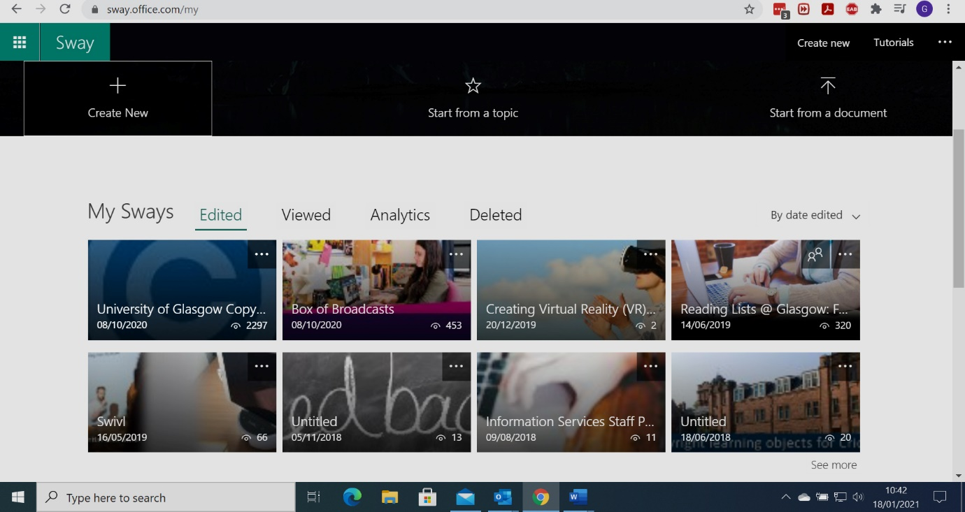
Total views of Copyright Sway page as of 18/01/2021: 2297

