8/3/2021
Greg Walters
University of Glasgow
Creative Commons
Basic guidance on Creative Commons (CC) licences and providing attribution.
Version 1

Table of Contents
What are Creative Commons (CC) licences? 3
Creative Commons from a creator’s perspective 3
Creative Commons from a “consumer” perspective 3
The four conditions found in CC licences. 4
The six types of CC licence 5
Scale of restrictions 6
Individual Creative Commons licences 7
CC BY 7
CC BY-SA 8
CC BY-NC 8
CC BY-NC-SA 9
CC BY-ND 9
CC BY-NC-ND 10
CC0 10
Public Domain 11
Providing Attribution 12
Resources 13
Appendices 14

What are Creative Commons (CC) licences?

Creative Commons from a creator’s perspective

From the perspective of some who is creating a work (image, video text etc.),
CC is a suite of licences that enable creators to assign a simple, standardized way to give people permission to share and use their creative work. The licences enable creators to choose how their work reused, edited, and built upon. For example, a creator may choose to only allow a piece of work they create to be reused non-commercially.

The licences are not tied to any specific means of distribution or platform, so a creator may choose to distribute their work across platforms like, Flickr, YouTube, Vimeo for example.

CC licences can be used either by individual creators to large institutions as a simple, standardized method of granting the public permission to use their creative work under copyright law.

It should be noted, there is no cost to using the licences either.

Creative Commons from a “consumer” perspective

From the perspective of someone who is using materials that have a CC licence associated with them. They allow you to reuse the copyright material without having to contact the owner for permission. The licences tell you how to use, share and distribute the work.

The four conditions found in CC licences.

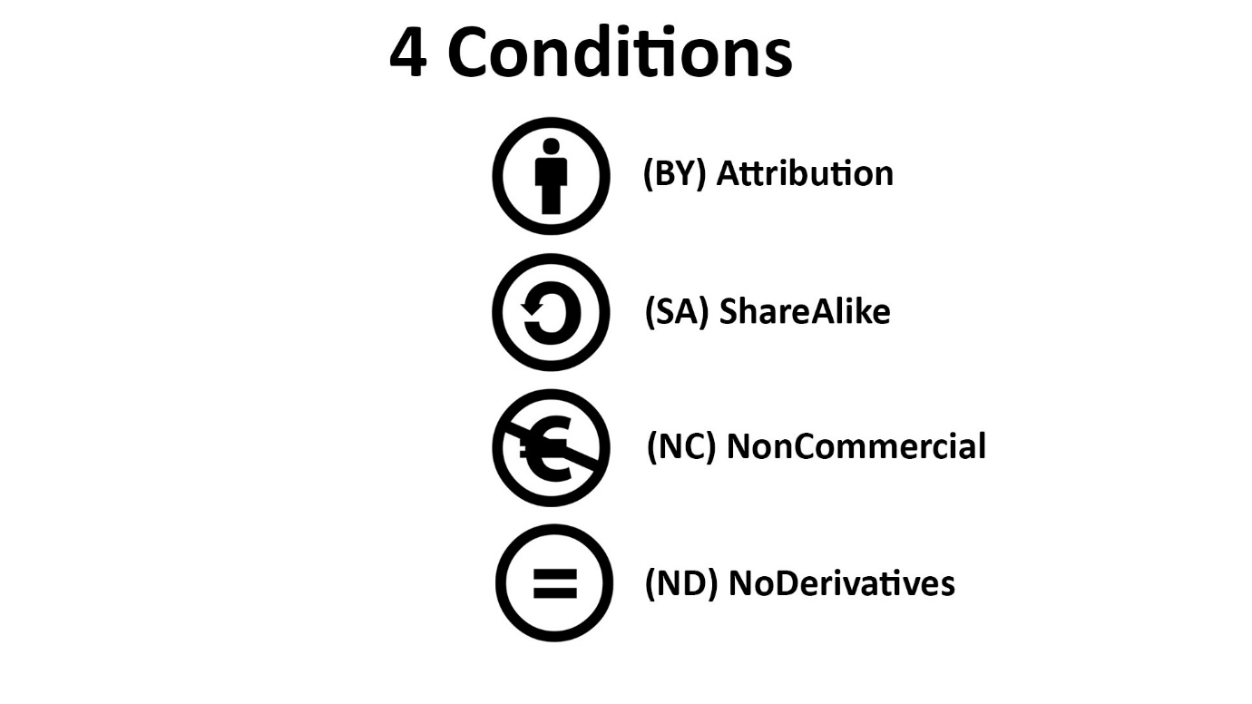
The Creative Commons licences contain one or multiple conditions, the creator/copyright owner can decide what conditions they want attached to the licence.
The four conditions are examined below.
- (BY): Is the condition of attribution, where people using the work, have to acknowledge/attribute who the creator is.
- (SA): The condition of Share Alike, is for those who create an adaptation of a work, they then have an obligation to share it under the same conditions as the original piece of work.
- (NC): The condition of non-commercial use, which excludes work from being used commercially.
- (ND): The no derivatives condition, where the user is not allowed to create derivatives or adaptations of the work.

The six types of CC licence

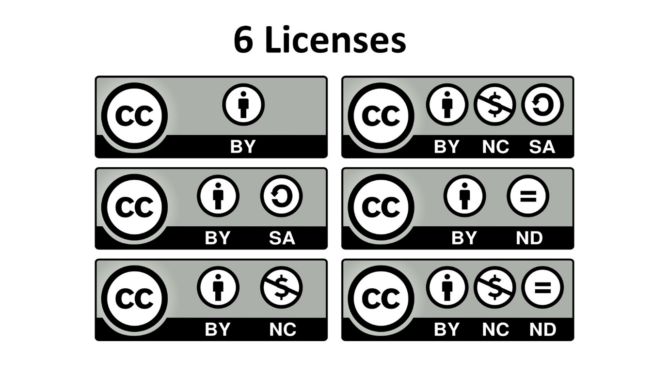

When the four conditions are mixed and matched, they create the six Creative Commons licenses that are available, from the most open type of licence CC BY to CC BY-NC-ND, which is the most restrictive type of licence.

Scale of restrictions

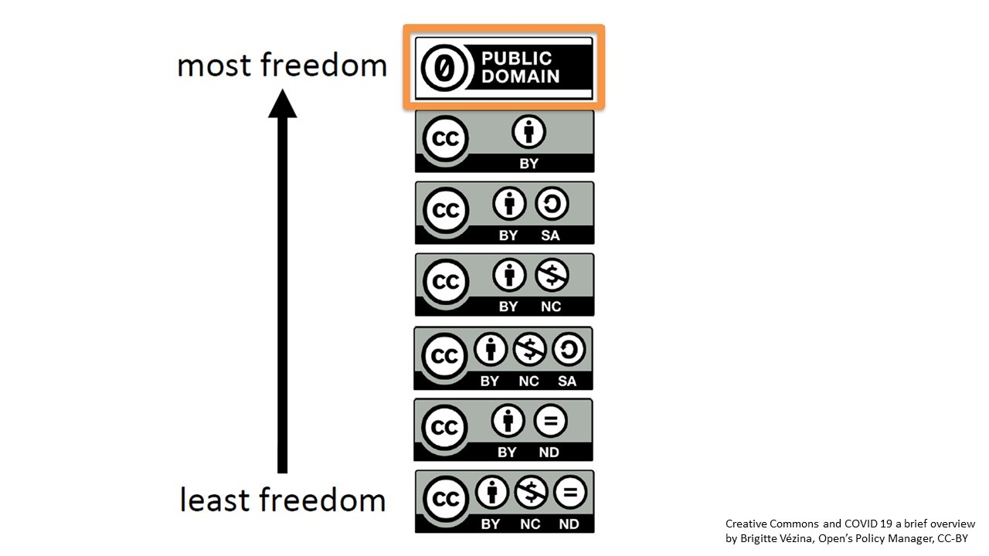
The above scale highlights these levels of restriction, with the licence at the bottom being the most restrictive of the open licenses to ones at the top providing the most freedoms. At the top of the scale, we have something called Public Domain (CC0), this is referred to as a ‘public domain’ dedication tool, and when an author applies this to a work, they waive all their rights and puts the work into the public domain.

This document has covered what Creative Commons is, from the perspectives of a creator and consumer, along with how the four factors are used to create the six different types of licences and the associated restrictions. Going forward the individual licences will be examined.

Individual Creative Commons licences

The following section will examine the different types of Creative Commons licences.
N.B, the resources section contains links to online sources that provided examples of what is permitted under the four conditions e.g., “what is adaptation” and “commercial VS non-commercial use”.

CC BY

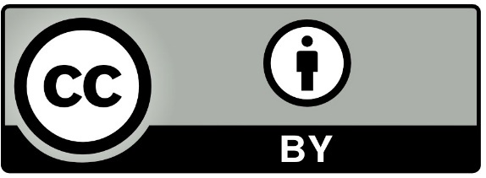
- BY – Credit must be given to the creator.
This license allows re-users to distribute, remix, adapt, and build upon the material in any medium or format, so long as attribution is given to the creator. The license allows for commercial use.
Materials that have this licence type associated with it, are versatile as they could be used in thesis, teaching materials and even Massive Online Open Courses (MOOCs), providing attribution to the creator is provided.

CC BY-SA

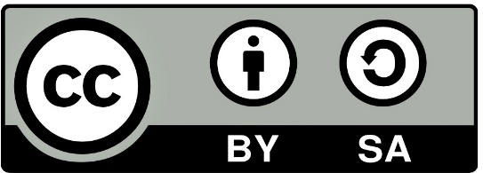
- BY – Credit must be given to the creator.
- SA - Adaptations must be shared under the same terms.

This license allows re-users to distribute, remix, adapt, and build upon the material in any medium or format, providing attribution is given to the creator. The license allows for commercial use. If you remix, adapt, or build upon the original material, you must license the modified material (what you produce) under identical terms, i.e., the same licence CC-BY-SA.

CC BY-NC

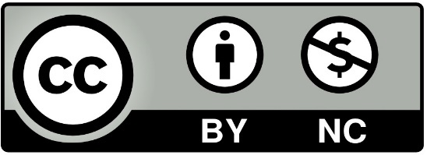
- BY – Credit must be given to the creator.
- NC - Only non-commercial uses of the work are permitted.
This license allows re-users to distribute, remix, adapt, and build upon the material in any medium or format for non-commercial purposes only, and only so long as attribution is given to the creator.
When non-commercial (NC), is introduced to a licence, you can observe that certain uses become more restricted, for example materials that have this licence type would not be suitable for use in a MOOC course as they have a commercial element associated with them.

CC BY-NC-SA

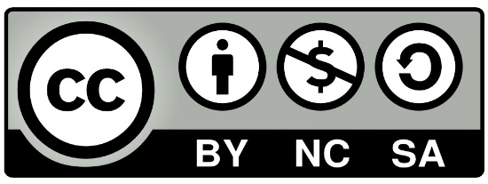

- BY – Credit must be given to the creator.
- NC - Only non-commercial uses of the work are permitted.
- SA - Adaptations must be shared under the same terms.
This license allows re-users to distribute, remix, adapt, and build upon the material in any medium or format for non-commercial purposes only, and only so long as attribution is given to the creator. If you remix, adapt, or build upon the material, you must license the modified material under identical terms.

CC BY-ND

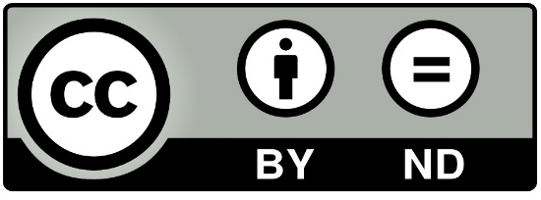

- BY – Credit must be given to the creator.
- ND - No derivatives or adaptations of the work are permitted.
This license allows re-users to copy and distribute the material in any medium or format in un-adapted form only, and only so long as attribution is given to the creator. The license allows for commercial use.
The ‘no derivatives’ aspect of this licence does make the reuse more limited, as you cannot adapt, edit or build upon the original material. Therefore, you will have to carefully consider how you intend to use this type of material.

CC BY-NC-ND

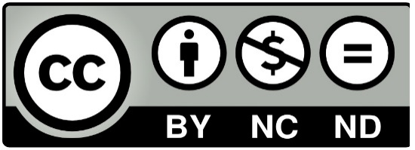

- BY – Credit must be given to the creator.
- NC - Only non-commercial uses of the work are permitted.
- ND - No derivatives or adaptations of the work are permitted.
This license allows re-users to copy and distribute the material in any medium or format providing it’s for non-commercial purposes, is unmodified and attribution is provided for the creator of the original work.
As we saw in the previous section (Scale of restrictions), this is the most restrictive Creative Commons licence type, due to the restrictions on not being able to modify the original work and the exclusion of not being able to distribute works commercially.
N.B: Before continuing, it is worth noting both CC0 and the ‘Public Domain Mark’, are different in their application and use, compared to the licences that make use of the 4 conditions that have been examined. Both are effectively ‘public domain tools’, which enable those authors/creators a means of dedicating their works to the worldwide public.

CC0

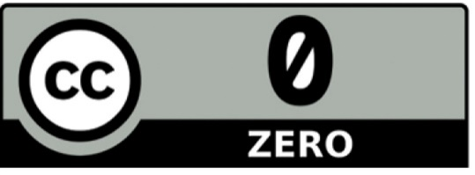

CC0 enables creators and owners of copyright- or database-protected content to waive those interests in their works and thereby place them as completely as possible in the public domain, so that others may freely build upon, enhance, and reuse the works for any purposes without restriction under copyright or database law.

Public Domain

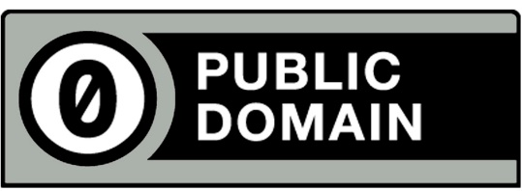

Creative Commons Public Domain ‘mark’ is an effective method of marking works that are no longer restricted by copyright, in a simply and standardised way. This also helps making them identifiable and more discoverable to others. It may be mostly cultural heritage institutions, like Libraries, Museums etc... who possibly make of this tool as a means of making their materials like, manuscripts, books, and paintings in their collections available to the public.
Only use this tool if you have identified a work that is free of known copyright restrictions. Creative Commons does not recommend this tool for works that are restricted by copyright laws in one or more jurisdictions.

Providing Attribution

“Glasgow-kelvingrove-museum-1” by Thyes is licensed under CC BY-SA 3.0
Above is an ideal example of an online attribution when using materials that have a Creative Commons licence. The attribution links to the image source, the creator, and the type of licence.
The reason the example on screen is an ideal attribution is because the title of the image is mentioned, along with the original source and the creator is given credit with the CC license being linked to.
Notice also the four elements the ideal attribution includes, the title, the author, the source and the licence, all of these should be included when providing attribution for the use of CC based works.
Title? “Glasgow-kelvingrove-museum-1”
Author? “Thyes” linked to their profile page.
Source? Glasgow-kelvingrove-museum-1 - Linked to original page in Wikimedia Commons.
License? CC BY-SA 3.0 -Link to type of CC license

If you are unable to provide an attribution that includes links to the applicable sources, the following would be acceptable:
“Glasgow-kelvingrove-museum-1 by Thyes available at: https://en.wikipedia.org/wiki/File:Glasgow-kelvingrove-museum-1.JPG under a CC BY-SA 3.0. Full Terms at: https://creativecommons.org/licenses/by-sa/3.0/deed.en

Resources

- Choosing a licence for research data – draft version 3, of an information guide, which is intended to aid researchers’ teachers, librarians, administrations and many others using and encountering the need to make research data available under an Open Access licence.
- Creative Commons FAQ – this web page provides answers to questions around creative Commons from numerous perspectives.
- Creative Commons for Educators and Librarians – a book (PDF, via Google Docs) which provides a wide array of information about Creative Commons. Pages 51 – 52 contain explanations and examples of Non-Commercial vs Commercial use, and examples of adaptations which relates to No Derivatives.
- Creative Commons Licence Chooser – useful online source, which will aid you in choosing an appropriate licence which can be applied to work you are creating or have created.
- FAQ on Creative Commons and Open Access - This information guide contains questions and responses to common concerns surrounding Open Access, Creative Commons, and the publication of research. It is intended to aid researchers, teachers, librarians, administrators, and many others using and encountering the Open Access movement in their work.
- Factsheet Creative Commons and Open Science - This information guide contains questions and responses to common concerns surrounding open science and the implications of licensing data under Creative Commons licences. It is intended to aid researchers, teachers, librarians, administrators and many others using and encountering Creative Commons licences in their work.
- Self-paced learning object, about best practice for providing Creative Commons attribution - interactive learning object, which examines best practices around how to provide attribution when using someone else’s CC materials.
- Self-paced learning object, about Creative Commons licences – interactive learning object, which examines CC licences in detail.
- Share Alike FAQ – goes over how Share Alike can be used and applied
- Why Sharing Academic Publications Under “No Derivatives” Licenses is Misguided – a article around the use of why the use No Derivatives publications is at odds with Open Access.

