Library
Knowledge Base

Google Scholar settings

Level: Type in level here

Contents

Linking to full-text articles 3
Exporting citations to Endnote from Google Scholar 5
The Google Scholar button 6
Library support for your research 7

Linking to full-text articles

You can set Google Scholar to show links to full-text articles provided by the University of Glasgow.
This has two advantages:
- You can link to the article and immediately access the full-text or login when prompted with your GUID and password. This saves time having to look around the publisher or other web page, for the appropriate login prompt.

- You can see at a glance which articles the University of Glasgow provides in full-text and those that it does not. This avoids having to link through the publisher page to find that you cannot access the article in full text.
To set up the links:
- Go to Google Scholar scholar.google.co.uk
- Click on Settings at the top of the screen
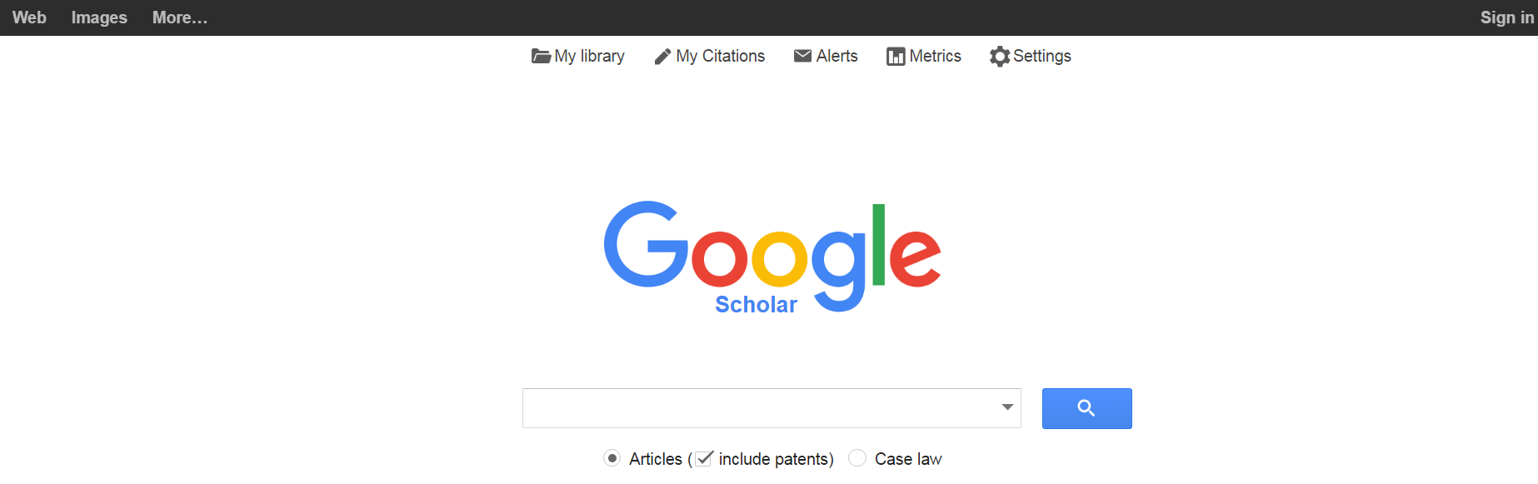
- Choose Library links from the options on the left menu
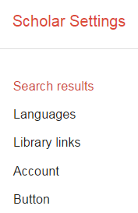
- On the Library links page, type University of Glasgow in to the search box and press the search button
- Tick the box beside the search result for University of Glasgow – Full text from Glasgow and press Save
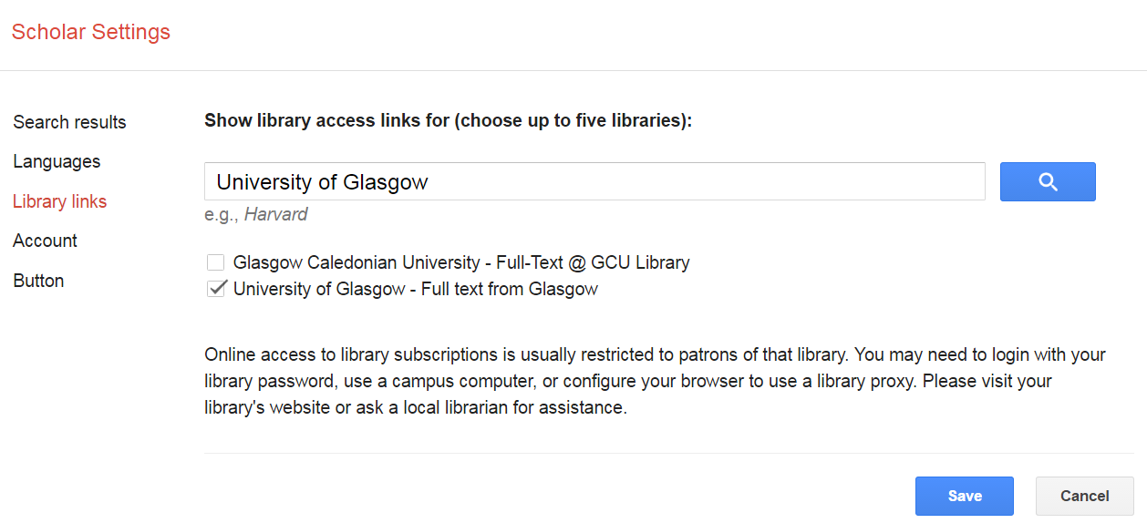
- When you run a search now on Google Scholar, you will see the link Full text from Glasgow to the right of your search results
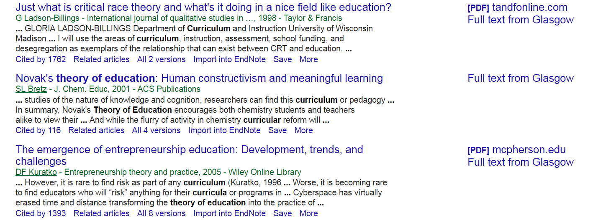
- Clicking on this link will take you directly to the full text, or to the login prompt for University of Glasgow resources

Exporting citations to Endnote from Google Scholar

You can set up a direct export for citations from Google Scholar to Endnote. This can save you time.
- Go to Google Scholar scholar.google.co.uk
- Click on settings at the top of the screen
- On the main screen, at Bibliography manager, choose Endnote from the drop-down menu and press Save
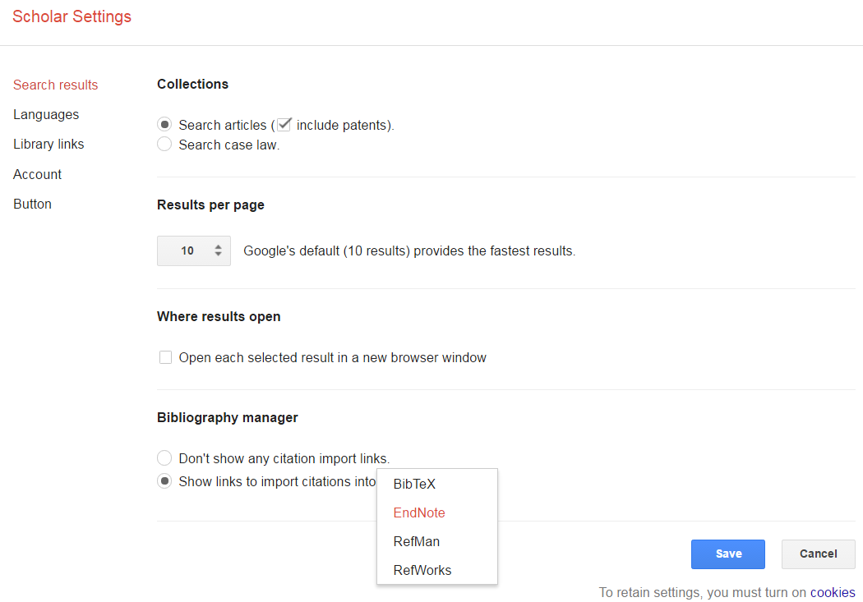
- When you run a search now, you will see a link to Import into Endnote under the search result
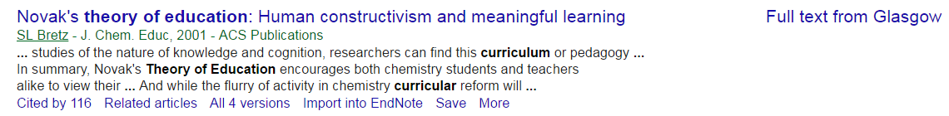
- Clicking on this open your Endnote account and import the citation

The Google Scholar button

You can add the plug-in, Google Scholar button to your web browser. This allows you to search Google Scholar from any web page. Simply highlight the text you want to search on Google Scholar and press the Google Scholar button on your browser address bar.
For example, you could search for a paper from the reference list on a journal article or bibliography in a book chapter.
- Go to Google Scholar scholar.google.co.uk
- Click on Settings at the top of the screen
- Click on Button from the menu on the left, and then on the Install Scholar Button to look up papers as you browse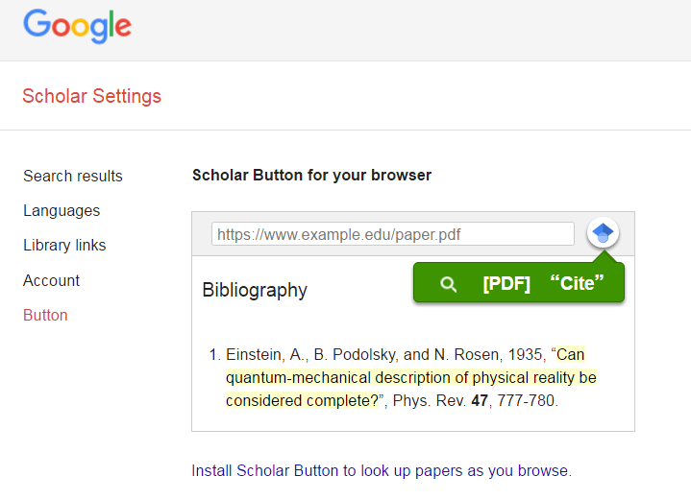
Click here to install the button

- The button will appear to the right of your browser search box – as shown above
- Highlight text on any web page you are viewing and press the Google Scholar button to run a search

Library support for your research

If you encounter any problems using the settings here, or they have changed, please get in touch.
The College Librarians are here to provide tailored one-to-one support for your research. We can help with tips for effective searching, identifying key resources, research metrics and using reference management software. Please contact us and we will be happy to help:
http://www.gla.ac.uk/services/library/subjectssupport/collegelibrarians/

January 2017

