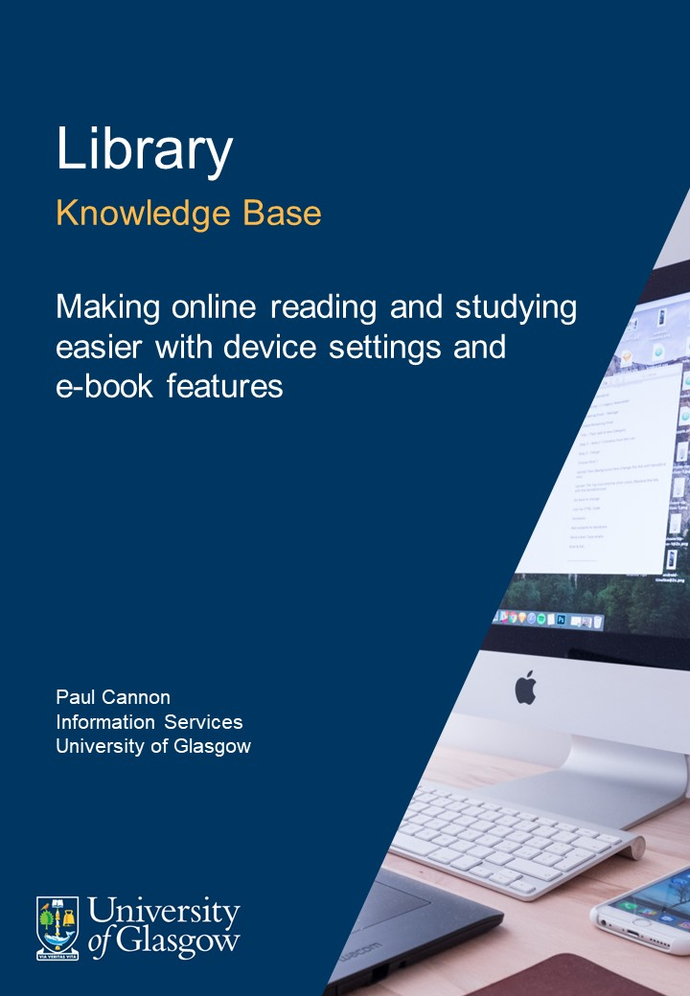

Table of Contents
1. Introduction 3
2. Device settings 3
2.1. Night light and dark mode 3
2.2. Accessibility features 3
3. App settings 4
3.1. Office theme and apps 4
3.2. Adobe Reader 4
4. E-book features 4
4.1. Annotate and highlight e-books 4
4.2. Exporting citations 5
5. What do you find useful? 5
6. Credits 5

Introduction
There is no way of getting around it, online reading and writing is a natural part of the research and studying process. So, how do you make reading online easier and make studying more efficient?
This guide will cover some simple device and app settings and e-book features to help you get the most out of online reading.
This guide does not provide information on accessibility software. Please speak with the University of Glasgow Disability Service if you have a disability, learning difficulty, or medical condition.

Device settings

Night light and dark mode
There are two settings that might help reduce eye strain: night light, and dark mode. These features are useful regardless of the time of day or ambient light levels.
On a Windows PC:
- Night light
- Dark mode
On a Mac:
- Night shift
- Dark mode
On a phone:
- Android: Extra dim and dark theme
iPhone: Night shift and dark mode

Accessibility features
Some useful features such as changing text size and colours, screen contrast, and text-to-speech are often found in a device’s accessibility menus.
Accessibility features:
- On a Windows PC
- On a Mac
- On an Android phone
- On an iPhone

App settings
Let's look at two apps used for academic reading and writing that are supported by the University: Office 365 and Adobe Reader.

Office theme and apps
- Changing the Office Theme is a universal setting in that all Office apps will be changed at once, regardless of which app you are using.
- To change the document colours, use Dark Mode for Word (similar options appear in other Office 365 apps). Having the option to switch between light and dark modes within an app is useful because some images and figures do not render as well in dark mode.
- Immersive reader in Word and Office Accessibility tools such as text-to-speech and using your voice to type are also useful features to aid efficient reading and writing.

Adobe Reader
- Adobe Reader has the option to change text size and app theme.
- There is no dark mode, but you can mimic these settings. To do so, click on Edit, Preferences, then Accessibility. You now need to Replace Document Colours, switching the Page Background to black and the Document Text to white. If an image or figure doesn't render well on this view, simply untick Replace Document Colours, then turn it back on again when required.

E-book features
Full guidance on accessing, downloading, printing, and using e-books on a mobile device or e-reader can be found via the University Library Books and e-books help webpages.

Annotate and highlight e-books
Functionality varies between the e-book publishers and aggregators but, generally speaking, selecting text within an e-book reader or a pdf in Adobe Reader will open a pop-up box allowing you to highlight text (often in a range of colours) and add notes. If you are logged into the e-book provider’s website, these annotations are often automatically saved. If you are using Adobe Reader, ensure that the pdf is saved to a suitable location, and periodically click ‘Save’ to avoid loss of work.

Exporting citations
Similarly, most e-book readers allow you to export a citation (reference details) in a range of formats for reference management software. Once you have a reference, this animation shows just how easy it is to add a citation into Word.
If you are not using a reference manager, you can find out about EndNote and download a copy to a personal device.
Remember to use reference management software in conjunction with the appropriate referencing style.

What do you find useful?
Is there anything I've missed? Let me know: paul.cannon@glasgow.ac.uk

Credits

Author credit
Paul Cannon, Information Services, University of Glasgow

Cover image
Photo by Domenico Loia on Unsplash

