Library

Arts: finding books on your topic

Table of Contents
Introduction 3
Library Search/Specific Book search 3
COPAC 4
WorldCat 5
Google Books 5
Subject databases 5
Other resources 5
Getting hold of books we don’t have in the Library 6
Get more help 6

Introduction

Library Search should be your starting point when you need to find a range of books on your topic, but there are lots of other options. This guide will suggest other places to search.

Library Search/Specific Book search

Library Search (the search box on the Library home page) allows you to search across the Library’s collections of print and electronic books and journals (as well as other types of material). If you want to look specifically for books you can refine your search once you have done your initial search:
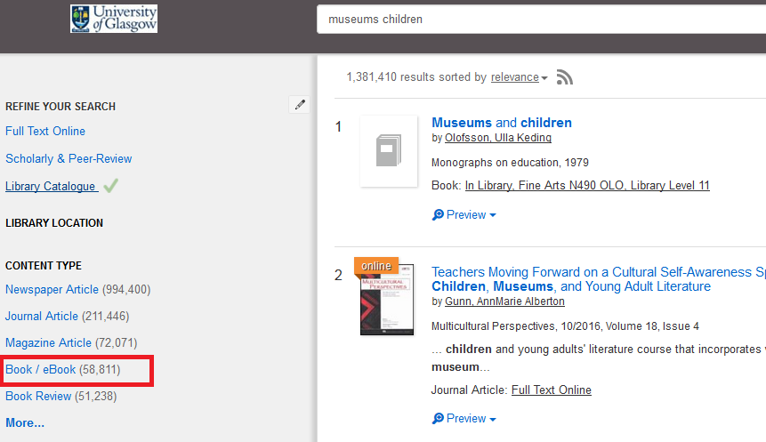
From the results screen you can see brief details about books – click on Preview for more information.
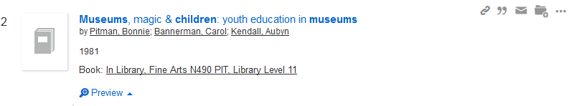
If you click on the Book: In Library link you will be taken to our traditional Library catalogue interface (which also contains details of the books, journals and other material we hold, but does not have information about individual journal articles).
If you choose Specific Search: Books on the Library home page you are choosing to search only for books.
Bear in mind that neither Library Search nor the library Catalogue have details of all of the individual chapters within books. This means that your search terms (keywords) will only be found in the author, title or subject headings of bools. You may find it useful to keep your keywords quite broad and not to include too many at once.
The Library won’t have every book published on your topic area. There are other resources you can search. If you discover a book that looks interesting we can usually borrow it for you from another Library.

Library Hub Discover

Library Hub Discover is the combined library catalogues of most of the university libraries in the UK and Ireland as well as the national libraries.
It lets you find out about a much wider range of books than you would find by using Library Search or the Library Catalogue.
You can search Library Hub Discover for specific books or for books on a topic. If you are interested in a book you can request it via your Library account and we will try and borrow it for you.

WorldCat

WorldCat has records for over 179 million items including books and many other resources. The information is sourced from libraries worldwide (with the majority based in the US). Like COPAC, it can be used to find out about a wider range of books on your topic than what you could find by only using Library Search and the Library Catalogue.
You can access WorldCat via Databases on the Library home page.

Google Books

Google Books is one of various search options offered by Google, and allows you to search the full text of many books. Not all of the books it lists are available in full online, but many have at least a preview. Unlike many library catalogues, Google Books enables you to search the full text of many of the books it indexes. This allows you to make your searches much more specific.

Subject databases

Many of the subject databases offered by the Library give details of books and book chapters as well as journal articles. Check the Help section to see if books are covered. You can access them Databases on the Library home page.

Other resources

There are a number of other resources you can use to find out about books on your topic:
- Printed bibliographies, encyclopedias and reference books: there may be printed reference sources relevant to your subject that provide bibliographies on your topic. Check with your College Librarian.
- Online bookshops, e.g. Amazon

Getting hold of books we don’t have in the Library

There are a couple of options if you find out about a book but we don’t have it in the Library.
- You can ask us to borrow it for you from another Library. You can do this via your Library account.
- You can contact your College Librarian and ask them to buy a copy of the book for the Library – subject to funds being available they will often be able to do this.
- You can see if a freely available copy of the book is online – check Google Books and archive.org (http://archive.org).

Get more help

If you need help working out which search tools will be most helpful for your topic you can get in touch with your College Librarian.
Richard Bapty (richard.bapty@glasgow.ac.uk) and Morag Greig (morag.greig@glasgow.ac.uk) are the Arts College Librarians. See Help with your subject to find out who supports your subject area.
You can make an appointment to see us using the link on the Student page on the Library site to Book an appointment or e-mail us directly.

