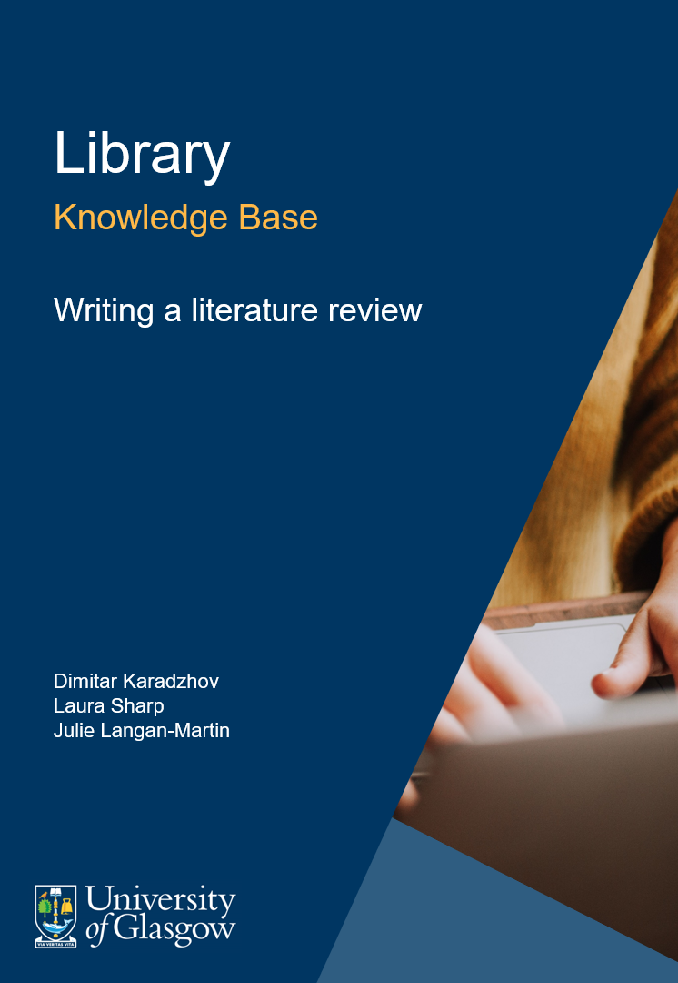

Table of Contents
1. What is a literature review and why is it important? 3
2. Classification of literature reviews 4
3. The critical review 4
4. Searching the literature 4
5. Assessing and synthesising the evidence base 5
6. Approaches to critiquing quantitative and qualitative research 6
7. A focus on quality: evaluating literature reviews 6
8. Being critical when conducting the literature review 7
9. References 8
10. Credits 8

What is a literature review and why is it important?
As a research synthesis, a well-conducted literature review provides an assessment (qualitative or quantitative (numeric) of the strength of the available evidence and the quality of the studies in a particular field of work (Booth et al., 2012). This can guide practitioners, service users, managers, researchers and policy-makers in their evaluation of how well a policy, programme, intervention or technique works under particular conditions (Booth et al., 2012). Furthermore, the literature review should highlight weaknesses in the extant scholarship and provide recommendations for further research.
By conducting a literature review, students are able to demonstrate their understanding of the most relevant vocabulary, theories, debates, controversies, variables and phenomena, and research methods of a particular field of enquiry (Randolph, 2009). In this process, students become familiar with works of the most influential authors and research groups in the field (Randolph, 2009).
To summarise, there are both practical and theoretical reasons for conducting a literature review. For one thing, literature reviews help systematise the large volume of extant scholarship on a particular topic; This skill is one of the attributes of information literacy (Booth et al., 2012). Moreover, a literature review helps to identify new approaches to interpreting gaps in previous research and also to resolve conflicts across seemingly disparate previous studies (Booth et al., 2012).

Classification of literature reviews
Grant and Booth (2009) offer an analysis of the fourteen most common types of literature reviews including an assessment of their strengths and weaknesses.
Read and examine the different review types featured in Grant, M.J. and Booth, A., 2009. A typology of reviews: an analysis of 14 review types and associated methodologies. Health Information & Libraries Journal, [e-journal] 26, pp.91-108. https://dx.doi.org/10.1111/j.1471-1842.2009.00848.x.

The critical review
According to Grant and Booth (2009), a critical review requires that the author conduct an extensive literature search and critically evaluate its quality. A successful critical review synthesises and analyses evidence from diverse sources, and presents the analysis in a logical, coherent and engaging way. A critical review aims to produce a set of recommendations for further research, a novel approach to interpreting the existing evidence base and/or even derive a new hypothesis or a model (Grant and Booth, 2009).
Carnwell, R. and Daly, W., 2001. Strategies for the construction of a critical review of the literature. Nurse Education in Practice, [e-journal] 1(2), pp.57-63. https://doi.org/10.1054/nepr.2001.0008.

Searching the literature
Following the selection, narrowing down and justification of your review question, it now has to be translated into a search strategy. How systematically you conduct your literature search will depend on the aims and type of your literature review. It is usually recommended that reviewers begin this process by conducting a scoping or preliminary search (Booth et al., 2012). The aim of this stage is to enable reviewers identify existing reviews and influential primary studies relevant to the objectives of the particular review and also obtain an idea about the quality and quantity of the available literature on the topic. Next, reviewers should assemble their search strategy and conduct a more broad and thorough search consulting a variety of sources. Some of those strategies/sources include: database searches, citation searches, author searching, bibliographic searches, grey literature searches, existing reviews on the topic, free-text searching and use of Boolean operators.
The pointers below offer reviewers some tips on how to plan, execute and assess their literature search:
- Think about the purpose of your review-how systematic does your search need to be to fulfil the purpose of the review?
- What types of databases may index articles on your topic area? What terms might describe each of the concepts in your focused question?
- Do you know any key citations or authors in your topic area? What do you evaluate their impact on the field?

Assessing and synthesising the evidence base
Assessing the relevance and discussing the limitations of the evidence included are an integral component of critical reviews writing. When conducting critical appraisal or quality assessment (Booth et al., 2012), the reviewer is assessing different properties of the evidence base such as internal validity, external validity, generalisability, applicability, etc. Critical appraisal can be defined as “the process of assessing and interpreting the evidence by systematically considering validity, results and relevance” (Parkes et al., 2011, as cited by Booth et al., 2012).
Critical appraisal can be a flexible process adapted to the type of evidence available (quantitative, qualitative, mixed-method, etc.) or it can follow standardized guidelines for quality assessment such as the COREQ (Tong et al,. 2007) and the CONSORT statement (Schulz et al., 2010). It is important to remember that checklists are only a guide-the reviewer may spot and report on features that are not captured by the standardised checklists.

Approaches to critiquing quantitative and qualitative research
Critical appraisal refers to “the use of explicit, transparent methods to assess the data in published research, by systematically considering such factors as validity, adherence to reporting standards, methods, conclusions and generalisability” (Booth et al., 2012, p. 258).
In 2007, Coughlan, Cronin and Ryan produced a step-by-step guide to evaluating quantitative research. In ‘Table 1’ of their article, the authors summarise the questions that reviewers should ask about each element of a quantitative research study in the critical appraisal process. Please examine ‘Table 1’ in more detail, and read the explanatory sections in the article.
Now, please read Ryan, Coughlan and Cronin’s (2007) step-by-step guides below to critically appraising qualitative research.
- How do the evaluation criteria for qualitative research differ from those for quantitative research?
- How do the authors conceptualise ‘rigour’ or ‘trustworthiness’?

A focus on quality: evaluating literature reviews
Standardised guidelines exist for the reporting of systematic literature reviews (see Moher et al., 2015). Given the time and resource constraints, the expectations of a systematic review project as part of university coursework are less stringent with respect to how systematic and comprehensive a review is.

Review ‘Table 1: Literature review scoring rubric’ as an exemplar evaluation framework offered by Boote and Beile (2005).
Boote, D.N. and Beile, P., 2005. Scholars before researchers: on the centrality of the dissertation literature review in research preparation. Educational Researcher, [e-journal] 34(6), pp.3-15. https://doi.org/10.3102%2F0013189X034006003.

Being critical when conducting the literature review
The below is an exemplar list to stimulate and guide self-assessment in order to help learners enhance the quality of their critical reviews.
- How well have you justified your reasons for conducting the critical review?
- Have you demonstrated an awareness of the limitations of the scope of your critical review in terms of time and space constraints, and in terms of how systematic your literature search is?
- How well have you maintained the balance between description and critical appraisal of your included studies?
- How do you decide whether an article is worth reading? What makes an article convincing?
- What contribution(s) to existing research is your critical review hoping to make?
- What do you think are the main pitfalls in conducting a successful critical review? How would you tackle them?
- How explicit have you made your approach to critiquing the research evidence base?
- Have you used a variety of approaches to research evidence appraisal?
- Might it be worth contacting leading authors in your chosen topic and ask if they can point you towards any supplementary publications that you have not previously identified?

References
- Boote, D.N. and Beile, P., 2005. Scholars before researchers: on the centrality of the dissertation literature review in research preparation. Educational Researcher, [e-journal] 34(6), pp.3-15. https://doi.org/10.3102%2F0013189X034006003.
- Booth, A., Sutton, A. and Papaioannou, D., 2012. Systematic approaches to a successful literature review. London: Sage.
- Carnwell, R. and Daly, W., 2001. Strategies for the construction of a critical review of the literature. Nurse Education in Practice, [e-journal] 1(2), pp.57-63. https://doi.org/10.1054/nepr.2001.0008.
- Coughlan, M., Cronin, P. and Ryan, F., 2007. Step-by-step guide to critiquing research. Part 1: quantitative research. British Journal of Nursing, [e-journal] 16(11), pp.658-663. https://doi.org/10.12968/bjon.2007.16.11.23681.
- Grant, M.J. and Booth, A., 2009. A typology of reviews: an analysis of 14 review types and associated methodologies. Health Information & Libraries Journal, [e-journal] 26, pp.91-108. https://dx.doi.org/10.1111/j.1471-1842.2009.00848.x.
- Moher et al., 2015. Preferred reporting items for systematic review and meta-analysis protocols (PRISMA-P) 2015 statement. Systematic Reviews, [e-journal] 4(1). https://doi.org/10.1186/2046-4053-4-1.
- Randolph, J., 2009. A guide to writing the dissertation literature review. Practical Assessment, Research and Evaluation, [online] 14(13) Available at: https://pareonline.net/pdf/v14n13.pdf.
- Ryan, F., Coughlan, M. and Cronin, P., 2007. Step-by-step guide to critiquing research. Part 2: qualitative research. British Journal of Nursing, [e-journal] 16(12), pp.738-744. https://doi.org/10.12968/bjon.2007.16.12.23726.
- Schulz, K.F., Altman, D.G. and Moher, D., 2010. CONSORT 2010 Statement: updated guidelines for reporting parallel group randomised trials. BMJ, [e-journal] 340. https://doi.org/10.1136/bmj.c332.
- Tong, A., Sainsbury, P. and Craig, J., 2007. Consolidated criteria for reporting qualitative research (COREQ): a 32-item checklist for interviews and focus groups. International Journal for Quality in Health Care, [e-journal] 19(6), pp.349-357. https://doi.org/10.1093/intqhc/mzm042.

Credits

Author credit
Dimitar Karadzhov, Laura Sharp and Julie Langan-Martin.

Cover image
Christin Hume on Unsplash.

