Library

Finding information for your dissertation   
or thesis

Guide for Education students

Contents

How do you start? 3

Developing a search strategy 3

Identifying the key concepts in the question 3

How to generate keywords & phrases 4

Select the relevant databases & resources 4

Combining search terms with Boolean operators 4

Other useful search operators 5

Putting it all together 6

Searching Subject Specific Education Databases 6

## How do you start?

Ensure you have a well-constructed research question that has a clear objective and is neither too specific nor too broad in scope.

Identify the type of information you need e.g., books, journals, government papers, statistics etc.

Decide on limit and scope of the research. For example are you looking at a specific sector in education, or gathering evidence from selected stakeholders.

## Developing a search strategy

A search strategy is a structured organisation of terms used to search the library or subject specific database or a search engine like Google. The search strategy sets out how these terms combine in order to retrieve the best results for your research question.

This figure identifies the five stages of development

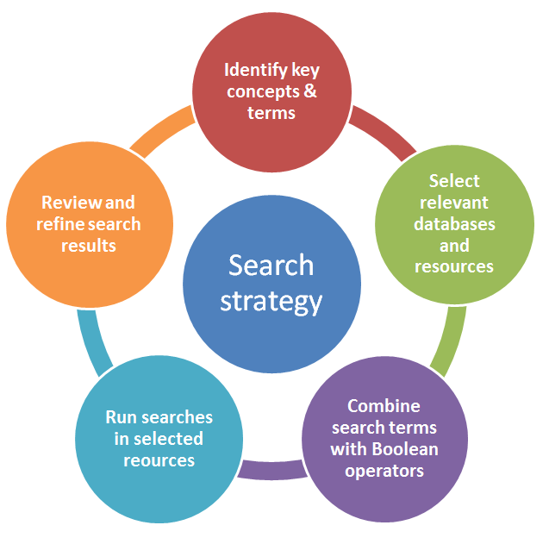

1. Identify key concepts & terms
2. Select the relevant databases & resources
3. Combine search terms with Boolean operators
4. Run searches in selected source
5. Review and refine search results

## Identifying the key concepts in the question

Be clear about your research question. Think of the individual concepts that form your research topic. Create a list of keywords and phrases to reflect these concepts and add to this list as you progress with your research. Use your first few searches to identify the terminology used in your research area/discipline.

### How to generate keywords & phrases

* Your knowledge of the subject
* **Key books** – look at the content pages and introductions to chapters for key theories, terms, theorists or experts
* **Journal articles** – use the abstract and author-assigned keywords (often under the abstract in an article).  Major ideas should be represented in the abstract.
* Use a **bibliography, encyclopedia or handbook** to get an overview of a subject or topic. The library has the [Oxford Handbooks online](http://www.oxfordhandbooks.com.ezproxy.lib.gla.ac.uk/) which give in-depth expert overviews on a topic
* Remember that each academic discipline has its own language/terminology

## Select the relevant databases & resources

The library should be your starting point for everything you will need for your dissertation. A useful place to start is Library search on the Library homepage. However, before starting a search it is important to understand how to search effectively and efficiently, so let us move to the next step and understand how to combine your keywords / phrases with Boolean operators.

Screenshot of the main library search box

## Combining search terms with Boolean operators

Boolean operators re used to connect and define the relationship between your search terms. When searching electronic databases, you can use Boolean operators to either **narrow** or broaden your **record sets**. The three Boolean operators are AND, OR and NOT.

Combining terms with **AND** means that both terms must appear in the same record – it reduces the number of references & increases the specificity of the search.

**e.g.** adults **AND** education



Combining terms with the **OR** operator increases the number of records retrieved as at least one of the terms must appear somewhere in each record. You should use this operator when there is more than one way to describe something.



**e.g.** adolescent **OR** youth **OR** teenager

To specify that a term is **NOT** present (reduces the number of references and increases the specificity of the search) **Warning -** this should be used with caution – eliminating one would also eliminate articles which mention both.

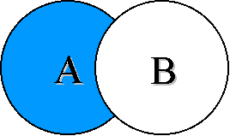

**e.g.** child **NOT** adolescents

### Other useful search operators

**Phrase searching** – to search for an exact phrase, enclose the phrase inside quotation marks

e.g. **“community development” “higher education” “curriculum planning”**

**Wildcards (?)** Use the wildcard symbol **?** to replace a single character in a word. It is useful for finding UK and American English spellings or for some plurals

**e.g. organi?ation will search for organisation AND organization  
e.g. wom?n will search for woman AND women**

**Truncation (*)** when you place the truncation symbol **\*** after the stem of the work it replaces multiple characters at the end of the word

**e.g. psychology* retrieves results for psychology, psychologies, psychologist, psychologically etc.**

## Putting it all together

In this example, we are looking for materials on leadership and innovation in secondary education in Scotland & have created the following search string:

leadership **AND** innovation **AND** “secondary education” **OR** “secondary school” **AND** Scotland

This will search for materials with the keywords leadership and innovation and the phrases secondary education or secondary schools AND the keyword Scotland.

Because we are going to run this search on Library search in the first instance, we need to put the two phrases connected with OR inside brackets

leadership **AND** innovation **AND** (“secondary education” **OR** “secondary school”) **AND** Scotland



This search returns lots of hits! You can refine the results using the filter panel on the left of the screen. For example, you might decide to limit your research to the Education discipline only, or by date or type of information. You could also decide to add more keywords or phrases or change the first part of the search to make it a more specific phrase e.g. “Innovative leadership” AND …

## Searching Subject Specific Education Databases

You might want to consider searching across a more comprehensive range of materials in your subject area, rather than just what the Library can supply. The Library subscribes to a number of Education databases, which index a comprehensive range of literature on the topic. Which one(s) to use depends, to some extent, on the focus of your dissertation topic.

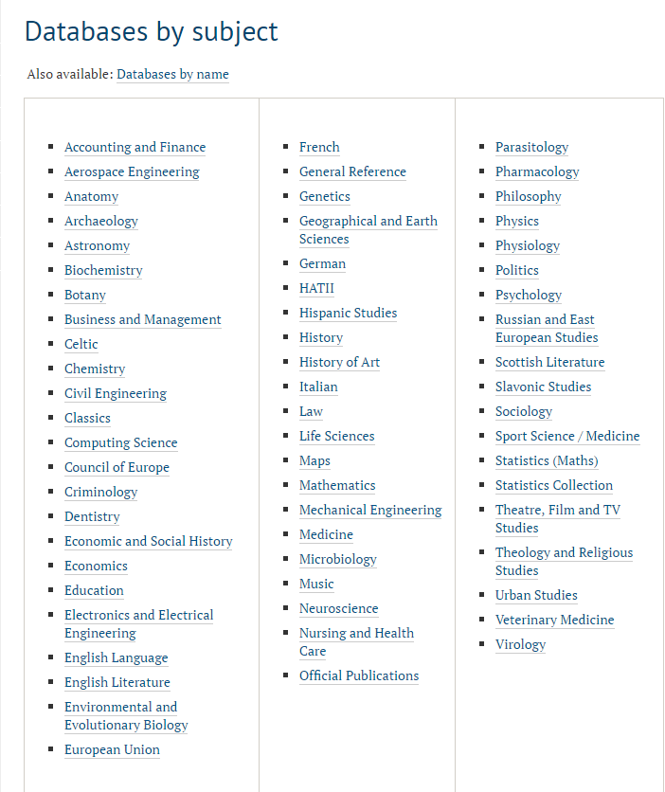Databases are arranged by major subject area – click on **Education** from the list to see the databases that the Library subscribes to. From the list click on the Connect to link to access – you will get a prompt to enter your GUID.

All databases are slightly different in how they look, but the principles of searching them is basically the same as searching Library search – just look for the search box and add your search string!

## Remember its not just about books & articles

Depending on your topic, you may need other types of information, for example: government documents, statistics, newspaper reports or papers from international agencies such as the United Nations or European Union. **Library Search or the Education databases do not index this type of material**. There are a number of specialist databases and websites for some of these categories of materials – but the easiest way to get access to a lot of this type of material is to go to the websites of the organisations themselves.

## Information skills – getting some help

Library staff can provide help and advice on how to find access and use the information you need. Contact the College Library Support Team for help with searching. You can either email them with quick enquiries, or you can make an appointment. At certain times of the year the team are busy so you may have to wait for an appointment. [library-college-support@glasgow.ac.uk](mailto:library-college-support@glasgow.ac.uk)

Web pages with appointment booking link <https://www.gla.ac.uk/myglasgow/library/collegesupport/>

To save time waiting for an appointment and take the opportunity to gain some skills yourself, consider using other resources created by library staff to help. There is a full dissertation toolkit of guides available at this link <https://edshare.gla.ac.uk/id/eprint/1377>

Updated September 2024