Table of Contents
Keyword searching 3
Generating keywords from your existing knowledge 3
Generating keywords from textbooks, handbooks and research monographs 4
Generating keywords from journal articles 4
Subject headings and controlled vocabulary 6

Keyword searching
Most literature searching is conducted using keywords or controlled vocabulary (subject headings). Keywords are the words that make up a source (the content) and the record of a source (the metadata). Keywords can be matched against the full text or the item title, author, abstract, subject headings, publication name etc.

There is a distinction between finding and searching. Finding is when you discover relevant materials during your exploration of search results or from your reading – perhaps through references, the citing literature or from mentions in social media or research networks.
​
Here we are focussing on searching. Searching is the process of expressing your information need in the form of keywords or subject terms structured in a ‘search string’ or field search and matching these to the literature.

To aid searching, it is useful to make a list of all the search terms relevant to your research question, including:

synonyms
antonyms
and related terms

Library
Knowledge Base

Searching – keywords and controlled vocabulary

Level: Beginner

You might do this in a notebook, or table or mind map.
​
How do you identify relevant keywords?

Generating keywords from your existing knowledge
Generate keywords from your existing knowledge of a subject. Keywords can be theories, concepts, authors, reports, publications or a combination of these.

All disciplines have their own research culture and researchers use the language and discourse of their discipline in their writing and research. List terms relevant to your research question based on your reading and existing knowledge of the subject, bearing in mind that there may be multiple ways to express the same keyword or concept, including differences in how this is expressed in different disciplines.

Generating keywords from textbooks, handbooks and research monographs
You might also find it useful to generate keywords from key textbooks or research handbooks. Research Handbooks reflect the current key arguments and theories in a research area and are an excellent way to gather relevant search terms. Use the chapter headings, chapter introductions and the index to identify: ​
- Concepts​
- Theories​
- Studies​
- Key authors and experts​
- Sources of further information

Book records in Library Search often have a summary description of content and chapter headings for both print and eBooks. Use the Preview link to see this information in book records.

Open the full text of eBooks to scan chapter headings and the introduction. ​You can also use the reference lists to identify other relevant works.

Generating keywords from journal articles
You might also find it useful to generate keywords from published journal articles. You can find keywords from reading the full text of the article. However, looking at the abstract or author-supplied keywords or subject headings is a good way to quickly generate lists of relevant key terms for searching. You can often see these parts of a record without opening the full text.

A quick scan read of the introduction can also be useful. ​ See an example below.
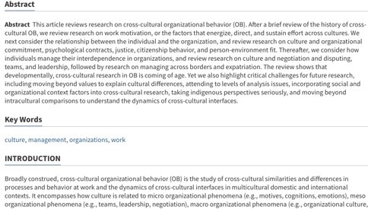
In Library Search use the Preview link in your results search to read the abstract and to see all the related bibliographic data about the article, including relevant subject headings.
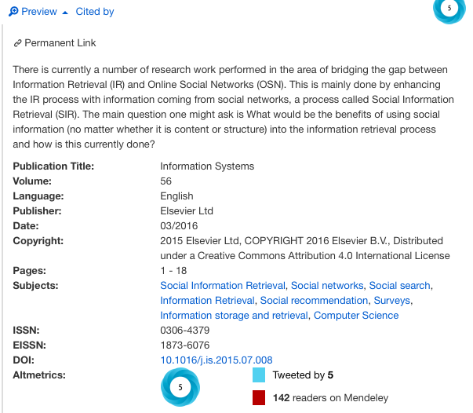

Subject headings and controlled vocabulary
Another common method of searching is to use subject headings or controlled vocabulary. These are broader than keywords and are applied to indexed published literature usually in databases. Subject headings are usually applied by an indexer.

- Subject terms connect related literature on a given topic ​
- Subject terms can incorporate all related terms (e.g. sub headings) ​
- They are applied to records by indexers who read the article or book chapter to identify its main focus
- They are usually hyperlinked to allow you to link to other material with the same subject heading.
- They aid precision in searching

The example below has several headings. [the hyperlinks are shown on the detailed record screen]. This is taken from a record in the database Business Source Premier:
You may want to read this article https://doi-org.ezproxy.lib.gla.ac.uk/10.1080/01639374.2014.917447 for arguments comparing keyword and controlled vocabulary searching.
Systematic and rigorous searching of the literature is likely to be a combination of both keyword searching and controlled vocabulary searching.
Having identified your keywords, you can then create your search. See the guide ‘Searching - tips for effective searching’ for guidance on how to create effective searches using operators, truncation, nesting and field searches.

