EdShare
User Guide

Embedding EdShare multimedia
files within Moodle

Level: Advanced

Table of Contents
Preface 3
Introduction 3
Uploading a resource to EdShare 4
Step 1 of 11: Uploading a resource to EdShare 4
Step 2 of 11: Uploading a resource to EdShare 4
Step 3 of 11: Uploading a resource to EdShare 5
Step 4 of 11: Uploading a resource to EdShare 5
Step 5 of 11: Uploading a resource to EdShare 7
Step 6 of 11: Uploading a resource to EdShare 9
Step 7 of 11: Uploading a resource to EdShare 10
Step 8 of 11: Uploading a resource to EdShare 12
Step 9 of 11: Uploading a resource to EdShare 12
Step 10 of 11: Uploading a resource to EdShare 13
Step 11 of 11: Uploading a resource to EdShare 14
Uploading e-Learning objects, i.e. Articulate Storyline 15
Step 1 of 10: Uploading E-Learning objects to EdShare 15
Step 2 of 10: Uploading E-Learning objects to EdShare 15
Step 3 of 10: Uploading E-Learning objects to EdShare 16
Step 4 of 10: Uploading E-Learning objects to EdShare 16
Step 5 of 10: Uploading E-Learning objects to EdShare 16
Step 6 of 10: Uploading E-Learning objects to EdShare 17
Step 7 of 10: Uploading E-Learning objects to EdShare 17
Step 8 of 10: Uploading E-Learning objects to EdShare 18
Step 9 of 10: Uploading E-Learning objects to EdShare 18
Step 10 of 10: Uploading E-Learning objects to EdShare 19

Preface

Before continuing with this guide, it is assumed you have read the document titled ‘EdShare User guide: Uploading resources. It is advised you read this document before proceeding as it will give you an understanding of how EdShare functions and how to upload resources to the platform.

Introduction

The purpose of this guide is to provide you (the reader) with an overview of how to embed multimedia files, e.g. video and audio within the institutions VLE Moodle using two different methods.

How to link to EdShare multimedia files within Moodle

Resources that are stored within EdShare can be embedded or linked to Moodle. The differences between the two methods are:

- Embedding – This produces a ‘snapshot’ of your resource within Moodle. Allowing them to interact with it without having to leave Moodle
- Linking – Students can view your EdShare resource by clicking on a link within a Moodle course

To link to a resource within EdShare from Moodle, please go through the following steps

Step 1 of 3: linking to EdShare resources via Moodle

Within your EdShare resource manager, click on the item you wish to link to and then right click on the Download text and select ‘Copy link address’.
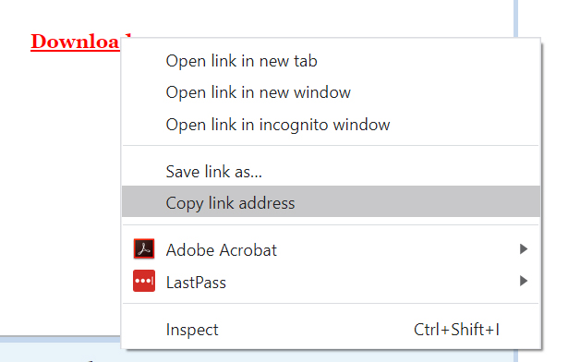

Step 2 of 3: linking to EdShare resources via Moodle

Within Moodle (and with editing turned on) select URL from the Resources menu and click the ‘Add’ button.
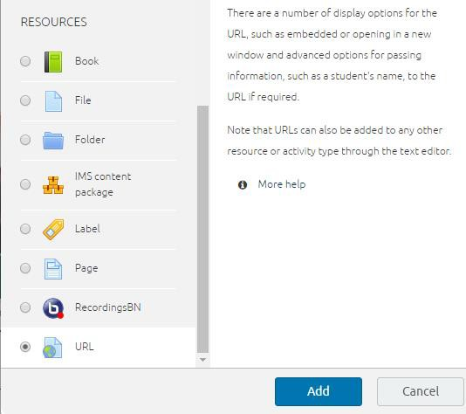

Step 3 of 3: linking to EdShare resources via Moodle

Give your link a name, and within the ‘external URL’ field, paste your copied link within this space. Provide a description for your link to inform users of its purpose and you can enable your link to appear in a new window if you wish.
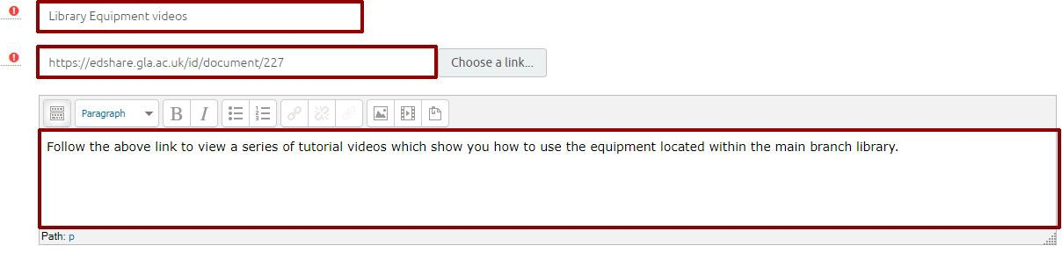
After you have checked your URL fields, scroll down and click on the ‘Save and return to course’ button.
You will be returned to your Moodle course where you will see that a link to your EdShare resource has been created. Click on this to open your newly created link.

How to embed EdShare multimedia files within a Moodle course

N.B, with video files, the format that is most suited for upload to EdShare is MP4, as this can be accessed on different web browsers and devices. If your video file is not in a MP4 format, then you may wish to consider using a free video converter tool.

Step 1 of 7: embedding multimedia files within Moodle

Before beginning, you will need to be logged into both EdShare and Moodle and have them both open for the entire duration of this tutorial in separate browser windows.

Within EdShare, click on the ‘Source Code’ button (this will only be available once your video has been processed), underneath your chosen video and copy the source code shown in the image below.
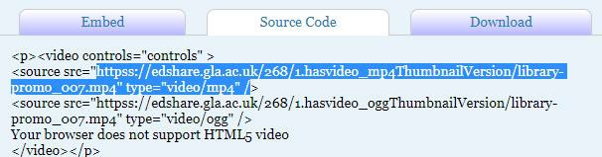
Leave the browser window with your video within EdShare open, do not close this as we’ll be returning to this shortly.

Step 2 of 7: embedding multimedia files within Moodle

In the text below, replace the three ‘source src’ instances with the EdShare ID of your chosen video. This is the text you copied in step 1.
Take a note of the width of your video controls, this will be required later on. Ensure for your three source addresses, they begin with ‘https’ not ‘httpss’.

<!DOCTYPE html>
<html>
<body>
<video width="350" controls>
<source src="https://edshare.gla.ac.uk/268/1.hasvideo_mp4ThumbnailVersion/library- promo_007.mp4" type="video/mp4">
<source src="https://edshare.gla.ac.uk/268/1.hasvideo_mp4ThumbnailVersion/library- promo_007.mp4" type="video/webm">
<source src="https://edshare.gla.ac.uk/268/1.hasvideo_mp4ThumbnailVersion/library- promo_007.mp4" type="video/ogg">
Your browser does not support HTML5 video.
</video>
</body>
</html>

Once you have replaced the three sources (highlighted in bold), copy the above text and paste it into a text editor, i.e. notepad and then save your text file as ‘video_index.html’.
N.B, you can also choose to adjust the width of your video as well by adjusting the current value of “350”, (currently highlighted in bold)

Step 3 of 7: embedding multimedia files within Moodle

Upload your newly created ‘video_index.html’ file to accompany your video file within EdShare. Do so, by returning to your browser window with your EdShare video open and scroll down the screen and then click on ‘edit Item’ button/text.
Click on the ‘Choose file’ button, select your HTML file and then click on ‘Upload’ the button. You should now have something similar to the image shown below within EdShare.
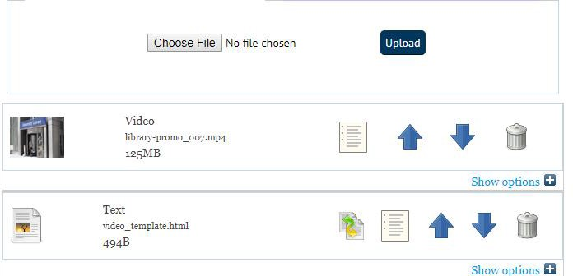
Scroll down and click on the ‘Save and Return’ button.

Step 4 of 7: embedding multimedia files within Moodle

You should now have an HTML file which accompanies your video file within EdShare.
Moodle should be open within your other browser window, log in (if required) and navigate to the course you want to embed your video into.
Within your chosen Moodle course do the following:

- Turn the editing on
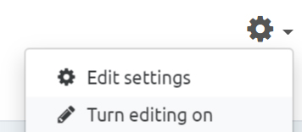
- click on Add and activity or resource.
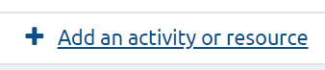
3. Under ‘Resources’ select ‘Label’ and click on ‘Add’.
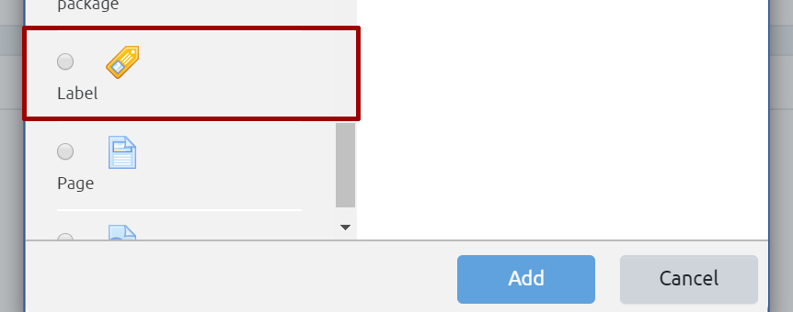

Step 5 of 7: embedding multimedia files within Moodle

Click on the ‘toggle toolbar’ icon, to make sure the HTML editor is being displayed within the toolbar.
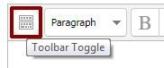

The toolbar within the Label, should now have the HTML editor button shown – click on this (highlighted in image below).
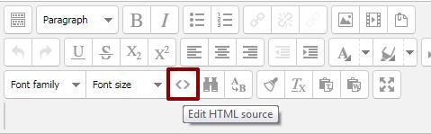

Step 6 of 7: embedding multimedia files within Moodle

Note, this is an involved step, with multiple sections to it.
Within the new HTML editor pop up, copy and paste the text shown below into it.
<p><iframe width="380" height="214" src=" " frameborder="1" allowfullscreen=""></iframe></p>
Once you’ve pasted the above text into the HTML editor within Moodle, a source will need to be added. To add a source, open the browser window with EdShare and select your video (if not already selected). Once the video file has been selected, do the following:
- Select the HTML file
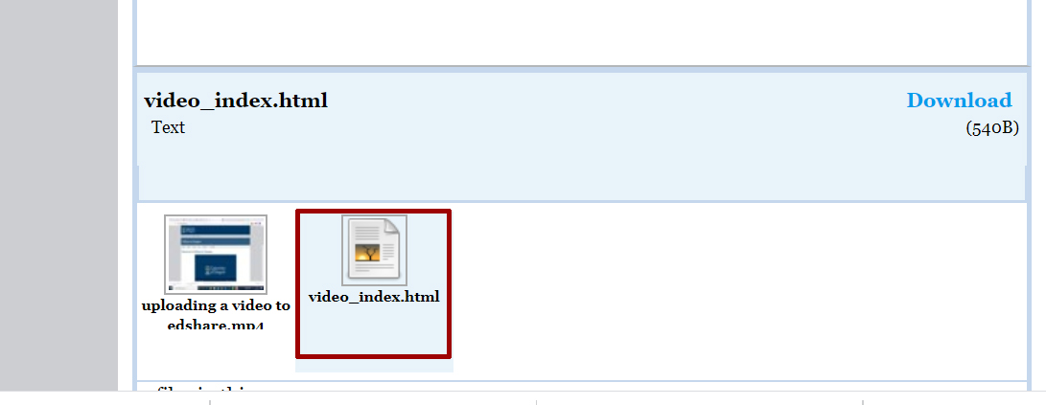
- Click on the ‘Download’ text displayed on screen.
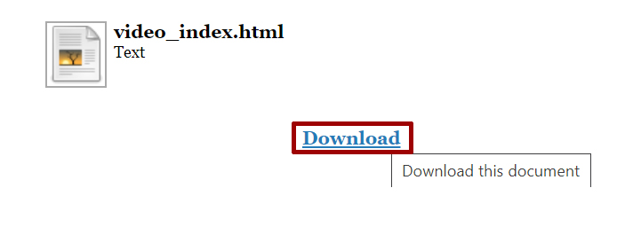

- Right click on the address within your browser bar and select copy from the drop-down menu
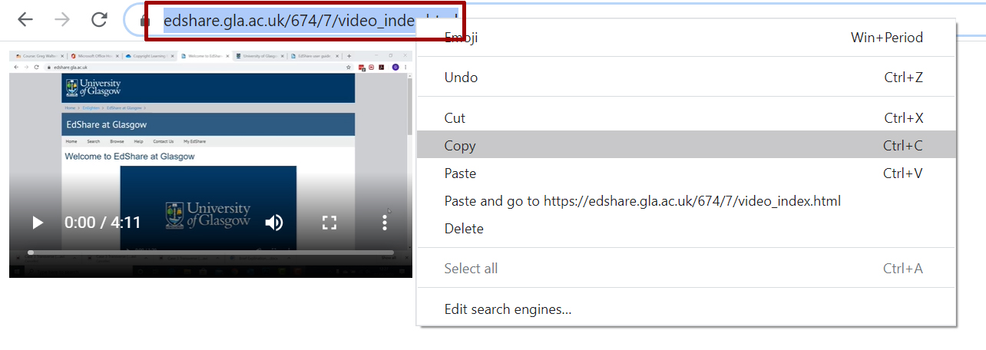

- Now return to Moodle and paste the copied URL between the quotations (” “) within the text you pasted into the HTML editor (Moodle).

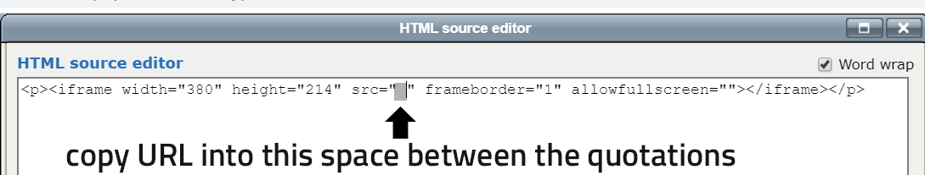

- Once you have copied the source URL in, the HTML should look like this (please see example below). Note, the placement of the code in between the quotations.

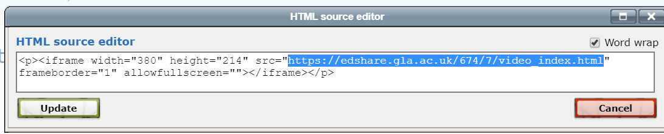

Step 7 of 7: embedding multimedia files within Moodle

Still working within the Moodle HTML editor pop up, we can now make one final adjustment before we can return to our course and view our embedded EdShare video file.
Adjust the width value and height values in the HTML source code (highlighted below). Make sure the width value you enter matches the one you chose during step 2 of this guide.
You can refer to the aspect calculator below (by clicking on it), to help determine what height your video should be.
Link to aspect ratio calculator
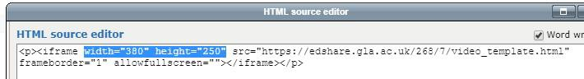

With the code copied in, you can now click on the ‘update’ button (HTML Source Editor pop up, left hand corner), to return to the Label editor screen.
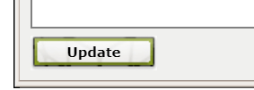

Within the Label editor screen, you should now see a preview of your video within the text section of the HTML editor.
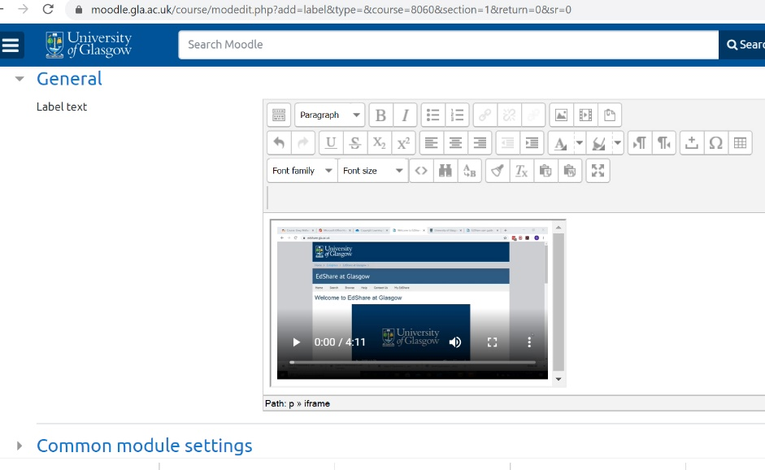

If you’re satisfied with your video, you can scroll down and click on the ‘save and return to course’ button.
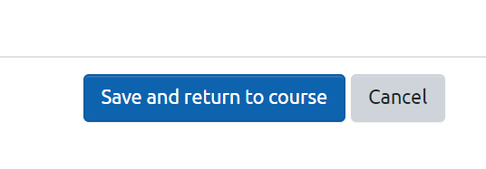
This will return you to your main Moodle course page, where you should now see the embedded EdShare video.
