Copyright
Searching for online image sources
using Tineye

Level: Beginner

Table of Contents
What is TinEye 3
Using TinEye 4
Step 1 of 4 4
Step 2 of 4 5
Step 3 of 4 6
Step 4 of 4 7
Tips for filtering your search results 7
TinEye plugin for Firefox and alternative search engine 8

What is TinEye

TinEye, is a reverse image search engine that will search through the internet for online matches, whenever you upload an image to it. The results it produces will show if the image you used is found on a particular website or image collection, i.e. Shutterstock. This is useful when you don’t know where the image came from and want to determine if it has Copyright associated with it or if its more freely available.

TinEye can be accessed by the following web address (for free): https://tineye.com/

Using TinEye

Step 1 of 4

Open up your web browser and go to https://tineye.com/.
Once you’ve accessed TinEye, click on the arrow button pointing up, near the centre of the screen to choose what image you would like to upload

Step 2 of 4

A file browser will appear once you’ve click on the arrow pointing up in TinEye.
Navigate to your chosen image, and once you’ve selected it, click on the ‘open’ button.

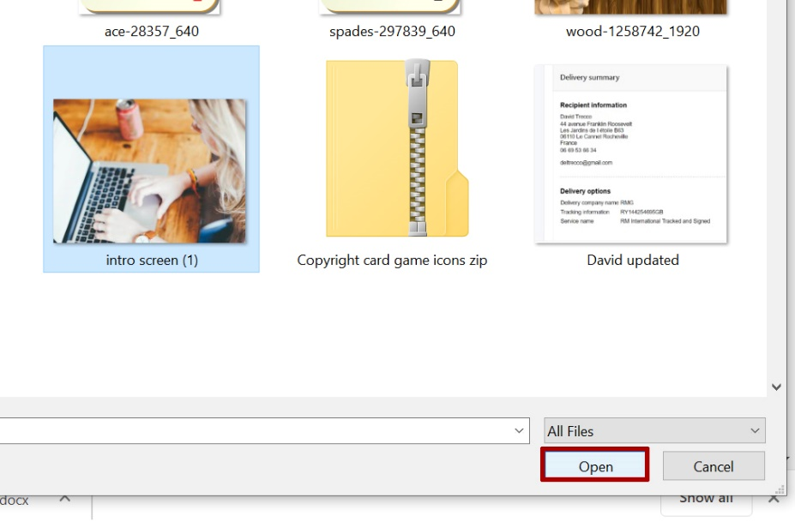

Step 3 of 4

At this point your image will be processed (note spinning circle indicating this), the time this takes may vary, so please be patient.

Step 4 of 4

Your image results will be returned with a list of wherever your image has been found online.
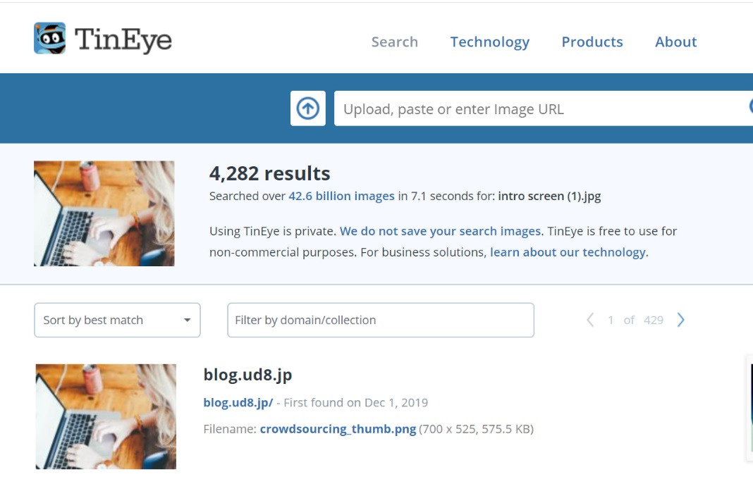

Tips for filtering your search results

If you find the image you uploaded has appeared in a high number of search results, then you can try further refining your search by typing text into the domain/collection text field. This will allow you to determine if your image is from copyright free collections like; ‘Pixabay’, ‘Unsplash’, or commercial image banks like ‘Shutterstock’

TinEye plugin for Firefox and alternative search engine

There are other image search options available for Google Chrome and other internet browsers, e.g. Firefox. Below are two links to browser extensions which enable more effective online image searches.
TinEye extension (for Firefox) – Tineye is a reverse image search engine, which adds a context menu to Firefox enabling you to search for an image and find out where it came from.
Google reverse Image search (3rd party) – this 3rd party extension for Firefox enables you to perform a reverse image search using Google Images and find other copies of the image you’re looking for online.

