Library
Knowledge Base

Accessing your Reading Lists

Level: Type in level here

Contents

Accessing Reading Lists 3
Reading List Arrangement 4
Navigate the list by using the Table of Contents 5
How to access items on your reading list 6
Advanced Features of ReadingLists@Glasgow 7
View Bibliography and Export References 9
Create Bibliography & Export References 10

Accessing reading lists

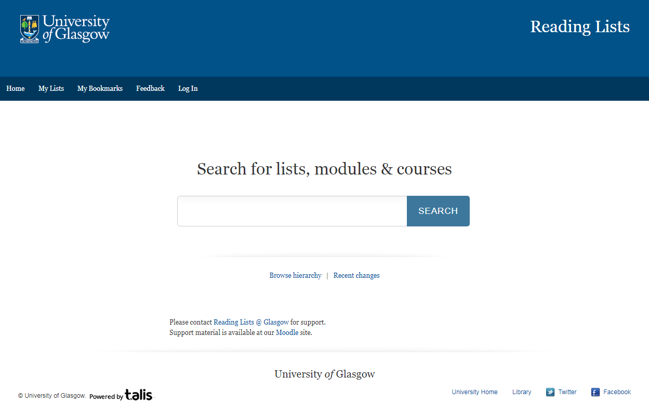
The Reading List is where you can find the details of the books, book chapters, and journal articles your lecturer expects you to review in preparation for seminars, tutorials and assignments.
- Your course Moodle should have a link to the course Reading List.
- Or go to the ReadingLists@Glasgow and enter your Course Code or Title into the search box

Reading list arrangement
Each lecturer can set up the Reading List as they wish. It may be arranged by:
- week / assignment – everything you need to review for a particular discussion or assignment
- literature type – books; journal articles; professional guidance
- importance – required reading, suggested reading, for information
Once you have worked out how your Reading List has been arranged, you will be able to move around it quickly.
This is an example of a PGT Reading List from the Adam Smith Business School (Accounting & Finance) You can navigate around the list by scrolling down or by clicking on the Table of Contents

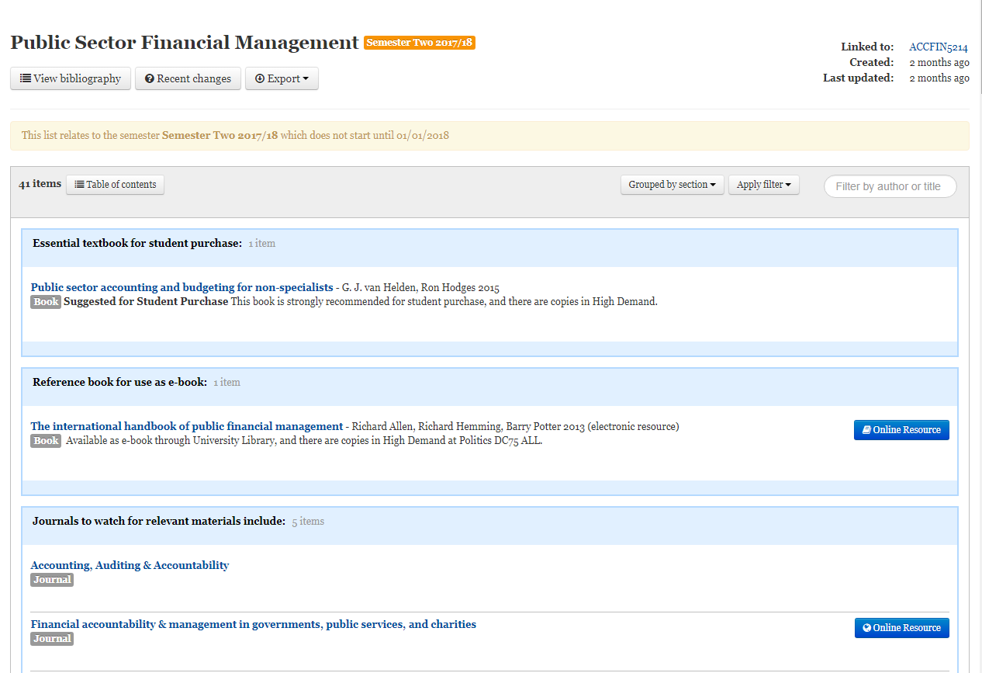

Navigate the list by using the Table of Contents

When you click on Table of contents, it’s much quicker & easier to navigate around the list, and find the section you require.
In this example you can use the Table of Contents to find
- Essential textbooks
- Reference books
- Journals to watch out for
- Detailed readings for each lecture

How to access items on your reading list

.
If the material is only available in print, then click on the title link and you will be given information about where in the Library the item can be found, how many copies etc.
If the material is available online, then click on the online resource button to link directly to ebooks, ejournal articles, digitised readings, and websites

Advanced features of ReadingLists@Glasgow
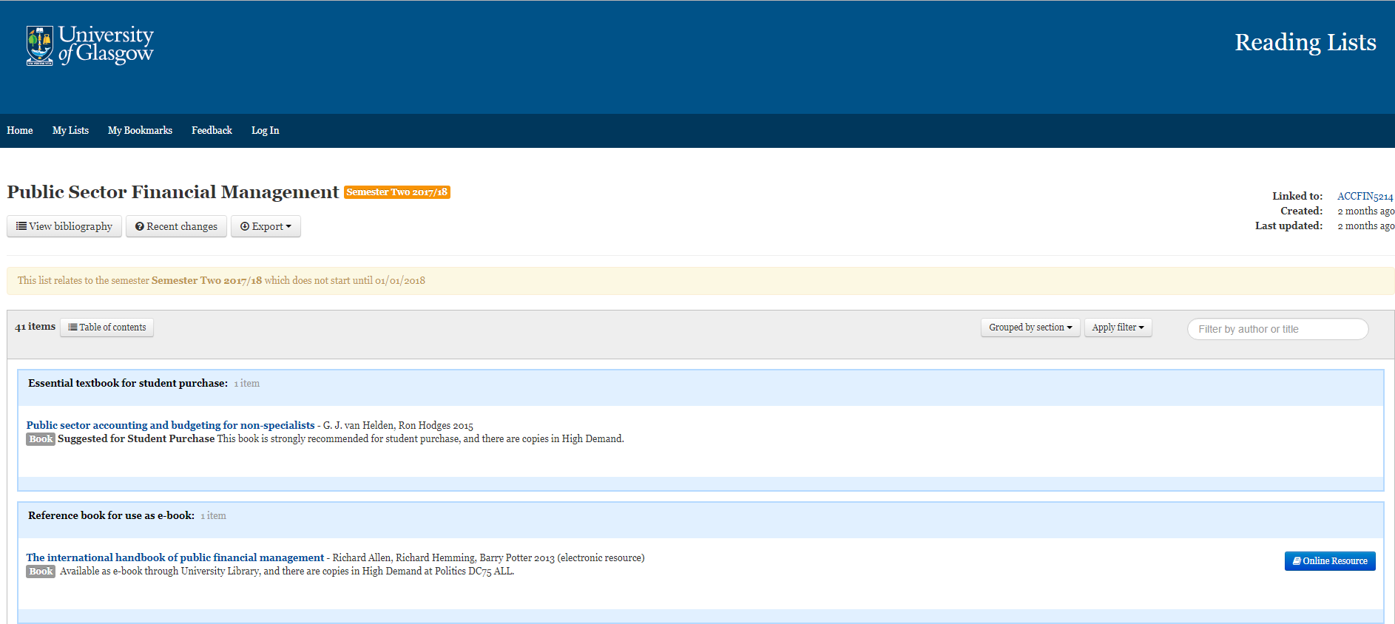
To use all the features of ReadingLists@Glasgow you must Log In
When you click on the Log In link at the very top of the screen – you will be prompted for your GUID.

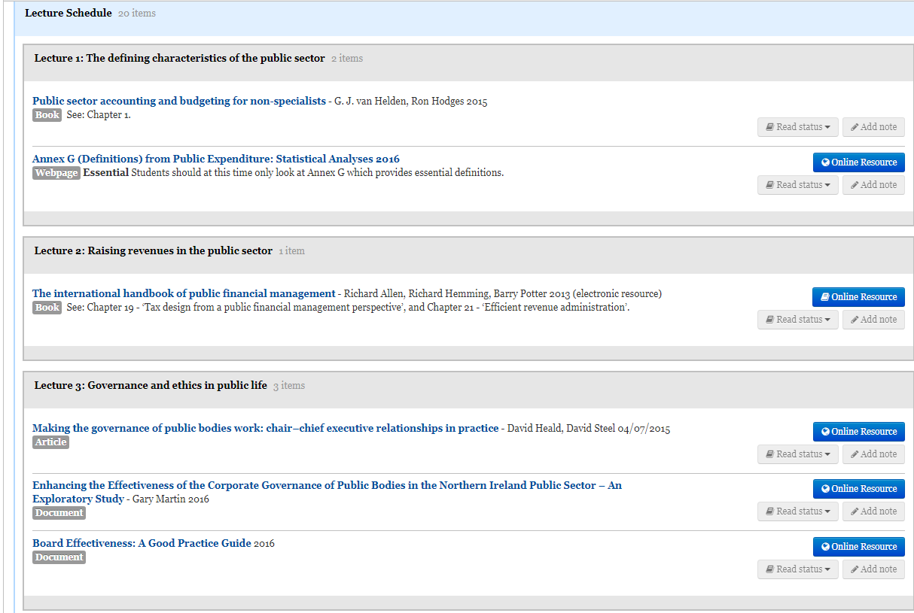

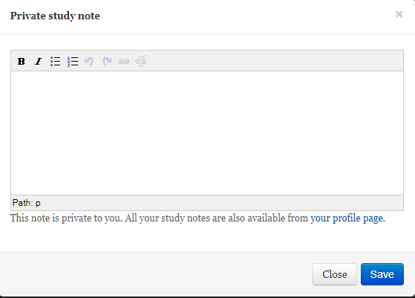
Use the Read status and Add note features to prioritise your reading, and keep notes on what you have read.

View bibliography and export references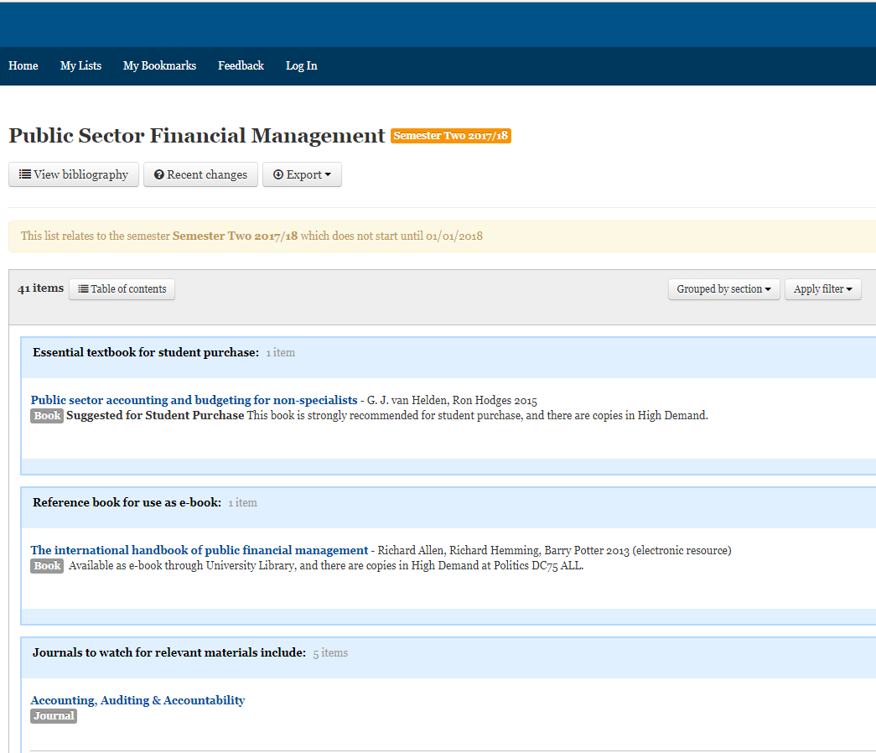
Use the View bibliography and Export options to help you reference and cite accurately in your assignments

Create bibliography & export references

The default referencing style is Harvard – which is the preferred style for the Adam Smith Business School – but other options are available by clicking on the arrow in the Harvard box.
You can also export references from here into other formats PDF for example. Click on the arrow in the Export box for options.

