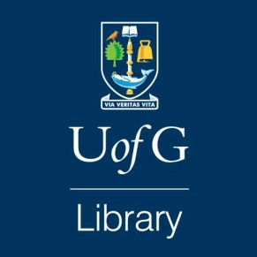
Key reference books for English Literature

While the Library offers a wide range of electronic resources, there are also a number of key printed reference works relevant to English Literature that are well worth looking at.
Title | Shelf mark | Details
Dictionary of Literary Biography | Gen Lit qE10 DIC (multiple volumes | Comprehensive literary biographies written by recognized literary scholars and critics. Some volumes cover individual authors, others are themed e.g. Twentieth-century American dramatists
Reader’s guide to literature in English | English qE19 HAW | Thematic entries for e.g. novel – romantic era, British gothic fiction, modernism – poetry etc.
John’s Hopkins guide to literary theory and criticism | Gen Lit qA700 JOH | A comprehensive historical survey of the field's most important figures, schools, and movements
Literary movements for students : presenting analysis, context, and criticism on literary movements | Gen Lit qA205 GAL vol. 1 & 2 | Analytic, context and criticism on a wide variety of literary movements. Entries cover movement origins, representative authors and works, themes and style, movement variation, criticism, bibliography.
Encyclopedia of literary modernism | Gen Lit A395.M54 POP | A-Z of writers and themes plus bibliographies
The Victorian literature handbook | English E461 WAR | One stop resource introducing historical and cultural context to key authors, text and genres.
The Modernism handbook | English E478.M6 TEW | One stop resource introducing historical and cultural context to key authors, text and genres.
Critical Heritage series | Title specific | Gathers together a large body of critical sources on major figures in literature. Each volume presents contemporary responses to a writer's work.
Casebooks in criticism | Title specific | Offers analytical and interpretive frameworks for understanding key texts in world literature and film.

