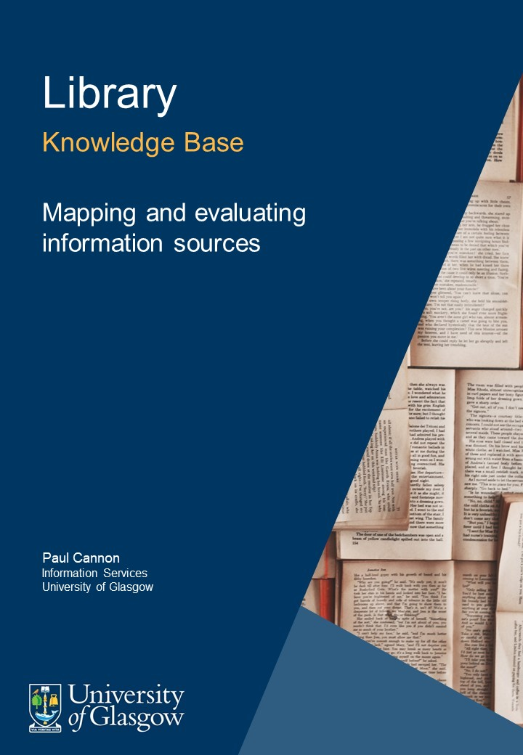

Table of Contents
1. Introduction 3
2. What makes an authoritative website? 3
3. Mapping the book landscape 4
4. Journal articles and critical appraisal 4
5. What makes an expert? 5
6. Credits 6

Introduction
This guide is aimed at students planning a literature search, it follows the resource ‘Formulating a research question and structuring a literature search’.
- The guide will help you:
- Identify appropriate resources for an assignment
- Use tools designed to critically appraise the sources of information
- Identify the key experts in your field.
If you are new to university study, it would be advisable to familiarise yourself with the resource ‘Identifying the right source of information for the right purpose’ before reading this resource.
The type or types of information you need to answer your research question will determine where and how you conduct your search. These factors will also be influenced by assessment guidance or advice given from lecturers, the module outcomes and your level of study.
As a broad example, if you were asked to research the global burden of mental health a primary source of information might be the World Health Organization, whereas research on electroencephalography to study neural activity would rely far more on journal references. The first assignment would require knowledge of internet search engines, the second, bibliographic databases; the sources used and depth of searching could vary significantly.

What makes an authoritative website?
The DISCERN Instrument has been designed to evaluate consumer health information. The first section, however, can be used for evaluating most information types.
Use the DISCERN Instrument (http://www.discern.org.uk/discern_instrument.php) to evaluate patient information site for the drug Havidol (http://havidol.com/index.php). Read through the DISCERN general instructions before commencing the task (http://www.discern.org.uk/general_instructions.php).
Hopefully you have realised that Havidol is a spoof website, but looks can be deceiving…
There are many academic studies using the DISCERN Instrument as a method for evaluating website content. See this PubMed search as an example: https://www.ncbi.nlm.nih.gov/pubmed?term=(discern%20tool%5BTitle%2FAbstract%5D)%20OR%20discern%20instrument%5BTitle%2FAbstract%5D
DISCERN is one of many appraisal tools. The U.S. National Library of Medicine also has a guide to evaluating health websites that can be generalised to other websites outside of health, see https://medlineplus.gov/healthywebsurfing.html. There are even guides to spotting fake news.

Mapping the book landscape
Books in the library can be found by using the books search. You can type in keywords on broad topics (i.e. invertebrate zoology or molecular genetics), or the title of a book from a reading list.
When you find a book you’ll have the option to see if the University Library holds a print, electronic or both versions of the book. Whether or not you can get a print book immediately depends on its status. If a book is on loan you can request it by placing a hold on the item.
Looking beyond the University of Glasgow Library, copac allows you to search across the collections of many UK and Ireland university and research libraries.
If there are books that the University Library does not hold, you can ask the Library to loan them for you, ask the Library to purchase the book, or you can visit another university library with the SCONUL Access scheme.

Journal articles and critical appraisal
Knowing the appropriate bibliographic database to start a literature review can be difficult. The Databases by Subject link on the University Library homepage will provide a good starting place. Each database has a link to ‘Full details of this resource’ that provides a brief description of the database – allowing you to make a judgement on which databases to use.
Assessing the quality of a journal and the articles contained within them is a further difficult task. The peer review process employed by many journals provides an initial evaluation of research quality. Most bibliographic databases have an option to filter results to peer reviewed articles.
Read the sections ‘What is peer review?’ and ‘How does it work?’ from:
Research Information Network, 2010. Peer review: a guide for researchers. [online] Research Information Network. Available at: http://bit.ly/2El79oh
Individual articles can be assessed by employing one of many common tools for appraising the quality of medical studies. For those new to critical appraisal, NHS Choices Behind the Headlines provides a useful introduction to evaluating the research found in newspaper articles.

What makes an expert?

Using the database Scopus, search for the dsDNA virus ‘myoviridae’ across the title, abstract and keyword field.
Sort the results by ‘Cited by (highest)’.
The same groups of researchers have the most highly cited papers – probably indicating expertise in the field. However, citations can be given for negative reasons, such as poor research practice or even scientific fraud.
Citations also take a long time to accrue. You might note that most of the papers are 10-20 years old. High citation counts, therefore, tend to favour older research, which in some fields may now be less relevant.
Now use the ‘Analyze search results’ button and select the ‘Author’ tab.
The authors that publish most frequently are now listed. Does this constitute expertise or just that the author is a prominent author?
What makes an expert in your judgement?

Credits

Author credit
Paul Cannon, Information Services, University of Glasgow

Cover image
Patrick Tomasso on Unsplash.

