Introduction
This guide suggests several methods to help keep up-to-date with published literature. The methods listed and the associated pros and cons of each method are not exhaustive, are subjective, and therefore intended to be illustrative only. Reading is a highly personal activity and you are encouraged to try various tools and techniques to suit your desired reading experience.
Guide contents
  - Twitter and social networks
  - Journal databases and preprint servers
  - Table of contents (ToC) alerts
  - Citation alerts
  - Peer reviewing
  - Apps and other tools

Twitter and social networks
Photo by Sara Kurfeß on Unsplash

Pros: Helps develop an academic community around shared research interests
Cons: Be aware of your digital wellbeing
Cons: There is no quality filter; anyone can post anything
Notes: The information gained can be self-selecting based on whom and the hashtags you follow
Notes: Once you know the right hashtags to use when posting and follow, your contact and information network will quickly grow
Notes: Retweets, likes and comments do not necessarily correlate to quality nor mean that others have read the article they are sharing

Journal databases and preprint servers (via email and RSS feeds)
https://www.biorxiv.org/ screenshot

Pros: Journal databases have journal inclusion criteria and therefore come with a degree of editorial control. The quality of the articles in the journals, however, is not guaranteed
Pros: Search alerts can be as sensitive or specific as you wish to make them, thereby retrieving a wide range of information with many results, or a focussed alert based on a narrow search that will retrieve fewer but more relevant articles
Pros: Search alerts are journal agnostic and therefore increase the breadth of your reading
Cons: Email alerts and RSS feeds can get lost in your inbox
Notes: Content can be self-selecting depending on the databases or servers you get the alerts from. Depending on your research interests you may need to set alerts from several databases to retrieve the cross-disciplinary breadth of the topic of interest, or use a multidisciplinary database
Notes: Preprints allow the sharing of very new research, but they are not yet peer reviewed. Use your critical appraisal skills to judge their quality
Sources: A list of databases by subject; A list of preprint servers by subject

Table of contents (ToC) alerts (via email and RSS feeds)
Photo by pranav anand on Unsplash

Pros: Table of contents alerts notify you when new issues of journals are published. You can therefore filter the alerts to journals you know publish relevant research
Cons: Articles published in ‘high impact’ journals do not necessarily correlate to good research
Cons: Email alerts and RSS feeds can get lost in your inbox
Notes: Content can be self-selecting depending on the journals you are alerted to
Sources: Zetoc; JournalToCs

Citation alerts (via email and RSS feeds)
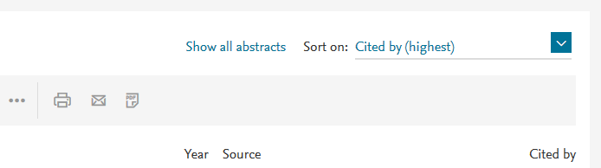
https://www.scopus.com screenshot

Pros: Identify who is reading your work or the work of prominent authors
Pros: People citing your work are possible future collaborators
Pros: Analyse who is citing relevant work and develop a citation network
Cons: Email alerts and RSS feeds can get lost in your inbox
Cons: Reading can be focussed on one topic and self-selecting based on who you follow
Sources: Scopus; Web of Science; Altmetric Explorer

Peer reviewing
Photo by Helloquence on Unsplash

Pros: Peer reviewing can enhance your academic CV and develop your critical reading skills
Pros: Sites like Publons allow you to practice and develop your peer review skills in a closed community
Cons: The peer review process can be time consuming

Apps and other tools
Photo by You X Ventures on Unsplash

Pros: Offer personalised recommendations based on your reading history/library/interests
Cons: Content filters may ‘silo’ your reading
Cons: Some are premium/paid for services
Notes: Be aware of the privacy settings of apps and tools
Sources: Society publishers; Mendeley, F1000, Read by QxMD, amongst many others [this list is not a recommendation of tools or services]

Credits

Author credit
Paul Cannon, Information Services, University of Glasgow

Cover image
Bernd Klutsch on Unsplash

