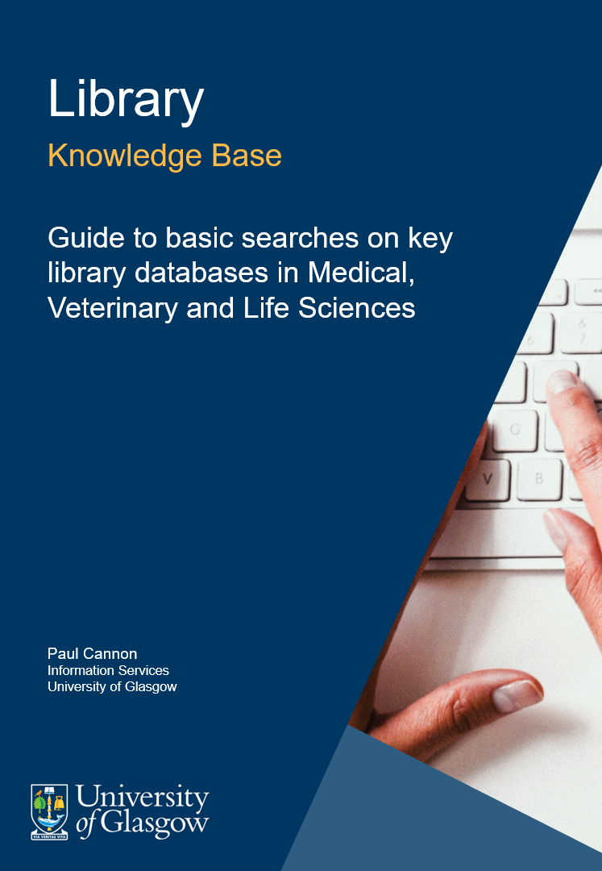

Table of Contents
1. Guide aims 3
2. OvidSP (Medline and Embase) 3
3. EBSCOhost (CINAHL and PsycINFO) 4
4. Web of Science (Web of Science Core Collection, BIOSIS Previews, Zoological Record and CAB Abstracts) 5
5. Cochrane Library 6
6. Truncation and wildcard crib sheet 7
7. Credits 8

Guide aims
This guide provides information on searching key library databases in Medical, Veterinary and Life Sciences.
The searches performed in the videos take you beyond simple textword (title and abstract) searching and introduce a level of rigour with the addition of subject headings to a search.
The processes illustrated are relevant to all types of literature review, although systematic-type searches will need to be a lot more exhaustive in the use of synonyms, acronyms and additionally searching and browsing for relevant subject headings.
Refer to the database help text for detailed search guidance for each database.

OvidSP (Medline and Embase)
This video will illustrate a basic search conducted on the database Medline via the OvidSP interface. The same search process can be used for Embase.
The search focuses on anxiety in frail elderly people.
This video can also be found at https://edshare.gla.ac.uk/278/2.hasvideo_mp4ThumbnailVersion/Ovid.mp4.

EBSCOhost (CINAHL and PsycINFO)
This video will illustrate a basic search conducted on the database PsycINFO via the EBSCOhost interface. The same search process can be used for CINAHL and other EBSCOhost databases.
The search focuses on anxiety in frail elderly people.
This video can also be found at https://edshare.gla.ac.uk/278/3.hasvideo_mp4ThumbnailVersion/EBSCOhost.mp4.

Web of Science (Web of Science Core Collection, BIOSIS Previews, Zoological Record and CAB Abstracts)
This video will illustrate a basic search conducted on the database CABI: Cab Abstracts and Global Health via the Web of Science interface. The same search process can be used for BIOSIS Previews and Zoological Record and other Web of Science databases. Note that the ‘standard/default’ Core Collection does not have the thesaurus options illustrated.
The search focuses on the welfare of farmed salmon.
This video can also be found at https://edshare.gla.ac.uk/278/4.hasvideo_mp4ThumbnailVersion/CABI.mp4.

Cochrane Library
This video will illustrate a basic search conducted on the database Cochrane Library database via Wiley Interscience interface.
The search focuses on anxiety in frail elderly people.
This video can also be found at https://edshare.gla.ac.uk/278/5.hasvideo_mp4ThumbnailVersion/Cochrane.mp4.

Truncation and wildcard crib sheet

Interface and database name(s) | Phrase searching | Truncation | Wildcard (mandatory one character) | Wildcard (zero or one character) | Proximity
OvidSP (Medline and Embase) | Automatic | * or $ | # | ? | adjX (where X can be from 1 to 99)
EBSCOhost (CINAHL and PsycINFO) | “Quotation marks around phrases” | * | ? | # | nX
Web of Science (BIOSIS Previews, Zoological Record and CAB Abstracts) | “Quotation marks around phrases” | * | ? | $ | near/X
Cochrane Library | “Quotation marks around phrases” | * | ? | * or ? depending on use | near/X

Credits

Author credit
Paul Cannon, Information Services, University of Glasgow

Cover image
Damian Zaleski on Unsplash

