Moodle Best Practice
and Accessibility
Guidelines for University
of Glasgow

Written by Greg Walters

Moodle Best Practices and accessibility
1: Introduction 3
2: Why Use e-learning? 4
2.1: Drivers for using e-learning, from a University of Glasgow perspective 4
3: Literature review 5
3.1: Pedagogical and accessibility benefits of using e-learning 5
3.1a: Assessment and feedback 6
3.1b: Community of Inquiry (CoI) 6
3.1c: Using different types of technology to provide additional context and learning opportunities 7
3.2: Summary of benefits when e-learning is used 7
3.3: Considering the student perspective when developing accessibility guidelines 8
3.4: Identified barriers 9
Barrier 1 – Duplication of materials within Moodle 9
Barrier 2 – Lack of knowledge in relation to good Instructional design practices 9
Barrier 3 – Consideration of academics using Moodle who may be disabled 10
3.5: Solutions to identified barriers 10
Notes on guidance within guidelines 10
4.1: Best Practices for Layout and course structure in Moodle 11
4.2: Types of Course Format 11
4.2a: Collapsible format 12
4.2b: Grid format 13
4.3: Consistent Layout 14
4.4: Use informative headings and sub-headings within Moodle 15
4.5: Resource / Activity names 16
4.6: Don’t display content in your Moodle course page 17
4.7: Use of images within a Moodle Course front page 19
4.8: Completion Tracking 20
Checklists for Layout and course structure 21
5.1: Designing an Accessible a Moodle course and resources 24
5.2: Developing accessible text 25
5.2a: Writing Style for accessible text 25
5.2b: Accessible font style, size and background contrast in a Moodle front page 26
5.2c: Colour of text 28
5.3: Creating accessible documents 29
5.3a: Accessible documents (Moodle Book) 29
Figure 17: The above image shows where Moodle Books are located and can be added to a course 29
5.3b: Accessible PowerPoint presentations 30
5.3c: Workflow for creating accessible optional Word/PDF documents 32
5.4: Accessible Images 34
5.5: Accessible Video 35
5.6: Creating accessible Hyperlinks (URLs) 36
5.7: Accessible Activities and Resources within a Moodle Course 37
5.8: Accessibility for University of Glasgow staff 38
Checklists for Accessibility 40
References 48
Appendix 1: Accessibility and Open Resources 51
1. Links to online Image Resources 52
2. Links to online Audio resources 54
3. Links to online Video resources 55
Appendix 2: Tutorial Resources 56
Guide to enabling Grid format in Moodle 57
Guide to Enabling Collapsed Topic Format 59
How to upload images from your computer to a Moodle course 61
How to Enable Student Tracking 64
How to Enable File Size and Type 66
How to embed your own YouTube Video within your Moodle Course 68
How to enable TinyMCEHTML Editor 73
Showing Accessibility Tools 75

1: Introduction
This Customised Study is the development of a set of guidelines, which examines the accessibility of disabled students. The intended audience is staff at the University of Glasgow to utilise when developing and designing Moodle courses. There are three specific areas from the Equality Act 2010, which relate specifically to Moodle.
- Section 20 – Duty to make adjustments
- Section 29 – Provisions of service etc.
- Schedule 25 – Information Society Services

In the context of the University Glasgow (UoG), during the academic year 2016/17 there were 26,803 under and post graduate students who accessed the 8453 Moodle courses. Out of the 26,803 - 1603 identified as being disabled or have an impairment. Given this number it is important to ensure every type of student has an accessible learning experience when using Moodle in accordance with the Equality act 2010 legislation.
Disability | Student Headcount
Specific learning difficulty | 595
Mental health condition | 354
Long standing illness | 202
Multiple Disabilities | 160
Phys impairment/mobility issue | 119
Autism Spectrum Condition | 66
A Disability Not Listed | 49
Blind/Serious visual impairment | 36
Deaf/hearing impairment | 22
Table 1: a breakdown of the different types of disabilities UoG students 2016/17
This guide is aimed at UoG staff who are developing Moodle courses for both under and post graduate students. The guidelines that follow will enable UoG staff to make a series of reasonable adjustments which can be easily made to their Moodle courses and content. By making these adjustments, the UoG students will benefit as they will have access to Moodle courses which offer them an accessible and equitable learning experience. These guidelines will provide additional student-centred accessibility guidance, instead of just relying on the Web Content Accessibility Guidelines (WCAG).

2: Why Use e-learning?

2.1: Drivers for using e-learning, from a University of Glasgow perspective

You may be asking yourself, why should I use e-learning instead of traditional teaching; do students access our Virtual Learning Environment (VLE) and through what technology? To answer these questions, we should first briefly refer the senate approved (6th June 2013) e-learning strategy. The strategy addresses the question of traditional teaching by recognising that overall campus class sizes have increased, this can have the effect of de-personalising the student learning experience. To solve this issue, online learning has the potential to be used to deliver highly personalised learning experience for a student even in a very large class. Turning now to the question of ‘do students access our VLE (Moodle)? The numbers provided in the strategy indicate a large number of increased accesses from students, starting at 8.4 million times during 2006/7 to 32.7 million times during 2011/12. These numbers illustrate that students do actively access the institutions VLE in relation to how students are accessing Moodle, we should refer to the trends of technology referred to in the e-learning strategy. A survey amongst first year students in 2013 revealed 95% of them had access to a laptop with two thirds having access to a mobile phone. The survey data also revealed a shift in attitudes amongst students, with around 10% expecting access to video and audio content as part of their course (University of Glasgow, 2013).
Based on the evidence above it is important to utilise e-learning as it addresses the issue of increasing classroom sizes, by providing students with additional online resources which can be accessed any time by students via their laptops or mobile devices.
The section below (literature review) describes the pedagogical benefits of using e-learning to teach students and examines the potential accessibility barriers and solutions that may be encountered in an online environment.

3: Literature review

In this literature review I will examine the pedagogical benefits of using e-learning to teach learners. This examination will be further extended by analysing the advantages of assessment and feedback, building an effective online community that utilises a variety of technology, benefits and challenges of using e-learning, along with examining accessibility barriers, solutions and the legislation which supports it.

3.1: Pedagogical and accessibility benefits of using e-learning

From a pedagogical perspective e-learning enables an individual to design and develop a personalised online course that can incorporate engaging activities, assessment, discussion and media to compliment the learning objectives and subject matter. Lessons and sections within an online course can be structured to benefit the student learning and navigation experience by being structured into a meaningful format, e.g. weekly. This instructional design is good pedagogical practice as content elements are presented in a logical sequence to the student(s) (Vai, M. & Sosulski, K. 2011. pp. 154 – 156).
Aside from the pedagogical benefits, online courses address potential geographical barriers by enabling students from different locations to access to access materials via their computer or mobile device. Another accessibility benefit of using e-learning is, online courses can be accessed by students at a time that is convenient for them, enabling self-paced study and progress (Pegler, C. & Littlejohn, A. 2007 pp.32 – 33).
The first paragraph mentions activities, assessment, discussion and media in relation to e-learning. Given the scope of these of these areas, each of them will get their own section so the benefits of using them in e-learning can be discussed.

3.1a: Assessment and feedback
Online assessments can be developed, ranging from quizzes which incorporate media to providing secure online spaces for students to submit their essays. Depending on the platform, the assessments you design will be customisable, for example a Moodle quiz can be adjusted to be available to students at a specific time and date or the number of attempts is limited. This is not the only method of customisation as feedback can be greatly expanded upon in the e-learning environment. Traditionally lecturers would provide feedback in a text based format, however by using technology feedback online can incorporate both audio and video. As demonstrated by Anne Crook’s research into the benefits of using video in assessment feedback, which concluded the use of video was beneficial to students and lecturers feedback experiences. Due to the emotive aspects of the video feedback provided by the lecturer, which allowed students to gauge the reaction of and emphasis of a lecturer (Crook, A. & et al. 2012. pp 394). The use of technology in e-learning feedback can greatly benefit the student as it is personal, has additional context and more accessible to disabled students due to the inclusion of audio and video.

3.1b: Community of Inquiry (CoI)
In the previous paragraph the benefits of providing personalised student feedback was examined, we’ll now analyse developing commination further by highlighting the benefits of a Community of Inquiry (CoI). Online communication can be challenging, especially if restricted to text via a discussion forum, as the nuance and context cannot always be interpreted. If students feel isolated or unable to communicate, asynchronous activities e.g. discussion forums can suffer due to lack of engagement (Kear, K. 2010). To address this issue a CoI can be employed as this framework combines, social, cognitive and teaching presences to create an environment which has a diversity of perspectives and encourages critical and reflective discourse (Garrison, D.R. 2011. pp. 21). This supports the online learning of the student and benefits the students by creating a diverse and inclusive online community.

3.1c: Using different types of technology to provide additional context and learning opportunities
E-learning enables a wide variety of media, i.e. images, video, audio and interactive materials like games to be incorporated into online courses and materials. These types of media and interactive elements can enhance the students learning experience by adding additional context and explanation to subjects. In terms of interactive materials, e.g. games, these can be examined more closely as their application can lead to different learning opportunities.
As the literature around e-learning highlights there have been discussions around key areas such as ‘Does technology improve learning?’ Several reports within Selwyn’s book illustrate how technology can be used to engage students in problem solving activities, i.e. the use of commercial games like The Sims or Sim city to support exploratory spaces for constructivist learning (Collins & Haverson. (2009) as cited in Selwyn, N. (2011). These examples of technology used in online learning provide students with the learning opportunities to explore learning through successful and unsuccessful experiences.

3.2: Summary of benefits when e-learning is used
- Courses and materials can be developed that incorporate both good instructional design and pedagogical practices
- Distance learning students can access their learning materials remotely via their computer, which removes both geographical and travelling barriers
- Students can access their learning materials at a time that is convenient for them and study at their own pace
- Through the use of technology customised assessment can be developed which is complimented by feedback that provides additional context and explanation for students
- Engaging, critical and reflective discussion can be facilitated in e-learning by the use of CoI

3.3: Considering the student perspective when developing accessibility guidelines

Institutions who relied solely on using WCAG guidelines as a method of assessing accessibility barriers, found unperceived barriers were not identified. This was evident when academics from the University of Manitoba (Canada) conducted a student-centred accessibility evaluation of Moodle 2.0. Twenty-four undergraduate students (twelve identified as disabled) took part in two research activities; moderated and unmoderated interaction of a Moodle course. The unmoderated activity used online automated tools (AChecker and WAVE), which were aligned to WCAG web accessibility guidelines to report any potential barriers when students engaged with Moodle and the course contents. The findings demonstrated student-centred methods were an essential component of e-learning accessibility evaluation, as the automated evaluation tools based on WCAG accessibility guidelines were not effective at identifying all potential barriers (Kumar & Owston, 2015, pp.280).
When using ACheker to evaluate their online e-learning webpages and VLE – Moodle, the Open University (OU) had a similar experience compared to the University of Manitoba. The software proved to be quick at evaluating technical barriers, but did not take the learner perspective into account (Cooper, M & et al. 2007, pp.234) As previously stated this methodology is unsuccessful at identifying unforeseen accessibility barriers. To address this issue the OU staff produced a document with accessibility issues they identified and then worked with the Moodle Open Community to address these issues (Cooper, M & et al. 2007, pp.239 -pp.240).
In contrast to the previous two institutions, a Lisbon institution demonstrated by adding an accessibility block to Moodle, disabled students could change the text size and colour along with background colour (Espadinha, C, A. 2016. pp. 285). This demonstrates simple adjustments can be made to Moodle that align to World Wide Web Consortium (WC3) guidelines and are student focused. Let us now consider another form of assessing student centred accessibility which is called Universal Design for Learning (UDL). This framework is aligned to the social model of disability, which places the problem with the environment not the person (Collins, B. 2014. pp.22) and was used in conjunction with WC3 by a Brazilian institution to assess Moodle chat facility. Two specialist participants were used to interact with Moodle’s chat facility using UDL and WC3. Their research led them to determine a useful accessibility feature would be for students and lecturers to highlight the most important information in a chat thread (Calvo, R. & et al. 2017. pp. 604).
The above examples emphasise the requirement to have guidelines that account for accessibility needs beyond the technical aspects highlighted in the WC3 and consider the student perspective as well.
When the literature relating to this review is examined several barriers are identified which will need to be addressed to ensure the advice given in the guidelines is comprehensive.

3.4: Identified barriers

Barrier 1 – Duplication of materials within Moodle
When reading the literature, three common types of disability are revealed; blindness, deafness and dyslexia. Either assistive technology, i.e. screen readers or additional adjustments within Moodle courses or resources are recommended to make courses more accessible for disabled students. To adhere to WC3 guidelines it is recommended that all text and non-text items have an equivalent file, i.e. a document, should have an accompanying audio file and file to be printed in Braille (Ulbricht, V, R. & et al. 2012. pp.140). In addition to the above accessible formats, Flor asserts, PowerPoint, PDF’s, text files etc should be able to be read in sign language (Flor, C, S. & et al. 2015. pp. 162). However, there is an inconsistency with this argument as Flor has not made clear how exactly PowerPoints, PDF’s can be read in sign language. There is no mention of assistive technology or software plugins that enables this or indication if she was speaking figuratively from a translation point of view? The area that Flor has highlighted requires further research as there is a lack of evidence to support Flor’s current assertion.
The above examples highlight that lecturers must upload additional files to a Moodle course so. This is where the problem of duplication occurs as a lecturer would have to create and upload different versions of the same file to provide accessible copies for various types of disabled students.

Barrier 2 – Lack of knowledge in relation to good Instructional design practices
Good instructional design techniques should be employed when developing accessible Moodle courses, as these practices will complement the accessibility guidelines. These design techniques do not have to be complex or technical adjustments within Moodle. By simply ‘chunking up’ a long piece of text within Moodle, a dyslexic student at a FE college in England could have had a more accessible experience (Parsons, A. 2017. pp. 279). Within the literature associated with this review, only two papers briefly mentioned ‘Universal Design for Learning (UDL)’ when developing a set of guidelines for accessibility in relation to Moodle (Primo, L. Ulbricht, V & Fadel, L, M. 2017. pp.576). Would the inclusion of the UDL guidelines enhance the accessibility of all the Moodle courses and systems analysed in the papers? Is UDL a design frame work that learning technologists could provide advice on and incorporate into good Moodle course design practice? As previously stated this frame work is aligned to social model of disability and could be used as an additional method of assessing Moodle course design and accessibility.
When the literature is reviewed it indicates teaching staff in other institutions have either insufficient knowledge of instructional design or not been provided training in this area. This is an important area which will need to be addressed in the guidelines.

Barrier 3 – Consideration of academics using Moodle who may be disabled
Adjustments within Moodle and guidance should be provided to disabled academics, otherwise staff may not be able to adjust their courses. This was evident in a Brazilian study, where due to a lack of proper adjustments being made within Moodle the disabled student participants were not able to execute specific tasks. For example, edit HTML or tables due to the screen reader not being able to interpret them (Calvo, R. & et al. 2014). pp. 323).
The above illustrates adjustments must be made in Moodle for disabled academic staff.

3.5: Solutions to identified barriers
Three barriers were identified as a result of conducting a literature review. The solutions to these barriers are presented below and will be addressed further in the guidelines below:
- Barrier 1
Recommend students who are disabled gain access to copies of learning and teaching materials early via Moodle. This will let the students review the materials and save the academic time by not having to create multiple versions of the same file.
Barrier 2
- Provide guidelines that align to the WC3 guidelines and incorporate good instructional design practices. As demonstrated early in the literature review relying solely on WC3 or WCAG 2.1 guidelines exclusively resulted in accessibility barriers not being identified. Provide links to and guidance on how to ensure media is as accessible as possible.
Barrier 3
- Consider the disabled academic staff as well, to ensure there is advice and guidance on how to adjust Moodle so they can use it effectively.

N.B, the initial alignment in barrier 2, was to WCAG 2.0, this was updated to WCAG 2.1, in response to the UK Governments ‘Public sector bodies websites and mobile applications No 2 Accessibility Regulations 2018’. This came into effect on September 23rd 2018.

Notes on guidance within guidelines
The guidelines below are not a ‘how to’ or tutorial. If you require guidance on how to carry out the adjustments detailed in the sections below, please refer to the appendix two section which contains tutorials on make the required adjustments highlighted within the guidelines.

4.1: Best Practices for Layout and course structure in Moodle
This section of the guidelines focus on good instructional design practices based on the recommendations of Jisc, other Higher Education institutions which can be applied to the Moodle courses you have created or are planning to develop. Despite being focused on good instructional design, the guidance below does further enhance the accessibility of your courses by making your courses easier to navigate.

4.2: Types of Course Format
To make materials easier to find in your course and more accessible to students, the suggested course formats that could be used are; ‘Collapsed topic’ and ‘Grid’.
The advantage of using the suggested formats, is they allow you to organise large volumes of resources into sections which reduces the vertical scrolling within a Moodle course.
The Collapsible and Grid formats are recommended by other Higher Education institutions. The image below (figure 1) taken from the London School of Economics website, illustrates how they recommend the use of both the collapsible and grid formats to structure Moodle courses, especially lengthy courses.
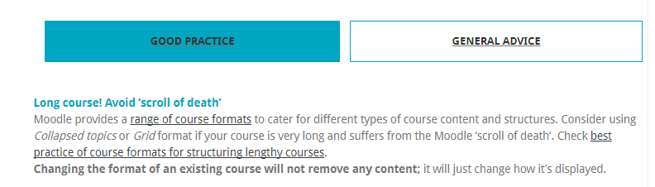
Figure 1: taken from: http://lti.lse.ac.uk/moodleportal/structuring-your-moodle-course/

4.2a: Collapsible format
The Collapsed topic format aids in cutting down the vertical scrolling by allowing you to organise course materials into collapsible sections.
Please refer to the document titled: How to in Moodle within the Moodle Best Practices course to find out how to create and apply a collapsed topic format to a Moodle course.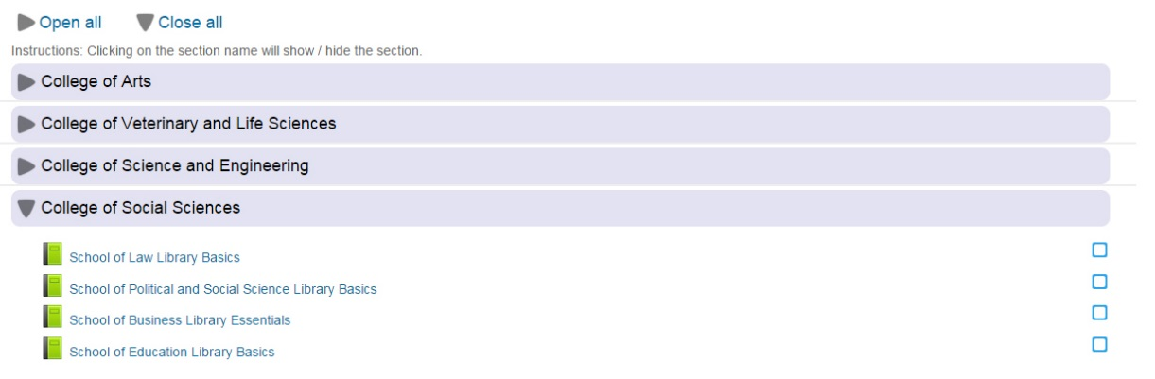
Figure 2: showing a Moodle course using the collapsible topic format
The Collapsed topic format has an additional feature which enables you to highlight a particular section, which is particularly useful if your course is designed in a weekly format. This enables you to highlight the current section and resources to the students, which aids in focussing their learning.
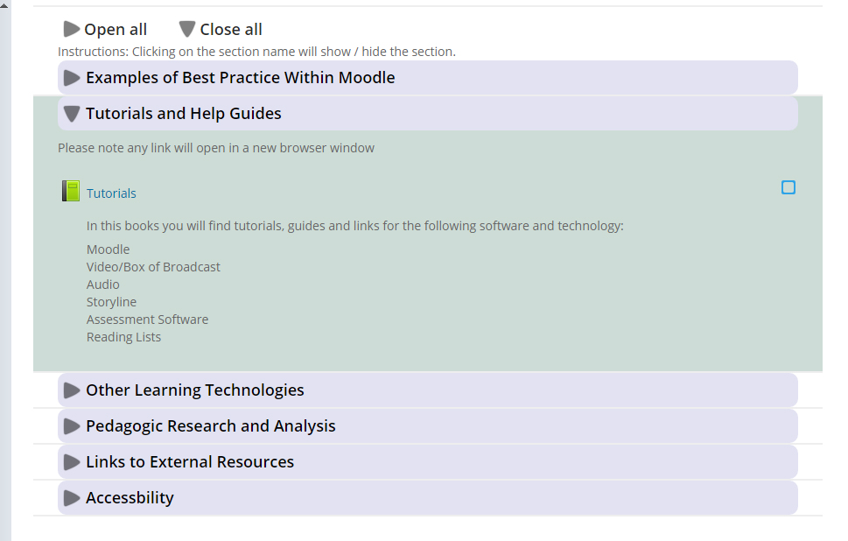
Figure 3: showing a Moodle course with a particular topic highlighted
To find out how to highlight a section within a collapsed topic Moodle course, please refer to the tutorial found in appendix 2.

4.2b: Grid format
The grid format (shown in figure 3) reduces the vertical scrolling within Moodle courses by allowing materials to be organised into sections which are accessed by clicking on the buttons (large images).
Using the grid format presents you with the optional step of designing you own buttons which can be done in PowerPoint or even free image editing software like GIMP.
To find out how to create a grid format within Moodle, please refer to the tutorial found in appendix 2.
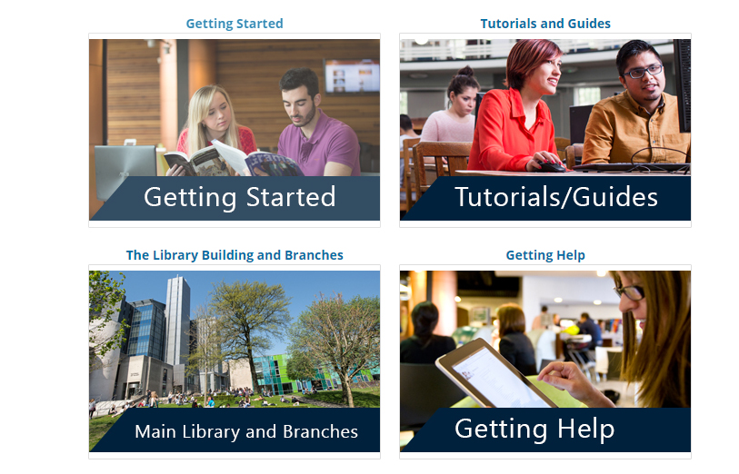
Figure 4: illustrating the use of ‘grid’ Moodle course format
N.B. The grid format does reduce vertical scrolling, however as noted by Warwick University and London School Economics (LSE), there are steps that need to be address in order for this format to be as accessible as possible. Please refer to checklist (Page 21) to see what additional steps need to be taken.

4.3: Consistent Layout
E-learning consultant Michelle Moore recommends the instructional design practice of ensuring your Moodle course has a consistent layout of text and non-text elements (Moodle Moot. 2011. 4:43 – 4:56). This is echoed in the Universal Instructional Design (UID) principals for Distance Education. Where the design principals’ states course design should be simple and intuitive and eliminate any unnecessary complexity (Tanya, E. 2010. pp.5).
The reason for applying the above design principals is they enable students to navigate through a Moodle course more effectively due to the consistent layout of materials. This aids in making your Moodle course more accessible to students.
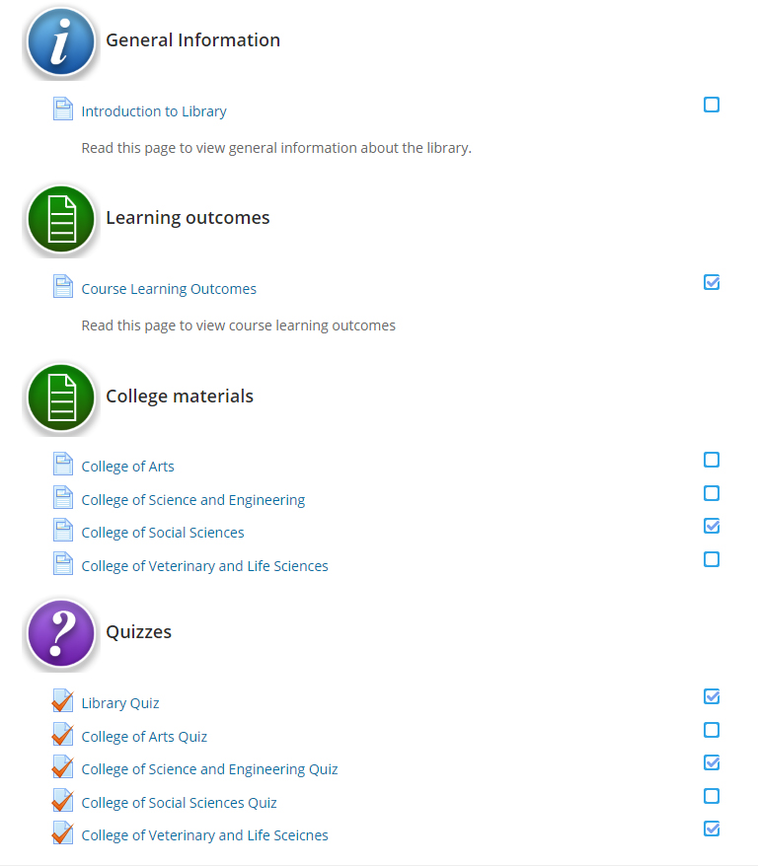
Figure 5: illustrates a consistent layout within Moodle. You could apply the same format to all of your activities and resources across all topics, to ensure a consistent and easy navigate course for your learners.

Please note, the Moodle Moot citation contains a link to a video which can be viewed to provide further context for content. Click on the blue coloured numbers to view the video

4.4: Use informative headings and sub-headings within Moodle
It is important to write informative topic headings within a Moodle course as these will inform students what they are going to learn in a particular section.
According to Ian Wild, labels should be used as sub-headings to guide students to a particular resource within a Moodle course topic (Wild. 2011, pp.155). However, Wild failed to take into account a labels lack of accessibility as they cannot be interpreted by screen readers unless a Moodle heading is used as the text (Open University, 2011). Based on this critique and information, the best practice is to use labels that contain Moodle headings as the text as this enables visually impaired students to navigate through your course using screen reading software. This is a useful practice as its helps focus the students learning experience and makes your course more accessible to a visually impaired audience.
Please refer to Figure 6 below, to see a Moodle course that has applied the above practices.
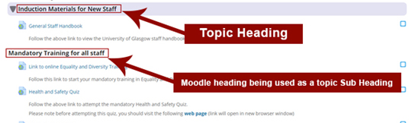
Figure 6
When using headings within Moodle is advisable to understand the hierarchy that can be applied. As Calvo’s study revealed two disabled participants could not complete twenty tasks in Moodle due to the inappropriate use of headings in Moodle (Calvo, R., Iglesias, A. & Moreno, L. 2014. pp. 323). To address this issue, please refer to the link below which illustrate the hierarchy structure and how to appropriately use headings within a Moodle course.
Click here to view a video about: Accessibility and Moodle – Headings and structure
Click here to view Jisc accessibility slide show, view slides 49 - 50

4.5: Resource / Activity names
To save students reading unnecessary text within your Moodle course, it is advisable to use short concise descriptions for activities and resources. If every resource and activity have a lengthy description (i.e. a small paragraph), you risk excluding dyslexic students and increase the vertical scrolling within your Moodle course. Feedback from dyslexic students at a FE college reflected this, where they said having to scroll though text made it harder for them to read (Parsons, A. 2017. pp. 279).

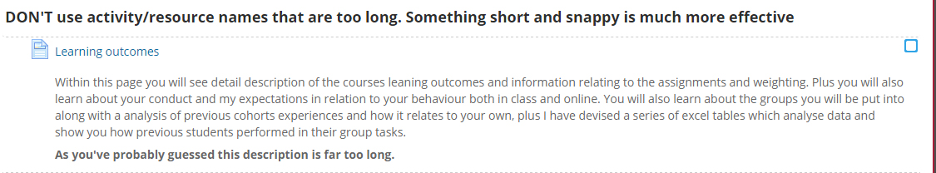
Figure 7: demonstrating an example of a Moodle activity that has a description that is too long – a short sentence giving a summary of the activity or resource would be more effective.

Figure 8: illustrating an activity with a title that is a suitable length. It describes the purpose of the activity and doesn’t overwhelm the learner with too much text and information.

4.6: Don’t display content in your Moodle course page
Displaying lengthy paragraphs of text and images on your Moodle course page leads to an increase in vertical scrolling and lack of accessibility for dyslexic students due to the large volumes of text on screen. This can also lead to specific resources getting ‘lost’ or not being easy to find, due to the text and images on screen.
A solution to the above, is to use your Moodle course page as a ‘launch pad’ to internal and external resources. Michelle Moore asserts a student should be able to see a week’s worth of content on screen as an easy to understand chunk of learning (Moodle Moot. 2011. 4:58 – 6:03).
An example of unnecessary text that doesn’t have to be displayed on a Moodle course page is the programme or module description and learning outcomes. The description(s) and learning outcome text could be inserted into either a PDF or Moodle Book within your course. Both of these are screen reader accessible formats and would allow students to download them.
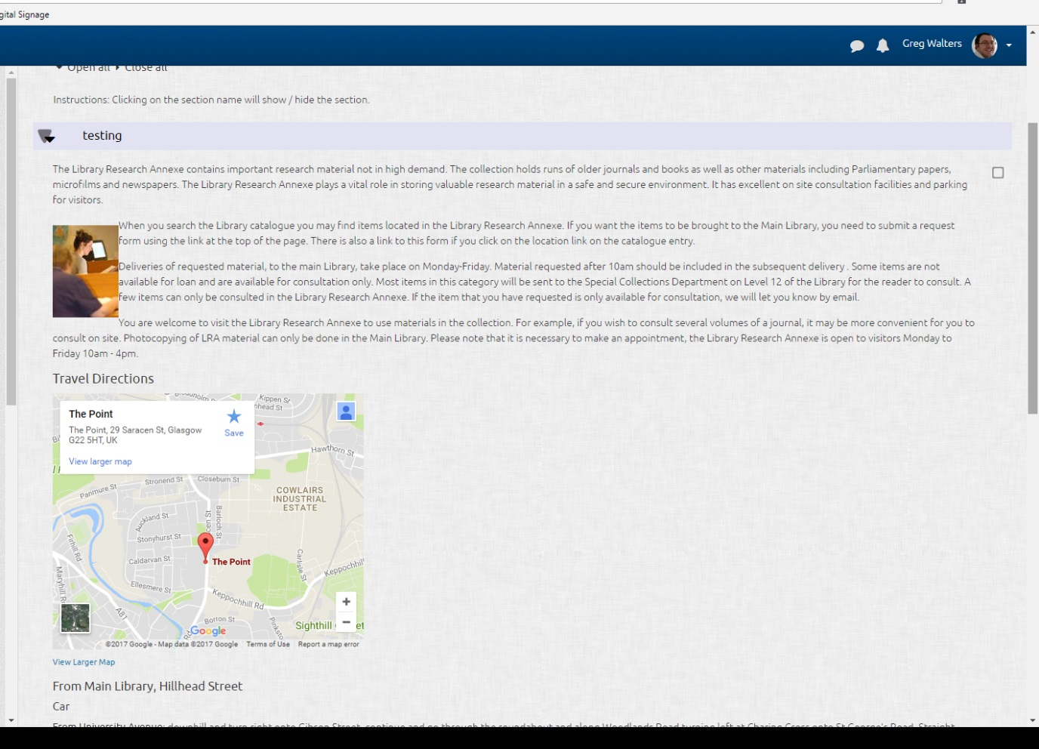
Figure 9: illustrates a Moodle course with too much text and images on the front page. Note both the text and images increases the vertical required within a Moodle course.
Please note, the Moodle Moot citation contains a link to a video which can be viewed to provide further context for content. Click on the blue coloured numbers to view the video
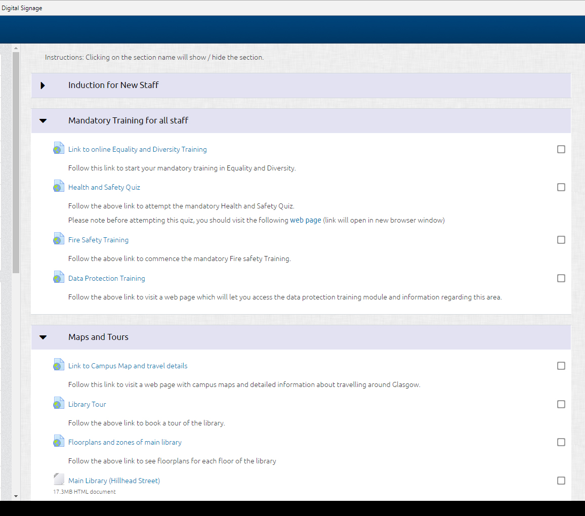
Figure 10:
Figure 10 shows an example of a Moodle course front page being used as a ‘launch pad’ to internal and external resources. Note the use of short, concise descriptions for the resources within the Moodle course.

4.7: Use of images within a Moodle Course front page
As the Grid Moodle course format has already demonstrated, images in a front page can be used as navigation to other sections. This is an effective use of images as they are being used to aid students navigating through your course and can provide further visual context of what is being taught in a particular section. Images can be used to enhance content within a Moodle course front page by offering additional context (Moodle Moot. 2011. 11:58 – 12:38).
Images should not be used in a decorative fashion on a Moodle course front page as this increases the vertical scrolling and does not add any educational value to the resources. An example of this can be seen in Figure 11 below, where a banner image has been used along with graphics down either side of the image. The banner image and graphics do benefit the student’s educational experience.

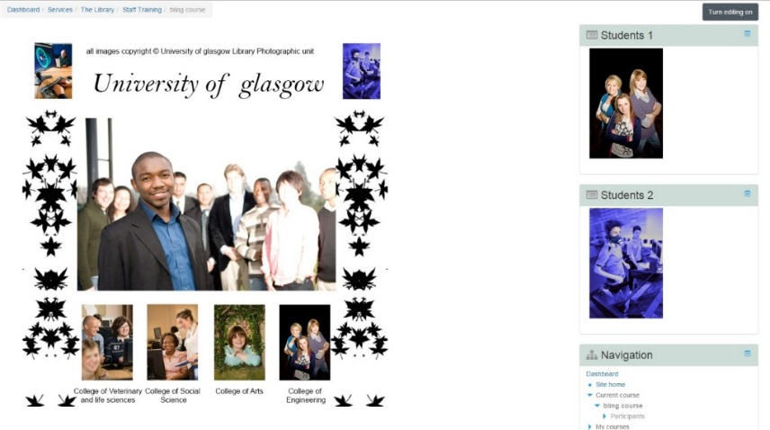
Figure 11: Illustrating a Moodle course which has too many unnecessary images and graphics
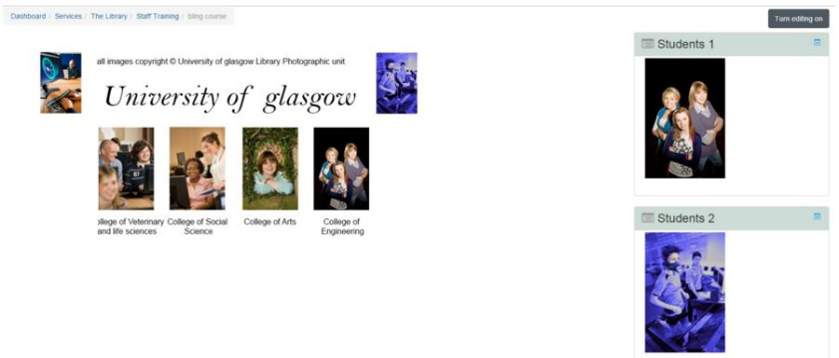
Figure 12: Illustrating a Moodle course which has removed the unnecessary images and graphics

Please note, the Moodle Moot citation contains a link to a video which can be viewed to provide further context for content. Click on the blue coloured numbers to view the video

4.8: Completion Tracking
From a design perspective, it is advised to enable completion tracking as this allows students to see what Moodle courses resources they have previously viewed and what they still have to. Based on Michelle Moore’s recommendations, it is advised to allow students to manually check (tick) what resources they have looked at as this will enable them to develop their own learning plan and define their own pace of learning (Moodle Moot. 2011. 15:19 – 17:22). From a student perspective the completion tracking appears as a series of tick boxes next to individual Moodle course resources (as can be seen in figure 17 below)
Figure 13: showing a Moodle course (from a student perspective) which has completion tracking enabled

Please note, the Moodle Moot citation contains a link to a video which can be viewed to provide further context for content. Click on the blue coloured numbers to view the video

Checklists for Layout and course structure
Below are two checklists to assist you in meeting the required adjustments that should be implemented within the Moodle courses you develop. The answer to each question asked in the checklists should be ‘Yes’ or ‘No’. If the answer is ‘No’ then it suggested, that this area(s) are addressed and corrected or a reasonable justification given.
Checklist for Format, Layout and navigation
The purpose of this checklist is to enable you to check that the layout, structure and communication methods you have employed will benefit the learners’ experience. You will also be able to gauge if your course is accessible to the learners in the context of navigation, can they navigate throughout your course and find content easily?
1. Format, layout and Navigation Checklist | Yes | No
- Has either the Collapsed Topic or Grid Format been applied to the course in order to make navigation and content easy to access for learners

- Does each section have short concise, descriptive names? Have headings and sub-headings been utilised to breaks up content and guide students to resources/activities and content?

- Has a consistent layout been applied throughout the course, resources and activities – to enable ease of access and finding content?

- Is there familiar/predictable navigation throughout the course?

- *Grid format, under the ‘course layout’ section, have you selected ‘Show one section per page’, so this format can be accessible for keyboards and screen readers

- *Grid format, have you made sure the topic/section are visible and not within the image (a screen reader can’t read text within an image)

Checklist for Displaying content and instructions within a Moodle Course
The purpose of this checklist is to assist in checking if measures have been taken to ensure both media and text based content is displayed in a manner that benefits the learners learning experience and is not merely for decorative purposes.
2. Checklist for displaying content and instructions along with communication within a course | Yes | No
- Is content displayed in the appropriate format, e.g. putting large images and amounts of text in a Moodle Book or document?

- Do the images within the Moodle front page compliment the course content? Are the images being used for non-decorative reasons?

- Do resources and activities have short concise explanations to inform students what the purpose of them is?

- Are there instructions and learning outcomes present to guide and inform the learners about the purpose of the course and what is expected of them?

Please note, this relates specifically to courses that are being taught to active learners.

- Is there clear guidance for students on what the purpose of the course is and topics within it?
- If required are additional programme/course documents provided to give information, i.e. course handbook

Please note, this relates specifically to courses that are being taught to active learners.

- Has text and content been chunked/broken into manageable short easy to understand sections?

Checklist for accessible files and topics within a Moodle course
The purpose of the following checklist is to ensure text; in terms of colour contrast and layout are accessible for all types of learners, particularly for anyone with Dyslexia or other impairment.
3. Checklist for accessible files and topics within a Moodle course | Yes | No
- Has ‘completion tracking’ been enabled within the Moodle course – enabling leaners to see what resources they have previously accessed?

- Are the file type (i.e., PowerPoint, Word, Excel, PDF files) and size displayed next to all uploaded resources within the Moodle Course?

- Has completion tracking been enabled, which allows learners to track the resources they’ve viewed within a Moodle course?

- If you are teaching or facilitating a course that has a weekly format or sequential format, you have the option of using the ‘Highlight section/topic, which will highlight the current topic/section to learners.
This is an optional step and is more specific to people running or teaching a Moodle course with active learners.

- Ensure ‘Automatic’ has been enabled, which opens the file automatically for learners and give them the option to download it as well.

5.1: Designing an Accessible a Moodle course and resources
The following sections will provide information on how to develop a Moodle course that is accessible to disabled students. This will provide an equity of experience for the 1603 University of Glasgow students who identified themselves as disabled during 2015/16.
The guidance within the Accessibility section will be student centred, and go beyond the scope of being only compliant with the Web Content Accessibility Guidelines (WCAG) 2.1 guidelines. As highlighted in Kumar’s study of evaluating e-learning by student focused methods, using WCAG as the sole method of assessing accessibility needs can lead to barriers being missed (Kumar, K. Owston, R. 2016. pp.278 – pp.280).
All of the adjustments suggested can be implemented within Moodle or Microsoft Office software.

5.2: Developing accessible text
When developing text for both your Moodle course and resources that will populate it, i.e. PDF’s, PowerPoints etc., you should consider both disabled and non-impaired students. If you don’t ensure your text is accessibility friendly otherwise, you will exclude disabled students from learning your content. Given the scope of this area, the following sub-sections will go over specific areas of good practice and adjustments that can be applied within Moodle and resources to ensure the text you develop is accessible.
5.2a: Writing Style for accessible text
The sentences you write should be short, concise and provide any necessary instruction, ideally between 10 – 20 words (van der Waarde, K. (1999) as cited in Maceri, K. (2003). Avoid double negatives within your sentences and use an active voice instead of a passive voice. By applying these practices to your text both deaf and dyslexic students will be able to understand and interpret what is written more easily (British Dyslexia Association. 2017).
Like sentences, paragraphs should not be too lengthy otherwise dyslexic, autistic and deaf students will have problems absorbing information due to the large volume of text (Flor, C, S. et al 2015.; Parsons, A. 2017. pp. 279). To address this issue, it is advisable to chunk up a lengthy paragraph into shorter paragraphs which consider the audiences reading ability and expectations (Maceri, K. 2003. pp. 2).
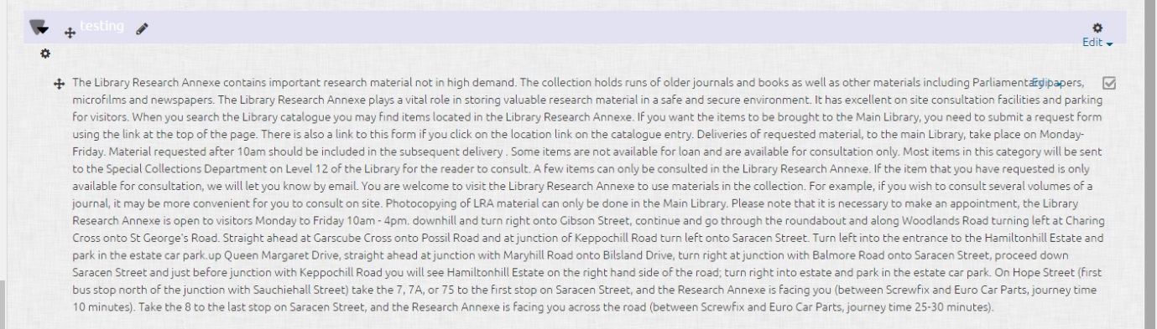
Figure 14: The above image is showing an example of a long, unbroken paragraph that should not be used in your Moodle course or materials, due to being inaccessible to dyslexic and visually impaired students.
5.2b: Accessible font style, size and background contrast in a Moodle front page
It is Important to recognise the accessibility issues of font size, style, colour and background contrast affect both dyslexic and visually impaired students. If a font size within text is too small, it is difficult for not just disabled but non-impaired students to read as well. The style of the font is an accessibility issue as well for dyslexic and visually impaired students, due to serif based fonts i.e. Times New Roman, being harder for them to interpret and read. When reading text dyslexic students experience an associated difficultly called Scotopic Sensitivity can occur. This perceptual condition can make text appear to dither (McKay, M. Maguire, J. 2012). All of these accessibility issues can make reading text inaccessible to dyslexic or visually impaired students.
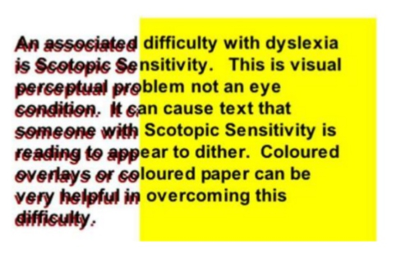
Figure 15: The left had side of the above image is illustrating the dyslexic perceptual problem of ‘dithering’.
Image taken from: https://www.slideshare.net/rscscotland/creating-inclusive-information (slide 9 of 61)

To address all of the above accessibility issues a single tool can be used within the current version of Moodle (3.2) being used at the University of Glasgow. The ‘Accessibility Tools’ allows students to change the font style and size along with adjusting the background colour within a Moodle course.

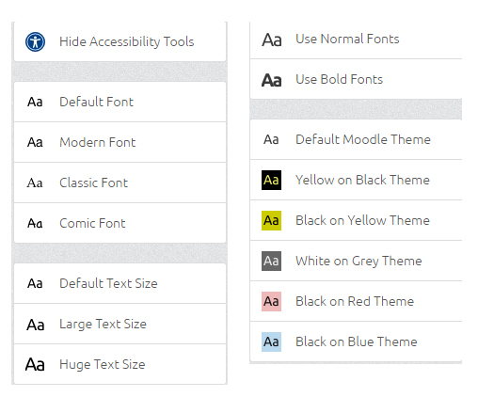
Figure 16: The above image shows the wide range of settings that disabled students can adjust within a Moodle course to ensure they receive the most accessible experience possible.
Please refer to the guide within Appendix 2 to find out how to show the Accessibility Tools within Moodle.
5.2c: Colour of text
Text that incorporates multiple colours will be inaccessible to dyslexic and visually impaired students due to poor contrast and Scotopic Sensitivity. Text that includes multiple colours affects non-impaired students by increasing their cognitive load, which requires them to spend more time trying to process the text as opposed to absorbing the information (Moodle Moot. 2011. 3:19 – 4:44).
To address the accessibility issues relating to colour when applied to text, the following recommendation should be followed:
- Keep your delivery of text simple do not use more than three types of Serif fonts and colours
- Do not use colour to provide explanation or context, i.e. ‘red for ‘danger’ or ‘warning’
- Do not use more than three colours within your text
- If you do use colours within your text, use an accessibility contrast checker like WCAG Contrast Checker
Both (Moodle Moot. 2011) & (McKay, M. Maguire, J. 2012) were used to inform the above best practices.
Below is example of text that is not suitable for both disabled and non-impaired students
This will not enhance your content or learning, by having text in bright colours and lots of them.
Using different fonts and styles just makes it harder to read your content, avoid this practice, by having a maximum of 3 font types
Remember and check the contrast of your font colour against the background colour. To make sure it is accessible and legible.
Do not use text to add meaning or context.

5.3: Creating accessible documents
This section (5.3), has been updated to reflect the recent regulations (24th September update) produced by the UK government for making your public sector website inclusive and accessible. It is now a legal requirement from 23rd September 2018 onwards for any Word documents and PDFs uploaded to a public sector website (this includes Moodle), to be as accessible as possible. A minimum standard being the Level AA of the Web Content Accessibility Guidelines (WCAG 2.1).
Please note any documents that were uploaded to Moodle prior to the 23rd of September 2018, do not have to adhere to the new Government Legislation unless they are modified and then re-uploaded.
In relation to the new guidelines, if someone requests it, an accessible alternative format must be provided within a reasonable amount if the original content does not meet accessibility standards.
The sections below, provide information, checklists and links on how to make your documents within Moodle as accessible as possible.

5.3a: Accessible documents (Moodle Book)
Moodle books are a native format, which allow you to type your text directly into Moodle and provide your students with a format that they do not have to download or have a plug in for. Moodle Books can include images, videos and links to provide a media rich experience for your students. Another benefit of using Moodle Books, is the accessibility features as it provides a table of contents, allowing learners to navigate through your document and due to being an HTML format adheres to the UK Governments (24th September 2018) recent guidelines on making your public sector website accessible and inclusive. Moodle Books allow you to edit your text etc... within Moodle instead of having to edit your source document, save the changes and then re- upload your document to Moodle.
Moodle books can be found under the ‘Resources’
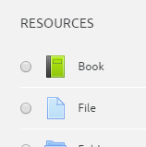
Figure 17: The above image shows where Moodle Books are located and can be added to a course

5.3b: Accessible PowerPoint presentations
Before continuing, it is important to note that in the context of the University of Glasgow, if you have lecture slides that you intend to upload to Moodle, please retain this native PowerPoint format (.ppt & .pptx) as the conversion process to PDF has been shown to strip away accessibility features and make it harder for screen readers to interpret them.
The literature around accessibility has demonstrated you cannot base guidelines solely on the WCAG checklist(s) as unpredictable barriers will occur. This was demonstrated when
disabled students who were participating in Kumar’s research into assessing accessibility, highlighted unpredicted barriers when using PowerPoint. The students reported “navigation buttons not being recognised by assistive technology” and “too much information presented” (Kumar, K. Owston, R. 2016. pp.275). To address the unforeseen accessibility barriers, refer to the suggested best practices below as a starting point.
When developing an accessible PowerPoint presentation, the following points should be implemented:
- Use a large san serif text like Arial 24pt to make your text readable to visually impaired students
- Make sure there is a good contrast between the text and background colours, use WCAG Contrast Checker to check the contrast
- Keep the text within slides, short concise and to the point. You can expand on points within slide notes
- Ensure each slide has a unique title to aid students find the information they require
- Make use of the PowerPoint layouts for slides as this provides an automatic reading order for items within the slide
- Avoid using PowerPoint’s inbuilt action buttons and other shapes as navigation to other slides or to perform actions, as these are not recognised by assistive technology
- All Images, tables and graphs should have alt text to provide a text based description for visually impaired students
- Closed Captions or a downloadable transcript should accompany any embedded or linked to video or audio file
- Make use of the accessibility checker within PowerPoint to check for any potential accessibility barriers
- Avoid using animations in your slides, as they can cause screen readers to read the slide containing the animation twice
The above best practices were informed by the links below, as these addressed the specific barriers identified by the student participants of Kumar’s research.

Microsoft PowerPoint Links:
Click here to view information about creating accessible PowerPoint (versions 2013, 2016) presentations
Click here to view information about creating Accessible documents with Microsoft PowerPoint
Click here to view an additional list of adjustments that can be applied to create accessible PowerPoint documents

5.3c: Workflow for creating accessible optional Word/PDF documents
The UK Government accessibility regulations, state by UK law you must create an accessible PDF document if you decide to include one within your course.
Please refer to the links on the following page which will provide you both with the UK Government and Microsoft guidance on how to produce an accessible PDF document. Based on the Jisc presentation, the suggested workflow for developing accessible documents is to create them in Microsoft Word and save them as PDFs (McKay, M. Maguire, J. 2012). Below are steps involved in creating an accessible document that can be uploaded to a Moodle course.
- Use Microsoft Word to create your document as it has a host of accessibility features, i.e. both headings & table of contents that can be used for navigation by screen readers. Refer to the links at the end of this section for a full list of what accessibility features can be implemented in Word.
- Before preparing to save your document in Word, use the accessibility checker to check for any potential accessibility issues. The accessibility checker is available in Word 2007 – 2016 and can be found in the File> Info panel
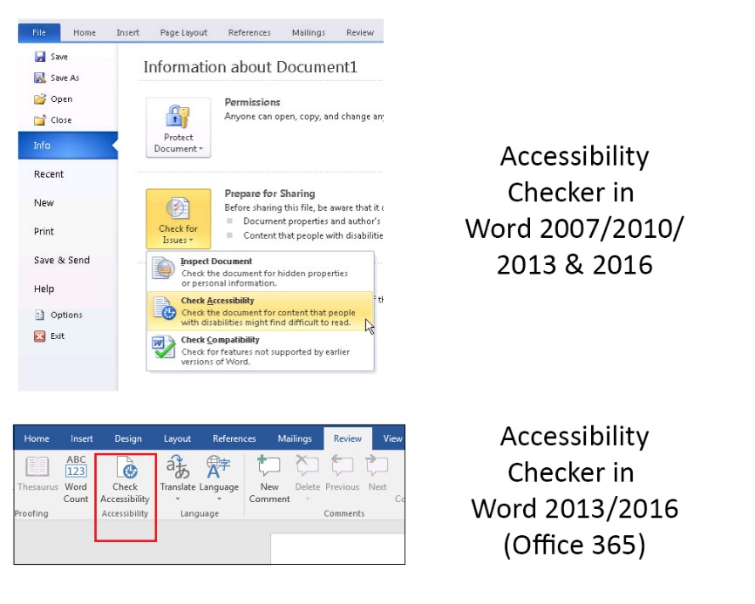
Figure 18: The above image shows where the accessibility checker can be found in different versions of Microsoft Word
- Save your document as PDF

Microsoft Word and Adobe PDF Links:
Click here to view how to create accessible Word (versions 2013, 2016) documents
Click here to view how to create Word documents which are accessible for Screen Readers (Word 2007, 2010)
Click here to view how to set up Adobe PDF Accessibility Features
UK Government guidelines on producing accessible PDF documents
Further guidelines on creating an accessible PDF

5.4: Accessible Images
Both the W3C guidelines and literature relating to these guidelines highlight the importance of ensuring all images should use alt text. If images do not have alt text or descriptions, then screen readers have no means of providing visually impaired students with descriptive information. This is illustrated by a screen reader user (Jennifer a second-year university student), who said the following: “It’s important to have the description of images to help a visually impaired person imagine what that image could be” (McKay, M. Maguire, J. 2012). Jennifer’s statement highlights the importance of providing descriptive alt text for visually impaired students as it enables them to interpret what the image may look like and makes your Moodle course and teaching materials more inclusive.
Alt text can be added to images used within your Moodle course and resources that are uploaded, i.e. PDFs.
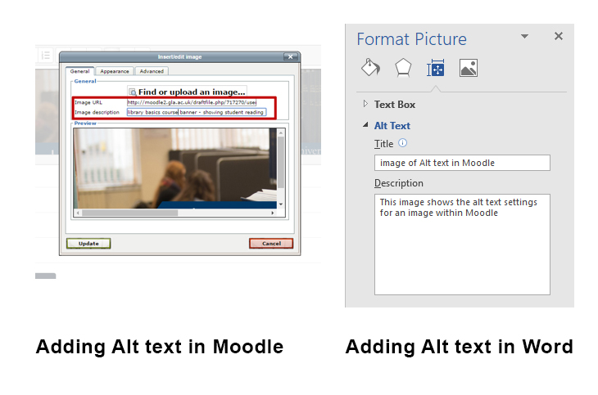
Figure 19: Illustrating Alt can be added in both Moodle and Microsoft Word

Refer to the links below to see instructions on adding alt text to images in Word and PowerPoint.
Adding alt text to an image within a Word document 2013, 2016
Adding alt text to an image within a PowerPoint presentation 2013, 2016
Please refer to the guide within Appendix 2 to find out how to add alt text to images within a Moodle course.

5.5: Accessible Video
Videos are a visual and audio based medium, however this does not automatically make them accessible to every type of student. Both the WC3 guidelines and Flor’s research agree videos at the very least should have closed caption text and or be accompanied by a transcription to make videos accessible to disabled students. The WC3 guidelines do not require sign language to be included for videos, however in contrast to both Flor’s and Skourlas research suggest further discussion should be given to have sign language included for both deaf and dyslexic students ((Flor, C. 2015. pp. 160 – 162; Skourlas, C. et al. 2016. pp. 152) . I would agree with Flor and Skourlas’s assertions as Flor’s paper highlighted the text within closed captions can be too fast for deaf people to interpret (Flor, C. 2015. pp. 160). This is an area that requires further investigation as there is no clear guidance on how to produce videos with sign language and what exactly is involved. Therefore, the current guidance for accessible videos within a Moodle course is to include the following.
- Ensure a transcript is provided (please refer to this WC3 example)
- Provide closed captions in your videos (please refer to this example)
Creating accessible Video Links:
How to add Closed Captions to YouTube videos
Guidance for creating a transcript file

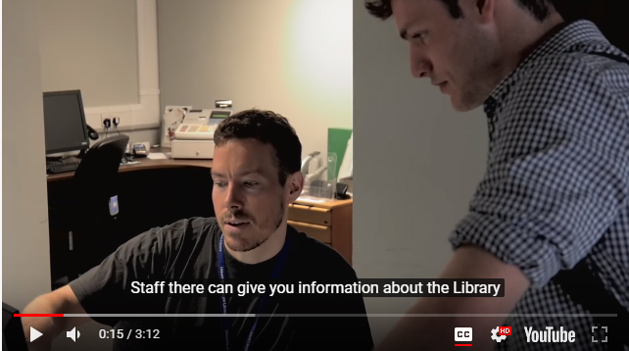
Figure 20: showing a video that has Closed Captions, which benefit deaf and dyslexic students in terms of accessibility

5.6: Creating accessible Hyperlinks (URLs)
Hyperlinks are subject to the same accessibility guidelines and best practice as illustrated in the WC3 guidelines. It is important links can be interpreted effectively by students using screen reading software as poorly written or constructed links can be of no benefit. This can be illustrated in the following example:
If a link is worded in the following manor, ‘Click here to find out about Jupiter’. The only part of the link that will be interpreted by screen reading software is ‘click here’, this offers no description of the links purpose or destination. A hyperlink must make sense out of context (McKay, M. Maguire, J. 2012).
Below is a list of best practices that can be applied to text based hyperlinks, based on the WC3 guidelines. It is suggested you consult the link below which is the WC3 guidelines lines full list of link accessibility best practices.
Click here to view the WC3 web link accessibility guidelines
- Include a short and concise description of where the link goes and its purpose
- External links should open in a new window, internal course links should open in the same window
- Indicate when a link opens in a new window (i.e. this link opens in a new browser window)
- Make sure your links are up to date and link to live websites and resources
- Avoid using URL’s as links i.e. ‘https://www.gla.ac.uk/myglasgow/library/’., these can be long and unintelligible after four or five letters
- If you are linking directly to a download, remember and inform disabled students of this in the link description
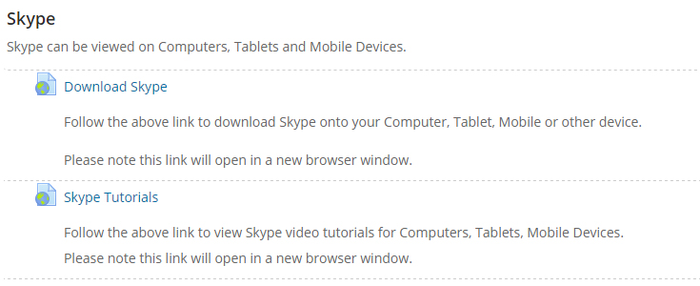
Figure 21: the above image illustrates URL’s within a Moodle course which use descriptive text that will be understood by screen reading software. Note the use of ‘follow’ at the start of the description and informing the student the link will open in a new browser window.

5.7: Accessible Activities and Resources within a Moodle Course
Moodle has a wide range of activities and resources that can be added to a Moodle course to provide students with additional learning and engagement opportunities. These can be, quizzes, glossaries, Wikis, Moodle Book, Chat rooms and potentially many more. The one aspect that can often get overlooked is Moodle resources and activities, these are still subject to accessibility guidelines and best practices. The above Moodle resources and activities that are listed, all have elements of text, images and even video, these should all have the same accessibility best practices that have been covered in this guide applied to them.
Another approach you may wish to adopt is considering alternative platforms to Moodle’s internal resources and activities. As already discussed in the literature review of this document, Calvo’s research revealed Moodle’s chat facility lacked functionality in terms of students and lecturers not being able to highlight important messages in a chat thread (Calvo, R. & et al. 2017. pp. 604). To address this issue, I would have suggested the lecturers try using Microsoft Yammer, which is free chat software with functionality that allows messages to be liked, shared and bookmarked. This alternative path may require more research in terms of analysing software in terms of accessibility and functionality, but it does result in a solution that suits both your requirements and is accessible to students. You could also consult with your College’s or departments Learning Technologist to get advice from them in relation to what software equivalents are available.
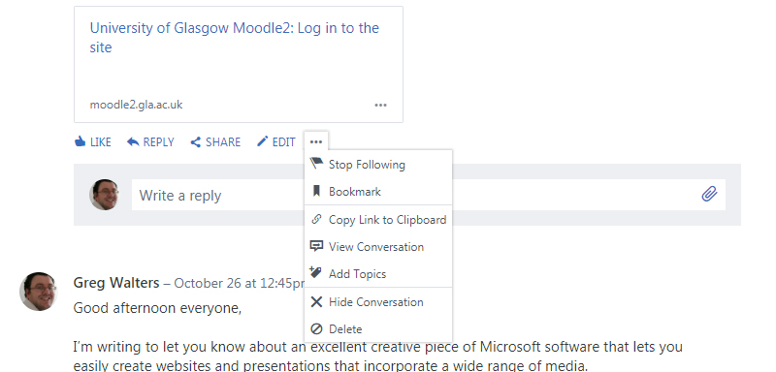
Figure 22: The above image is illustrating the functionality within yammer that enables users to highlight messages.

5.8: Accessibility for University of Glasgow staff
University of Glasgow (UoG) staff who may have some form of disability are a very important audience as well and should have an accessible experience when using Moodle.
This section will differ from the other sections found within this document as it is a series of steps that can be implemented to give you the most accessible experience possible in Moodle.
- You may have already made provision for this or visited this department already, but it is advised that you contact the disability service as they can ensure the appropriate support is arranged for you. This department will be able to recommend and provide assistive technology.
Click here to visit the University of Glasgow disability service webpage
- When you login into the institutions Moodle, the landing page you will always be taken to is your ‘dashboard’. This page display all of the courses you have created and /or enrolled in. As with any page in Moodle it is advisable to make sure you have the accessibility features enabled. These let you change the background colour and adjust the font type and size within Moodle. You can access these features in the ‘dashboard’ panel located down the left-hand side of your screen.
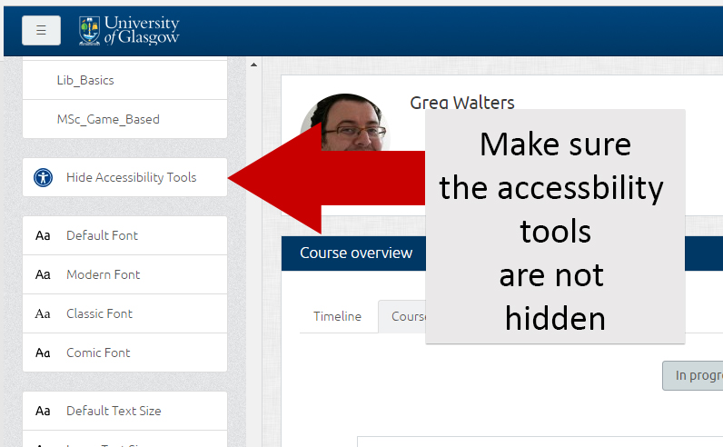

If you find the panel down the left-hand side of your screen is missing. Click on the grey square, located in the top left-hand corner of your screen to reveal the dashboard panel.
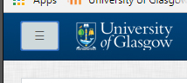

- If you are visually impaired it is worthwhile changing your Moodle HTML (text) editor to TinyMCE as this can be interpreted by screen readers and is compliant with keyboard shortcuts. The other benefits of using the TinyMCE editor are highlighted in Vania’s research, which mentions the editors’ functionality of enabling accessible images and video to be added to labels (Ulbricht, V, R. 2012. pp.141). The TinyMCE editor is both accessible and provides additional functionality in terms of adding media to your Moodle label content.
To view a tutorial on how to choose the TinyMCE editor, please view the tutorial in Appendix 2.
The three steps detailed in this section will aid you in experiencing an accessible online experience within Moodle. However, if you encounter any accessibility barriers or other functionality issues, please initially contact your College or departments Learning Technologist and if required the IT helpdesk.

Checklists for Accessibility

Below are several checklists to assist you in meeting the required adjustments that should be implemented within the Moodle courses you develop. The answer to each question asked in the checklists should be ‘Yes’ or ‘No’. If the answer is ‘No’ then it suggested, that this area(s) are addressed and corrected or a reasonable justification given.
The purpose of the following checklist is to ensure text; in terms of colour contrast and layout are accessible for all types of learners, particularly for anyone with Dyslexia or other impairment.
1. Checklist for Readability and accessibility of text | Yes | No
- Has a consistency been applied to text within the course and uploaded resources, in terms of sizes, fonts and headings?

- Has there been an appropriate usage of white space, indents, paragraph breaks within the main text of the course to aid in the readability of the text?

- Has a clean simple layout been applied to the text within the Moodle course and uploaded resources?

- Have you avoided the use of justified text and double spacing after periods – as both make text less accessible for learners with Dyslexia?

- Have either or a combination of serif fonts or italicise text been used? If so change these, as both of these practices make text more difficult to read for learners with Dyslexia

- Have you used WCAG Contrast Checker to ensure there is a contrast between text and background?

- Have you written short sentences (10 – 20 words) that are descriptive and use an active voice?

- Have you written paragraphs that are short and consider your audience?

Checklist for creating additional Word/PDF documents
Moodle Book(s), are the suggested format for use within a Moodle when presenting students with documents. Remember PDF’s should only be included in addition to an HTML version (Moodle Book).
The checklist below will ensure the additional PDF documents you upload to your Moodle course are as accessible as possible to all types of learners.
- Checklist for creating accessible documents using Microsoft Word | Yes | No
- Have you used headings within your document? Headings allow a table of contents to be created which is allows for navigation throughout your document.

- Have got a table of contents within your document? A table of content can be interpreted by screen readers and allows disabled students to navigate through your document.

- Have you used a san-serif style (i.e. Arial) font for ease of reading and accessibility purposes?

- Have you refrained from using colour to emphasise meaning within your document? Remember, text that uses multiple colours is both inaccessible for impaired and non-impaired students

- Have all images within your document got an alt text description?

- Have all of your table rows and columns used headings to make them accessible to screen readers?

- Within: Microsoft Word, PowerPoint make sure you use the accessibility checker. It is advisable to do this as this will enable you to double check your document is accessible to disabled students before saving

- If you have PowerPoint lecture slides, save them as the native format, it is ill advised to save them as PDF as this will strip away the accessibility features and make it more difficult for screen readers to interpret them

- Refer to the UK Government and Microsoft links to ensure the additional PDF you’re including is as accessible as possible

Checklist for creating accessible PowerPoint
The checklist below has been created to ensure the PowerPoints you upload to your Moodle course are accessible to all types of learners.
- Checklist for creating accessible PowerPoint | Yes | No
- Have you used large san-serif fonts, i.e. Arial 24 pt in your presentation? Do not go below the font size of 24 pt as it will be more difficult for students to read

- Have you kept the amount of text within your slides to either short sentences or bullet points? It is advisable to avoid a lot of text within PowerPoint slides as this is inaccessible to both disabled and non-impaired students.

- Have you given every slide a unique title? By giving each slide a different title you are making it easier for impaired students to find the information they require

- Have you refrained from using colour to emphasise meaning within your document? Remember, text that uses multiple colours is both inaccessible for impaired and non-impaired students

- Have all images within your PowerPoint got an alt text description?

- Have all of your table rows and columns used headings to make them accessible to screen readers?

- Have you provided Closed Captions or a downloadable transcript when accompanying any embedded or linked to video or audio file?

- Have you made use of the PowerPoint layouts for slides? This provides an automatic reading order for items within the slide

- Have you used PowerPoints inbuilt buttons or shapes as navigation within your presentation? If so, please refrain from using these as they cannot be interpreted by assistive technology

- Have you used PowerPoint’s accessibility checker? It is advisable to do this as this will enable you to double check your document is accessible to disabled students before saving

Checklist for accessible videos and images
The purpose of the following checklist is to ensure video and images within your model course are accessible for all types of learners.
4. Checklist for accessible videos and images | Yes | No
- Is video within the Moodle course accompanied by a text based transcript or Closed caption?

- Is the video an appropriate size, so it can be displayed on not only desktop computer, but tablets and mobile devices as well?

- Has the video been linked to or embedded, in order to save the learners downloading or viewing a large video file?

- Do images have additional alt text, providing a description of the image and its purpose?

Please note in addition to the above checklist, you should consider the copyright implications of the videos and images you use within your Moodle courses or resources (i.e., PowerPoint, Word or PDF files) you have uploaded to it.

Checklist for creating accessible Hyperlinks
The purpose of the following checklist is to ensure hyperlinks are accessible by providing explanation of their purpose and can be read by screen reading software.
5. Checklist for creating accessible Hyperlinks | Yes | No
- Does the link contain a short message telling learners the purpose of the link and what online resource or web page they are being directed to?

- Do hyperlinks to resources external to the Moodle Course open up in a new browser window?

- Do internal hyperlinks within the Moodle Course open up in the same source window?

- Have you checked to make sure the hyperlink within the Moodle course is linking to an active webpage or resource?

- Have hyperlinks been carefully worded so they can be interpreted by assistive technologies like Screen Readers?

- Is text included within the hyperlink to inform learners if it opens in a new browser window?

References
British Dyslexia Association. Dyslexia Style Guide [Online] [Retrieved 15 March 2017].
http://www.bdadyslexia.org.uk/common/ckeditor/filemanager/userfiles/About_Us/policies/Dyslexia_Style_Guide.pdf
Calvo, R., Iglesias, A. & Moreno, L. (2014). Accessibility barriers for users of screen readers in the Moodle learning content management system. Universal Access in the Information Society 13, 3, pp 315–327. Retrieved September 23 2017 from: https://link-springer-com.ezproxy.lib.gla.ac.uk/article/10.1007%2Fs10209-013-0314-3#citeas
Calvo, R. Iglesias, A. & Castano, L. (2017). Evaluation of accessibility barriers and learning features in m-learning chat applications for users with disabilities. Universal Access in the Information Society. 16, 3. pp.593 – 607. Retrieved September 28 2017 from: http://apps.webofknowledge.com.ezproxy.lib.gla.ac.uk/full_record.do?product=UA&search_mode=GeneralSearch&qid=6&SID=Q1wHG6jRdIlwn397yEc&page=1&doc=1
Collins. A. & Halverson. R. (2009) Rethinking education in the age of Technology, New York, Teachers College Press. Cited by Selwyn. N. (2011). Education and Technology Key Issues and Debates.
Collins, B. (2014). Universal design for learning: What occupational therapy can contribute? Occupational Therapy Now, 16,6. pp.22-23. Retrieved October 2 2017 from: http://eprints.bournemouth.ac.uk/21426/1/Collins.pdf
Cooper, M. Colwell, C. & Jelfs, A. (2007) Embedding accessibility and usability: considerations for e-learning research and development projects. ALT-J, 15:3, pp 231-245. Retrieved September 23 2017 from: http://dx.doi.org/10.1080/09687760701673659
Crook, A., Mauchline, A., Maw, S., Lawson, C., Drinkwater, R., Lundqvist, K. & Park, J. (2012). The use of video technology for providing feedback to students: Can it enhance the feedback experience for staff and students?. Computers & Education, 58(1), 386-396. Retrieved November 30 2017 from: http://www.sciencedirect.com.ezproxy.napier.ac.uk/science/article/pii/S036013151100203X
Espadinha, C, A . (2016). Network Support for Students with Special Educational Needs in the Universidade de Lisboa: ‘Rede NEE-ULisboa’. Proceedings of the 7th International Conference on Software Development and Technologies for Enhancing Access. Retrieved September 26 2017 from: https://dl-acm-org.ezproxy.lib.gla.ac.uk/citation.cfm?id=3019984
Flor, C, S. Saito D, S. Pivetta, E, M. Ulbricht, V, R. & Vanzin, T. (2015). Moodle accessibility for the deaf: approach to deaf and hearing discourses. Transformation, 27, 2. pp.157-163. Retrieved September 25 2017 from: https://dx.doi.org/10.1590/0103-37862015000200005
Garrison, R.D (2011). E-Learning in the 21st Century A framework for research and practice (2nd edition). Routledge. New York.
Kear, Karen (2010). Social presence in online learning communities. In: Proceedings of the 7th International Conference on Networked Learning 2010, 3-4 May 2010, Aalborg, Denmark. Retrieved from: http://oro.open.ac.uk/21777/
Kumar, K, L. Owston, R. (2016). Evaluating e-learning accessibility by automated and student-centered methods. Educational Technology Research and Development. 64, 2. pp.263 – 283. Retrieved September 26 2017 from: https://link-springer-com.ezproxy.lib.gla.ac.uk/article/10.1007%2Fs11423-015-9413-6
Maceri, K. (2003). Document Design for Users with Reading Disorders. Retrieved October 23 2017 from: http://www.angelfire.com/tn3/writing/DesignUsersReadDis.pdf
McKay, M. Maguire, J. (2012). Creating Inclusive Learning and exploring the Accessibility Features of Moodle, Jisc RSC Scotland [Online] [Retrieved October 24 2017]: https://www.slideshare.net/rscscotland/creating-inclusive-information
Moodle Moot 2011 (producer). (2011). Michelle Moore - Teaching with Moodle: Best Practices in Course Design. Retrieved from: https://www.youtube.com/watch?v=kmZlETMdf5U
Open University. (2011). Moodle Accessibility Specification. [Online] [Retrieved October 22 2017]. https://docs.moodle.org/dev/Moodle_Accessibility_Specification
Parsons, A. (2017) Accessibility and use of VLEs by students in further education. Research in Post-Compulsory Education, 22, 2, pp 271-288. Retrieved September 23 2017 from: http://www-tandfonline-com.ezproxy.lib.gla.ac.uk/doi/full/10.1080/13596748.2017.1314684
Primo, L. Ulbricht, V & Fadel, L, M. (2017). Accessibility in the Virtual Learning Environment Moodle Identification of Problems’ Class. Recent Advances in Information Systems and Technologies. WorldCIST 2017. Advances in Intelligent Systems and Computing, 570. pp.572 – 580. Retrieved September 27 2017 from: https://link.springer.com/chapter/10.1007/978-3-319-56538-5_58#citeas
Selwyn. N. (2011). Education and Technology Key Issues and Debates. Continuum International Publishing Group. New York
Skourlas, C. Tsolakidis, A. Petros Belsis, Vassis, D. Kampouraki, A. Kakoulidis, P. & Georgios G, A. (2016) .Integration of institutional repositories and e-learning platforms for supporting disabled students in the higher education context. Library Review. 3, pp. 136 – 159. Retrieved September 28 2017 from: http://www.emeraldinsight.com.ezproxy.lib.gla.ac.uk/doi/abs/10.1108/LR-08-2015-0088
Tanya, E. (2010). Universal Instructional Design Principles for Moodle. The International Review of Research in Open and Distributed Learning, 11, 2. Retrieved February 25 2017 from http://www.irrodl.org/index.php/irrodl/article/view/869/1575
The Equality Act 2010. [Online] [Retrieved 16 March 2017]. http://www.legislation.gov.uk/ukpga/2010/15/contents
Ulbricht, V, R. Vanzin, T. Amaral, M. Vilarouco, V. P. de Quevedo, S, R. Moretto, L, A, M. & Flores, A, R, B. (2012). A tool to facilitate including accessible content in Moodle to the person with visual impairment. Procedia Computer Science, 14. Pp 138 – 147. Retrieved September 27 2017 from: http://www.sciencedirect.com/science/article/pii/S1877050912007788

University of Glasgow. (2013). E-Learning strategy 2013 – 2020. Retrieved November 30 2017 from: https://www.gla.ac.uk/media/media_297622_en.pdf
Vai, M. Sosilski, K. (2011). Essentials of Online Course Design. Routledge publishing. New York
Van der Waarde, K. (1999). Typographic Dimensions and Conventional Wisdom: A Discrepancy? Cited in Maceri, K. (2003). Document Design for Users with Reading Disorders. Retrieved from: http://www.angelfire.com/tn3/writing/DesignUsersReadDis.pdf
W3C Standards. Accessibility [Online] [Retrieved 20 March 2017] https://www.w3.org/standards/webdesign/accessibility
Wild, I. (2011). Moodle 2.0 Course Conversion, (Second Edition). Packt Publishing. Retrieved October 22 2017 from: https://www.dawsonera.com/abstract/9781849514835

Appendix 1: Accessibility and Open Resources

For more advice on Accessibility please visit the following:
Accessible and Inclusive e-Learning for All
http://www.altformat.org/xstandard/A%20guide%20to%20ensuring%20your%20e-learning%20materials%20are%20accessible%20and%20inclusive.pdf
Tech Dis Accessibility Consideration:
https://www.jisc.ac.uk/guides/open-educational-resources/accessibility-considerations
University of Glasgow, Disability Service: Assistive Technology
http://www.gla.ac.uk/services/disability/assistivetechnology/

1. Links to online Image Resources

List of example online image based sources you may wish to consider using in your professional and academic practice.

Please note, in some cases below, you may need to create an account in order to download images.
Always give attribution (credit) to the rights holder.

Ancestry Images – a collection of historical prints for non –commercial use (providing attribution has be given to the rights holder). Do not use the maps available on this website, instead refer to MOPs based at UoG, as they have an extensive collection of both current and historical maps

Avopix – a large collection of images and vector illustration images. Remember to specify ‘free’ images when searching, otherwise you get commercial/copyright protected images appearing in your search results.
The British Library (copyright free images) – this is the official Flickr account for the British Library, which contains over one million copyright free images.

British Cartoon Archive – in some cases images can be downloaded (when the license permits it) from the vast and historical archive

Creative Commons Search – you can search for media in a number of websites that use Creative Commons (CC).

Foter – a nice range of images, some a little more obscure. You can refine your search specifically for CC, which would always be suggested

FreeFoto – this website, currently has an archive of 130,000 images that are free to ‘private non-commercial’ users. Some images can be used subject to you providing attribution and others are licensed through CC. The website allows images to be used for educational purposes and in some online mediums, providing attribution is provided.

Harry Ransom Center – this is a collection of 10,000 movie posters spanning from 1920 – 1970. Please make sure you read the rights usage 9licence) associated with each image you intend to use

John Johnson Info – this search engine is aimed towards students. Image results are taken from Flickr and it provides an attribution link

Microsoft Office – there is a mixture of images and clip art in this site. As always, check the terms and conditions before using material from this site.

Morgue File – largely high quality images. When searched for specifically, there is a range of CC images. Please note you have to click on each individual image to see what license is associated with it.

Open clip Art – a website that contains images and graphics that are of a cartoon nature.

Pics4Learning – currently this site has roughly 28,000 images, all of which are donated by students, academics and amateur photographers. Providing it is in an educational setting, both teachers and students are free to use the images within; print, multimedia and video productions.

Picsearch – an image search engine, please read the licence agreement associated with images found using this search engine to make sure they are suitable for you to use

Pixabay – has a wide range of high quality images and graphics, all of which fall under the CC0 licence, a very copyright friendly site.

TinEye - this is a reverse image search engine. Ideal if you’re trying to track down the online source of an image.

Unrestricted Stock – this website has high quality images and vector graphics available, however it does not quite have the same range as other sites. According to the current license agreement, everything on the website is free

Unsplash – expansive collections of free to use images for non-commercial and commercial purposes. There is a wide variety of subjects ranging from; portraits, political, technology, animals etc... Although attribution is not required, it is still encouraged to provide credit for the creator of an image, please click here to view how to give credit for Unsplash images you have used in your academic or professional practice.

VADs – online resource for visual arts. Please read the terms and conditions when using materials from this website.

Van Gogh Museum’s French Printmaking – Amsterdam’s Van Gogh museum has made available a most impressive collection of French prints from 1890 – 1905, which can be downloaded for non-commercial use.

Victorian Illustrated Archive – created by PhD graduate (Michael Goodman), this archive contains over 3,000 digitised line drawings from four major volumes of Shakespeare’s complete works in the Victorian era. Please remember and provide attribution (credit to the rights holder), when using one of the images from this collection.

2. Links to online Audio resources

List of example online sound based sources you may wish to consider using in your professional and academic practice.

Please note, in some cases below, you may need to create an account in order to download sounds (audio file(s)

Always give attribution (credit) to the rights holder.

Free Music Archive - the free music archive contains a wide range of music from various genres, created by artists and uploaded by them

Free Sound Effects from the BBC - choose a free sound effect from 16,016 which can be used for personal, educational or research purposes

Free Sound- an extensive library of sound effects

Dig CC Mixter - original music created by arts is uploaded to the extensive and growing music library. Please observe the licences associated with work from this website.

InCompetech - a wide selection of background music and music tracks

Sound Image - music and sounds effects created by a single artist

3. Links to online Video resources

List of example online video based sources you may wish to consider using in your professional and academic practice.

Please note, in some cases below, you may need to create an account in order to download video files.

Always give attribution (credit) to the rights holder.

Box of Broadcasts (BoB) – Box of Broadcasts (BoB) National is an innovative service that enables all staff and students in subscribing institutions record television programmes on and off campus. You can record any broadcast programme from 65+ TV and Radio channels. You can automatically request a programme from the permanent archives, which go back as far as mid-2007 and contain programme content from 9 channels. To find out more about BoB, please click here.
iTunes U - This iPad app allows students within a University and on the internet to access educational videos and audio materials which are managed, distributed and controlled by iTune U. Content is free to users, although in some cases password restrictions may apply in order to manage specific content within an institution. Some Universities have licensed content under Creative Commons.
Moving Image Archive - This library of videos contains digital movies uploaded by Archive users. Many of the movies in the collection are licensed with Creative Commons (CC) licenses. If a movie has a Creative Commons licenses associated with it, a CC logo will be visible – click on his to see the particular license.
Open Culture - The aim of this website is to provide a wide range of cultural and educational media including, free films, courses and books (available in audio).
YouTube EDU - This popular video service, offers content, which has been shared by some of the world’s leading Universities. It should be noted, in order for Universities need to apply in order to get content shared on this channel – so there is some form of quality control.
YouTube TED - This channel contains video recordings of TED talks, which are licensed under Creative Commons, which allows you to link, or embed the videos.
Teacher Tube - This service is modelled after the popular video service YouTube. It not only has video, but also has a range of images, audio and other teaching resources that can be searched for. Schoolteachers have produced a bulk of the content, although there is some University level material is available. It should be noted, resources can be linked to or embedded into online learning materials; however, the copyright belongs to the contributor and are not available for download.

Appendix 2: Tutorial Resources

The tutorials below are present for the purposes of this submission to show the guidance available to staff through the ‘Moodle Best Practices Course’.

Guide to enabling Grid format in Moodle
This guide will inform you how to enable the ‘grid format’ within your Moodle course. This format allows you to use images (thumbnails) as means of navigation to your materials. The materials are presented within their own section. When using this type of course format, remember and refer to the good practice course for laying out resources – unlike the collapsed topic format there is no way to vertically reduce the scrolling of materials.
Step 1 of 4. Under the administration block, click on ‘Edit settings’.

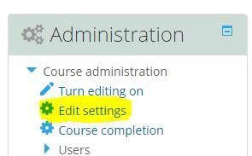

Step 2 of 4. Scroll down until you see the tab called ‘Course format’ – click on the blue arrow to expand this section.

Step 3 of 4. Next to ‘Format’, click on the arrow pointing down to reveal the drop down menu and select ‘Grid format from the list.

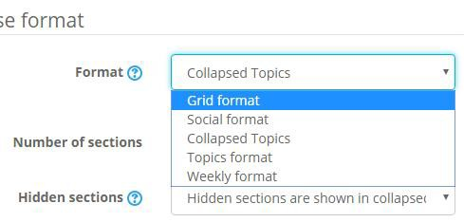

Step 4 of 4. Scroll down to the bottom of the screen and click on ‘save and display’ button

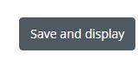

Additional Changes

There are a number of additional steps which you can implement to customise the grid format look and feel. The additional settings can be found under the ‘Course Format’ section as shown below

Make any additional changes, before clicking on the ‘Save and Display button’ in step 4.

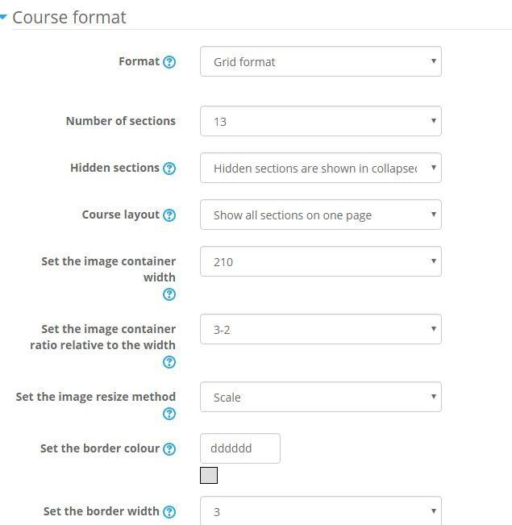

If you’re looking for an explanation of what each setting does, click on the question mark icon to see additional information.

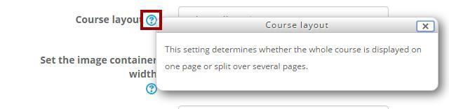

Guide to Enabling Collapsed Topic Format
This guide will inform you how to enable the ‘collapsed topic format’ within your Moodle course. The advantage of using this format is; it drastically reduces the vertical scrolling within courses by placing content in expandable sections.

Step 1 of 4. Under the administration block, click on ‘Edit settings’.

Step 2 of 4. Scroll down until you see the tab called ‘Course format’ – click on the blue arrow to expand this section.

Step 3 of 4. Next to ‘Format’, click on the arrow pointing down to reveal the drop down menu and select ‘Collapsed Topics’ from the list.
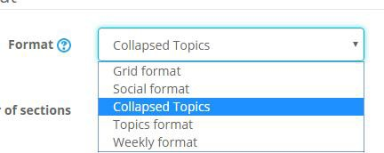
Step 4 of 4. Scroll down to the bottom of the screen and click on ‘save and display’ button

Additional Steps
You may wish to implement a couple of additional steps, which are detailed below. These steps take away the unnecessary additional text found in topic tabs and
Do the steps below, before clicking on the ‘Save and Display button’ in step 4.

Step 1 of 2. Scroll down, until you come to ‘Elements’, click on the arrow pointing down and select ‘No additions’ from the drop down menu.
image 1 of 4 - adminstration block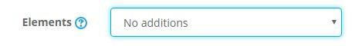

Step 2 of 2. Scroll down, until you come to ‘Toggle text alignment’, click on the arrow pointing down and select ‘Left’ from the drop down menu.
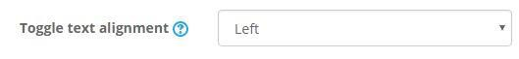

How to upload images from your computer to a Moodle course
Images are great way to enhance your course by providing further explanation of written content or subject. As with any media based resource it is important to consider the copyright associated with the image; is it your own work, did you produce it? If this is the case you can use the image without having to consider any rights clearance. However if you did not produce the image and it’s a commercial 3rd party image then you will have to obtain permission from the rights holder or consider obtaining an alternative from an Open Access resource like Creative commons materials or from Wikimedia Commons.
Please note images can be added to Moodle Books and Pages, just skip to step 3 in both cases.

Step 1 of 9. Click on the ‘Turn editing on ‘button.
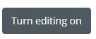
Step 2 of 9. Click on ‘Add an activity or resource’ in the topic you want to add the image to and select
‘label’ under the resources list. When you have selected file from the list, click on the add button.
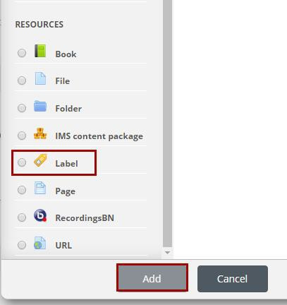
Step 3 of 9. In the next screen click on the image icon within the toolbar.

Step 4 of 9. A pop up will appear, click on the button/text that is displayed as ‘Find or upload image…’ .
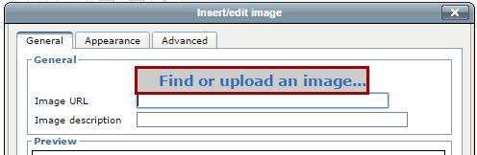

Step 5 of 9. From the new file picker pop up, make sure ‘upload a file’ is selected and click on the
‘choose file’ button.
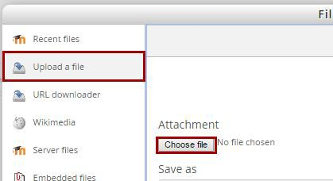
Step 6 of 9. The usual file browser for choosing files will appear, allowing you to select files within your computer. Navigate and select the image you would like to upload and click on the ‘open’ button.
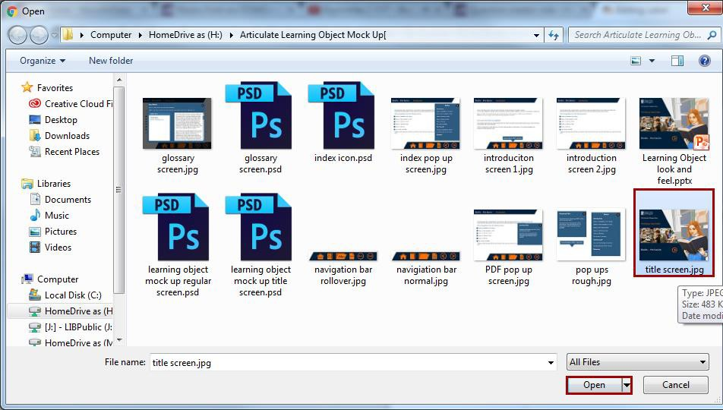

Step 7 of 9. When you have selected your image file, the pop up will disappear, now name the image you’re uploading and choose a license to associate Creative Common’s license to be associated with it from the drop down menu. More guidance for choosing the Creative Commons licenses can be found here. After you have named your image and chosen the applicable CC license, click on the ‘Upload this file’ button.
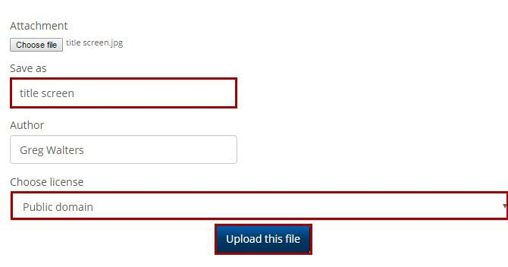
Step 8 of 9. Enter a description for your image; this is important for accessibility reasons. By giving your image a description you are providing text based information for students who may be using screen readers to access your course. When you have entered the description of your image click on the ‘appearance’ tab.
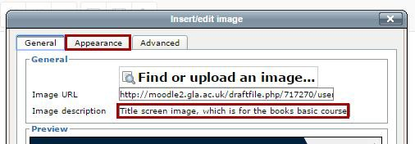
Step 9 of 9. If you are happy with your image, click on the ‘save and return to course’ button.
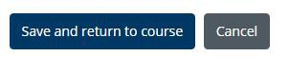
You will now be returned to the main page of your course where you will be able to see your image embedded within it.

How to Enable Student Tracking
By enabling completion tracking you enable students to check off what activities they have looked at within a course. This is good accessibility feature to have enabled, especially in courses that have a lot of individual resources as it allows the student to quickly see what resources they have looked at and what they still have to
Please note, it is advised to enable this setting before adding resources to a module. However if you are setting up completion tracking on an existing module with activities, please refer to the additional steps below to show how to add activity completion.
Step1 of 4. Under the administration block, click on ‘Edit settings’
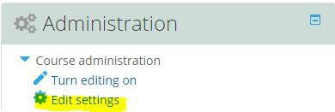
Step 2 of 4. Scroll down until you see the tab called ‘Completion Tracking’ – click on the blue arrow to expand this section
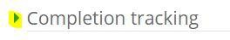
Step 3 of 4. You’ll see a box next text saying ‘Enable completion tracking’, click on the arrow pointing down to open up the drop down menu and choose ‘Yes’ if it’s not already selected
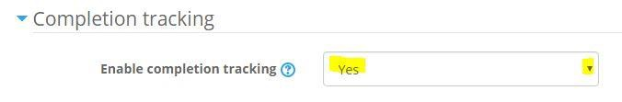
Step 4 of 4. Now click on the ‘save and display’ button and return to your course
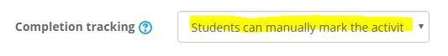

Additional steps
Step 1 of 5. Within your course, click on the ‘Turn editing on’ button
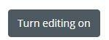
Step 2 of 5. Locate a particular resource within your course and click on the ‘Edit’ with arrow pointing down the way and click on the ‘Edit Settings’ text
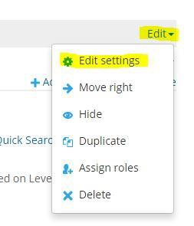
Step 3 of 5. Scroll down and click on the arrow next to the ‘Activity completion’ text
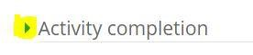
Step 4 of 5. Next to completion tracking, make sure ‘Students can manually mark the activity as completed’ is selected within the drop down menu.
Note you can also select ‘Show activity as complete when conditions are met’. Conditions can vary from ensuring students have viewed an activity to achieving a passing grade in a quiz. This setting is optional and will depend if you have activities you want to ensure have been completed by students
Step 5 of 5. Click on the ‘save and return to course’ button

How to Enable File Size and Type
Enabling file size and type allows students to see what format a particular file is along with its size. Having file size and type visible to students allows them to see what could be an unfamiliar file format and in turn download the required player. By displaying the file type you enable students to assess if they want to download a large file to view, this is especially relevant to students using mobile phones who may have a data download limit or allowance.
Please note, you may have to repeat the steps below for each file within your module if you are editing an existing module.
Step 1 of 5. Within your course, click on the ‘Turn editing on’ button
Step 2 of 5. Locate a particular resource within your course and click on the ‘Edit’ with arrow pointing down the way and click on the ‘Edit Settings’ text
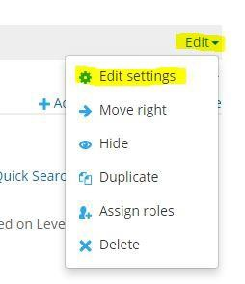
Step 3 of 5. Scroll down and click on the arrow next to the ‘Appearance’ text
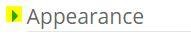
Step 4 of 5. Make sure the boxes next to ‘Show size and type’ are ticked along with ‘Display resource description’.
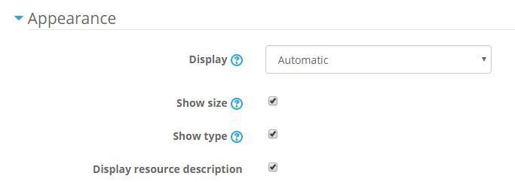

Step 5 of 5. Click on the ‘save and return to course’ button

Final Output within a Moodle Course
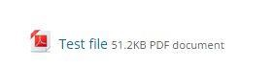
You’ll notice the file now has its file type displayed along with its size.

How to embed your own YouTube Video within your Moodle Course
Before commencing, this guide demonstrates how to embed YouTube video directly into your Moodle course. It is assumed the YouTube video you are going to embed is your own work.
If you did not produce the YouTube video, it is advised to link to the video instead (unless you have permission from the rights holder) of embedding it directly into your course.
Step 1 of 14. From the resource list, select Label and click on the ‘Add’ button
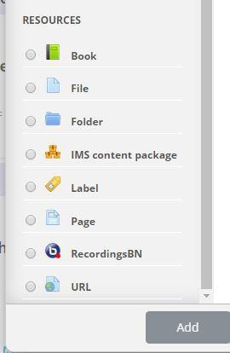
Step 2 of 14. If you find you only have row of icons within the label menu click on the ‘toolbar’ toggle
button (highlighted in screenshot below). This will open a further two rows of icons
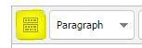
Step 3 of 14. Next choose the Edit HTML Source button from the toolbar
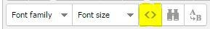

Step 4 of 14. You’ll be presented with the following pop up, type in the title of your video, press return a couple of times (in the pop up window). Then in your internet browser, open a new window and copy the following URL, to take you to YouTube: http://www.youtube.com.
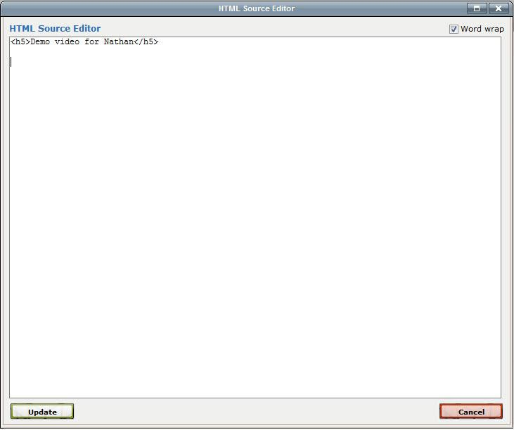
Keep the window you have Moodle open in active, don’t close it. As I said above, open a new
window in your browser and go to YouTube.

Step 5 of 14. Find the video you’re looking for by using YouTube’s search facility.

Step 6 of 14. When you found the video you wish to embed, click on the share tab located below the YouTube video
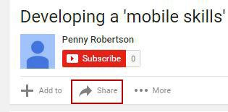

Step 7 of 14. Now click the Embed button, located underneath the share button.
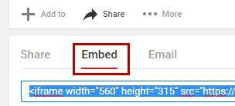
Step 8 of 14. Click on the ‘show more’ button underneath the line of code to get more options.
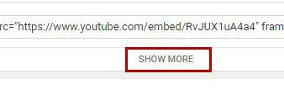
Step 9 of 14. A video preview will appear underneath the embed code and additional options. Make sure you untick ‘Show suggested videos when video finishes’ and select ‘Custom size’. A good size to choose for custom size is 320 x 180, this will allow the video to be displayed on smaller screen sizes and mobile devices.
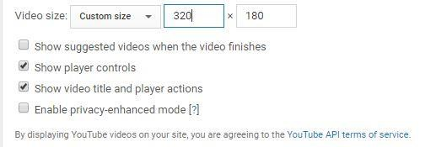

Step 10 of 14. Now click in the embed code box above the preview video and use the keyboard shortcut of ctrl + a, to select all of the code. It will now be highlighted in blue, now use the keyboard short cut of ctrl + c to copy all of the code. We can now return to our Moodle window open within our browser.
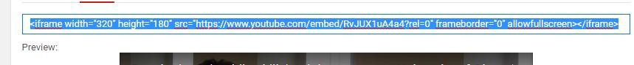

Step 11 of 14. Go back to the browser window you have Moodle open in and paste the YouTube embed code into the pop up window by, ctrl+v or right mouse button clicking and pressing “paste”
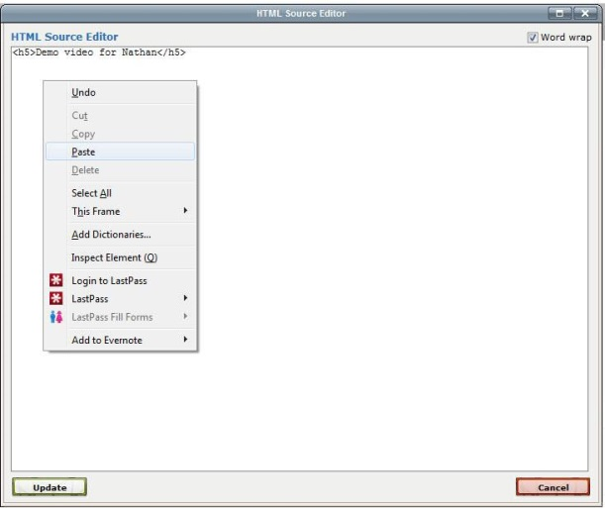
Step 12 of 14. With the YouTube embed code pasted into the pop up space, press the Update button
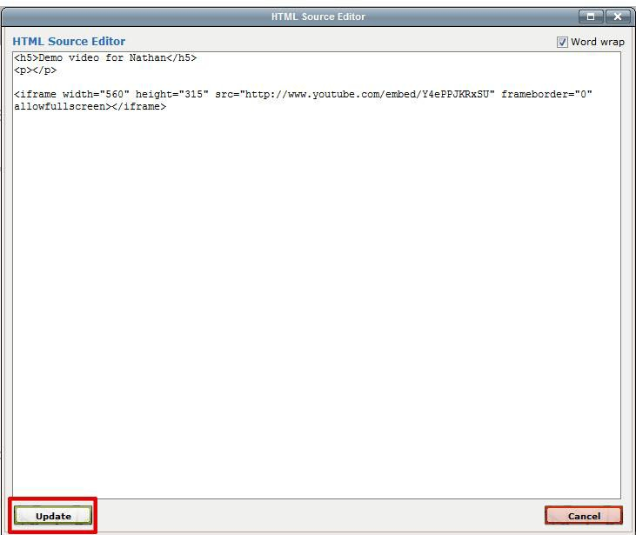
Step 13 of 14. You will now see your YouTube video embedded within the label.
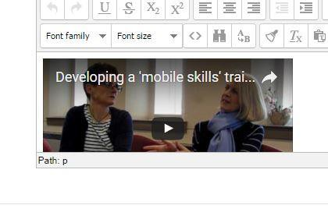

Step 14 of 14. Click on ‘Save and return to course’ button.
Conclusion: You will now see your embedded YouTube Video ready to play
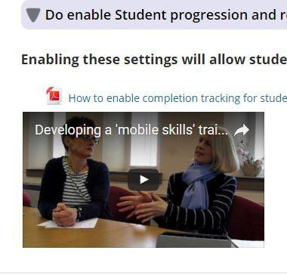

How to enable TinyMCEHTML Editor

To choose the TinyMCE editor, please do the following quick steps:
Step 1 of 5. On your dashboard page, click on your profile (top right-hand corner of screen)
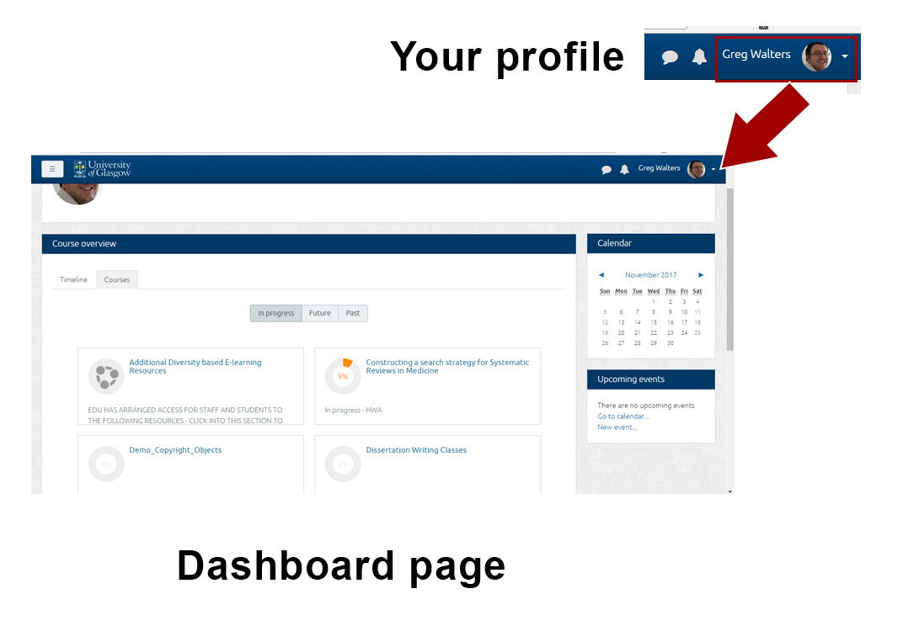
Step 2 of 5. From the drop-down menu, select preferences
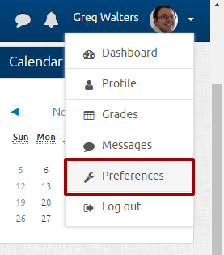

Step 3 of 5. In the next screen, chose ‘Editor preferences’ from the list found under user account to the left-hand side of your screen
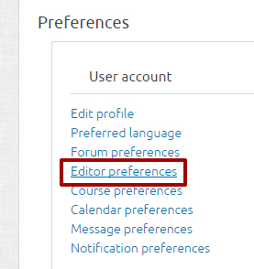
Step 4 of 5. Click on the text editor field and choose ‘TinyMCEHTML’ editor from the drop-down list and then click on the ‘save changes’ button
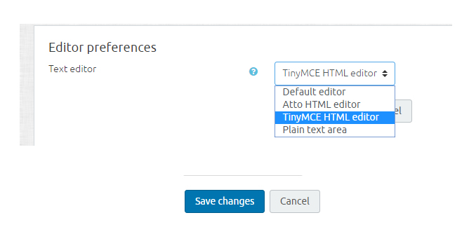

Step 5 of 5. Click on ‘Dashboard’ to return to this screen
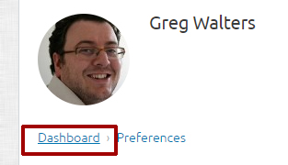

Showing Accessibility Tools
You can show the Accessibility Tools on any page within the Moodle dashboard and course pages. Just repeat the steps shown below.
Step 1 of 2. If you don’t already have the side bar displayed down the left-hand side of your screen, then please click on the grey box located in the top left-hand corner of screen to reveal it.
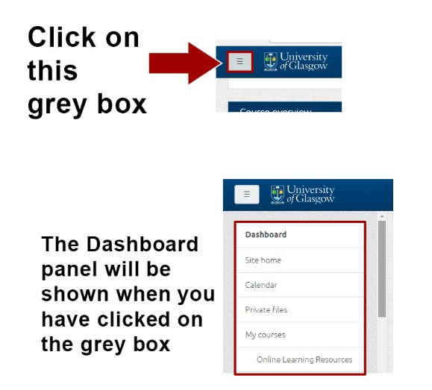
Step 2 of 2. Scroll down the Dashboard panel and select ‘Show Accessibility Tools’ if they are not currently visible on screen
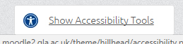

When you have performed ‘Step 2’, you will notice a series of accessibility options appear at the top of your Moodle course front page.
