EdShare
Accessibility Guidelines for University
of Glasgow

Accessibility guidelines for EdShare UofG
Creating accessible documents 2
Accessible PowerPoint presentations 3
Workflow for creating accessible Word/PDF documents 5
Accessible Video 7
Accessible Images 8
Creating accessible Hyperlinks (URLs) 9
Checklist for creating additional documents 10
Checklist for creating accessible PowerPoint 12
Checklist for accessible videos and images 14
Checklist for creating accessible Hyperlinks 15
References 16

Creating accessible documents
This document has been produced to inform staff about the recent regulations (24th September 2018 update) produced by the UK government for making your public sector website inclusive and accessible. It is now a legal requirement from 23rd September 2018 onwards for any Word documents and PDFs uploaded to a public sector website (this includes EdShare), to be as accessible as possible. A minimum standard being the Level AA of the Web Content Accessibility Guidelines (WCAG 2.1).
Please note any documents that were uploaded to EdShare prior to the 23rd of September 2018, do not have to adhere to the new Government Legislation unless they are modified and then re-uploaded.
In relation to the new guidelines, if someone requests it, an accessible alternative format must be provided within a reasonable amount if the original content does not meet accessibility standards.
The sections below, provide information, checklists and links on how to make your documents within EdShare as accessible as possible.

Accessible PowerPoint presentations
Before continuing, it is important to note that in the context of the University of Glasgow, if you have lecture slides that you intend to make available through EdShare, please retain the native PowerPoint format (.ppt & .pptx) as the conversion process to PDF has been shown to strip away accessibility features and make it harder for screen readers to interpret them.
The literature around accessibility has demonstrated you cannot base guidelines solely on the WCAG checklist(s) as unpredictable barriers will occur. This was demonstrated when
disabled students who were participating in Kumar’s research into assessing accessibility, highlighted unpredicted barriers when using PowerPoint. The students reported “navigation buttons not being recognised by assistive technology” and “too much information presented” (Kumar, K. Owston, R. 2016. pp.275). To address the unforeseen accessibility barriers, refer to the suggested best practices below as a starting point.
When developing an accessible PowerPoint presentation, the following points should be implemented:
- Use a large san serif text like Arial 24pt to make your text readable to visually impaired students
- Make sure there is a good contrast between the text and background colours, use WCAG Contrast Checker to check the contrast
- Keep the text within slides, short concise and to the point. You can expand on points within slide notes
- Ensure each slide has a unique title to aid students find the information they require
- Make use of the PowerPoint layouts for slides as this provides an automatic reading order for items within the slide
- Avoid using PowerPoint’s inbuilt action buttons and other shapes as navigation to other slides or to perform actions, as these are not recognised by assistive technology
- All Images, tables and graphs should have alt text to provide a text based description for visually impaired students
- Closed Captions or a downloadable transcript should accompany any embedded or linked to video or audio file
- Make use of the accessibility checker within PowerPoint to check for any potential accessibility barriers
- Avoid using animations in your slides, as they can cause screen readers to read the slide containing the animation twice

Microsoft PowerPoint Links:
Click here to view information about creating accessible PowerPoint (versions 2013, 2016) presentations
Click here to view an additional list of adjustments that can be applied to create accessible PowerPoint documents

Workflow for creating accessible Word/PDF documents
The UK Government accessibility regulations, state by UK law you must create an accessible PDF document if you decide to include one within your course.
Please refer to the links on the following page which will provide you both with the UK Government and Microsoft guidance on how to produce an accessible PDF document. Based on the Jisc presentation, the suggested workflow for developing accessible documents is to create them in Microsoft Word and save them as PDFs (McKay, M. Maguire, J. 2012). Below are steps involved in creating an accessible document that can be uploaded to EdShare.
- Use Microsoft Word to create your document as it has a host of accessibility features, i.e. both headings & table of contents that can be used for navigation by screen readers. Refer to the links at the end of this section for a full list of what accessibility features can be implemented in Word.
- Before preparing to save your document in Word, use the accessibility checker to check for any potential accessibility issues. The accessibility checker is available in Word 2007 – 2016 and can be found in the File> Info panel
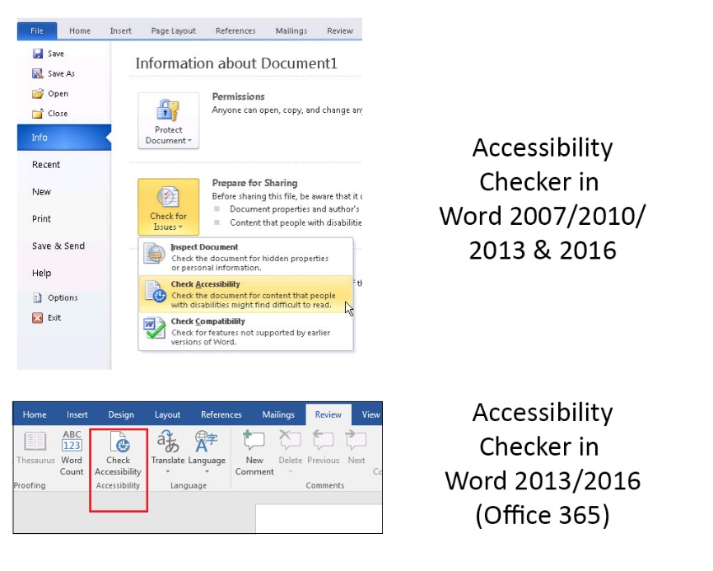
The above image shows where the accessibility checker can be found in different versions of Microsoft Word
- Save your document as PDF

Microsoft Word and Adobe PDF Links:
Click here to view how to create accessible Word (versions 2013, 2016) documents
Click here to view how to create Word documents which are accessible for Screen Readers (Word 2007, 2010)
Click here to view how to set up Adobe PDF Accessibility Features
UK Government guidelines on producing accessible PDF documents
Further guidelines on creating an accessible PDF

Refer to the links below to see instructions on adding alt text to images in Word and PowerPoint.
Adding alt text to an image within a Word document 2013, 2016
Adding alt text to an image within a PowerPoint presentation 2013, 2016

Accessible Video
Videos are a visual and audio based medium, however this does not automatically make them accessible to every type of student. Both the WC3 guidelines and Flor’s research agree videos at the very least should have closed caption text and or be accompanied by a transcription to make videos accessible to disabled students. The WC3 guidelines do not require sign language to be included for videos, however in contrast to both Flor’s and Skourlas research suggest further discussion should be given to have sign language included for both deaf and dyslexic students (Flor, C. 2015. pp. 160 – 162; Skourlas, C. et al. 2016. pp. 152) . I would agree with Flor and Skourlas’s assertions as Flor’s paper highlighted the text within closed captions can be too fast for deaf people to interpret (Flor, C. 2015. pp. 160). This is an area that requires further investigation as there is no clear guidance on how to produce videos with sign language and what exactly is involved. Therefore, the current guidance for accessible videos within EdShare and a Moodle course is to include the following.
- Ensure a transcript is provided (please refer to this WC3 example)
- Provide closed captions in your videos (please refer to this example)
Creating accessible Video Links:
How to add Closed Captions to YouTube videos
Guidance for creating a transcript file

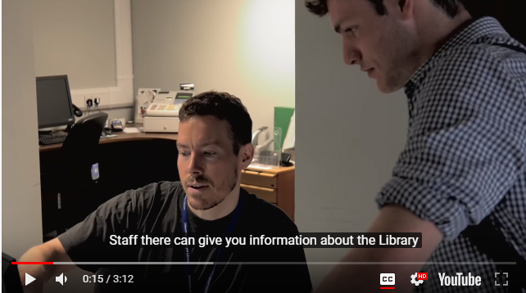

Accessible Images
Both the W3C guidelines and literature relating to these guidelines highlight the importance of ensuring all images should use alt text. If images do not have alt text or descriptions, then screen readers have no means of providing visually impaired students with descriptive information. This is illustrated by a screen reader user (Jennifer a second-year university student), who said the following: “It’s important to have the description of images to help a visually impaired person imagine what that image could be” (McKay, M. Maguire, J. 2012). Jennifer’s statement highlights the importance of providing descriptive alt text for visually impaired students as it enables them to interpret what the image may look like and makes your Moodle course and teaching materials more inclusive. Although this is a Moodle based example, the same principle applies to any image uploaded online, it should always be accompanied by alt text and description.

Refer to the links below to see instructions on adding alt text to images in Word and PowerPoint.
Adding alt text to an image within a Word document 2013, 2016
Adding alt text to an image within a PowerPoint presentation 2013, 2016

Creating accessible Hyperlinks (URLs)
Hyperlinks are subject to the same accessibility guidelines and best practice as illustrated in the WC3 guidelines. It is important links can be interpreted effectively by students using screen reading software as poorly written or constructed links can be of no benefit. This can be illustrated in the following example:
If a link is worded in the following manor, ‘Click here to find out about Jupiter’. The only part of the link that will be interpreted by screen reading software is ‘click here’, this offers no description of the links purpose or destination. A hyperlink must make sense out of context (McKay, M. Maguire, J. 2012).
Below is a list of best practices that can be applied to text-based hyperlinks, based on the WC3 guidelines. It is suggested you consult the link below which is the WC3 guidelines lines full list of link accessibility best practices.
Click here to view the WC3 web link accessibility guidelines
- Include a short and concise description of where the link goes and its purpose
- Indicate when a link opens in a new window (i.e. this link opens in a new browser window)
- Make sure your links are up to date and link to live websites and resources
- Avoid using URL’s as links i.e. ‘https://www.gla.ac.uk/myglasgow/library/’., these can be long and unintelligible after four or five letters
- If you are linking directly to a download, remember and inform disabled students of this in the link description

Checklist for creating additional documents
The checklist below will ensure the additional documents you upload to EdShare are as accessible as possible to all types of users.
- Checklist for creating accessible documents using Microsoft Word | Yes | No
- Have you used headings within your document? Headings allow a table of contents to be created which is allows for navigation throughout your document.

- Have got a table of contents within your document? A table of content can be interpreted by screen readers and allows disabled students to navigate through your document.

- Have you used a san-serif style (i.e. Arial) font for ease of reading and accessibility purposes?

- Have you refrained from using colour to emphasise meaning within your document? Remember, text that uses multiple colours is both inaccessible for impaired and non-impaired students

- Have all images within your document got an alt text description?

- Have all your table rows and columns used headings to make them accessible to screen readers?

- Within: Microsoft Word, PowerPoint make sure you use the accessibility checker. It is advisable to do this as this will enable you to double check your document is accessible to disabled students before saving

- If you have PowerPoint lecture slides, save them as the native format, it is ill advised to save them as PDF as this will strip away the accessibility features and make it more difficult for screen readers to interpret them

- Refer to the UK Government and Microsoft links to ensure the additional PDF you’re including is as accessible as possible

Checklist for creating accessible PowerPoint
The checklist below has been created to ensure the PowerPoints you upload to EdShare are accessible to all types of learners.
- Checklist for creating accessible PowerPoint | Yes | No
- Have you used large san-serif fonts, i.e. Arial 24 pt in your presentation? Do not go below the font size of 24 pt as it will be more difficult for students to read

- Have you kept the amount of text within your slides to either short sentences or bullet points? It is advisable to avoid a lot of text within PowerPoint slides as this is inaccessible to both disabled and non-impaired students.

- Have you given every slide a unique title? By giving each slide a different title you are making it easier for impaired students to find the information they require

- Have you refrained from using colour to emphasise meaning within your document? Remember, text that uses multiple colours is both inaccessible for impaired and non-impaired students

- Have all images within your PowerPoint got an alt text description?

- Have all your table rows and columns used headings to make them accessible to screen readers?

- Have you provided Closed Captions or a downloadable transcript when accompanying any embedded or linked to video or audio file?

- Have you made use of the PowerPoint layouts for slides? This provides an automatic reading order for items within the slide

- Have you used PowerPoints inbuilt buttons or shapes as navigation within your presentation? If so, please refrain from using these as they cannot be interpreted by assistive technology

- Have you used PowerPoint’s accessibility checker? It is advisable to do this as this will enable you to double check your document is accessible to disabled students before saving

Checklist for accessible videos and images
The purpose of the following checklist is to ensure video and images within your EdShare are accessible for all types of learners.
4. Checklist for accessible videos and images | Yes | No
- Is video accompanied by a text-based transcript or Closed caption?

- Is the video an appropriate size, so it can be displayed on not only desktop computer, but tablets and mobile devices as well?

- Have you considered the quality and size of the image? Remember small images that are of low resolution will be difficult to view

- Do images have additional alt text, providing a description of the image and its purpose?

Please note in addition to the above checklist, you should consider the copyright implications of the videos and images you use within the resources you upload to EdShare, please refer to the document linked below.
Click on this link to view the copyright advice relating to EdShare

Checklist for creating accessible Hyperlinks
The purpose of the following checklist is to ensure hyperlinks are accessible by providing explanation of their purpose and can be read by screen reading software.
5. Checklist for creating accessible Hyperlinks | Yes | No
- Does the link contain a short message telling learners the purpose of the link and what online resource or web page they are being directed to?

- Have you checked to make sure the hyperlink is linking to an active webpage or resource?

- Have hyperlinks been carefully worded so they can be interpreted by assistive technologies like Screen Readers?

- Is text included within the hyperlink to inform learners if it opens in a new browser window?

References

Flor, C, S. Saito D, S. Pivetta, E, M. Ulbricht, V, R. & Vanzin, T. (2015). Moodle accessibility for the deaf: approach to deaf and hearing discourses. Transformation, 27, 2. pp.157-163. Retrieved September 25 2017 from: https://dx.doi.org/10.1590/0103-37862015000200005
Kumar, K, L. Owston, R. (2016). Evaluating e-learning accessibility by automated and student-centered methods. Educational Technology Research and Development. 64, 2. pp.263 – 283. Retrieved September 26 2017 from: https://link-springer-com.ezproxy.lib.gla.ac.uk/article/10.1007%2Fs11423-015-9413-6
McKay, M. Maguire, J. (2012). Creating Inclusive Learning and exploring the Accessibility Features of Moodle, Jisc RSC Scotland [Online] [Retrieved October 24 2017]: https://www.slideshare.net/rscscotland/creating-inclusive-information

