University of Glasgow Second Life:
A Getting Started Guide

Written by Gemma McLean of Gemixin for the University of Glasgow

Introduction

This guide will show you how to get started in the virtual world Second Life and access the University of Glasgow virtual campus (called Glasgow University Online).
Once you have learned the absolute essentials in this guide, you will be able to take part in interactive tutorials on the University of Glasgow virtual campus orientation area, to teach you everything you need to know to use Second Life effectively.

Creating a Second Life Account
In your computer’s web browser visit the following web site:
Second Life University of Glasgow
https://maps.secondlife.com/secondlife/Glasgow%20University%20Online/225/46/22
Click Join Now, it’s free to create an account.
You will be presented with a selection of avatars to choose from. This is how your virtual character will appear in the virtual world so choose wisely, although you can change your avatar’s appearance at a later stage.
Once you have found your desired character, click “Choose This Avatar” to proceed.
The next step is to choose a username. It will need to be unique so check the availability before proceeding.
Now it’s time to enter your registration details. Alternatively you can use your Facebook account to register. Once you have completed this, you need to select which type of account you want. Select “Free” and you are finished creating your account.
The final screen you are presented with provides a link to download and install Second Life. If you click this, an installer will begin downloading and a web page with installation instructions will appear. If Second Life is already installed on your computer, you can skip this.
Follow the instructions that appear in your browser to install the Second Life Viewer (the application that lets you access the virtual world Second Life) on your Windows or Linux PC or Apple Mac.
If for any reason you need to re-download the latest version of the Second Life Viewer, visit this page:
https://secondlife.com/support/downloads/
Logging In and Getting to Glasgow
When you launch the Second Life Viewer that you previously installed, you will be presented with various news and promotions, but most importantly, a log in section at the top.
Enter your username and password in the relevant boxes.
Next, type the following in the “Type a location” box below the username and password boxes:
Glasgow University Online
Now you can click the “Log In” button next to this box.
If this is the first time you are using the software, you will need to agree to the Terms of Service popup that appears. Once the application finishes loading, you will find your avatar in the virtual University of Glasgow campus orientation area. Next time you log in you can choose to log in from your last location instead.
Getting to Glasgow from Elsewhere
If for some reason you end up somewhere else other than the Glasgow campus, or visit another Second Life location and want to return to the campus, simply use the menu bar at the top of the Second Life Viewer.
Select “World” and then “World Map” to bring up a map of the Second Life world.
The map will show your current location. Use the “Find on Map” section to type in the name of a place you want to visit, and select the place from the list of results. For example you could type “Glasgow” and then select “University Glasgow online” from the results.
Once you have selected your target destination, click “Teleport” to transport* your avatar there.
* Teleporting is a way of moving instantly from one place to another in Second Life.
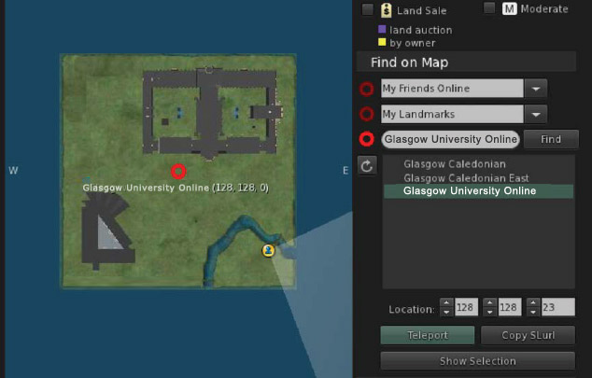
Tip: You can set a location as your home, which means you can teleport there at the touch of a button. When at the campus, go to “World” and then “Set home to here” in the top menu bar. Then anytime you want to return to Glasgow, simply go to “World” and then “Teleport home”, or click the home button below the top menu bar (house icon).
Use the back and forward buttons underneath the top menu bar to teleport to previous locations, much like a web browser with visiting previous web pages.

Basic Tutorial
The virtual campus orientation area will teach you most of what you need to know for using Second Life, but there are a couple of things you need to know to be able to use the orientation area effectively.
1. Movement
To move your avatar, use the arrow keys (or the WASD keys if you prefer) on your keyboard. Left and Right will turn your avatar whereas Up and Down will move them forwards and backwards. Alternatively, use your mouse to click on the piece of land that you want your avatar to walk to.
2. Zooming
Zoom in and out by scrolling up and down with the mouse. If you zoom in too far, you will enter mouselook mode.
3. Mouselook Mode
Mouselook mode allows you to see the world through your avatar’s eyes. This is very useful for reading signs and examining things closely. You’ll need it to read the orientation area tutorials effectively.
There are 2 ways to enter mouselook mode. The first is to hit the M key on the keyboard. The second is to zoom in as far as you can go (scroll up on the mouse).
Once in mouselook mode you can look around by moving the mouse. You can still move your avatar as normal with the keyboard.
To exit mouselook mode, zoom out (scroll down on the mouse), hit the M key or hit the Escape key.
3. Graphic Preferences
is a good idea to set up your graphics preferences on your first time logging in.
Go to “Me” and then “Preferences” in the top menu bar and select the “Graphics” tab.
The rule of thumb is, the better your computer’s specification, the better graphics settings you can have. If you set the graphics preferences too high for the performance of your machine, you may find it laggy to use. Try and find a nice balance.
Use the sliders to edit the settings.
“Draw distance” refers to how far your avatar can see. The higher the number, the more objects you will be able to see on the screen at any one time.
The “Advanced Lighting Model” setting is a good option to enable if your computer performance allows, as it displays objects with realistic lighting.
If you click the “Advanced” button you can edit more detailed settings but beware of doing this without the correct knowledge.
5. Sun Settings
You can change the sun settings in Second Life manually. This is useful for if you visiting the campus when it is dark, and you want to see things in the best possible light.
Go to “World” and then “Sun” in the top menu bar and select “Midday” to set the current daylight to the most optimal setting.
Now you know the basics of using Second Life you are ready to try the interactive orientation area on the virtual University of Glasgow Campus. Make your way around the numbered tutorials and learn more about how to use Second Life.

Further Information
To learn more about Second Life, including how to change your avatar’s appearance and display name, and join groups, visit the following web page:
http://support.secondlife.com
This guide and the virtual orientation area assume you are using the latest version 3 Second Life viewer.

Glossary
Avatar -­‐ your very own Second Life character.
Mouselook Mode – a first person viewing mode where you move the mouse to look around.
Second Life Viewer – the application (PC, Mac or Linux compatible) that you install and run to use Second Life.
Teleport – instant travel from one location to another.

