Copyright
Searching for images effectively
online

Level: Beginner

Table of Contents
How to search for images effectively online using filters and extensions 3
Searching for Images using Google Chrome: Steps 1 - 4 4
Step 1 of 4 4
Step 2 of 4 5
Step 3 of 4 6
Step 4 of 4 7
Searching for images using Browser extensions 7

How to search for images effectively online using filters and extensions

Potential copyright risk can be heightened when searching for images online using the standard browser settings, e.g. Google, as results are unfiltered and could be copyright protected. To lessen the risk for inadvertently infringing copyright, image searches can be adjusted via settings or extensions to filter results to include copyright free images only. By refining image search results, you reduce potential copyright infringement and have selection of images which can be used in your academic or professional materials.

Please follow the quick and easy step by step guide below to see how to refine image search results when using Google Chrome and browser extensions.

Searching for Images using Google Chrome: Steps 1 - 4

Step 1 of 4

Click on the link below to access Google Advanced Search – this method of searching allows you to filter results via licence.
https://www.google.co.uk/advanced_image_search

Or alternatively, if you’ve already launched an image search, but wish to refine it, then follow the step below.
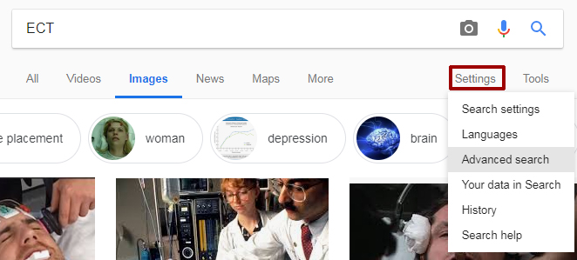
Within Google Chrome image search results screen, click on the ‘Settings’ button and from the drop down menu choose ‘Advanced Search’.

Step 2 of 4

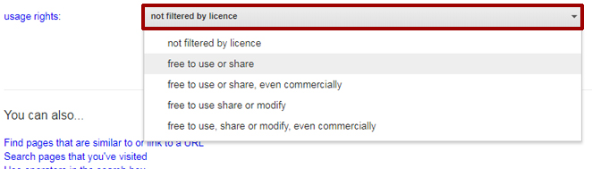

Scroll down the settings screen and click on the ‘not filtered by licence’ tab‘, from the drop down menu. This will allow you to filter your image search by licence type, for example ‘free to use or share’ provides images which may be used in non-commercial, educational materials.

After you’ve selected your usage filter, click on the ‘Advanced Search’ button.

After you’ve clicked on the ‘Advanced search’ button, you’ll be taken to the image search results. Notice the filter you applied can be seen under the ‘Images’ text – at this point you can peruse the images from your search or change the filter setting if you wish.

Step 3 of 4

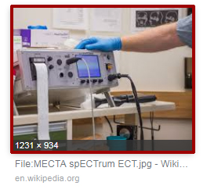
When you find an image you would like to use within your search results, click on it once.

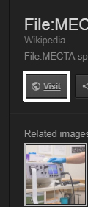
Before saving the image, it is advisable to view the online source, in case there is an associated licence or terms and conditions which must be adhered to. In order to view the online source, click on the ‘Visit’ button.

Step 4 of 4

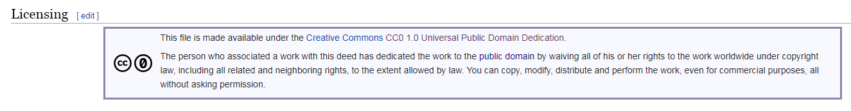
The above image is an example licence associated with an image take from Wikimedia Commons. It is always advisable to check the online source of an image before using it, as there could be terms and conditions that must be adhered to, i.e. providing attribution (credit) for the person who created the image.

Searching for images using Browser extensions

There are other image search options available for Google Chrome and other internet browsers, e.g. Firefox. Below are two links to browser extensions which enable more effective online image searches.
TinEye extension (for Firefox) – Tineye is a reverse image search engine, which adds a context menu to Firefox enabling you to search for an image and find out where it came from.
Google reverse Image search (3rd party) – this 3rd party extension for Firefox enables you to perform a reverse image search using Google Images and find other copies of the image you’re looking for online.

