EdShare
User Guide

Additional features

Level: Beginner

Table of Contents
Preface 3
Introduction 3
Collections 4
Step 1 of 3: creating a collection 4
Step 2 of 3: creating a collection 5
Step 3 of 3: creating a collection 6
Additional/Optional step 7
Templates 8
Step 1 of 4: creating a template 8
Step 2 of 4: creating a template 8
Step 3 of 4: creating a template 9
Step 4 of 4: creating a template 10
Analytics 11
Step 1 of 2: analytics 11
Step 2 of 2: analytics 11
Version Control 13
Step 1 of 3: version control 14
Step 2 of 3: version control 14
Step 3 of 3: version control 14

Preface

Before continuing with this guide, it is assumed you have read the Copyright and legal guidance found in the document titled ‘EdShare Copyright Guidance’. It is advised you read this document before proceeding as it will give you an understanding of how UK Copyright Law and policy can be applied to resources that are uploaded to the institutions EdShare repository.

Introduction

The purpose of this guide is to provide you with an overview of the additional features available within EdShare. The Collections feature enables you to organise your learning materials into collections and groups according to their subject matter. Using the templates feature saves the replication of metadata for items of a similar nature. This guide also covers how to retrieve and examine the viewing and download analytics for resources you upload to EdShare.

Collections

Within EdShare you can organise learning materials that share subject matter, or are part of the same course, into Collections and groups.
Collections you’ve created can be found under the ‘Collections’ tab located in your Resource Manager page.
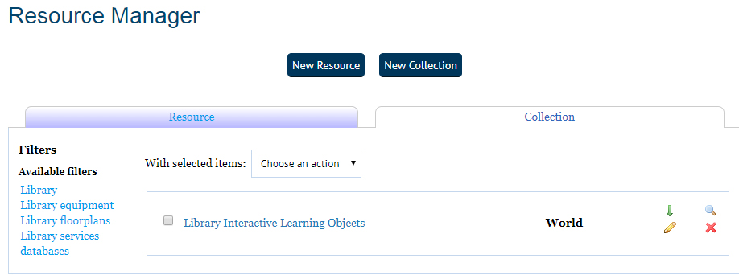
Please follow the steps below to create a collection for resources within EdShare.

Step 1 of 3: creating a collection

To create a collection using your own materials, navigate to your Resource manager, and from the list on screen, select which resources you want to add and then click on the ‘New Collection’ button.
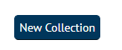

Step 2 of 3: creating a collection

You can add items to your collection by clicking on the ‘My Deposits tab’ and selecting them from the list that appears on screen.
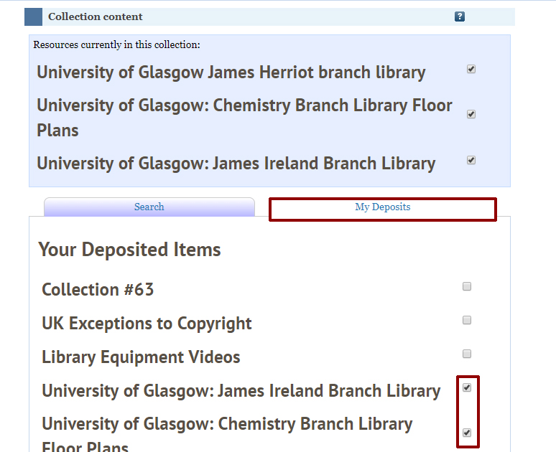

After you have added your chosen items, provide a title and description for your collection. You can also create and add tags (key searchable words) for the Collection.
Please remember if any resources within your collection contains 3rd party copyright protected permission you cannot make it available to the ‘World’. The UK Copyright Exceptions could not be used to defend the inclusion of this material as it would effectively be available to the public. The only circumstance that would allow you to include 3rd party content within your resources that are available to the public is if you had explicit written permission from the rights holder to do so. It is therefore suggested to set the viewing permissions to ‘University’ if your resources contain 3rd party copyright protected content.

Step 3 of 3: creating a collection

Choose your editing permissions and adjust accordingly. Click on ‘Save and Return.
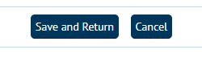

Additional/Optional step

After you have created your collection you can add more items by selecting a particular resource(s) (when within Resource manager) and from the drop down menu choose ‘Add to Collection’.
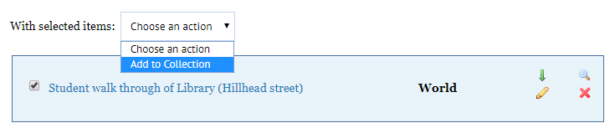

Now choose if you would like to add your chosen resource to a new or existing collection (from drop down menu), then, click on the ‘Update Collection’ button.
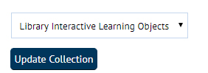

Templates

The template feature can be used if you intend to upload resources that are similar in both their content and metadata. Using the template feature saves you having to repeatedly enter the same metadata for similar items uploaded to EdShare. This feature creates an exact duplicate of a resource which you can edit and upload. There is no connection between the two resources.

Step 1 of 4: creating a template

To use the Template feature, navigate to your resource manager and within the list of resources, select one item.

Step 2 of 4: creating a template

Once you have selected a resource, scroll down to the ‘View item’ button, which is located underneath the metadata panel.
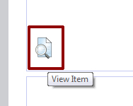

Step 3 of 4: creating a template

You will see four tabs, select the ‘Actions’ tab and click on ‘Use As Template’ button. A new resource is created which you can edit.
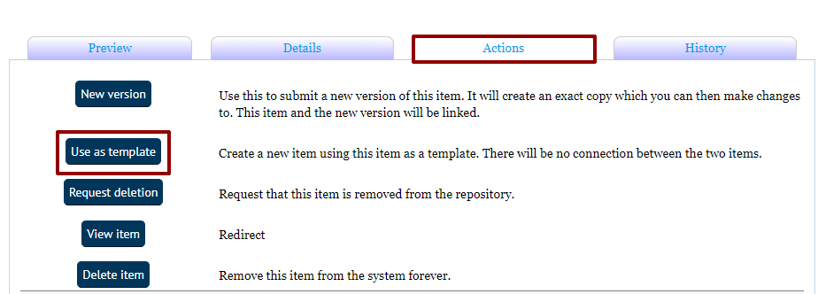

Step 4 of 4: creating a template

Now upload your new resource and edit any fields as required, e.g. Title, Creators etc. and then click on the ‘Deposit’ button to upload your new resource.
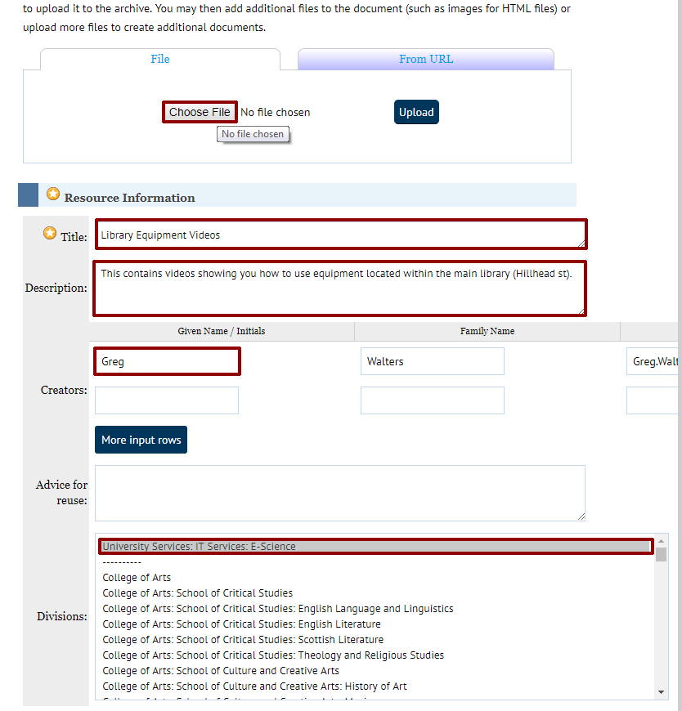

Analytics

Whenever you upload a resource to EdShare, a set of download and view analytics are created.

Step 1 of 2: analytics

You can view statistics for a particular item by navigating to the resource manager and selecting one of your resources.

Step 2 of 2: analytics

After selecting one of your uploaded resources you will be taken to a screen containing information about your resource. Scroll down and click on the blue coloured chart button to view statistics for your chosen resource.
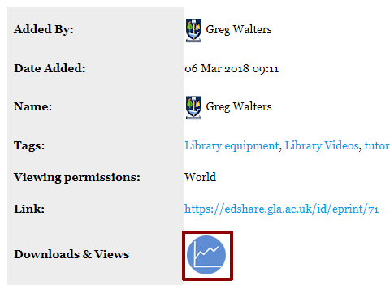

.
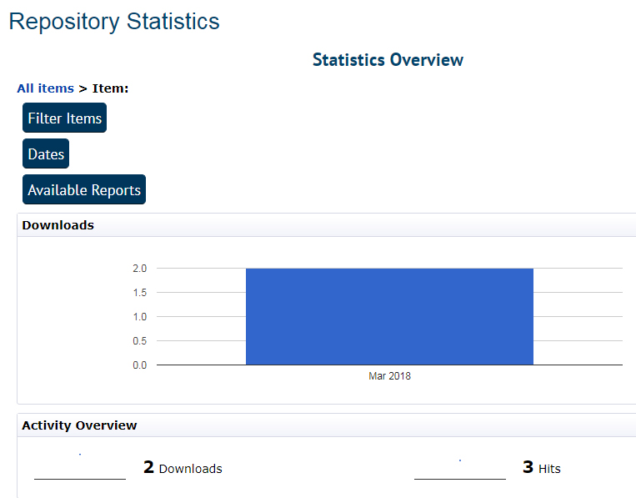

You can click on the item buttons to further refine your statistics.

Version Control

We appreciate that certain institutional documentation i.e. learning and teaching resources, policies are subject to frequent updates or changes. EdShare is a repository is intended for the storage long term storage of resources only, with the long term goal of facilitating the preservation of the institutions output of educational materials. Therefore there is no functionality for staff to delete items uploaded to EdShare. Instead staff are encouraged to make use of EdShare’s inbuilt version control, which enables resources that are frequently updated to be maintained and stored under one instance.
When a new version of a particular resource is upload to EdShare the following actions are taken by the system:
- The latest version is linked to older versions already stored within EdShare.
- The metadata associated with the latest version is updated to incorporate links to older versions stored within EdShare.
- Older versions metadata is updated to direct users to the latest version available within EdShare.
- To avoid confusion, the metadata associated with older version is hidden from EdShare search function to ensure that the only the latest version is discoverable.
To create a new version of an existing resource, please follow the quick steps below.

Step 1 of 3: version control
Select your chosen resource by using either the search function within Edshare or navigating to your ‘resource manager’ and choosing it from there. When you have selected your chosen resource click on the ‘view item’.
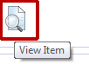

Step 2 of 3: version control

From the four tabs available, select ‘Actions’ and click on ‘New version’. A new version of your resource has been created within Edshare which can be edited.
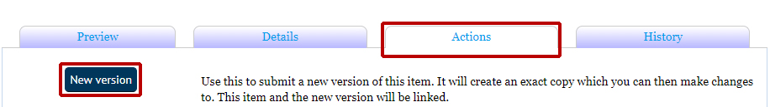

Step 3 of 3: version control

Select the ‘Details’ tab and then click on the ‘Edit item’ button. You can now upload a new version of your document by clicking on the ‘Choose File’ button and removing the old version by clicking on the bin icon. Now is your opportunity to update any metadata, e/g creators, title, divisions, and then click on the ‘save and return’ button to complete uploading your new resource.

