EdShare
User Guide

Uploading resources to EdShare

Level: Beginner

Table of Contents
Preface 3
Introduction 3
Uploading a resource to EdShare 4
Step 1 of 11: Uploading a resource to EdShare 4
Step 2 of 11: Uploading a resource to EdShare 4
Step 3 of 11: Uploading a resource to EdShare 5
Step 4 of 11: Uploading a resource to EdShare 5
Step 5 of 11: Uploading a resource to EdShare 7
Step 6 of 11: Uploading a resource to EdShare 9
Step 7 of 11: Uploading a resource to EdShare 10
Step 8 of 11: Uploading a resource to EdShare 12
Step 9 of 11: Uploading a resource to EdShare 12
Step 10 of 11: Uploading a resource to EdShare 13
Step 11 of 11: Uploading a resource to EdShare 14
Uploading e-Learning objects, i.e. Articulate Storyline 15
Step 1 of 10: Uploading E-Learning objects to EdShare 15
Step 2 of 10: Uploading E-Learning objects to EdShare 15
Step 3 of 10: Uploading E-Learning objects to EdShare 16
Step 4 of 10: Uploading E-Learning objects to EdShare 16
Step 5 of 10: Uploading E-Learning objects to EdShare 16
Step 6 of 10: Uploading E-Learning objects to EdShare 17
Step 7 of 10: Uploading E-Learning objects to EdShare 17
Step 8 of 10: Uploading E-Learning objects to EdShare 18
Step 9 of 10: Uploading E-Learning objects to EdShare 18
Step 10 of 10: Uploading E-Learning objects to EdShare 19

Preface

Before continuing with this guide, it is assumed you have read the Copyright and legal guidance found in the document titled ‘EdShare Copyright Guidance’. It is advised you read this document before proceeding as it will give you an understanding of how UK Copyright Law and policy can be applied to resources that are uploaded to the institutions EdShare repository.

Introduction

The purpose of this guide is to provide you (the reader) with an overview of how to upload a resource(s) to the EdShare platform and if required embed it in within Moodle and or another online source.
Edshare is a versatile platform which enables you to upload a wide variety of resources, e.g. documents, PowerPoint presentations, images, video, audio files and zipped folders.

Uploading a resource to EdShare

Step 1 of 11: Uploading a resource to EdShare

To log out of EdShare follow this link to go to the log out page , and then click on ‘My EdShare’, from the drop down menu click on ‘Login’.
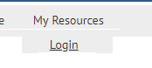

Step 2 of 11: Uploading a resource to EdShare

When prompted, enter your GUID for then click on the ‘Login’ button.
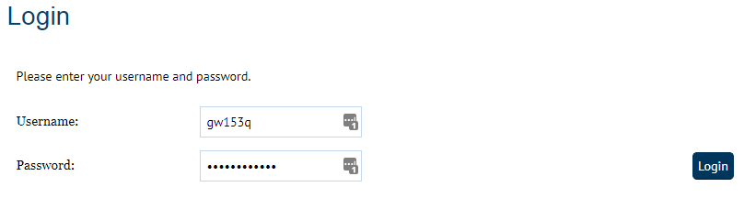

Step 3 of 11: Uploading a resource to EdShare

To upload a file, click on the ‘Choose file’ button.
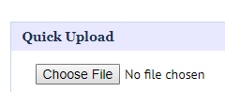

Please note, Google chrome displays ‘Choose button’ other internet browsers will display this button as ‘Browse Button’.
This guide refers to ‘choose button’ throughout, if you are not using Google Chrome, please remember and replace this with the ‘Browse button’.

Step 4 of 11: Uploading a resource to EdShare

From the pop up that appears on screen, navigate to your video file and click on it. After you have selected your chosen video file, click on the ‘open’ button.
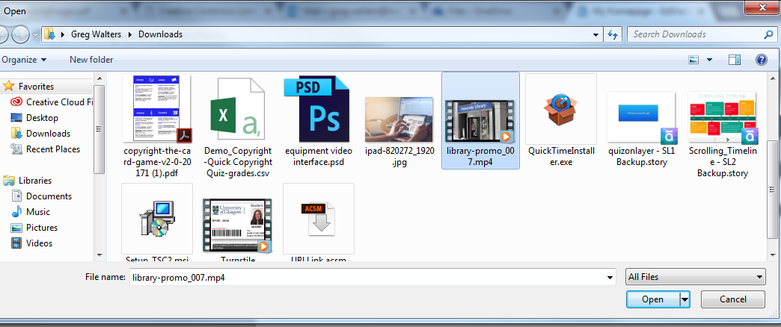

Additional notes relating to specific file types uploaded to EdShare

Note: If you are uploading a text-based document to link to from a Moodle course, then it advised to make sure it is a Word format as this is the most accessible format. You can copy the direct link to your document by right clicking (using your mouse) on the text that says ‘download’ and selecting ‘copy link address’.
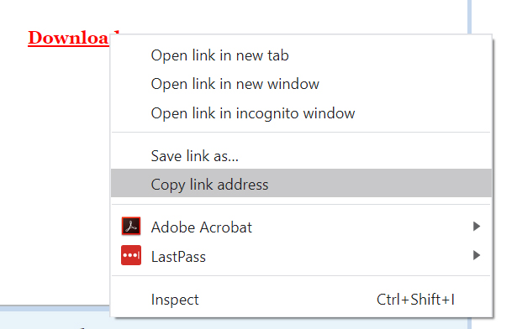

When in Moodle, select URL (found under resources), and within the ‘External URL’ field right click and select ‘paste’ from the drop-down menu to link to your document in EdShare. Fill out the remaining fields and when finished, scroll down and select either, ‘Save and Return to Course’ or ‘Save and display’.
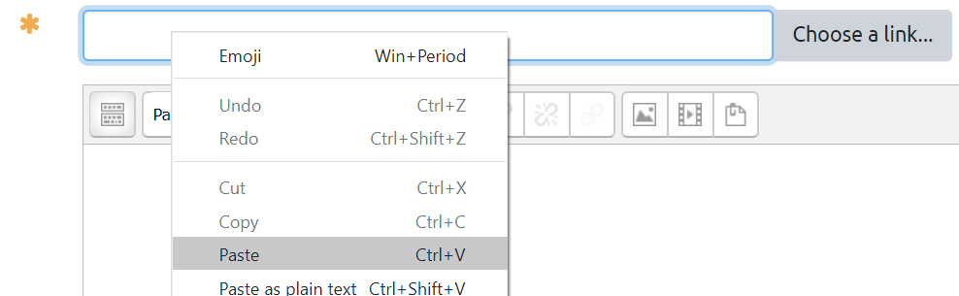

Note: Multimedia file types, e.g. video and audio create a number of derivative files when uploaded to EdShare. These files are normally generated within several minutes of upload. Multimedia files uploaded to EdShare, can be embedded in other online platforms, e.g. Moodle and webpages via the generated ‘embed’ file. To see a series of short tutorials in how to embed Multimedia files, please refer to the ‘Embedding Multimedia files within Moodle’ document.

N.B, with video files, the format that is most suited for upload to EdShare is MP4, as this can be accessed on different web browsers and devices. If your video file is not in a MP4 format, then you may wish to consider using a free video converter tool.

Step 5 of 11: Uploading a resource to EdShare

With your video file chosen, click on the ‘upload’ button.
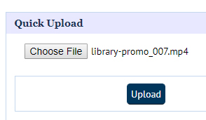

Optional Step to upload supplementary files
Note, at this point you can upload supplementary files if required. An example of this would be if your video file has an accompanying Closed Caption text file for accessibility reasons.
You can add supplementary files to your uploaded resource by clicking on the File button (shown below).
Once you have clicked on the file button, a new pop up will appear, click on text saying, ‘click to add supplementary files to this document’.
A further pop up will appear on screen, click on the ‘OK’ button to continue
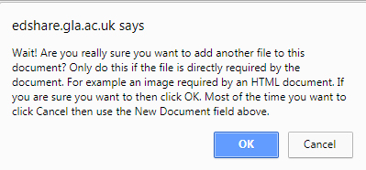

Optional step to upload supplementary continued..

You will now notice the ‘Choose file’ button has appeared – click on this to choose the supplementary file. Navigate to your file and click on the ‘open’ button in the file chooser.
When you have chosen your file, click on the ‘Upload additional file’ button.
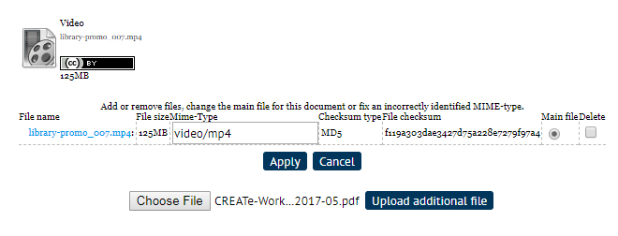

After you’ve clicked on the ‘Upload additional file’ button, you’ll be returned to the editing screen. If you wish to edit your main file and supplementary file, click on the ‘File button’ button again. This will allow you to assign which is the main file or delete unwanted items by selecting the item and then clicking on the ‘Apply’ button. You can upload more than one supplementary file if required.

Step 6 of 11: Uploading a resource to EdShare

Provide a brief description of your resource, i.e. video, transcript as this will aid users identify at a glance what each file is.
After you have entered your description you should choose a licence to be associated with the resource you’re uploading to EdShare. The resources deposited within UoG EdShare can be granted
different licences under the Creative Commons (CC) scheme. CC licences are tools that enable individual creators a simple and standardised way to assign copyright to their creative work. Every CC licence allows the creator to retain copyright whilst allowing others to copy and distribute and make use of their work.
It is your responsibility to choose an appropriate Creative Commons licence for the resources you upload to EdShare.
To find out more about Creative Commons Licences and examine which licence would best align to the resource you plan to upload, please click on the link below to view a learning object which provides detailed information about each CC licence.
Visit this webpage to view resources that provide information about Creative Commons Licecnes
Note: If you intend to upload an Open Educational Resource (OER) to UoG EdShare, it is advisable to use the ‘CC – BY’ licence as this will allow other people to use it freely.
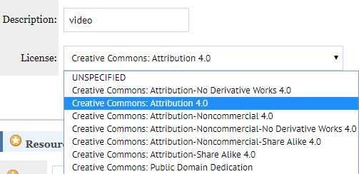

Step 7 of 11: Uploading a resource to EdShare

Under Resource Information:
- Title - Type in the title of your resource and provide a description. Remember and make your title concise and helpful to users i.e. instead of ‘Lecture 1’ try ‘Cardiovascular system, lecture 1 February 2018’.
- Description - Provide a description of your resource to aid users in identifying what subject matter or content is covered within it
- Creators – in this section, you can list the person or people responsible for creating the resource. Type in a family name and use the autocomplete functionality to enter the remaining details for UoG staff members. Alternatively, you can complete these fields manually for any external contributors. You can add additional creators by clicking on the ‘More input rows’.
- Advice for reuse – If required, you can specify or advise how the resource can be used in other mediums or sources, i.e. ‘this is a video is a student led tour of the library and is suitable for use in online, presentation and print based promotional materials’
- Divisions - From the scrollable list you can choose which college or service to associate your resource with

The associated image can be viewed on next page, which shows all of the above fields mentioned.
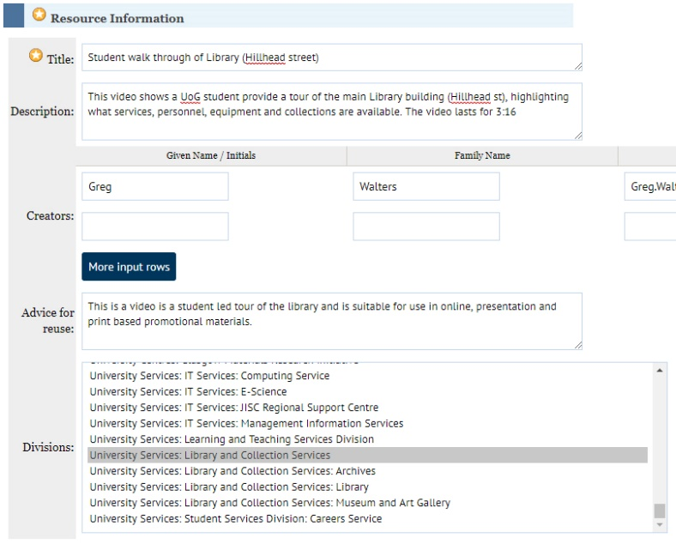

Step 8 of 11: Uploading a resource to EdShare

Tags are keywords or phrases which not only describe the content of the resource, but also provide users with an explanation of what they are.
You can add a tag to your resource by typing into the field and pressing return on your keyboard when complete or by clicking on the ‘Add’ button. More tags can be added by simply repeating the above process. If you would like to delete a tag, click on the small grey cross next to it to remove.
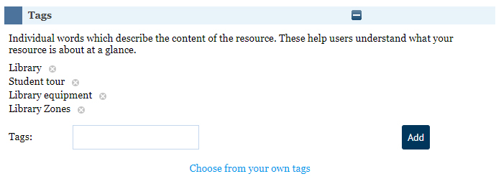

Step 9 of 11: Uploading a resource to EdShare

Course codes are the standard University codes for taught modules which you can add in the usual way: COMP1003, HIST3014, PSYC6018 etc.
You can add a course code by typing it in the field provided and pressing return on your keyboard or by clicking on the ‘Add’ button.

Step 10 of 11: Uploading a resource to EdShare

There are various levels of viewing permissions for the resources you upload to EdShare. We will now examine the four levels of access you can choose from:
- Just me – only you will be able to view this resource, it will not be online and will not appear in search results
- Selected users – you can allow access to specific UoG individuals by entering their names or email addresses
- University – currently this makes your resource available only to UoG staff.
- World – makes your resource available to anyone. They will be able to view and download the resource. This setting is not suitable if your uploaded resources contain 3rd party copyright protected material
You can choose a particular level selecting it from the options on screen.
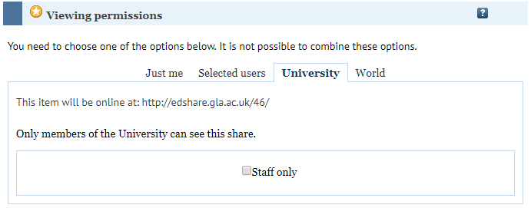

Step 11 of 11: Uploading a resource to EdShare

Editing permissions allow you to add either selected users or all University staff as editors to your object. This means anyone else who has access would be able to adjust settings e.g. change the tags associated with your resource.
The levels of editing permission are:
- Only Me – as the title suggests, only you have permission to edit your resource
- Selected Users – you can select specific UoG individuals to have editing privileges for your selected resource by entering their name or email address
- University – Any member of UoG will have the rights to edit your resource. This can be set to be for UoG staff only.

After you have entered all of the information required for your resource, review it, take this opportunity go over items like the title, tags, licence etc.. After you have reviewed your chosen settings, click on the ‘Save and Return’ button.
Your resource is now published to EdShare.

Uploading e-Learning objects, i.e. Articulate Storyline

Step 1 of 10: Uploading E-Learning objects to EdShare

Export your project/resource as a zip folder. Most e-Learning development software will allow you to export your project as a zip folder.
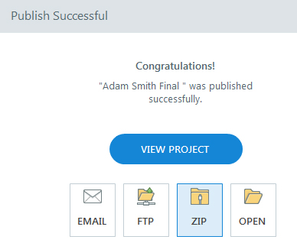

Step 2 of 10: Uploading E-Learning objects to EdShare

Go to your Resource Manager and click New Resource.

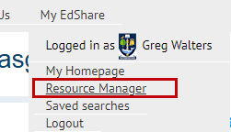

Step 3 of 10: Uploading E-Learning objects to EdShare

In the Files section, click on ‘Choose file’ to select your file and upload it.
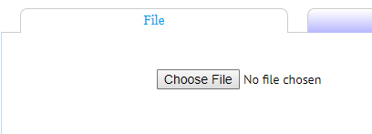

Step 4 of 10: Uploading E-Learning objects to EdShare

Once uploaded click on the Box Icon (to unpack the contents of your project)
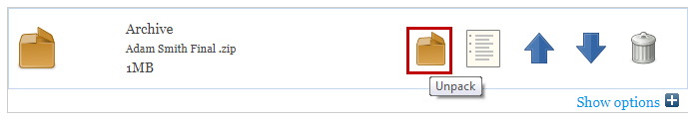

Step 5 of 10: Uploading E-Learning objects to EdShare

From the pop up that appears on screen select ‘Single’. Always make sure you select single as multiple will unpack your entire project into individual files. A second file will now display under the files section.
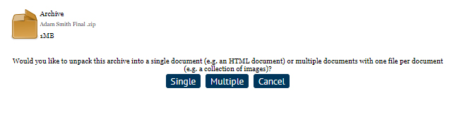

Step 6 of 10: Uploading E-Learning objects to EdShare

Next to this second file click the Files Icon, this will display a list of all the files that are part of your e-learning project.
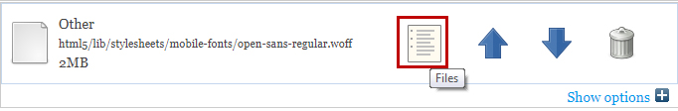

Step 7 of 10: Uploading E-Learning objects to EdShare

From the list, you should choose which item to make your main file. This may vary depending on what package you used, it may be an html or html5 file called either ‘index’ or ‘main’. After you’ve chosen your main file, scroll down and click on the apply button.
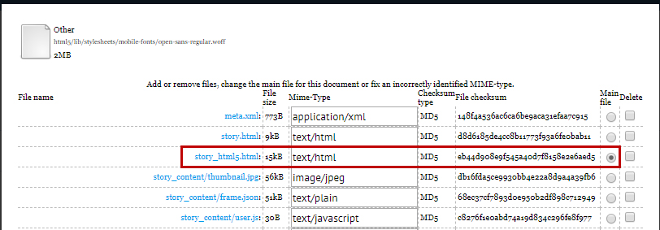

Step 8 of 10: Uploading E-Learning objects to EdShare

You will notice an additional symbol has appeared next to the second file indicating it’s now the main file. Click on the up arrow on the second file to make it the main file so that it can be opened and viewed when clicked on by a user.
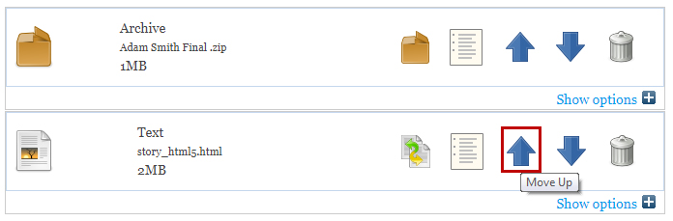
At this point, you can now delete the original zip folder if you wish.

Step 9 of 10: Uploading E-Learning objects to EdShare

Assign a licence to your e-Learning object by clicking on the show options text next to the file and choosing a licence from the drop-down menu. Provide a description for your object as well and then click on the ‘Update metadata button’.
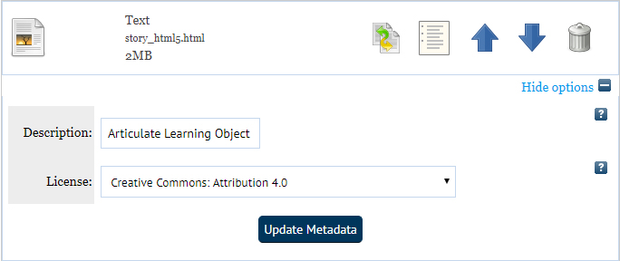

Step 10 of 10: Uploading E-Learning objects to EdShare

Fill in details for the resource information and other fields. After you have completed entering information within the fields scroll down and click on the ‘save and return’ button.
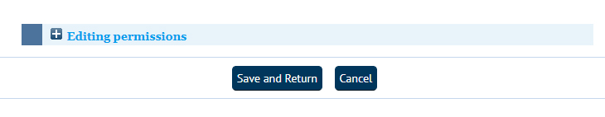

You’ll notice your e-Learning object does not generate a preview; this is due to the interactive nature of this type of file format. You can still view your object by click on the ‘Download’ text (please note you will not download anything by clicking on this text).
