Library
Knowledge Base

Finding eBooks

Table of Contents
Finding eBooks 2
Searching for eBooks – how search works on Library Search 2
Searching for specific books 2
Searching for books on a topic 3
Searching for books by a specific author 3
Evaluating search results – book records 3
Creating a book list 5

Finding eBooks
The easiest way to find eBooks is to use Library Search on the Library home page. When the Library purchases individual eBooks, eBook collections, or any other digital content these are added to the index on Library Search to make them discoverable. (Print material is also indexed.)
There is a Specific Search link under the search box which will allow you to choose to search for books.
You can then apply the Full Text Online filter on the left panel to limit results to just eBooks after you run a search:
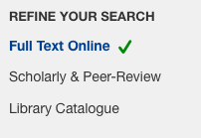
Alternatively, you can simply run a search from the main search box and apply the Books/eBooks filter and the Full Text Online filter on the left panel to limit your results to just eBooks.

Searching for eBooks – how search works on Library Search
Use keywords to retrieve books. The search function will search across the full book record. For print books this includes words in the following common fields:
Title
Author(s)
Publisher
Series Title
Book summary
Table of Contents/Chapter headings

For eBooks the search function will also search across the whole book.
The default search is across all fields, but you can use the Advanced Search option for more accuracy if you have too many search results or they are not relevant.

Searching for specific books
Put the title of the book between quotation marks. This is the most direct search. (It also works for journal articles.) Some examples:
“human resource management practices”
“systematic literature review method”
“writing a graduate thesis or dissertation”

Searching for books on a topic
Use combinations of keywords to retrieve relevant books. Use some basic search operators to focus your search (if desired).
Some examples:
Business AND “research methods”
“human rights law”
(dissertation OR thesis OR research*) AND (writing OR planning OR doing)

Searching for books by a specific author
Use the Advanced Search option to search for authors. The Advanced Search link is under the main search box. Choose the author option from the drop-down menu:
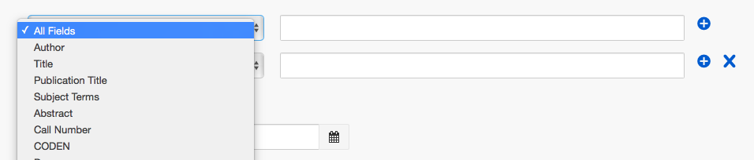

Evaluating search results for relevance – book records
Book records include book jacket images, metadata and summary information.:
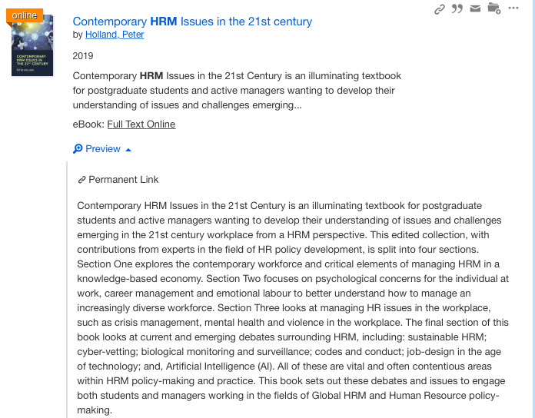
Connect to the full text by clicking on the hypertext title, or the Full Text Online link. Author names are hyperlinked to allow you to retrieve other works by the same author.
Records also include hyperlinked subject headings which you can use to link to related material:
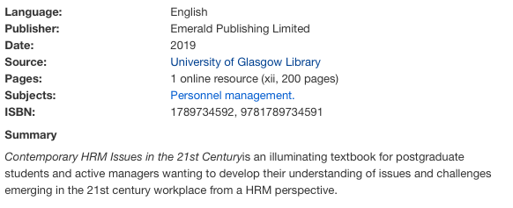

Creating a book list
Each record has icons which allow you to:
- Save items of interest
- Generate a stable URL linking to the record in Library Search
- Generate a quick reference in a style of your choice
- Email the item
To save items, click on the Folder icon to the right of the search result. This adds the item to a temporary folder. The icon turns red to indicate it has been added to the temporary folder.
Select all items of interest as you search.
To generate a reference list of the saved items, click on the temporary folder at the top right of the page. The folder will show the number of saved items in the folder:
You will see a list of all saved items with options to print or email these. They are displayed as seen on the search results page, but you can choose to display them in a reference format by choosing this from the drop-down option:
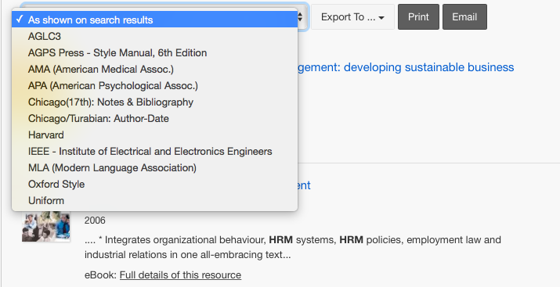
Results are shown in a list in the format of your choice (in the order you added them to the folder). Here is the saved list in Harvard format with links to the full text.
