Table of Contents
Search operators – Boolean AND 3
Search operators – Boolean OR 3
Search operators - Boolean NOT 4
Search operators – Wildcard and truncation 4
Search operators – phrase searching 5
Search operators – proximity or adjacency 6
Field searching 6
How to build a search – example searches 7
The search process 8
Finding versus searching – citation and other networks 9

Search operators – Boolean AND
Search operators are used in search engines and databases to combine search terms for more effective searching. Although there are database-specific operators their function is common across discovery tools. ​
​
​ 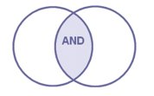
The Boolean AND​
Narrows and focusses a search by limiting results to records with all terms (phrases, authors, keywords, subject terms) Only records with all terms will be retrieved. ​
​
It is sometimes called the invisible AND as it is assumed by a search engine when you enter more than one keyword or phrase (without using an operator). The more keywords, the more focussed the search.

It can be represented by and, capital AND, & or a space. Check the database or search tool to see which to use. Capital AND is most commonly used. ​

Search operators – Boolean OR

The Boolean OR​
Broadens and expands a search by including records with any or all terms. It is very useful for synonyms, antonyms, related terms and alternative spellings.

This is useful when you are searching a multidisciplinary database or your research crosses disciplines (for example sociology, psychology and management). ​
​
It is often called the inclusive OR as it expands your search – to include alternative terms.

It is most commonly expressed as a capital OR, or small letter or. ​

Search operators - Boolean NOT
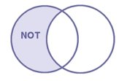
NOT​
Is a way to focus and limit search results by excluding records that contain certain keywords.

It can be useful if you are searching a large multidisciplinary index and you want to exclude concepts that may be implied by your search terms and which skew your results or if you are searching a very specific aspect of a topic. ​
​
An example might be "youth crime" NOT psychology to exclude material discussing the psychological aspects of youth crime. ​
​
It is the least used of the Boolean operators as you could exclude relevant material that happens to mention the concept, but which is nevertheless useful. ​

Search operators – Wildcard and truncation

Wildcard and truncation are common search operators that you may find useful. ​
​
Truncation​
Most commonly expressed as an asterisk * is a way to search for all forms of a word. It is usually used at the end of the stem of a word. You can use it simply to search singular and plural forms of a word or for more variations. ​
​
e.g. manage* searches: ​
Manage​
Manager​
Management​
Managerial
Managerialism etc.
​
Wildcard​
Is a bit like truncation but is more often used in the middle of a word – especially for alternative spellings. It is most often expressed as a question mark? or exclamation mark! ​
​
e.g. organi?ation - to search for organisation OR organization​

Search operators – phrase searching

"…......."​
Enclosing words in speech marks is a way to instruct a database or search engine to retrieve records with these words always together and in this order. It is a common operator and is used in almost all discovery tools. It is a way to focus and narrow a search and ensure that results are more relevant. ​

If you search for a phrase without using speech marks, most search engines will assume an AND between the terms and retrieve all records with these words whether they are in a phrase or not. It can make a vast difference to the volume of search results.

Only use for phrases that you would expect to find in the literature e.g. “transformational leadership”, “human capital”, “organizational success”, “employee engagement” etc.
​
It is also useful for finding specific books or journal articles – put the title between speech marks. ​
​
For related terms you can use a proximity operator (see next section) instead. Use your judgement to decide if you are really searching for a phrase or related terms.

Search operators – proximity or adjacency
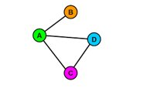

Adjacency or proximity operators are ways to retrieve records where terms appear near to one another. They are useful when you are searching across the full text of a document and need to focus your search results. (Other ways to search for words near to one another is to use a field search – see next section.)
​
Proximity operators focus your search and work well when a phrase search would be too restrictive or is not appropriate.

The most common way to express a proximity operator is with ADJ/n or NEAR/n where n is replaced by a number. In Library Search a proximity operator is expressed as "x.. x.."~n where x are adjacent terms and n is a number. ​
​
e.g. "innovation leadership"~10 would find records where the terms innovation and leadership appear within 10 words of each other. ​

Field searching
Records in a database – for example book chapters, journal articles, theses, conference proceedings, business or industry reports – are indexed using fields. Fields are sections of a record – most commonly: ​
​
- Author​
- Title​
- Abstract​
- Subject heading​
- Source or publication title​
- Affiliation (the author's place of work/university/college) ​
- Full text​

Using the Advanced Search screen in databases, you can match search terms against just these fields. This is a very effective way to focus a search. ​
​
You can combine a search using more than one field – e.g. a keyword in the full text combined with author or a source, to find works on a topic by a particular author or in a specific journal.

In the example below [taken from the EBSCO database Business Source Premier], the search is across the full text of articles in the journal Academy of Management Journal.

Use the drop down to the right of search boxes to choose the field you want to search. Use any combination or single search as required. The default search is across all fields.

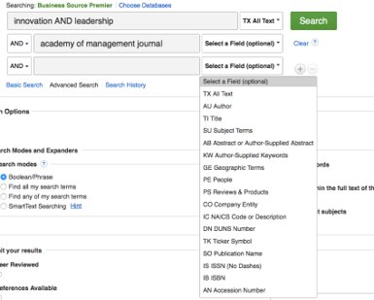

How to build a search – example searches
Brackets and nesting​
Use brackets to structure your search – especially where you are searching for related/alternative terms using the OR operator. This is called nesting and is a way to control your search. It overrides any search order in a database. ​
​
Here are some search examples using operators, synonyms and related terms to focus searches. These can be used to search across the full text of a document or in field searches e.g. matching search terms to the journal abstract only.

​
(employee* OR worker*) AND (engagement OR motivat*) AND ("business success” OR growth OR "organisational success”)

"transformation leadership"~10 AND "organizational performance"​
​
(organisation* OR organization* OR business) AND (success* OR growth OR expansion) AND (leadership OR innovation OR strategy) ​
​
("case study" OR survey OR interview OR questionnaire) AND "strategic innovation" AND ("SMEs" OR "small and medium sized enterprises”) ​

The search process

Searching is an iterative process. It is a form of extended exploration in which you start with a knowledge gap and move through a process of searching, reviewing results, perhaps changing search terms or discovery tool, searching again, evaluating the information you find, and identifying new knowledge gaps.

Finding versus searching – citation and other networks
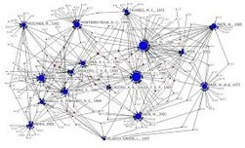

You will not search for all the sources of information that you use in your dissertation or research project. A very large proportion of what you use will come from information that you find as you read – from reference lists, from the citing literature, from database recommendations ('similar articles' and 'related searches' prompts) and from recommendations from other people. ​
​
Use the information that you find fully to exploit these connections: ​
​
- Use the reference lists in articles and books that you read to identify key sources of information [where did the author get the statistical data or survey results?] ​
- Use Google Scholar or citation paths in search engines and databases to find the citing literature. What are other authors saying about this paper? This is also useful for identifying more up-to-date papers on the same or related topics.
- Use advanced features in databases to locate related items – I.e. from the same authors, from papers with the same major subject headings or from papers citing the same sources etc.​

