Table of Contents
Comparison with others 3
Blurring of work/life boundaries 5
Constant checking 6
Sleep problems 8

Comparison with others

Platforms such as Facebook and Instagram encourage you to view continual feeds of friends' posts, meaning that it's easy to stay up to date with their lives. However, these posts often project the kind of life that the user wants to portray, rather than a balanced view of their day-to-day existence. It's easy to compare your own life to these specially curated moments and feel like a failure in comparison.
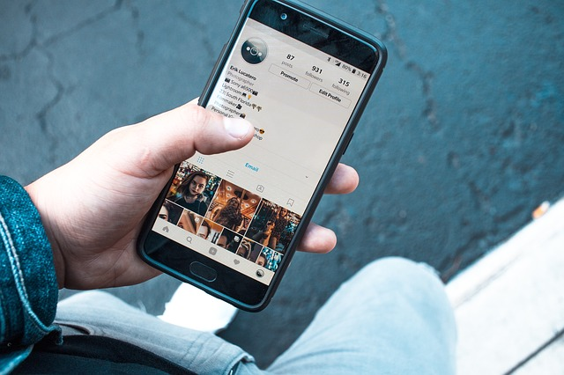

How to look after yourself
- Remember that you are comparing your insides with someone else’s outsides. They are purposefully curating a certain view of themselves and you aren't seeing the whole picture.
- If certain people's feeds lead you to feel particularly upset, consider removing them from your newsfeed or unfollowing them.
- Consider why the comparisons are upsetting you - it might be worth talking to someone about this if you feel it's really affecting you.
- Speaking to someone via direct message or in person might help break past that shiny online polish.
- Sometimes sharing your own difficulties, while scary, can help other people to feel less alone.

You can read more information about this area, by clicking on the links below:
- Huffington Post: 3 tips on how to stop comparing yourself on social media
- The Atlantic: The psychology of healthy Facebook Use: No comparing to other lives
- Tiny Buddha: Why we compare ourselves to others on social media and how to stop
Please note, the above links all open in new browser windows

Blurring of work/life boundaries

Feedback suggests that many of you organise study-related activities, and follow study-related accounts, on your personal social media (e.g. Facebook). You reported that this can make it really difficult to switch off from work: When you're relaxing on social media at home, reminders of work pop into your feeds and conversations.
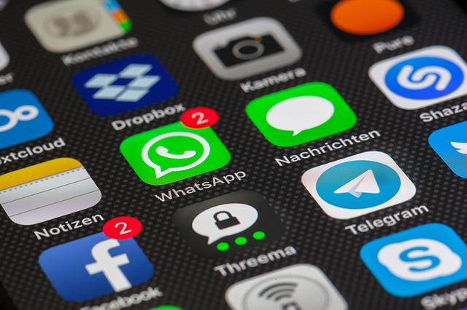

How to look after yourself
- Consider communicating using a different platform for study-related things. A good example of this is Yammer, which is a University-supported social networking tool
- Think about following study-related accounts on a separate platform. For example, you could use Facebook for personal things, and Twitter for more professional interests
- Unfollow work-related accounts, or have a separate list (e.g. on Twitter) for interesting professional accounts
Click on the link below to view Yammer (supported at UofG)
- Yammer (this link will open in a new browser window)

Constant checking

It can be easy to check social media platforms increasingly frequently. Reasons for this can include fear of missing out on social interaction and activities (FOMO); excitement about receiving positive feedback on your posts; or nervousness about receiving a negative interaction.
Checking can send your brain reward chemicals, which can make it hard to stop (a bit like eating chocolate).
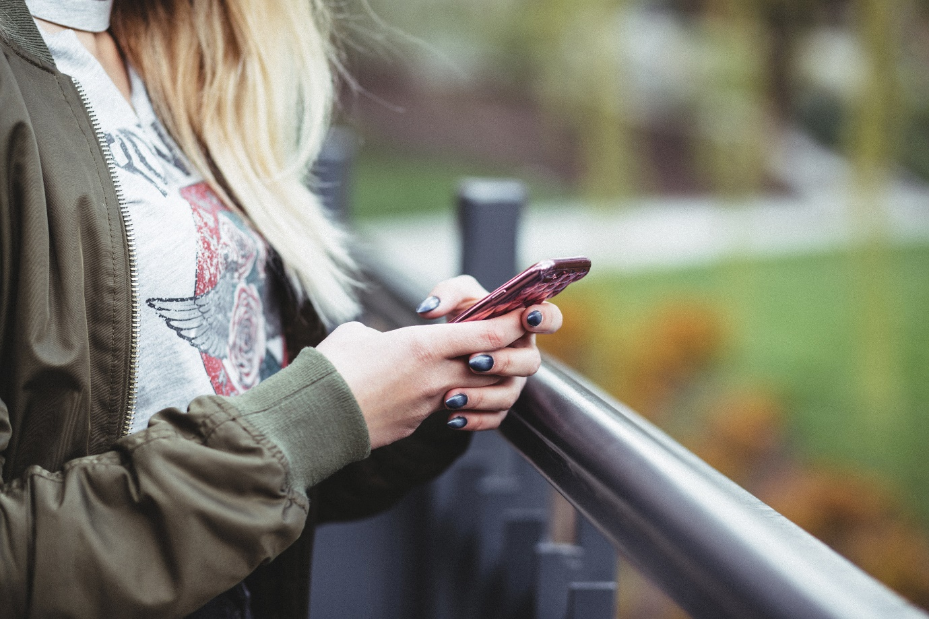

How to look after yourself
- Set yourself certain times to check your social media
- Talk to your friends on the phone or face-to-face
- If you're receiving negative feedback from particular people, consider blocking them, or speaking with them to address the issue
- Pay attention to how often you're checking and try waiting just 10 minutes longer. This can help to break the cycle of reflexively checking whenever you get the impulse.

For more information on FOMO, click on the links below to view news articles focusing on this area:
- BBC: FOMO: How the Fear of Missing Out drives social media 'addiction'
- Huffington Post: Social Media, FOMO and the Perfect Storm for the Quarter-Life Crisis
- Academic paper: Motivational, emotional, and behavioral correlates of fear of missing out
- Academic paper: College students’ academic motivation, media engagement and fear of missing out
- Academic paper: Social Media Use and the Fear of Missing Out (FoMO) While Studying Abroad
Please note, the above links will open in new browser windows.

Sleep problems

A recent study (2016) has shown a correlation between social media use and sleep disturbance. Click on the link below to explore the study and view some suggestions for combatting this issue.
Huffington post article: Tweeting, Not Sleeping? What Is Your Social Media/Sleep Balance? (this link will open in a new browser window)

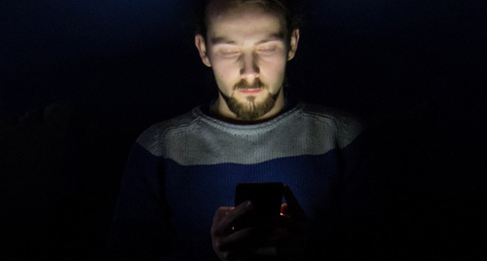

How to look after yourself
- Charge your phone/tablet away from your bed, preferably out of the room (or on silent mode in a different part of the room)
- Stay away from screens for an hour before you go to bed (build up to this if it's tough at first)
- Use this time for reading (not study books), stretching, or mindfulness/breathing exercises
- Don't check your devices if you wake in the night

