Library

Guide for new Law students
Finding Cases

Contents
Finding Cases Online 3
Westlaw UK 3
Searching for cases on Westlaw 3
Case analysis 4
Case status icons 5
Lexis+ 5
Finding cases in print 6
Law Reports 6
Current law and legal encyclopaedia 6
Library help 6

Finding Cases Online
Most of the cases you will be using are available in full text from the legal databases Westlaw UK or Lexis+. Westlaw UK and Lexis+ are specialist legal subscription databases which are updated regularly to reflect changes to the law. To access these, use the links provided via the library website to ensure that you can use your GUID and password.
To access go to the Law Key Databases list on the Library website and select either Westlaw UK or Lexis+ from the alphabetical list. Click on the database name and you will be prompted for your GUID and password.

Westlaw UK
The Westlaw UK database is intuitive to use and provides access to full text case reports and case analysis of decisions, including the authoritative case reports for England & Wales and Scotland as well as and PDFs of judgements of court decisions.
Full coverage of:
- Scottish Session Cases
- The Law Reports series – Appeal Cases, Queen’s bench or King’s Bench, Chancery and Family
As well as key care reports series, including:
- Scots Law Times
- Scottish Civil Case Reports
- Scottish Criminal Case Reports
- Weekly Law Reports
- Industrial Cases Reports
- Business Law Reports

Searching for cases on Westlaw
Westlaw has different types of legal materials - cases, legislation, journal articles, books, and commentary. To find cases click on the Cases tab at the top of the homepage to go to the Cases Search form.
If you have a specific case you want to find, you can search by case citation or party names.
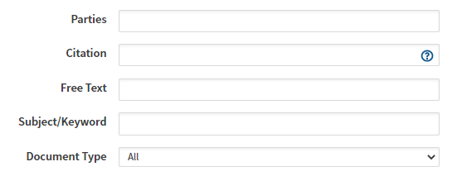
By case citation is the most efficient way as the citation is unique. Taking the example of:
Cadder (Peter) v HM Advocate 2011 S.C. (U.K.S.C.) 13
On the cases search screen, put the citation 2011 S.C. (U.K.S.C.) 13 into the search screen at Citation, or Cadder (Peter) v HM Advocate in the Parties search box.
To find cases on a particular topic, you can search by subject terms/keywords or free text. Subject terms and keywords are applied to cases indexed on Westlaw. Here is an example showing how these have been applied to a case:
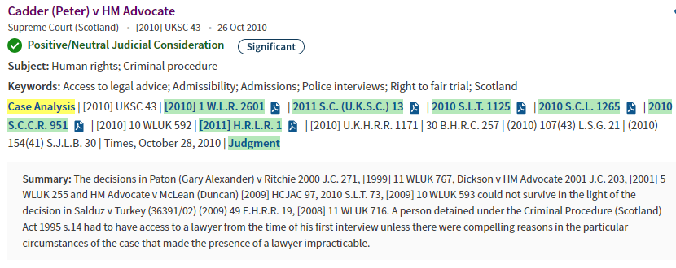
Click on the Westlaw logo to return to the main landing page. You will see a list of legal topics. These are expert overviews on an area of law, and in each key cases and legislation are listed and discussed. This is a useful way to find key cases in an area of law.
For example, if I choose to look at the overview article on ‘Human rights,’ as well as a narrative overview, significant cases are discussed and hyperlinked.

Case analysis
Case information in Westlaw, includes the powerful ‘case analysis’ feature. This brings together primary references (cases and legislation cited, and all cases citing), commentary references (books and journals discussing the case or judgement) as well as the case report itself. This means you have access to in-depth information about the case helping you to understand it.

Case status icons
In Westlaw, the status of a case is indicated by icons. Cases may:
- have received positive or neutral treatment (Approved, Followed, Applied, Distinguished, Cited, Considered, Referred to or Explained)
- have received mixed consideration (Disapproved, Doubted, Not Applied, Not Followed)
- has received negative consideration (Overruled, Reversed, Superseded in whole or in part and should no longer be considered ‘good law’)
- has an appeal outstanding
- has received no substantial treatment

Guidance and Significant labels
Cases may also be marked as ‘Guidance’ or ‘Significant.’ A case is deemed ‘Significant’ if it sets out new legal principles, extends the law, applies established principles to a new situation, overturns established legal authority, interprets, or defines statutory and non-statutory words and phrases, or is stated by the judge to be of public importance.
A case is regarded as a ‘Guidance’ case if it gives legal or procedural guidance or reinforces or explains existing guidance.
See the full search guides on Westlaw for more information on finding cases.

Lexis+
Lexis+ Legal Research has full text case reports and official transcripts. Case content is not the same between Westlaw and Lexis+. To see the case reports included in Lexis+, click on the View All Sources prompt to see the full list.
From the main search page, choose Legal Research, then Content and Cases to use the Cases search screen. From there, select the Advanced Search option which will allow you to search by party names (Case Name) or citation.
On the overview of the case, you will be able to read the catchwords and digest, explain what the case is about and a summary of the decision. There are also links to cases considered by the case as well as any subsequent cases citing this one.
When you link through to a case report, as well as the report there are links to ‘Related Documents’ which includes links to any commentary on the case in practitioner sources, as well as in books and journals.
See training materials for more help using Lexis+ https://lexisnexisuk.custhelp.com/app/lexisplus

Finding cases in print

Law Reports
If you have a case citation, it is easy to find cases in print in the library. Law Reports are shelved alphabetically and by year, and are stored in the Library Annexe on Level 7 in the Main Library.
If you know the year of the published case, find the case reports series on the shelf and go to the appropriate page which you will find in the case citation. For example,
Cadder (Peter) v HM Advocate 2011 S.C. (U.K.S.C.) 13
the case is printed at page 13 in the 2011 volume of the Session Cases.

Current law and legal encyclopaedia
If you want to find cases on a specific subject but you do not have a citation, there are printed sources you can use to help.
Cases are listed by subject in the major encyclopaedia for the laws of Scotland:

- Stair Memorial Encyclopaedia (Laws of Scotland) [available in print and online]

The major encyclopedia for the laws of England and Wales Halsbury’s Laws of England, is available online only.
Cases are listed by subject in the Current Law service –

- Current Law Monthly Digests and Current Law Yearbook [also indexed online in Westlaw]

You can also check the Tables of Cases in legal textbooks for key cases. Remember that the decisions in cases can be overturned so always check for any treatment of the case in court. Use the legal databases to do that.

Library help
There is a specialist helpdesk on level 7 where staff are trained in legal sources. They can help you if you are struggling to find something. The desk is staffed Monday-Friday 09:00-17:00.
Alternatively, email library@glasgow.ac.uk and staff will help.

