Instructions for accessing Eikon and Datastream



[Photo by [Sunil Ray](https://unsplash.com/@ray027?utm_source=unsplash&utm_medium=referral&utm_content=creditCopyText) on [Unsplash](https://unsplash.com/s/photos/computer-keyboard?utm_source=unsplash&utm_medium=referral&utm_content=creditCopyText)]

Contents

Connecting to Eikon 2

Launching Eikon 3

Signing in and out and saving files 4

Signing In 4

Signing Out 5

When you have finished using Eikon 5

Problems connecting to Eikon or Datastream 6

Training and support materials for using Eikon and Datastream 7

# Connecting to Eikon

You can use Eikon, and Datastream via Eikon on and off campus. Access is via a remote desktop.

Please be aware that access and usability can slow once users on the east coast of the U.S (United States). login (1 p.m. GMT/8 a.m. EST). Download times are therefore likely to be faster in the morning and after the end of the U.S. business day (10 p.m. GMT/5 p.m. EST).

Go to: <https://rdweb.wvd.microsoft.com/arm/webclient/index.html> and click on the Eikon Desktop icon.

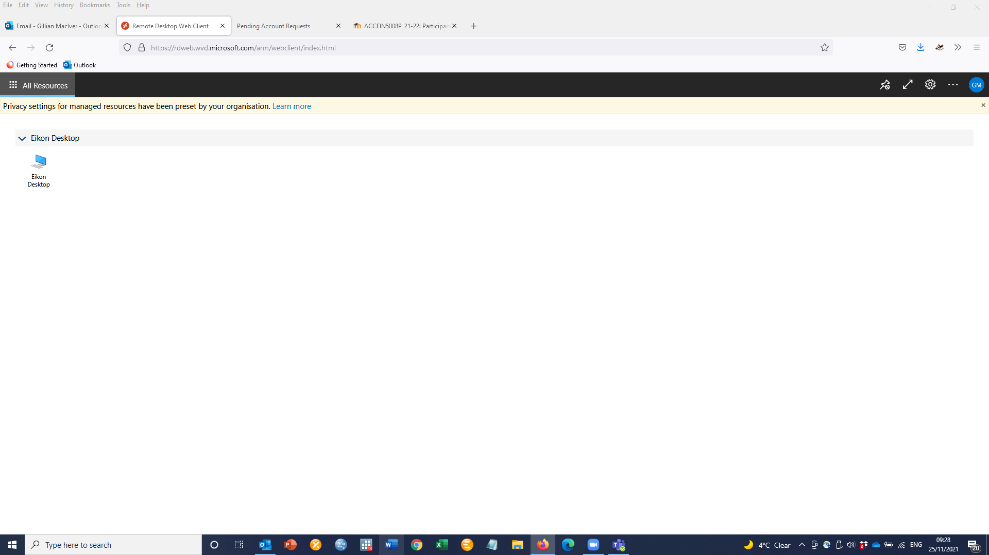

Select Allow from the pop-up window.

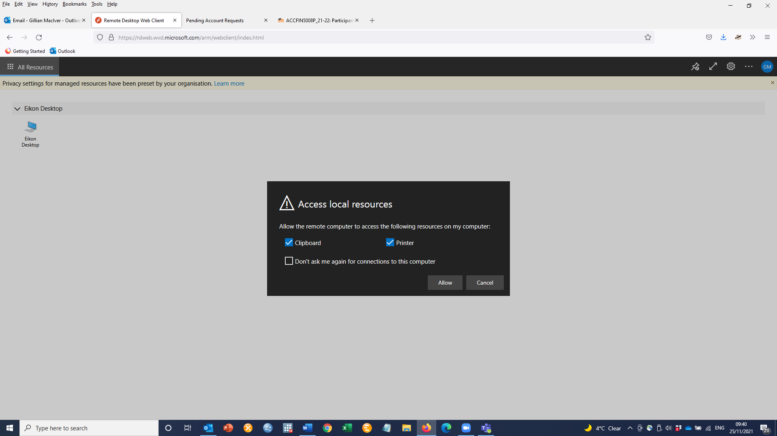

The username should populate with your university email address. If that does not happen automatically, type this in. You must use your university email account to access the databases. Enter your GUID (Glasgow Unique IDentifier) password and select Submit.

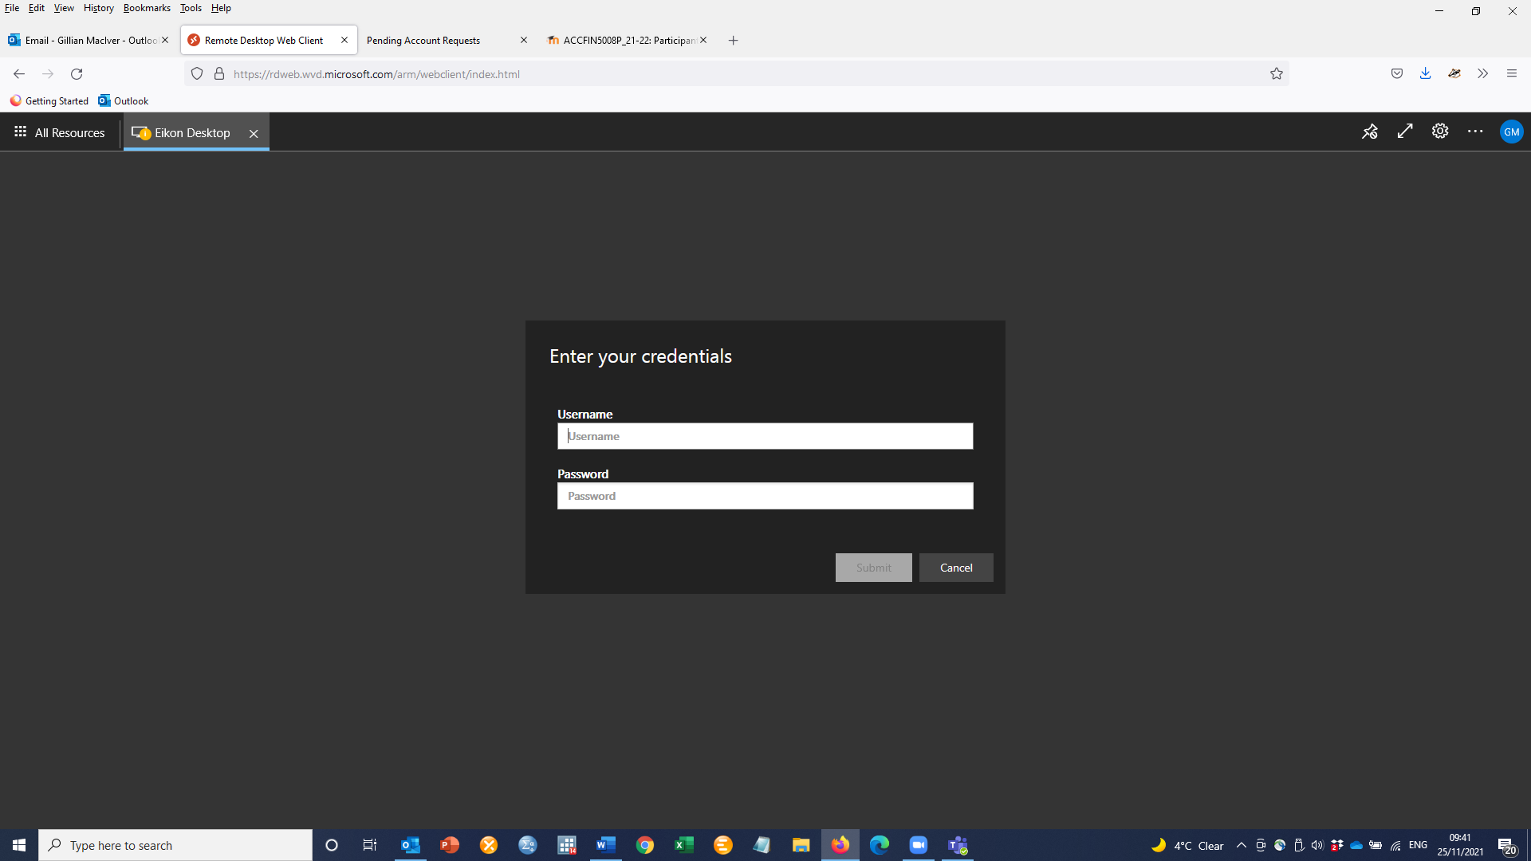

# Launching Eikon

Your personal profile settings will then be uploaded, and the remote desktop will be displayed. You will see two options – Eikon Excel Datastream and Eikon Main Application. Double click on the relevant Eikon icon to use that product. 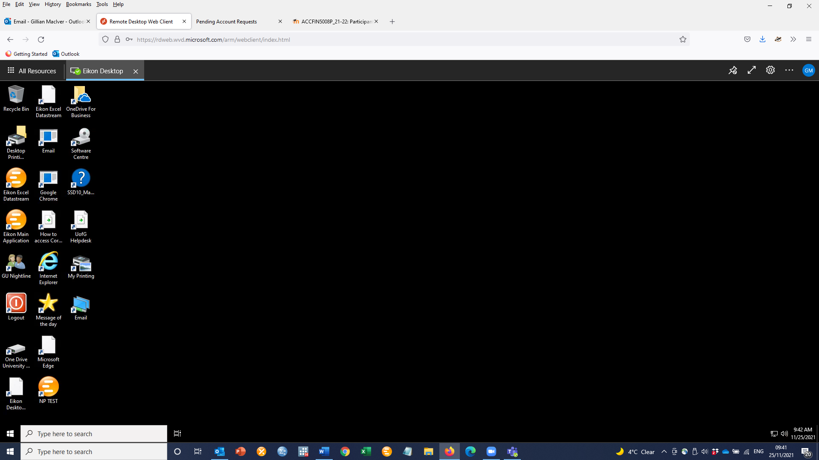

A Refinitiv pop-up window will display temporarily.

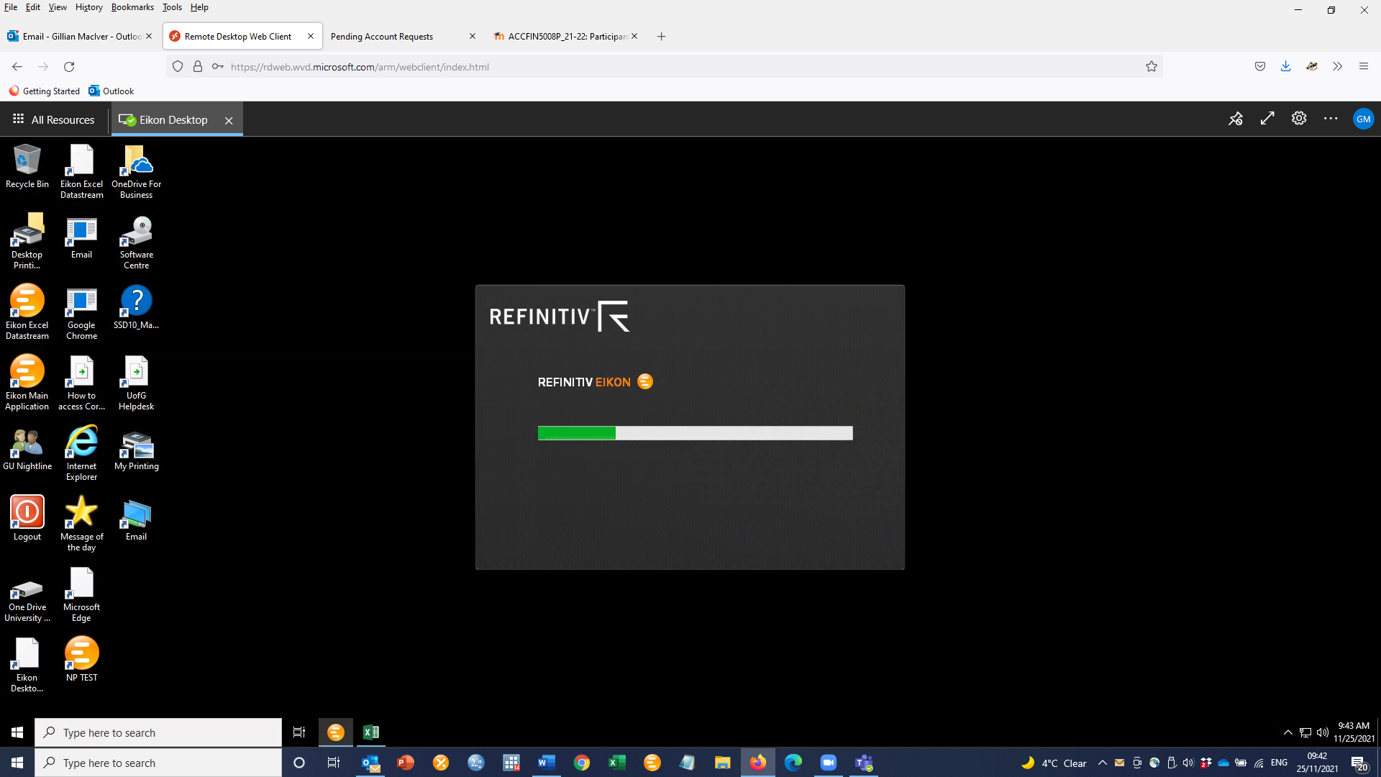

Using Eikon and DataStream in Excel

Datastream for Office (DFO) and Eikon Microsoft Office is the Microsoft Office add-in that enables you to build Excel models and reports using Datastream and Eikon datasets. See the Refinitiv training pages for more information on using [Eikon](https://training.refinitiv.com/eikon/) and [Datastream](https://training.refinitiv.com/datastream/) with Microsoft Office.

After selecting Eikon Excel Datastream, you will be transferred to Eikon’s Excel-based application. Select a blank workbook to begin.

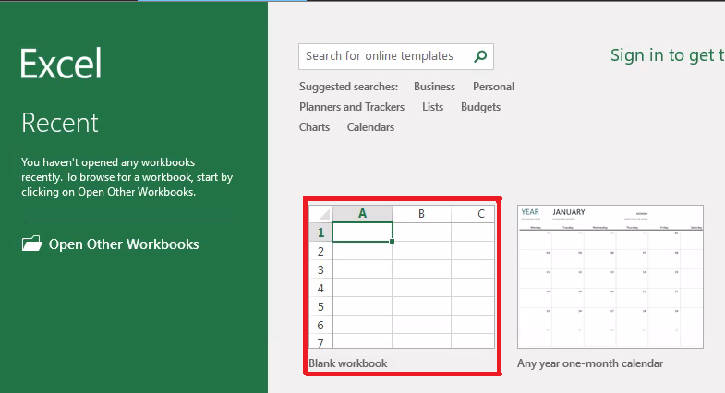

## Signing in and out and saving files

It is important you sign in and sign back out to avoid data loss or saving files in an unwanted location which may be accessible by others on shared devices.

### Signing In

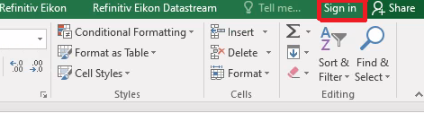

### Signing Out

Please ensure you sign out properly. Click on your name and choose the option to [1] Switch Account, the SIGN OUT option at the top of the screen [2] and finally the Sign out link [3] at the Current Account information.

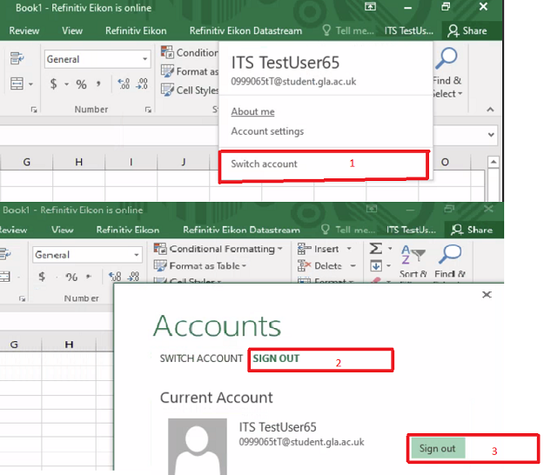

# 

# When you have finished using Eikon

## Logging out correctly

It is important that you log out from the remote desktop when you have finished using the application.

**When your session is finished, please use the red Logout icon on the Desktop to exit from the remote desktop.**

Logging off in this way improves performance and enables other users to connect to the service. Failing to logout stops others from using the service.

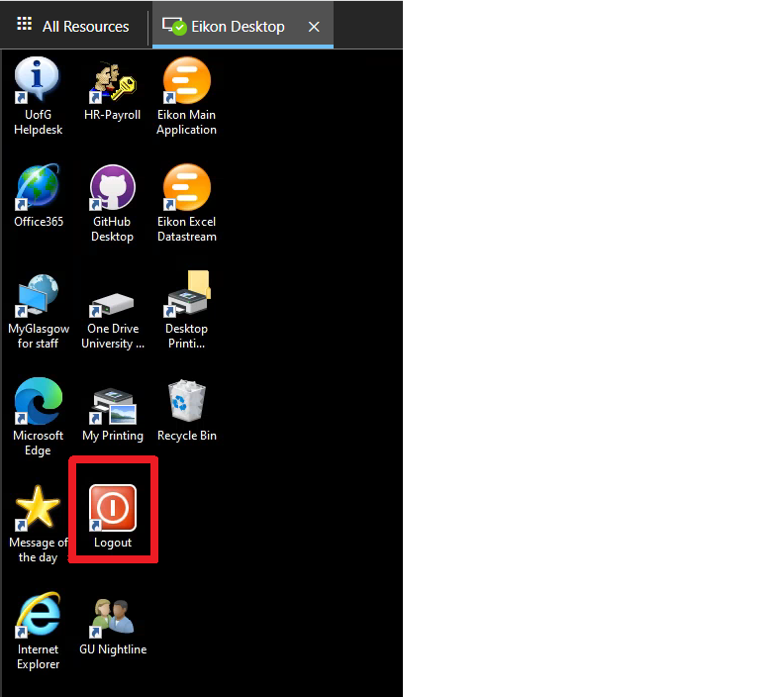

## 

## Logging out incorrectly

**Do not use the Sign Out or Shut Down option on the My Apps screen within Eikon.**  This creates access issues for other users as it logs out the service for the next user.

The MyApps page is only displayed from within the main Eikon application. **Please do not use the Sign Out or Shut down links.** Instead, please follow the instructions for logging out in the section above.

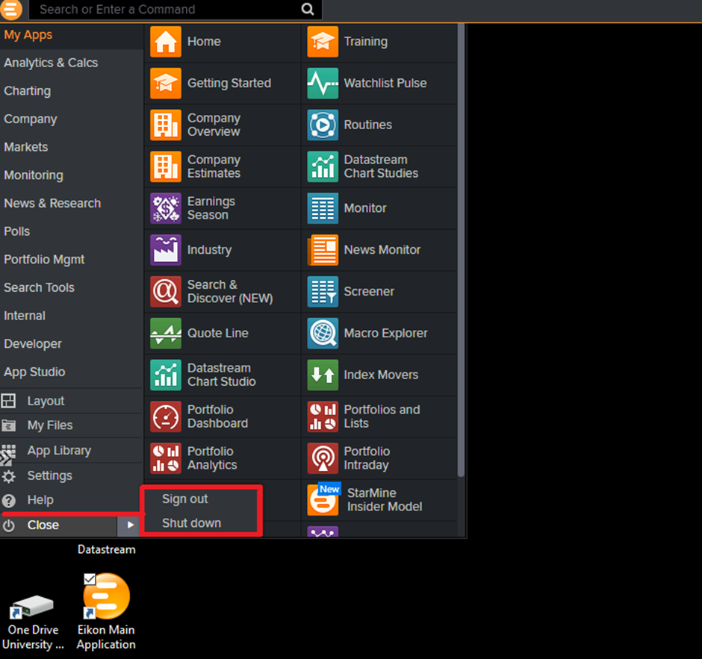

# Problems connecting to Eikon or Datastream

The IT-support access set up means that if the number of connections reaches 6 there are no more connections allowed. We have 6 Licenses for Eikon/Datastream and when all are in use and you try to connect, you will see an error message. If you see this message (below), try accessing again later.

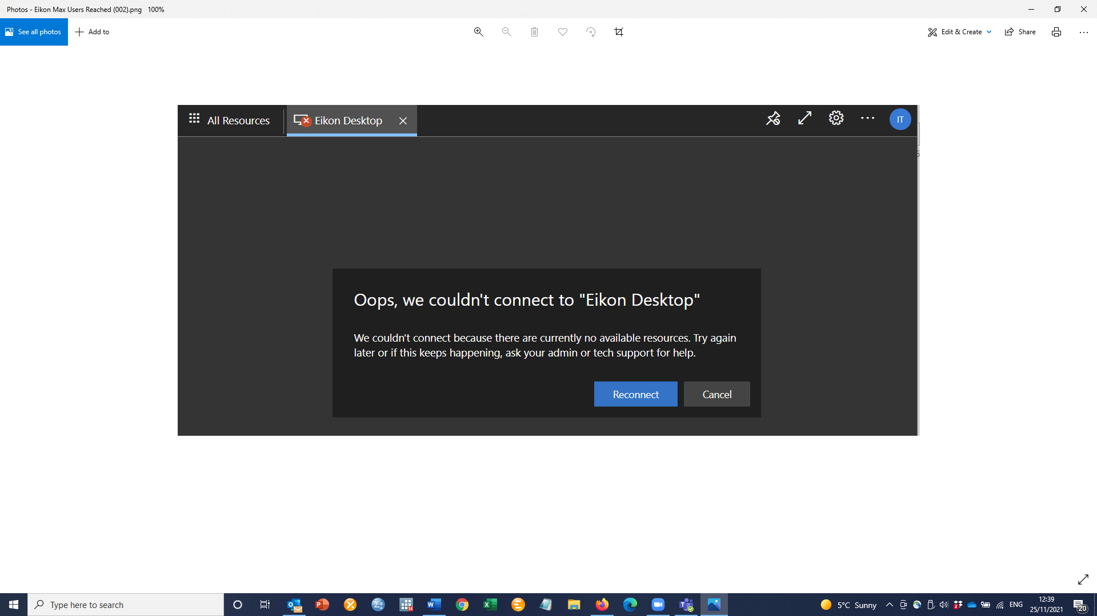

For any other technical issues accessing Eikon or Datastream, please log a call with the UofG (University of Glasgow) Helpdesk. <https://www.gla.ac.uk/myglasgow/it/helpdesk/>

# Training and support materials for using Eikon and Datastream

### Refinitiv training material

Refinitiv (the company who own and develop these products) provides comprehensive training guides and videos. To see the full range, access their webpage at <https://www.refinitiv.com/en/learning-centre>

### On-demand training and certification

You can learn at your own pace by using the on-demand catalogue of training to upskill at your own pace. The content is foundational and covers core functionality to help you become a more efficient user. When you are ready, you can request a test token to take the test and become certified Datastream or Eikon user. The course and certification is free. Add it to your CV to show prospective employers that you have completed the training. <https://www.refinitiv.com/en/learning-centre/certification>

[Updated February 2022]