Library

Using Arts subject databases:
how to search

Table of Contents
Introduction 4
Why use databases? Isn’t Google enough? 4
How do I know which database to use? 5
Types of database 5
Bibliographic databases 6
Full text databases 6
Primary source databases and other types 7
Searching databases: the basics 7
Combining keywords 7
Full text searching 8
Other search techniques 8
Exporting your results 8
What to do if you don’t find much 9
Get more help 9

Introduction

Subject databases are a key tool for finding information for an assignment or dissertation. This guide will explain what they are and how to use them.
Databases cover a wide range of subjects – some are multidisciplinary, and others cover more specific subjects. There are various different types of database. For most Arts subjects you need to search a range of databases to find all the publications relevant to your topic.

Why use databases? Isn’t Google enough?

Databases are designed specifically to help you find good quality academic information from sources that have undergone some form of evaluation or peer review. Search engines such as Google and Google Scholar are useful in a range of ways, and you can use them to find academic information but you need to be aware of the pros and cons.
Databases:
Strengths - enable you to find high quality, peer reviewed information. Help you to perform a comprehensive search for material on your topic.
Weaknesses -There are a lot of databases, and you need to know which are the best ones to use for your search. Not all databases give direct links to full text, so you may need to go back and check Library Search to see if we have the publication you need.
Search engines
Strengths – finding answers to specific questions, getting an overview of a new topic, getting some information where you are struggling to find anything on a topic, finding information on current or recent topics, finding openly available material.
Weaknesses – potential poor quality of information – there is no quality control of information, some of which will be inaccurate, biased or unreliable. Too much information – hard to filter down results to a manageable level. Tailored search results if you have a Google account – not always helpful for academic searching, as material may be filtered out.

How do I know which database to use?

The Library gives you access to lots of different databases – how do you know which are best for your topic area? On the Library home page you’ll find links to Databases. Have a look at the listing for your subject area by using the subject drop-down menu. You can also look for databases by type (e.g. streaming databases, primary source databases). Each subject has a list of Key Databases – these are the most generally useful ones to start out with.
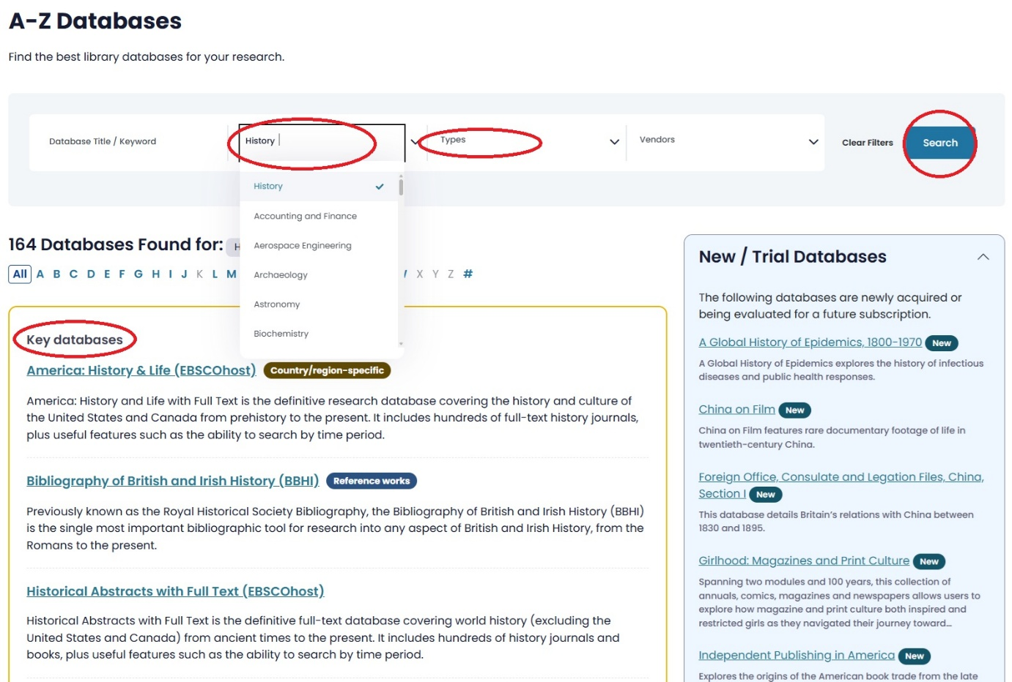
You may also find it useful to get in touch with your College Librarian, who will be able to advise you on the best databases to use for your topic.

Types of database

As well as covering different subject areas databases also fall into a number of different categories.
- Bibliographic
- Full text
- Primary source

Bibliographic/hybrid databases

You are only searching the details of publications (e.g. author, title, abstract, subject headings), not the full text. You may need to keep your search terms quite broad to pick up enough relevant results. You may need to return to Library Search to check if we have the publication you have found out about. Some bibliographic databases try to link back to the Library's search systems (as shown below). However, this doesn't always work, so if in doubt use Library Search directly to check if we have what you need. Some databases are hybrid – in other words, a mix of bibliographic details and full text.
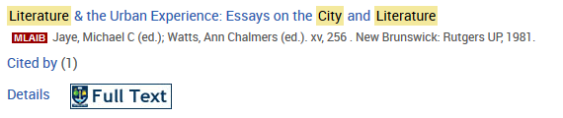
Bibliographic databases may not seem as immediately appealing as full text databases, but don’t dismiss them – for some subjects they may be the main way of finding out about books and articles.

Full text databases

You are searching the full text of contents of the database, and can immediately open and read any publications you are interested in. Bear in mind that you will often get a lot of results, and may need to limit your search by adding more keywords, choosing to search in Title only, or by limiting by date/language/subject area.
Some examples of full text databases are: JSTOR, Periodicals Archive Online, FIAF International Index to Film Periodicals Plus.

Primary source databases and other types

These databases offer the full text of original publications such as letters, manuscripts etc.
Other types of databases include streaming databases (e.g. the Naxos Music Library, Routledge Performance Archive) and annotated bibliographies (e.g. Oxford Bibliographies Online).

Searching databases: the basics

The Library offers you access to many different databases. The way in which you search them is usually very similar, although some of them may offer different features. Nearly all databases will have a Help section, so use this to get specific information about how an individual database works.
Come up with your keywords: do this before you start searching. Think of synonyms, related words, different forms of a word.
Searching options – basic and advanced search: most databases will default to a basic search. Usually you can add more than one keyword, and the database will find results where all the words appear. Advanced search will allow you to be more sophisticated with your searching.

Combining keywords

Usually you'll need to search for more than one keyword. You might want to look for two or more keywords with the same or similar meaning. Some databases allow you to do this using separate search boxes – others require you to combine using brackets, e.g. other databases allow you to do this using brackets, e.g. German AND (film OR cinema). This search will find results that include either German and film or German and cinema.
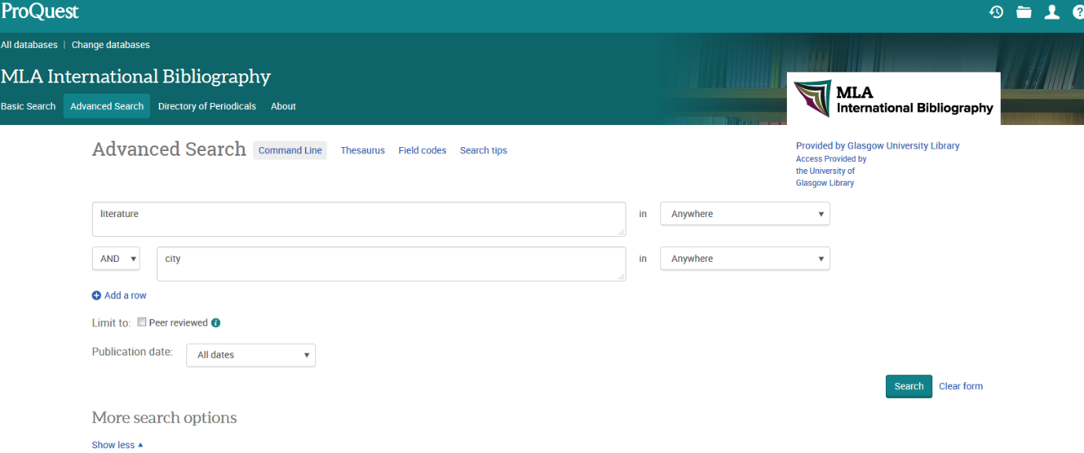

Full text searching

If you are searching the full text in a database (e.g. JSTOR) your initial search may produce lots of results. Some databases allow you to manipulate your search so that you are searching e.g. titles and abstract only. This should produce more relevant results. Some databases also enable you to do what's called proximity searching - in other words you specific that your keywords must be near one another.

Other search techniques

Truncation: most databases don’t automatically search for different forms of a word. Using a truncation symbol allows you to do this. Many databases use the * symbol to do this, e.g. scot* will find Scotland, Scottish, Scots etc..
Phrase searching: it can sometimes be useful to look for an exact phrase rather than two separate words. Many databases use quotation marks to do this e.g. “early music”.
Proximity searching: some databases such as JSTOR allow you to look for words near other words in order to make your search more relevant. Check the Help section of the database to find out if this is possible and how to do it.

Exporting your results

Databases usually allow you to save useful results in a variety of ways. This normally includes e-mailing, printing and exporting to bibliographic software such as EndNote or Zotero. Look for icons (as shown below) or a section called Export. You may sometimes need to add items to a folder first.

Different databases will have different ways of doing this, so have a look at the Help section if you’re not sure.

What to do if you don’t find much

There are a number of reasons why you may not get lots of relevant results straight away when you search a subject database. Here are some possibilities:
- The database may not include details of publications on your topic
- You need to think of alternative keywords (think of synonyms, related words, broader concepts)
- You have misspelt on or more of your keywords
- Your topic is not well covered by subject databases (e.g. you are looking for information on a topic that is very current, or a local topic that is not covered by academic books and journals.
If you are having problems finding information on your topic you can get advice from your College Librarian. See the ‘Get more help’ section for information on how to et in touch with us.

Get more help

If you need help working out which search tools will be most helpful for your topic you can get in touch with your College Librarian.
Morag Greig (morag.greig@glasgow.ac.uk) and Kirsteen Valenti (kirsteen.valenti@glasgaow.ac.uk) are the Arts College Librarians. See the Subject Guides page to find out who supports your subject area.

