
Using Library Search



Photo by Andras Vas on Unsplash

Contents
What is Library Search? 3
Accessing Library Search on and off campus 3
How to search 4
Using search operators 4
Advanced Search 6
Refining your search results using filters 6
Detailed item records - books 9
Detailed item records – journal articles 10
Saving Results 11
Saving to EndNote 12

What is Library Search?

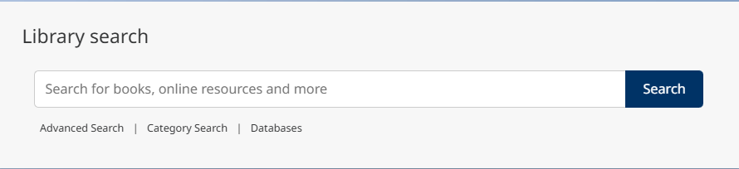
Library Search allows you to find and link to full-text material, including journal articles, books, and book chapters across all subjects in the library’s collections. Other indexed materials include newspaper articles, trade publications (professional literature) and conference proceedings.
Coverage: Library Search indexes most of the information that the library buys, owns or licences. This includes print and ebook collections, individual books, journals we buy directly from publishers, journal articles in databases, as well as book chapters and other types of information in databases. We also include open access books and articles. This makes it an excellent starting point for finding information.
There is some material that is not included in Library Search because of restrictions imposed by publishers and linking issues with some resources. If you are looking for some specific types of information, e.g., music scores, use the Category Search option under the Library Search box or a subject database for legal information such as case law or legislation. ask for help if you are not sure.

Accessing Library Search on and off campus

Library Search is on the Library homepage. You do not need to log in to search. You will only be prompted to log in when you want to read full text digital documents. When you run a search, you will see a prompt at the top of the screen ‘Sign in for the full experience’. Click on the Sign in link to log in with your UofG credentials.
Logging in is not essential for running searches, but it will mean that you avoid having to log into individual ebooks and ejournals when you want to access the full text.

How to search
Library Search is quick and easy to use. You can find information in a few simple steps:
- Enter search terms or phrases into the single search box
- Refine results using filters
  - to link directly to full text or more information
  - for information on print holdings

Library Search searches across print and online resources but you can limit results to full text online resources if you want to, for example if you are studying remotely.

Start your search by entering key words or phrases into the search box. You may be searching for a specific book, journal article or for information on a topic you want to research.

You can simply add the keywords to the search box, or you can use some search operators to make the search more effective.

Search operators focus or broaden a search to make it more comprehensive or specific. They can help you to get to the information you need more quickly, especially when you are searching across such a large amount of information.

Using search operators

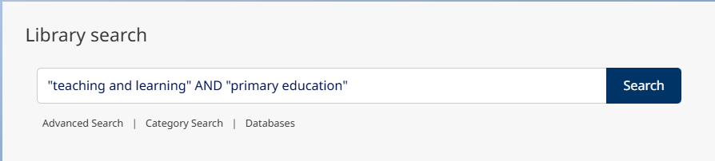
This example – “teaching and learning” AND “primary education” - uses a phrase search and the AND operator. This search will find documents with both phrases. If you simply added all the words in the search box without the quotation marks, you would get many more (less relevant) results.

Phrase searching
Use quotation marks when you want to search for a phrase. Some examples: "primary education", “human resource management”, “medical imaging”, “sustainable engineering”, “science fiction”.

Using quotation marks means that the words are searched together in a specific order. It ensures that only items with this phrase are retrieved which can make a big difference to the volume of results.

Only use quotation marks when you are searching for a phrase. Note that on Library Search, you cannot use truncation (see below) within phrases.
AND, OR and NOT (Boolean operators)
Use the operators 'AND', 'OR' and 'NOT' to focus or widen your searches. Boolean operators are common to most databases and search engines. You do not have to use capitals for the search operators on Library Search, but it can be helpful to distinguish search operators from search terms.

- AND combines search terms and focusses a search as all terms must appear in the search result. You can use a + sign in place of AND.
- OR broadens a search and is a way to search for related or synonymous terms.
- NOT allows you to exclude results from a search. You can use a minus sign – in place of NOT.

Here are some examples:

- “higher education” AND “student voice”
- (youth OR teenager OR “young adult” OR adolescent) AND (drugs OR alcohol)
- “citizen education” NOT voting

Use brackets to control the search when you are combining multiple search concepts.

Truncation and wildcards
Use an asterisk on the stem of word to find different endings. Some examples:

- psycholog* will find psychology, psychologist, psychological
- manage* will find manage, manager, managerial, managerialism

Use the hash sign # within a word to replace a single letter. This is useful for alternative spellings and some plurals. Some examples:

- organi#ation to find organisation or organization
- wom#n to find woman or women

Use a question mark ? within a word to replace 0-9 characters in a search term. You can use the ? on its own or specify the number of letters. Some examples:

- encyclop?dia to find encyclopedia or encyclopaedia
- res?4tion to find respiration, restoration, reservation etc.

Advanced Search
If you are finding too many results or want to set some limits before you search, you can use the ‘Advanced search’ option. This lets you limit your search to specific fields in a record e.g., the author, title or abstract. You can also specify filters for the search before you execute it.
This can be really helpful when you are looking for a specific book or journal, or article or works by a particular author.
To use Advanced Search, choose the ‘Advanced search’ link under the main search box. You will then see a screen with several options for limiting your search as well as drop-down options for the fields you want to search.
In this example, I am looking for journal articles published between 2020 and 2026 with the terms “systematic review” AND education in the title:
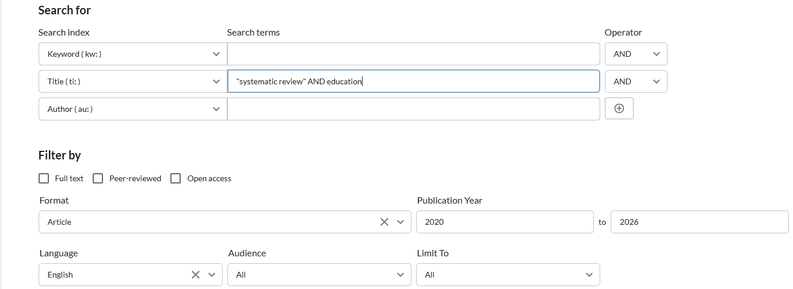

Refining your search results using filters
The number and variety of information sources indexed by Library Search, from across all subject areas, means that it is likely that you will have many search results. You can easily refine your results using some filters. These are shown on the left of the results screen.
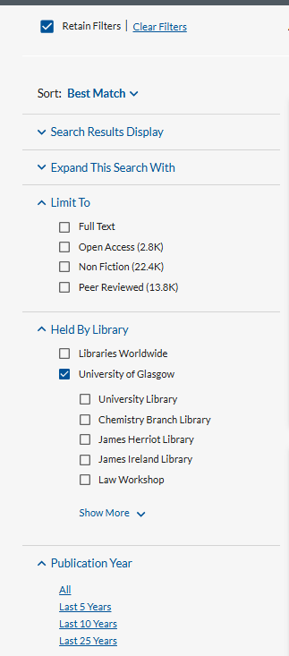

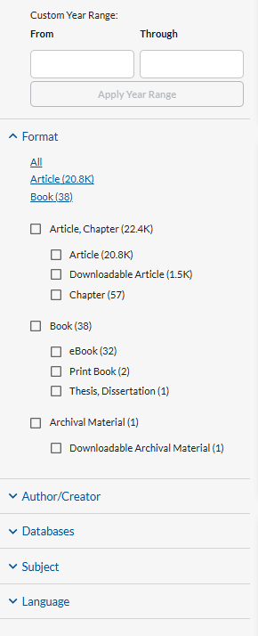

Limit to Full Text
By clicking on this option, your results will be limited to items available in full text online. This option is useful if you are working remotely and a trip to the library is not an option.

Peer reviewed
Limits results to peer-reviewed academic journal sources. Note that this limit only applies to journal articles.

Format
You can use this to limit your results to specific types of information. It can be useful to look at specific types of information together when you are evaluating results. For example, assess all the books published on a specific topic, or all academic journal articles.

In combination with the date filter, and using the summary information on Library Search, this helps you to evaluate large sets of results for relevance quickly.

Publication date

When you retrieve a lot of results you may want to limit results to recent publications (last 5 years or 10 years for example). There are preset options, for last 5 years, last 10 years, and last 25 years. You can also set your preferred date range.

Language
Select from the list of languages represented in your results.

Detailed item records - books

Each result will display the item title, author, edition details, and part of a summary description or contents pages if available, as well as a button to View eBook for digital copies, and links for all editions and formats in our collection.
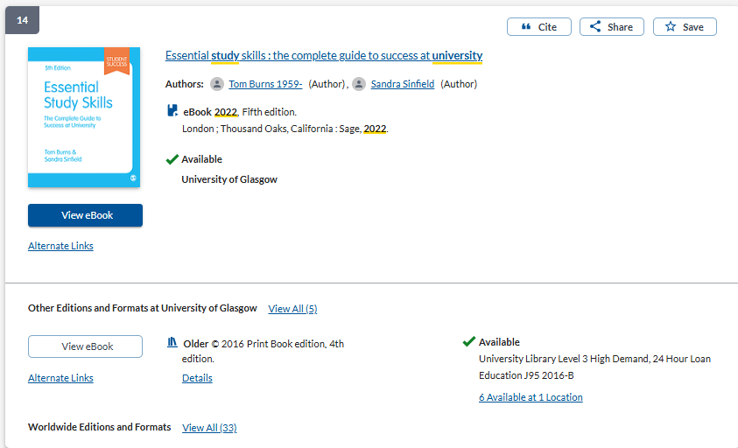
To see more information about an individual item, click 'Show More’. For books this will show a summary of the book and sometimes also the table of contents.
Click on the book title to see the full record. This provides full details of the book including author, title, publisher, place of publication, publication date, physical description and more. Click on ‘More item details’
Where the Library has print copies and an eBook, you can choose to open the eBook by choosing ‘View eBook.’ Live catalogue information will show if the print book of the same edition is on loan or available to borrow. The shelf number and location are provided.
All editions (print and digital) of the book are shown at the bottom of the detailed record.

Detailed item records – journal articles
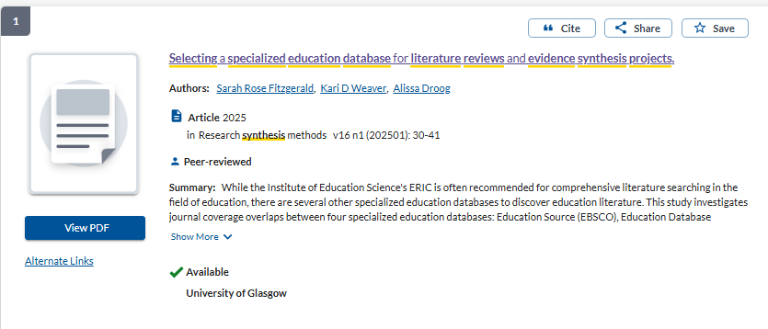
Journal article results have title, author(s), source information as well as links to download a PDF of the article or to read the article in full text online (Alternate Links.)
The Summary provides the article abstract which allows you to make a quick assessment of the article’s relevance to your search. You can save the article to a temporary folder or to a list if you are logged in. This allows you to continue searching as you find more keywords and search terms.
If you click on the journal title, you will see further information, including subject headings. Towards the bottom of the record there is a section called More from the Journal. This allows you to link out to explore more issues and articles from the journal:
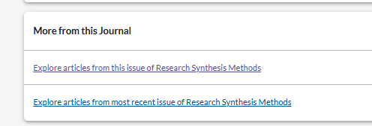

Saving Results
You can save items you find on Library Search to read later. This is useful when you are evaluating search results for relevance. You can add potentially relevant items to a ‘Saved items’ list as you continue searching. Saved items are added to a temporary list. The list is emptied when you exit the browser. However, you can log in to create a list and add your saved items. This is stored in your account.
You may want to link straight out to the full text of items and download, print or take notes. You may prefer to email or export your search results to read later.

- Click on the Save button to the right of the search result to add it to the Saved Items list. When you save an item the button changes to Saved.
- When you have finished selecting items click on the Saved items link at the top right of the screen.
- This will show your saved items.
- You can select all or some of the saved items and by selecting Cite you can create a quick reference list which you can copy/paste into a document.
- Alternatively, you can export these items to EndNote or another reference manager.
- Using the Share button you can email saved results to yourself or someone else.
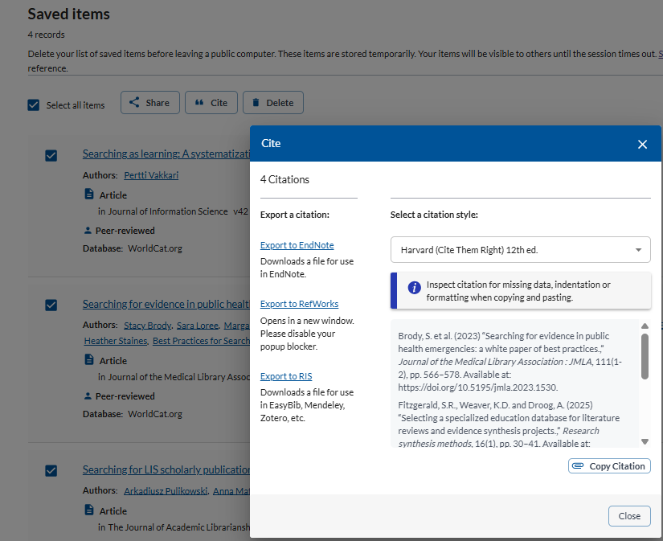

Saving to EndNote
- To save to EndNote Online click on the 'Export To EndNote ' link
- Save the .RIS file (Depending on the browser you are using; this may be saved to your Downloads folder).
- In your EndNote Online account click on 'Collect' and then 'Import references'.
- Browse for your downloaded file of references (it will be a .ris file)
- From the Import option list select 'Citation’
- Lastly, select a group to put them in - if you do not have any groups just select [Unfiled]
- Click on 'Import'. The references are then added to your Library.
- Please note that this will save only the bibliographic details not the full text. You will need to save the PDFs found via Library Search and attach them to your references manually.
- Alternatively, use the 'Find full-text' option from within EndNote to attach PDFs to references (although this might not find all of them, so you may need to attach some PDFs manually).

Information on using EndNote, downloading EndNote Desktop and signing up for EndNote training.

Updated September 2026.

